Utilisation analysis of PBS-listed medicines for heart failure

Prepared for: Department of Health and Aged Care
Reference ID: E23-78482
Prepared by: University of South Australia
Dr Svetla Gadzhanova
Prof Libby Roughead
Date: 1 May 2024

Contents

Table of abbreviations 4
Executive Summary 5
Background 9
Data 11
Methods 13
Utilisation of heart failure medicines in Australia 13
Treatment regimens 14
Standard of care in prevalent users of HF restricted medicines 14
Standard of care at initiation and add-on prescribing to standard care heart failure medicines 14
Treatment sequences 15
Treatment duration 16
Extent of use in accord and outside of PBS restrictions 16
Results 17
Utilisation of heart failure medicines in Australia 17
Prevalence 17
Incidence 20
Treatment regimens 25
Treatment regimens for PBS restricted HF medicines 25
Treatment regimens for restricted and unrestricted PBS listings for HF 29
Standard of care in prevalent users of HF restricted medicines 33
Standard of care at initiation and add-on prescribing to standard care heart failure medicines 34
Standard of care at initiation 34
Add-on prescribing to standard of care heart failure medicines 35
Treatment sequences 37
Treatment duration 39
Time to switch or cessation of PBS restricted HF medicine 40
Time to addition of a second PBS restricted HF medicine or cessation 41
Cumulative treatment duration - from first to last treatment episode 42
Survival analysis of 2020 and 2021 initiators of HF restricted medicines 43
Extent of use in accord and outside of PBS restrictions (2022) 45
Discussion 49
References 52
Appendix 1: Rx Risk medicines list and codes 53
Appendix 2: Additional survival analysis 55
Survival analysis of 2018-2021 initiators of HF restricted medicines, when considering HF restricted and unrestricted medicines 55
Survival analyses of 2018-2021 initiators of HF restricted medicines, when considering HF restricted medicines only, stratified by the individual index medicine 58
Survival analyses of 2020 and 2021 initiators of HF restricted medicines, when considering HF restricted medicines only, stratified by the individual index medicine 64
Survival analysis of 2020 and 2021 initiators of HF restricted medicines, when considering HF restricted and unrestricted medicines, stratified by the individual index medicine. 70

Table of abbreviations

Abbreviation | Description
CI | Confidence Interval
ATC | Anatomical Therapeutic Chemical Classification System
PBS | Pharmaceutical Benefits Scheme
PBAC | Pharmaceutical Benefits Advisory Committee
LVEF | Left Ventricular Ejection Fraction
FDC | Fixed dose combination
Classes of medicines
ACEi | Angiotensin-Converting Enzyme inhibitors
ARB | Angiotensin Receptor Blockers
ARNI | Angiotensin Receptor Neprilysin Inhibitor
BB | Beta Blocker
HCN | Hyperpolarization-activated Cyclic Nucleotide-gated
sGC | Soluble Guanylate Cyclase
SGLT2 | Sodium-Glucose co-Transporter 2 inhibitors
MRA | Mineralocorticoid Receptor Antagonist
Medicines
Biso | Bisoprolol
Carv | Carvedilol
Dapa | Dapagliflozin
Empa | Empagliflozin
Eple | Eplerenone
Ivab | Ivabradine
Meto | Metoprolol
Nebi | Nebivolol
S + V | Sacubitril + Valsartan
Veri | Vericiguat

Executive Summary
This report presents an analysis of contemporary medicine treatment patterns in patients with heart failure (HF) in Australia.
Recommended treatment for heart failure consists of multiple therapies. The Australian Medicines Handbook (AMH) recommends quadruple therapy to be considered in all patients with heart failure with reduced ejection fraction (HFrEF) unless contraindicated or not tolerated. The quadruple therapy includes a renin-angiotensin system inhibitor, a beta blocker (BB), a mineralocorticoid receptor antagonist (MRA) and a sodium glucose co-transporter 2 (SGLT2) inhibitor. In comparison to the AMH, the Heart Foundation guidelines recommends renin-angiotensin system inhibitors, a mineralocorticoid antagonist and beta-blockers as first-line agents up-titrated to maximum tolerated doses, with subsequent change to an angiotensin receptor neprilysin inhibitor if left ventricular ejection fraction (LVEF) remains at 40% or less. These guidelines, which were published in 2018, prior to the evidence emerging of the benefits of SGLT2 inhibitors in heart failure independent of diabetes, recommend SGLT2 inhibitors for people with diabetes and heart failure.
The Pharmaceutical Benefit Scheme (PBS) lists a number of medicines restricted to heart failure which include:
- beta blockers (BB) specific for HF (i.e. bisoprolol as fumarate, carvedilol, metoprolol as succinate, nebivolol),
- angiotensin receptor neprilysin inhibitor combination (ARNI) (i.e. sacubitril with valsartan),
- mineralocorticoid receptor antagonist (MRA) (i.e. eplerenone),
- sodium glucose co-transporter 2 (SGLT2) inhibitors indicated for HF (i.e. dapagliflozin and empagliflozin),
- hyperpolarization-activated cyclic nucleotide-gated channel blocker (HCN) (i.e. ivabradine) and
- soluble guanylate cyclase stimulator (SGC) (i.e. vericiguat).
While there are other medicines used to treat HF listed on the PBS including angiotensin-converting enzyme inhibitors (ACEi) and angiotensin receptor blockers (ARBs), digoxin, spironolactone and diuretics, these are listed as Unrestricted Benefits on the PBS. As these medicines may be used for indications other than HF (e.g. ACEi are frequently used for hypertension), the use of these medicines alone could not be used to identify a patient as having heart failure.
Therefore, in this report the cohort included in the study includes people who had been dispensed at least one medicine restricted for use in heart failure on the PBS (PBS restricted HF medicines) between January 2017 and June 2023. While some medicines are restricted to HF with a specified level of reduced ejection fraction, these restrictions were insufficient to characterise the population by severity. The restrictions are also insufficient to characterise the population with heart failure with preserved ejection fraction.
The results presented in this report should be interpreted within this context; the cohort does not necessarily capture the total heart failure population in Australia. The results in this report for incident users represent patients’ first use of a medicine restricted to HF on the PBS, not necessarily the newly diagnosed heart failure population. Similarly, the results for prevalent use represent individuals taking medicines restricted to heart failure on the PBS, not the prevalent diagnosed heart failure population.
To be consistent with PBS restrictions, in this report we considered standard of care to be dual therapy of a renin-angiotensin system inhibitor and beta-blocker, with or without an MRA, and with or without a SGLT2 inhibitor. Thus, standard treatment of heart failure with reduced ejection fraction (HFrEF) was considered to be therapy with:
- renin-angiotensin system inhibitor (ACEi, ARB or sacubitril with valsartan (ARNI));
- and heart specific beta-blocker;
- +/- Mineralocorticoid Receptor Antagonist (MRA);
- +/- Sodium Glucose Co-Transporter 2 (SGLT2) Inhibitors.
In 2022, PBS restricted HF medicines were supplied to 12 per 1,000 people in Australia (N=318,028), an increase from 8 per 1,000 in 2017. BB were the most frequently supplied class of PBS restricted HF medicines. The monthly number of people who received PBS restricted HF medicines in June 2017 was 122,727 increasing to 228,190 in June 2023. The mid-2017 monthly prevalence of 199,100 is slightly higher than the self-reported heart failure numbers of 143,700 from the 2022 Australian National Health Survey.
In 2022, the incident HF population, defined as initiation of PBS restricted HF medicine, was 3 per 1,000 people (N=81,343). The mean age at initiation was 70 years and 42% of initiators were females.
Standard treatment of HF involves the concurrent use of multiple medicines. Among PBS restricted HF medicines, the medicine classes including ARNI, SGLT2, HCN, and SGC, all have restrictions that require they are add on therapy to optimal chronic heart failure treatment which includes a beta-blocker. HCNs were first listed on the PBS in 2013, ARNIs in 2017, and SGLT2 inhibitors (indicated for HF) and SGCs in 2022. Thus, the opportunity for dual therapy for PBS restricted HF medicines has increased over time.
When considering only PBS restricted HF medicines in the prevalent population, over 80% of people were treated with a single class of PBS restricted medicine in June 2023. Consistent with increased listings of PBS restricted HF medicines over time and requirements within the restrictions for concomitant use, the proportion of patients receiving dual combination therapy has risen from 6% in 2017 to 15% in June 2023. The most frequently supplied combination of PBS restricted HF medicines was BB restricted for HF and ARNI.
Analysis of concurrent therapy with the inclusion of unrestricted PBS medicines likely to be used for heart failure, found that in the prevalent population in June 2023:
- 22% of patients were receiving monotherapy (most commonly BB, followed by ARNI),
- 34% of patients were receiving dual therapy (most commonly BB + ACEi or BB + ARB),
- 28% of patients were receiving triple therapy (most commonly BB + ACEi + loop diuretic or BB + ARB + loop diuretic); and,
- 17% of patients were receiving four or more therapies.
For 33% of the prevalent HF population, the combination therapies supplied met the definition of standard of care for HF with reduced ejection fraction in June 2023. The proportion of the population on standard of care was highest amongst people aged 65 to 84 years (37% in June 2023) and lowest amongst people aged 85 years and above (25% in June 2023) The lower rates of standard of care amongst the elderly may reflect challenges of managing competing health risks in a frail elderly population.
Among the incident HF population in 2022 (n=81,343), 40% of people who initiated PBS restricted HF medicines were initiated on standard of care. The combinations most frequently representing standard of care were a BB for HF and an ACEi (39%), and a BB for HF and an ARB (36%).
Treatment sequences with PBS restricted HF medicines were examined over time for people who initiated PBS restricted HF therapies between 2018-2021 (n=215,873). Over the follow-up period (up to June 2023), the majority of people (79%) received monotherapy only with the PBS restricted HF index medicine (i.e., did not add or switch to other PBS restricted HF medicines); 20% had a change in PBS restricted HF therapy – 6% switched to HF restricted medicine different to the index one, 10% had addition of second PBS restricted HF therapy and 4% stepped down from index HF restricted therapy. One percent of people were initiated on a combination therapy and stayed on it for the duration of the follow-up.
Amongst people who initiated monotherapy with HF restricted medicines between 2018 and 2021:
- The median time to a switch to a PBS restricted HF medicine different to the index one or break in therapy was 17 months.
- The median time to addition of a PBS restricted HF medicine or break in therapy was 15 months.
- The median cumulative duration of all treatment episodes was 3.4 years.
Consistent with the need for ongoing therapy, when the analyses include all medicines for heart failure, people stayed on at least one medicine that could be used for heart failure (restricted or unrestricted) for the duration of the study.
Analyses were undertaken to determine if initiation of PBS restricted HF medicines was in accord with PBS restrictions using an incident population in 2022 (n= 81,343):
- Overall, 67% of use of BB specific for heart failure was in persons who had previously been on an ACEi/ARB, although one third had not had a dispensing in the year prior.
- The initiation of an ARNI was frequently not in accord with the PBS restrictions, with only 39% having concomitant use of any BB and only 36% having had an ACEi/ARB in the year prior.
- Overall, 57% of SGLT2 inhibitor initiation was in persons already on at least one therapy that may be for heart failure. SGLT2 inhibitors are indicated for HF with preserved ejection fraction, which was not a PBS listed indication during the study period. This may account for a proportion of the 43% of the population that appear to have had the medicine outside of PBS restrictions as they had no-add therapy with ACEi/ARB/ARNI or a beta-blocker. The majority (88%) of people initiated on SGLT2 were not on a second SGLT2 inhibitor. It is possible that incorrect selection of PBS item codes may account for some of the 12% of dispensings that were dispensed for indications other than heart failure.
- The majority of HCN use, which is not a large proportion of the population, appears to be outside of PBS restrictions as 83% did not have concomitant use of a BB.
- The sGC market is too new and data were not available to assess the PBS restrictions.
SGLT2 inhibitors, dapagliflozin and empagliflozin, were listed on the PBS for heart failure in January and April 2022, respectively. It was hypothesised there may be a proportion of people with heart failure receiving PBS subsidised treatment with an SGLT2 inhibitor under a non-HF indication (e.g. type 2 diabetes, chronic kidney disease). The analysis found that in December 2022, 3% of prevalent users of PBS restricted HF medicines received a PBS subsidised SGLT2 inhibitor under a non-HF indication and were not dispensed any other medicines for diabetes. It is possible this use may represent SGLT2 inhibitor use for HF or use outside of PBS restrictions for diabetes (PBS restrictions do not currently allow monotherapy with an SGLT2 inhibitor for type 2 diabetes).
Among all people who had an SGLT2 inhibitor for HF, approximately 40% were supplied an ARNI, with around 25% - 30% supplied an ACEi/ARB concurrently. This compares with the estimates that between 11% and 20% of the standard of care population would likely be supplied an ARNI and the remainder would be on ACEi/ARB concurrently when dapagliflozin was assessed by the PBAC for PBS listing for heart failure.
This analysis shows less than half the PBS restricted HF population appear to be on standard of care and there appears to be significant use of PBS restricted HF medicines outside of the restrictions. In the absence of diagnostic data on disease severity and frailty, it is difficult to conclude the extent to which these analyses represent inappropriate or suboptimal use. It is possible that challenges in implementing quadruple therapy due to frailty or comorbidity are contributing to some of the observed results. The full extent of the influence of age, frailty, and comorbidity, as well as medicine intolerance and contraindications cannot be determined from the PBS data alone. The analysis does suggest that PBS restricted HF medicines are being used interchangeably more frequently than as add-on therapy, which may have implications for the realisation of the cost-effectiveness benefits of the listings.

Background

This report presents an analysis of contemporary medicine treatment patterns in patients with heart failure (HF) in Australia. Patients with heart failure may have reduced ejection fraction or preserved ejection fraction and treatment guidelines vary according to ejection fraction.
The Australian Medicines Handbook (AMH) [1] recommends quadruple therapy for to be considered in all patients with heart failure with reduced ejection fraction (HFrEF) (unless contraindicated or not tolerated) to prolong survival and reduce HF hospitalisations. The AMH recommends starting all medicines as soon as clinically possible, rather than using a step-wise approach, as early morbidity and mortality benefits have been shown. The quadruple therapy includes a renin-angiotensin system inhibitor, a beta blocker (BB), a mineralocorticoid antagonist (MRA) and a Sodium Glucose Co-Transporter 2 (SGLT2) inhibitor. According to the AMH, loop diuretics can be used to manage congestion and relieve symptoms of HF. A thiazide diuretic may be added under specialist advice if fluid retention persists.
In comparison to the AMH, the Heart Foundation algorithm for the Pharmacological Management of patients with HFrEF recommends renin-angiotensin system inhibitors, a mineralocorticoid antagonist and beta-blockers as first-line agents up-titrated to maximum tolerated doses, with subsequent change to an angiotensin receptor neprilysin inhibitor (ARNI) if left ventricular ejection fraction (LVEF) remains at 40% or less [2]. These guidelines were published in 2018 and recommend SGLT2 inhibitors for people with diabetes and heart failure. This time period was prior to the evidence emerging of the benefits of SGLT2 inhibitors in heart failure independent of diabetes comorbidity.
While the AMH recommends quadruple therapy, many patients with HF are older and have a number of chronic conditions. Some may be frail, some may have poor or worsening renal impairment, some may have hypotension, all of which may result in doctors choosing a step-wise approach to management rather than initiation of quadruple therapy to maximise benefit while minimising competing risk of exacerbating other conditions.
For these reasons, and to be consistent with PBS restrictions, in this report we considered standard of care to be dual therapy of a renin-angiotensin system inhibitor and beta-blocker, with or without an MRA, and with or without an SGLT2 inhibitor. Thus, standard treatment of heart failure with reduced ejection fraction (HFrEF) was considered to be therapy with:
- renin-angiotensin system inhibitor (ACEi, ARB or sacubitril with valsartan (ARNI))
- and heart specific beta-blocker
- +/- Mineralocorticoid Receptor Antagonist (MRA)
- +/- Sodium Glucose Co-Transporter 2 Inhibitors
The therapeutic options for treatment of heart failure with preserved ejection fraction are more limited with most conventional therapies not demonstrating an effect on overall survival. The exception is SGLT2 inhibitors, which have been shown to be effective in reducing the combined endpoint of cardiovascular death or hospitalisation for heart failure [2]. SGLT2 inhibitors were not listed on the PBS for preserved ejection fraction heart failure during the study period, becoming available on the PBS for this indication in March 2024.
PBS expenditure on medicines indicated for heart failure (HF) exceeded $183 million in 2022 according to Services Australia Pharmaceutical Benefits Scheme (PBS) statistics for prescriptions processed in this period. This figure is a conservative estimate of the total market as it does not include unrestricted PBS items used for HF such as angiotensin-converting enzyme inhibitors (ACEi), angiotensin receptor blockers (ARBs), digoxin, spironolactone and diuretics which can be used for non-HF indications. Of the total market in 2022, sacubitril + valsartan (S + V), an angiotensin receptor neprilysin inhibitor (ARNI), accounted for $113 million (at published prices) of expenditure with a corresponding increase in prescriptions from 170,620 (2018) to 599,115 (2022).
There have been no substantive changes to the PBS restrictions for HF medicines in the last five years. However, three new medicines were PBS-listed in 2022 for the treatment of chronic HF with the PBS restrictions for each requiring varying degrees of reduced left ventricular ejection fraction (LVEF): dapagliflozin, LVEF ≤40%; empagliflozin, LVEF ≤40%; and vericiguat, LVEF ≤45%.
The medicines and the associated PBS restrictions for subsidy are described below.
BB specific for HF
Moderate to severe HF indication: Patient must have stabilised on conventional therapy, which must include an ACEi/ARB, if tolerated.
ARNI
Symptomatic with NYHA classes II, III or IV;
LVEF of 40% or less;
Patient must receive concomitant optimal standard chronic HF treatment, which must include a BB, unless at least one of the following is present in relation to the beta-blocker: (i) a contraindication listed in the Product Information, (ii) an existing/expected intolerance, (iii) local treatment guidelines recommend initiation of this drug product prior to a BB;
Patient must have been stabilised on an ACEi/ARB at the time of initiation with this drug, unless such treatment is contraindicated;
Concomitant ACEi/ARB not permitted.
SGLT2 for HF
Symptomatic with NYHA classes II, III or IV;
LVEF of 40% or less;
Must be an add-on therapy to optimal standard chronic HF treatment, which must include a BB, unless contraindicated according to the TGA-approved PI or cannot be tolerated, AND
Must be an add-on therapy to optimal standard chronic HF treatment, which must include an ACEi/ARB/ARNI, unless contraindicated according to the TGA-approved PI or cannot be tolerated, AND
Patient must not be receiving treatment with another sodium-glucose co-transporter 2 (SGLT2) inhibitor.
MRA for HF
No PBS requirement for prior/concomitant use of other medicines;
LVEF of 40% or less;
Eplerenone: the condition must occur within 3 to 14 days following an acute myocardial infarction, AND
The treatment must be commenced within 14 days of an acute myocardial infarction.
HCN
Symptomatic with NYHA classes II, III;
LVEF of 35% or less;
Sinus rhythm;
Resting heart rate of 77 beats per minute or above at initiation (documented by ECG or echocardiogram);
Patient must receive concomitant optimal standard chronic HF treatment, which must include the maximum tolerated dose of a BB, unless contraindicated or not tolerated;
The treatment must be an add-on therapy to optimal standard chronic HF treatment, which must include a BB, unless contraindicated according to the TGA-approved PI or cannot be tolerated, AND
Must be an add-on therapy to optimal standard chronic HF treatment, which must include an ACEi/ARB/ARNI, unless contraindicated according to the TGA-approved PI or cannot be tolerated.
sGC
The treatment must be an add-on therapy to optimal standard chronic HF treatment, which must include a BB, unless contraindicated according to the TGA-approved PI or cannot be tolerated, AND
Must be an add-on therapy to optimal standard chronic HF treatment, which must include an ACEi/ARB/ARNI, unless contraindicated according to the TGA-approved PI or cannot be tolerated.

Data
The Department of Health and Aged Care engaged the services of UniSA to undertake a utilisation analysis of PBS-listed medicines for heart failure to explore the contemporary medicine treatment patterns in patients with HF in Australia, including switching between medicines, combination treatment and add-on therapy.
The analysis included a data extract for all persons with at least one dispensing for any medicine specifically listed for heart failure on the PBS (Table 1 below) from January 2017 to June 2023. PBS subsidised treatment with medicines listed in Table 1 are restricted for use in heart failure, so this cohort was considered to have a confirmed heart failure diagnosis. The results presented in this report should be interpreted within this context, as the cohort population does not necessarily capture the total heart failure population in Australia.
For each person within this cohort, all dispensings of medicines that have the potential to be used to treat heart failure (any medicine listed in Table 1 or 2 below) and SGLT2 inhibitors for all PBS listed indications were provided. While some SGLT2 inhibitors are subsidised on the PBS for use in heart failure (see Table 1 below), prior to 2022 this class was only PBS subsidised for use in type 2 diabetes, thus use of SGLT2i with the subsidised diabetes indication in the heart failure population was examined.
To determine each person’s level of comorbidity, all medicines dispensed in the prescription-based comorbidity index were analysed using the Rx-Risk comorbidity scale [3]. The Rx Risk identifies up to 45 individual conditions based on medicine use. It assumes use of the medicine is for the specified condition [3]. Its major limitation is that it is based on treatments (medicine use) and not diagnostic data. It has previously been shown to have good specificity for selected conditions, but poorer sensitivity (i.e it may not identify everyone who has the condition) [4]. Sensitivity and specificity does vary for each condition [4]. Its advantage is that it can be used for everyone who takes medicines and it is predictive of mortality and poorer self-reported health [3, 4], thus does serve as a measure of overall health. Rx Risk (the list of medicines and codes) used in the analysis are provided in Appendix 1.
Time of death for censoring individuals in the analyses examining duration was not available. A proxy measure was used instead, namely lack of dispensing for any medicine in Table 1 or Table 2 for 12 months. The date of the very latest dispensing + 365 days was used as a proxy date of death if it was before the end of study (if it was past the end of study, the person was considered to be alive). A sensitivity analysis was conducted using 180 days past the last dispensing which showed similar results for all survival analyses reported (results not shown).
Table 1 presents the medicines restricted to HF under the PBS and their PBS listing dates. It should be noted that a condition of subsidy for all these medicines (excluding eplerenone) includes prior or concomitant use with optimal standard chronic heart failure treatment unless contraindicated or not tolerated, usually one or both of the following:
- a renin-angiotensin system inhibitor (angiotensin-converting enzyme inhibitor (ACEi) or angiotensin receptor blockers (ARB))
- a beta-blocker.
Table 2 presents unrestricted PBS items which could be used for HF such as ACEi, ARB, digoxin, spironolactone and diuretics.
Table 1: PBS-listed medicines for heart failure (restricted benefit/authority required)
Class | Medicine | ATC code | PBS item code | PBS List date
Beta blockers | Bisoprolol (as fumarate) | C07AB07 | 8604W; 8605X; 8696Y | Aug 2002
 | Carvedilol | C07AG02 | 8255L; 8256M; 8257N; 8258P | May 1998
 | Metoprolol (as succinate) | C07AB02 | 8732N; 8733P; 8734Q; 8735R | May 2004
 | Nebivolol | C07AB12 | 9316H; 9311C; 9312D | Mar 2010
MRA | Eplerenone | C03DA04 | 8879H; 8880J | Feb 2006
SGLT2i | Dapagliflozin | A10BK01 | 12823X | Jan 2022
 | Empagliflozin | A10BK03 | 12918X | Apr 2022
ARNI | Sacubitril+Valsartan | C09DX04 | 11123K; 11131W; 11122J; | Jun 2017
HCN channel blocker | Ivabradine | C01EB17 | 10012Y; 2960T | Dec 2013
sGC stimulator | Vericiguat | C01DX22 | 13181R; 13178N; 13186B; 13189E; 13193J; 13192H | Dec 2022
Legend:
MRA - Mineralocorticoid receptor antagonist
SGLT2i – Sodium-glucose co-transporter 2 inhibitors
ARNI – Angiotensin Receptor Neprilysin Inhibitor
HCN - Hyperpolarization-activated Cyclic Nucleotide-gated
sGC – Soluble Guanylate Cyclase

Table 2. PBS-listed medicines with unrestricted benefit which can be used for heart failure
Class | ATC code | Specific medicines
ACEi | C09A;  C09B (FDC) | Any
ARB | C09C;  C09D (FDC) | Any  (note that Sacubitril+Valsartan (ARNI) is restricted for HF - Table 1)
BB | C07AA  C07AB  C07AG | Non-selective  Selective (metoprolol succinate and bisoprolol are restricted for HF – Table 1)  Alpha and beta (carvedilol is restricted for HF – Table 1)
Diuretics | C03 | Thiazide; Loop diuretics
Cardiac glycosides | C01A | Digoxin
MRA | C03DA | Spironolactone
Legend:
ACEi – Angiotensin-Converting Enzyme inhibitors
ARB – Angiotensin Receptor Blockers
BB – Beta Blockers
MRA - Mineralocorticoid receptor antagonist
FDC – Fixed dose combination

Methods

Utilisation of heart failure medicines in Australia
Prevalence
Prevalence was calculated as the monthly number of people who were dispensed any medicine from Table 1 from 2017 to 2022. We also reported prevalence by medicine class. We reported yearly rates per 1,000 people in Australia, and annual counts. Population estimates were based on the estimated Australian resident population at 30 June as reported by the Australian Bureau of Statistics [5].
We also established the point prevalence of all HF therapies in prevalent users of HF restricted medicines in April 2023 to provide a full twelve months from listing of empagliflozin on the PBS for HF (April 2022).
Incidence
Incidence was calculated as the monthly number of people who initiated any medicine from Table 1 between 2018 and 2022 (where incident use is defined as no dispensings of any of the medicines in the previous 12 months (we used 2017 as the baseline year). This result gives the incident heart failure population. We also reported incidence by medicine class. This result provides the incidence to a class of medicine, not incidence to heart failure. We reported yearly rates per 1,000 people in Australia, and annual counts.
We reported the demographics of age, sex, and comorbidities of incident heart failure population (by year).

Treatment regimens
Mono, dual, triple and quadruple therapies in prevalent users
We reported the proportion of the population on mono, dual, triple and quadruple therapy in prevalent users of HF restricted medicines. Results were reported as monthly proportions of people co-dispensed medicines in Table 1 or Table 2 by class. The medicine specific standard coverage days (SCDs) were used to estimate use or co-use of medicines in a given month. Fixed dose combinations (ACEi/ARB) were considered dual therapy. As a secondary analysis, we undertook this same analysis for heart failure specific medicines listed in Table 1 only. For the purposes of counting dual use sacubitril with valsartan was counted as one medicine (ARNI).

Standard of care in prevalent users of HF restricted medicines
The monthly proportion of prevalent users of HF restricted medicines who received standard of care was determined for HFrEF. Standard of care was defined as prescribing of renin-angiotensin system inhibitor (ACEi (including in FDC), ARB (including in FDC) or sacubitril with valsartan (ARNI)) and heart specific beta-blocker +/- MRA +/- SGLT2 inhibitor for HF.

Standard of care at initiation and add-on prescribing to standard care heart failure medicines
We defined standard of care as follows:
- renin-angiotensin system inhibitor (ACEi (including in fixed dose combinations (FDC)), ARB (including in FDC) or sacubitril with valsartan (ARNI))
- and heart specific beta-blocker
- +/- Mineralocorticoid Receptor Antagonist (MRA – eplerenone/ spironolactone)

The analysis considered SGLT2i use as ‘add-on treatment’ for consistency with PBS restriction criteria, however it should be noted that the AMH now recommends quadruple therapy including SGLT2i as part of standard of care for the treatment of HFrEF. We determined the proportion of the incident HF population in 2022 on standard of care at initiation of heart failure medicines using a time window of thirty days post first (index) HF restricted medicine using the standard coverage days methods (i.e. accounting for the duration a prescription lasts). For those people on standard of care at initiation, we reported the class or classes of add on therapy at initiation and within 3 months post initiation. Add on therapy was limited to medicines subsidised for HF only (Table 2.1).

Table 2.1. Medicines considered ‘add-on treatment’ to standard of care
Class | Medicine | PBS List date | PBS restrictions
SGLT2i | Dapagliflozin | Jan 2022 | Requires treatment with a BB (if tolerated) plus an ARB or an ARNI (if tolerated)
SGLT2i | Empagliflozin | Apr 2022
HCN | Ivabradine | Dec 2013 | Requires standard of care including a BB (if tolerated)
sGC stimulator | Vericiguat | Dec 2022 | Requires treatment with a BB (if tolerated) plus an ARB or an ARNI (if tolerated)
Legend:
SGLT2i – Sodium-glucose co-transporter 2 inhibitors
HCN - Hyperpolarization-activated Cyclic Nucleotide-gated; sGC – soluble Guanylate Cyclase

Treatment sequences
To identify treatment patterns and pathways within the heart failure population, we created a cohort of people who initiated any HF medicine in Table 1 (first ever) between 2018 and 2021 (2017 was used as the baseline year) to allow for at least 18 months of follow-up. It should be noted that even though only treatment with PBS restricted HF medicines were considered in this analysis, people may have also be taking non-HF restricted medicines. The unrestricted medicines were excluded in defining the initiation cohort because of the uncertainty on the indication.
Treatment pathways from the index dispensing to end of follow-up were assessed to determine switching, add on and treatment combinations of PBS listed HF medicines (as per Table 1). Prescription date of supply and medicine specific standard coverage days (SCDs), the latter calculated from the data for each medicine and reflecting the median number of days between dispensings, were used to define the start and end date (predicted refill date for next prescription) of each episode of treatment with the specific medicine. Treatment episodes for each patient and each medication were estimated on a weekly rather than daily basis to keep the data volume at a manageable level. This means that if the episode’s start date falls in a particular calendar week then the medication is deemed to cover that week. The same rule was applied to the medication episode’s end date. A break (long gap) in treatment was defined as a gap of two or more SCDs (i.e. the patient has not received re-supply at two consecutive expected refill dates). If multiple prescriptions of the same medication (but not the same strength) were supplied on the same day, it was assumed that these were necessary for dose escalation and the coverage period was not extended. If the multiple prescription of the same medication and the same strength were supplied on the same day (for example original and repeat prescriptions were supplied under Regulation 24 on the same day), then this was assumed to extend the coverage period (i.e. end of coverage period = supply date + number of prescriptions on the same day x SCD). Once medication episodes for each patient and each medicine were determined for every week, then regimens of monotherapy and co-administration were calculated. Short periods (less than one SCD which is 30 days for the majority of the medicines) of overlap between two different regimens were considered a switch rather than co-administration (for example A A+B B is considered as AB). Switches were defined as change from one treatment regimen to another.
We reported monotherapy, changes in therapy (switches from index medicine(s), addition of second line therapy to index therapy, step down from index therapy), and therapy with combinations over the follow-up period. This analysis was limited to medicines subsidised for heart failure only.

Treatment duration
We determined the duration of heart failure treatments using the following methods.
Duration of the index (first) episode was defined as time from index dispensing (1st ever HF medicine from Table 1) between 2018 and 2021, to study end (30 Jun 2023). The study end point for each patient was the time to discontinuation of the first therapy, either due to switch or cessation:
- switch was defined as change to a therapy not containing the index one,
- cessation was defined as a gap in refill based on the length of the estimated prescription duration which was calculated from the data and reflects the time period within which 75% of people returned for a repeat prescription. Gaps which were ≥ three times the length of the estimated prescription duration were considered to represent cessation.
Persons were followed up until cessation, switching to therapy not including the index medicine(s), death or end of study. Persons who ceased or switched therapy before the end of study were reported as “event” persons, while those who died or continued therapy with the index therapy at the end of study were reported as “censored” persons. As death data was not available, a proxy was used, namely the date of the very last dispensing for any PBS medicine from Table 1 or Table 2 plus 365 days (if it was before the end of study); if the date was after the end of study, the person was considered not to have died.
Where a person starts on multiple medicines, the duration was estimated as time to first change to therapy not containing any index medicine or cessation, whichever occurs first.
The duration of the index episode was stratified by the type of the index HF medicine (individual medicine). We reported results using Kaplan Meier methods. As heart failure prevalence is heavily influenced by age, we adjusted for age in the cox proportional hazards models to determine differences in persistence between medicines.
Overall duration was determined as time from index dispensing (1st ever HF medicine from Table 1) to last dispensing for a medicine from Table 1 (including gaps).
Using the same method, we also examined time to treatment intensification (i.e. add on therapy), where a new heart failure medicine is added to index therapy.
Noting that opportunity to switch or add has changed over time as different products have become available on the PBS, we used yearly cohorts of initiators in 2020, 2021 and assessed time to:
- first change in therapy (add, switch) from index heart failure medicine;
- first switch from index medicine;
- first addition to index medicine.
The primary analysis was limited to medicines in Table 1. Follow-up periods was limited to one year for the 2020 and 2021 cohorts. The secondary analysis included all medicines in Table 2.

Extent of use in accord and outside of PBS restrictions
To examine potential use of outside of PBS restrictions we investigated the following metrics reflecting recommended use in accord with PBS restrictions for subsidy:
- Proportion of people who initiated BB restricted for HF who had prior use of ACEi/ARB in the previous 12 months;
- Proportion of people who initiated ARNI who had concomitant use of any BB within 30 days prior and post initiation;
- Proportion of people who initiated ARNI who had prior use of ACEi/ARB in the previous 12 months;
- Proportion of people who initiated ARNI who had no co-use of ACEi/ARB within 30 days post initiation;
- Proportion of people who initiated SGLT2 for HF who had add-on therapy with any BB/ACEi/ARB/ARNI within 30 days prior and post initiation;
- Proportion of people who initiated SGLT2 for HF who did not receive treatment with another SGLT2 not for HF within 30 days post initiation;
- Proportion of people who initiated HCN who had concomitant use of any BB within 30 days prior and post initiation.
Initiation was defined as dispensing of any PBS restricted HF medicine after no dispensings of any HF restricted medicine in the previous 12 months. This analysis was completed for the calendar year 2022 as SGLT2 inhibitors were listed on the PBS for use in HF in 2022 (dapagliflozin was listed in January 2022, while empagliflozin was listed in April 2022).
Noting that SGLT2 inhibitors are PBS listed for indications other than heart failure and may be being used for those conditions we also determined the proportion of people on PBS restricted HF medicines who were dispensed SGLT2i subsidised and not subsidised for heart failure.
The submissions to the PBAC for SGLT2 inhibitors for heart failure included standard of care as the comparator where ACEi/ARB usage represented the majority of standard of care market, with ARNI use accounting for a smaller proportion of use; between 11% and 20% [7]. For this reason, we established the proportion of people dispensed dapagliflozin or empagliflozin in a given month who were also dispensed sacubitril + valsartan (ARNI) or an ACEi/ARB.

Results

Utilisation of heart failure medicines in Australia

Prevalence
The annual rates per 1,000 of people who were supplied PBS restricted HF medicines (listed in Table 1) increased from 7.9 in 2017 to 12.2 in 2022 (Table 3).
Table 3. Annual rate per 1,000 of people who were supplied PBS restricted HF medicines
Year | Number of people on PBS restricted HF medicines | Estimated Australian resident population at 30 June as reported by the Australian Bureau of Statistics | Prevalent rate per 1,000 people
2017 | 193,382 | 24,603,316 | 7.9
2018 | 211,807 | 24,987,751 | 8.5
2019 | 232,743 | 25,359,662 | 9.2
2020 | 257,234 | 25,692,600 | 10
2021 | 281,982 | 25,739,256 | 11
2022 | 318,028 | 25,996,144 | 12.2
Note: Year 2023 is not presented as only data to 30 Jun 2023 was available
There were 148,946 prescriptions for medicines restricted for HF (listed in Table 1) in June 2017 increasing to 327,391 in June 2023 (Figure 1). The graph shows increasing seasonality effect over time with peaks in December and troughs in January associated with the safety net effect resulting in additional dispensings during the period where people can fill dispensings under the safety net.

Figure 1. Number of prescriptions supplied for PBS restricted HF medicines by month
The monthly number of people who received PBS restricted HF medicines in June 2017 was 122,727 increasing to 228,190 in June 2023 (Figure 2). In June 2022, the monthly prevalence was 199,100 which is slightly higher than the self-reported heart failure numbers of 143,700 from the 2022 National Health Survey [6]

Figure 2. Number of people supplied PBS restricted HF medicines by month

When the analysis only included PBS restricted HF medicines, heart specific beta blockers were the most commonly supplied class of PBS restricted HF medicines, followed by an ARNI (sacubitril + valsartan), Figure 3. Two SGLT2 inhibitors (dapagliflozin and empagliflozin) were listed on the PBS for use in HF in 2022 (January and April, respectively), while a sGC stimulator (vericiguat) was listed for HF in December 2022.

Figure 3. Number of people supplied PBS restricted HF medicines by month and class.
Legend:
BB – Beta-blockers
MRA - Mineralocorticoid Receptor Antagonist
SGLT2 – Sodium-glucose co-transporter 2 inhibitors
ARNI – Angiotensin Receptor Neprilysin Inhibitor
HCN - Hyperpolarization-activated Cyclic Nucleotide-gated
sGC – Soluble Guanylate Cyclase

Incidence
The incident HF population, defined as incident to PBS restricted HF medicines, was two people per 1,000 in 2018, increasing to 3 per 1,000 in 2022 (N=81,343), Table 4.
The mean age at initiation was consistent across each year at 70-71, and 40-42% of the initiators were females in each year.
On average, people had three co-morbidities (using the Rx Risk) in addition to HF with the leading ones being hyperlipidaemia and gastro-oesophageal reflux disease. In the 2022 cohort, the five most common comorbidities were as follows: 15% of the incident HF population had hyperlipidaemia (measured by dispensings of lipid lowering therapy), 12% had gastro-oesophageal reflux disease (measured by dispensings of proton pump inhibitors), 10% had diabetes (measured by dispensing of anti-diabetic agents) , 9% were dispensed anticoagulants, and 8% had airways disease (measured by dispensings inhaled respiratory medicines). Two percent of the people in 2022 cohort had renal disease (measured by dispensings of sevelamer, lanthanum, sucroferrate, calcitriol, darbepoetin or methoxy polyethylene glycol-epoetin beta).
Table 4. Annual incidence rate per 1,000 (people who were initiated PBS restricted HF medicines after no dispensings of any medicine restricted for HF in the previous 12 months)
Year | Number of people initiated on HF restricted medicines | Estimated Australian resident population at 30 June as reported by the Australian Bureau of Statistics | Incident rate per 1,000 people | Mean age  at initiation (years), (SD) | Females | Mean number of co-morbidities  in the 12 months prior to initiation, SD
2018 | 51,268 | 24,987,751 | 2.1 | 71 (14.3) | 40.5% | 3.4 (2.5)
2019 | 55,921 | 25,359,662 | 2.2 | 71 (14.1) | 40.7% | 3.3 (2.5)
2020 | 61,427 | 25,692,600 | 2.4 | 70 (14.6) | 40.3% | 3.1 (2.5)
2021 | 63,448 | 25,739,256 | 2.5 | 71 (14.7) | 41.0% | 3.2 (2.5)
2022 | 81,343 | 25,996,144 | 3.1 | 70 (14.3) | 41.6% | 3.2 (2.4)
Note: Year 2023 is not presented as only data to 30 June 2023 was available; Year 2017 was used as baseline year

The monthly numbers of the incident HF population (defined as people who had no dispensing of PBS restricted HF medicines in the previous 12 months) are shown in Figure 4. The increase in the incident HF restricted medicine population in 2022 occurs at the time that two SGLT2 inhibitors were listed on the PBS for HF.

Figure 4. Population incident to PBS restricted HF medicines by month

Figures 5a and 5b show the incident HF population by the type of medicine (at the level of class) of initiation. Figure 5a shows that the majority of people were initiated on BB.

Figure 5a. Count of population incident to PBS restricted HF medicines by month and class
Legend:
“+” denotes initiation on combination
BB – Beta-Blockers
MRA - Mineralocorticoid receptor antagonist
SGLT2 – Sodium-glucose co-transporter 2 inhibitors
ARNI – angiotensin receptor neprilysin inhibitor
HCN - Hyperpolarization-activated Cyclic Nucleotide-gated
SGC – Soluble Guanylate Cyclase
Figure 5b shows the same data as Figure 5a, without the BB monotherapy initiators. SGLT2 monotherapy initiation accounts for the second most frequent initiation schedule by the end of the data period, with ARNI the third, while ARNI with SGLT2 is the fourth most frequent initiation schedule by the end of the data period.

Figure 5b. Count of population incident to PBS restricted HF medicines by month and class (excluding BB monotherapy initiators)
Legend: “+” denotes initiation on combination
BB – Beta-Blockers
MRA - Mineralocorticoid receptor antagonist
SGLT2 – Sodium-glucose co-transporter 2 inhibitors
ARNI – angiotensin receptor neprilysin inhibitor
HCN - Hyperpolarization-activated Cyclic Nucleotide-gated
SGC – Soluble Guanylate Cyclase

Figure 6 shows the counts of people initiating to a class of HF medicine defined as initiation of a given class after no dispensing for that class in the previous 12 months. (Note, in this analysis people may have had a prior different PBS restricted HF medicine). BB was the most commonly initiated class. While speculative, there does appear to be a slight fall in BB initiations in 2021 which may represent the influence of the COVID pandemic, and the slight rise in late 2022 may represent “catch up” prescribing. The slight rise in late 2022 may also be influenced by the reduction in the concessional safety net prescription threshold by 12 prescriptions in July 2022.

Figure 6. Population incident (count) to a class of PBS medicines restricted to HF
Legend: BB – Beta-Blockers, MRA - Mineralocorticoid receptor antagonist, SGLT2 – Sodium-glucose co-transporter 2 inhibitors, ARNI – angiotensin receptor neprilysin inhibitor, HCN - Hyperpolarization-activated Cyclic Nucleotide-gated
sGC – Soluble Guanylate Cyclase

Treatment regimens

Treatment regimens for PBS restricted HF medicines

Mono, dual, triple and quadruple HF regimens in prevalent users of PBS restricted HF medicines
The next section of this report examines whether combination therapy is used for heart failure (e.g., monotherapy, dual therapy). This analysis is in the prevalent population of medicines restricted to HF (listed in Table 1).
Figure 7 shows that over 80% of people were treated with a single class of heart failure restricted medicines in June 2023. The proportion on dual combinations has increased from 6% in December 2017 to 15% in June 2023. The rise in dual use aligns with the increased opportunity for dual therapy for PBS restricted HF medicines. Among the PBS restricted HF medicines, the medicine classes including ARNI, SGLT2 inhibitors, HCN, and SGC, all have restrictions that require they are add on therapy to optimal chronic heart failure treatment which includes a beta-blocker. HCNs were first listed on the PBS in 2013, ARNIs in 2017, and SGLT2 inhibitors and SGCs in 2022.

Figure 7. Percentage of prevalent users of PBS restricted HF medicines on mono, dual, triple and quadruple therapies

When considering the combination of classes of PBS restricted HF medicines used by the prevalent population, monotherapy with beta blockers was most frequently used, while BB plus ARNI was the most commonly used dual combination (Figure 8a). Figure 8b shows the same data with the BB monotherapy class excluded.

Figure 8a. Most common mono, dual and triple therapies restricted to HF in prevalent users of HF restricted medicines, by type of class (the presented therapies contribute to over 96% of all therapies in each given month)
Legend:
BB – Beta-Blockers
MRA (for HF)- Mineralocorticoid receptor antagonist for HF (Eplerenone)
SGLT2 (for HF)– Sodium-glucose co-transporter 2 inhibitors for HF
ARNI – angiotensin receptor neprilysin inhibitor (sacubitril+valsartan)
HCN - Hyperpolarization-activated Cyclic Nucleotide-gated

Figure 8b shows the same data as Figure 8a for combination therapies of PBS restricted HF medicines in the prevalent population with the BB monotherapy class excluded.
ARNI in combination BB is the most frequent regimen after BB monotherapy, followed by ARNI monotherapy (ARNI was considered a monotherapy as sacubitril is only available in combination with valsartan), SGLT2 monotherapy, BB in combination with SGLT2, and then ARNI in combination with SGLT2.

Figure 8b. Most common mono, dual and triple therapies restricted to HF in prevalent users of HF restricted medicines, by type of class (excluding monotherapy BB)
Legend:
BB – Beta-Blockers
MRA (for HF)- Mineralocorticoid receptor antagonist for HF (Eplerenone)
SGLT2 (for HF)– Sodium-glucose co-transporter 2 inhibitors for HF
ARNI – angiotensin receptor neprilysin inhibitor (sacubitril+valsartan)
HCN - Hyperpolarization-activated Cyclic Nucleotide-gated
We established the point prevalence of therapies restricted for HF in April 2023. Table 4.1 captures the therapies of 99.8% of all prevalent users of HF restricted medicines (N=216,039). Overall, 81% of people were treated with a single class of heart failure restricted medicines in April 2023.The most frequently prescribed combinations were ARNI + BB (9.3%) and ARNI + BB +SGLT2 (2.4%).
Table 4.1. Point prevalence of PBS restricted HF medicines in April 2023
Therapy | Number of people | Percent of all prevalent users of HF medicine in April 2023
BB monotherapy | 147723 | 68.4%
ARNI + BB | 20115 | 9.3%
ARNI monotherapy | 14998 | 6.9%
SGLT2 monotherapy | 8785 | 4.1%
ARNI + BB + SGLT2 | 5261 | 2.4%
BB + SGLT2 | 4322 | 2%
ARNI + SGLT2 | 3306 | 1.5%
HCN monotherapy | 2925 | 1.4%
MRA monotherapy | 2138 | 1%
BB + MRA | 1567 | 0.7%
BB + HCN | 858 | 0.4%
ARNI + BB + MRA | 730 | 0.3%
ARNI + BB + HCN | 669 | 0.3%
ARNI + HCN | 548 | 0.3%
ARNI + MRA | 453 | 0.2%
ARNI + BB + MRA + SGLT2 | 228 | 0.1%
ARNI + MRA + SGLT2 | 196 | 0.1%
ARNI + BB + HCN + SGLT2 | 193 | 0.1%
BB + MRA + SGLT2 | 157 | 0.1%
MRA + SGLT2 | 152 | 0.1%
ARNI + HCN + SGLT2 | 151 | 0.1%
Total | 215475 | 99.8%
Note: BB, MRA and SGLT2 are for HF indication
Legend:
BB – Beta-Blockers
MRA (for HF)- Mineralocorticoid receptor antagonist for HF (Eplerenone)
SGLT2 (for HF)– Sodium-glucose co-transporter 2 inhibitors for HF
ARNI – angiotensin receptor neprilysin inhibitor (sacubitril+valsartan)
HCN - Hyperpolarization-activated Cyclic Nucleotide-gated

Treatment regimens for restricted and unrestricted PBS listings for HF
The next section of this report examines whether combination therapy is used for heart failure (e.g., monotherapy, dual therapy) when the analysis is extended to include PBS restricted HF medicines and PBS listed unrestricted medicines that are recommended in HF (excluding calcium channel blockers). This population for this analysis is in the prevalent HF population (defined as supplied at least one PBS restricted HF medicine).
Dual or triple therapy combinations of heart failure treatments were the most frequent HF regimens (Figure 9). In June 2023, among the prevalent HF population (defined as supplied at least one PBS restricted HF medicine) 34% were on dual therapy, 28% on triple therapy, 22% on monotherapy and 17% on four or more therapies.

Figure 9. Prevalent users of PBS restricted HF medicines on mono, dual, triple and quadruple HF therapies (medicines restricted and unrestricted to HF)

Given the range of PBS listed medicines for HF, both restricted and unrestricted, there are numerous possible combinations of therapies. In this section of the report we show the market share of each regimen in three separate graphs, representing the monotherapy, dual therapy and triple therapy cohorts.
Figure 10.1 shows the treatment regimen in the monotherapy cohort. By definition, this cohort can only be on PBS restricted HF medicines (which represents 22% of the overall HF prevalent population in June 2023). Consistent with the previous analyses, the most frequently supplied mono therapies were with BB, followed by ARNI (Figure 10.1).

Figure 10.1. Market share of treatment regimens in the monotherapy cohort, which represents 22% of the overall HF prevalent population in June 2023)
Legend:
BB – Beta-Blockers,
MRA (for HF) - Mineralocorticoid receptor antagonist for HF (Eplerenone)
SGLT2 (for HF) – Sodium-glucose co-transporter 2 inhibitors for HF,
ARNI – angiotensin receptor neprilysin inhibitor ((sacubitril+valsartan)

Figure 10.2 shows the treatment regimen in the dual therapy cohort (which represents 34% of the overall HF prevalent population in June 2023). Consistent with guideline recommendations, HF restricted BB in combination with ACEi and HF restricted BB in combination with ARB represented the majority of dual therapies (Figure 10.2). There is an increase over time in ARNI in combination with BB and a decrease over time in BB in combination with loop diuretics.

Figure 10.2. Market share of treatment regimens in the dual therapy cohort, which represents 34% of the overall HF prevalent population in June 2023

Legend:
BB – Beta-Blockers
SGLT2 – Sodium-glucose co-transporter 2 inhibitors for HF
ARNI – angiotensin receptor neprilysin inhibitor (sacubitril+valsartan)
MRA (Spiro)- Mineralocorticoid receptor antagonist not for HF (Spironolactone)
ACE – Angiotensin-converting enzyme inhibitor
ARB – Angiotensin receptor blocker
CCB – Calcium channel blocker
Loop – Loop diuretic

Figure 10.3 shows the treatment regimen in the triple therapy cohort (which represents 28% of the overall HF prevalent population in June 2023). BB plus ACEi plus loop diuretic and BB plus ARB plus loop diuretics followed by BB plus ACEi plus spironolactone represent the three most frequent regimens (Figure 10.3).

Figure 10.3. Market share of treatment regimens in the triple therapy cohort, which represents 28% of the overall HF prevalent population in June 2023)

Legend:
BB – Beta-Blockers;
SGLT2 (for HF) – Sodium-glucose co-transporter 2 inhibitors for HF
SGLT2 (not for HF) – Sodium-glucose co-transporter 2 inhibitors not for HF
ARNI – angiotensin receptor neprilysin inhibitor
MRA (Spiro)- Mineralocorticoid receptor antagonist not for HF (Spironolactone)
ACE – Angiotensin-converting enzyme inhibitor;
ARB – Angiotensin receptor blocker
Loop – Loop diuretic
ACE_CCB – fixed dose combination of ACE with CCB
ARB_CCB – fixed dose combination of ARB with CCB
ARB_Thiaz – fixed dose combination of ARB with thiazide diuretic

Due to the large number of combinations of quadruple therapy, the quadruple therapy market is not shown.

Standard of care in prevalent users of HF restricted medicines
In this section of report, analysis is undertaken to determine the proportion of the HF population (as defined by PBS restricted HF medicines) on standard of care in the prevalent HF population (PBS restricted HF medicines).
For the purposes of this analysis standard of care was defined to include people on:
- Heart failure specific BB and ACEi (including in FDC) (+/- SGLT2 for HF) or
- Heart failure specific BB and ARB (including in FDC) (+/- SGLT2 for HF) or
- Heart failure specific BB and ARNI (+/-SGLT2 for HF) or
- Heart failure specific BB and ACEi (including in FDC) and MRA (Eplerenone/Spironolactone) (+/- SGLT2 for HF) or
- Heart failure specific BB and ARB (including in FDC) and MRA (Eplerenone/Spironolactone) (+/- SGLT2 for HF)
- Heart failure specific BB and ARNI and MRA (Eplerenone/Spironolactone) (+/-SGLT2 for HF).
This definition was used as it aligns with the PBS restrictions.
Figure 11 shows that in June 2023, 33% prevalent users were on standard of care. By the end of the study period (June 2023) 7% of standard of care regimens included SGLT2 inhibitors, 14% of standard of care regimens involved MRA, and 18% involved an ARNI. For a full breakdown of the standard of care combinations, refer to attachment 1: Standard_Care_Prevalent population results.xls

Figure 11. Proportion of people on PBS restricted HF medicine on standard of care

The proportion on standard of care was highest amongst people aged 65 to 84 years (37% in June 2023) and lowest amongst people aged 85 years and above (25% in June 2023) (Figure 12). The lower rates of standard of care amongst the elderly may reflect challenges of managing competing health risks in a frail elderly population. For example, there may be a need to reduce some therapies in order to maintain blood pressure while at the same time trying to optimise heart failure therapy.

Figure 12. Proportion of people on PBS restricted HF medicine on standard of care, stratified by age

Standard of care at initiation and add-on prescribing to standard care heart failure medicines

Standard of care at initiation
In this section of the report, analysis of treatment pathways was undertaken in the incident HF population. The incident population was restricted to persons incident to PBS restricted HF medicines in 2022 (i.e. no dispensings of PBS restricted HF medicines in the previous 12 months).
There were 81,343 people who initiated HF restricted medicines in 2022 (defined as having no dispensing of any HF restricted medicine in the previous 12 months).
Overall, there were 32,524 (40%) on standard of care at initiation (this compares with 33% in the prevalent population). Standard of care was defined as follows:
- renin-angiotensin system inhibitor (ACEi (including in FDC), ARB (including in FDC) or sacubitril with valsartan (ARNI))
- and heart specific beta-blocker
- +/- Mineralocorticoid Receptor Antagonist (MRA – eplerenone/spironolactone)
- +/- Sodium Glucose Co-Transporter 2 Inhibitor (SGLT2).
Table 5 shows a break-down of all therapies at initiation. Thirty-nine percent (N=12,810) of those on standard of care were initiated on BB (for HF) + ACEi and 36% (N=11,786) were initiated on BB (for HF) + ARB.
Of the 35,524 people on standard of care at initiation, 830 (2.3%) had SGLT2 inhibitors as part of their standard of care at initiation (Table 5). There were no people on standard of care and sCG stimulator at initiation as it was approved for HF in December 2022.
Table 5. Number of people on standard of care and type of all other therapies at initiation
Therapy at initiation | Number of people | Percent
BB (for HF) + ACEi | 12810 | 15.7%
BB (for HF) + ARB | 11786 | 14.5%
BB (for HF) + ARNI (+/-MRA) | 2386 | 2.9%
BB (for HF) + ACEi + MRA | 2660 | 3.3%
BB (for HF) + ARB + MRA | 1790 | 2.2%
BB (for HF) + ACEi + SGLT2 (for HF) | 287 | 0.4%
BB (for HF) + ARB + SGLT2 (for HF) | 241 | 0.3%
BB (for HF) + ACEi/ARB + HCN | 86 | 0.1%
BB (for HF) + ACEi + SGLT2 (for HF) + MRA | 302 | 0.4%
BB (for HF) + ARB + SGLT2 (for HF) + MRA | 176 | 0.2%
Sub-Total (Standard of care) | 32524 | 40.0%
BB (for HF) alone | 20391 | 25.1%
ARNI (including in combinations which are not considered standard of care) | 2871 | 3.5%
BB (for HF) in combinations which are not considered standard of care | 7682 | 9.4%
HCN (including in combinations which are not considered standard of care) | 1612 | 2%
MRA for HF (including in combinations which are not considered standard of care) | 1278 | 1.6%
SGLT2 for HF (including in combinations which are not considered standard of care) | 14985 | 18.4%
Sub-Total (Non standard of care) | 48819 | 60.0%
Note: There were no people who initiated BB + ARNI + SGLT2 (for HF) in 2022
Legend: BB (for HF) – Beta-Blockers for HF, SGLT2 (for HF) – Sodium-glucose co-transporter 2 inhibitors for HF
ARNI – angiotensin receptor neprilysin inhibitor, MRA - Mineralocorticoid receptor antagonist (Eplerenone/Spironolactone)
ACEi – Angiotensin-converting enzyme inhibitor (including in FDC), ARB – Angiotensin receptor blocker (including in FDC)
HCN – HCN channel blocker

Add-on prescribing to standard of care heart failure medicines
This section of the report examines add-on prescribing to standard of care in the incident heart failure population. Add-on therapies that were considered for patients already receiving conventional/standard of care medicines for HF were: SGLT2 inhibitors, HCN (ivabradine) and sGC (vericiguat). While SGLT2 was considered in the standard of care, this analysis also considered SGLT2i use as ‘add-on treatment’ for consistency with PBS restriction criteria and due to the recency of its listing on the PBS for the heart failure indication (January 2022). It should be noted that the Australian Medicines Handbook recommends quadruple therapy including SGLT2i as part of standard of care for the treatment of HFrEF. A three-month window post initiation was used as the window to examine add-on therapy.
Table 6 shows the add on therapy patterns. An SGLT2 inhibitor for HF was added to therapy in 3% of standard of care initiators within 3 months post initiation; a HCN channel blocker was added in 0.2% within 3 months post initiation of standard of care (Table 6).
Table 6. Number of people on standard of care at initiation and type of add on therapy within 3 months post initiation
 |  | Add on therapy within 3 months of initiation
Therapy at initiation | Number of people | No other add-on | HCN add-on | SGLT2 (for HF) add-on | sGC add-on | HCN+SGLT2 (for HF) add-on | SGLT2 (for HF) + sGC add-on
BB + ARNI | 2386 | 2048 | 21 | 317 | <6 | 7 | <6
BB + ACEi | 12810 | 12613 | 9 | 187 | 0 | <6 | 0
BB + ARB | 11786 | 11647 | 7 | 130 | <6 | <6 | 0
BB + ACEi + MRA | 2660 | 2520 | 10 | 125 | 0 | <6 | 0
BB + ARB + MRA | 1790 | 1714 | 7 | 68 | 0 | <6 | 0
BB + ACEi + SGLT2 | 287 | 285 | <6 | 0 | 0 | 0 | 0
BB + ARB + SGLT2 (for HF) | 241 | 240 | <6 | 0 | 0 | 0 | 0
BB + ACEi/ARB + HCN | 86 | 78 | 0 | 8 | 0 | 0 | 0
BB + ACEi + SGLT2 (for HF) + MRA | 302 | 300 | <6 | 0 | 0 | 0 | 0
BB + ARB + SGLT2 (for HF) + MRA | 176 | 175 | <6 | 0 | 0 | 0 | 0
Total | 32524 | 31620 | 60 | 835 | <6 | 15 | <6
Percent | 100% | 97.2% | 0.2% | 2.6% | 0% | 0% | 0%
Legend:
BB – Beta-Blockers
SGLT2 (for HF) – Sodium-glucose co-transporter 2 inhibitors for HF
ARNI – angiotensin receptor neprilysin inhibitor
MRA - Mineralocorticoid receptor antagonist (Eplerenone/Spironolactone)
ACEi – Angiotensin-converting enzyme inhibitor (including in FDC); ARB – Angiotensin receptor blocker (including in FDC);
HCN – HCN channel blocker

Treatment sequences
This section of the report considers treatment pathways with PBS restricted HF medicines over a longer time frame. To provide a longer window for follow up, the cohort in this analysis were all people who initiated PBS restricted HF medicines between 2018 and 2021; this allowed for at least 18 months of follow-up to 30 June 2023. It should be noted that people may have also be taking non-HF restricted medicines; the treatment pathways to unrestricted HF medicines are not included.
There were 215,873 people who initiated any PBS restricted HF medicine (first ever) between 2018 and 2021 (2017 was used as the baseline year to ensure incident use; people were followed for at least 18 months to 30 June 2023). Among this cohort, 84% were initiated on BB (53% on bisoprolol, 19% on nebivolol, 6% on metoprolol succinate and 6% on carvedilol). Seven percent were initiated on ARNI (sacubitril + valsartan), 2% on HCN channel blocker (ivabradine), and another 2% on MRA for HF (eplerenone). Overall, 5% were initiated on dual therapies. (Figure 13).

Figure 13. Type of index (first ever) PBS restricted HF therapy in incident users between 2018-2021 (cumulative 98%, including therapies >=0.5%);
Legend:
“+” denotes concurrent use
Biso – Bisoprolol (BB);
Nebi – Nebivolol (BB);
Meto – Metoprolol (BB);
Carv – Carvedilol (BB);
S+V – Sacubitril+Valsartan (ARNI);
Eple – Eplerenone (MRA for HF);
Ivab – Ivabradine (HCN channel blocker)

Over the follow-up, the majority of people (79%) received monotherapy only with the PBS restricted HF index medicine (i.e., did not add or switch to other PBS restricted HF medicines): 46% received bisoprolol only, 16% nebivolol only, 5% metoprolol succinate only, another 5% carvedilol only. (Figure 14). Please note that although ARNI is a FDC of sacubitril and valsartan, it was treated as a monotherapy with a single agent in the analysis because sacubitril is only available in this combination.

Twenty percent had a change in index heart failure restricted therapy: 10% had addition of second line therapy (e.g. Biso Biso+S+V in Figure 14), 6% switched to therapy different to the index one (e.g. Biso Nebi in Figure 14), and 4% stepped down from index HF restricted therapy (e.g. Biso+S+V Biso in Figure 14).
One percent of people were initiated on a combination therapy and stayed on it for the duration of the follow-up (for example Biso+S+V in Figure 14).

Figure 14. Treatment pathways of PBS restricted HF medicines after initiation of HF restricted therapy (cumulative 82%, including therapies >=0.3%); minimum 18 months of follow-up
Legend:
Biso – Bisoprolol (BB);
Nebi – Nebivolol (BB);
Meto – Metoprolol (BB);
Carv – Carvedilol (BB);
S+V – Sacubitril+Valsartan (ARNI);
Eple – Eplerenone (MRA for HF);
Ivab - Ivabradine (HCN channel blocker)

This analysis does not account for breaks in therapy and unrestricted medicines for HF are not included in this analysis. The next section of this report examines duration of therapy in this same cohort.

Treatment duration
This analysis examines the duration of use of PBS restricted HF medicines among the cohort of 215,873 people who initiated any PBS restricted HF medicine between 2018 and 2021 (2017 is baseline; people were followed for at least 18 months up to 30 June 2023). Unrestricted PBS HF medicines were not included in this analysis but are included in Appendix 2. Consistent with treatment guidelines, analysis of overall duration shows after starting a PBS restricted HF medicine, individuals did not cease heart failure treatment and stayed on at least one PBS medicine potentially indicated for heart failure over the period of follow-up (restricted or unrestricted listing) (Appendix 2: Figure A1).
The analyses in this section of the report estimates time to switching from one PBS restricted HF medicine to another PBS restricted HF medicine, as well as time to addition of a PBS restricted HF medicine to another PBS restricted HF medicine. The overall duration of treatment with PBS restricted HF medicines was also determined. Initial analyses of duration of use of PBS restricted HF medicines showed a large proportion of the population had breaks in supply of PBS restricted HF therapy (they continued unrestricted HF medicines during this time; see Appendix 2; Figure A1). Due to the large proportion of the population that had breaks in therapy, cessation of the PBS restricted HF medicines was considered to be an “event” in the time to switch and time to add analyses.
The cohort selection period is prior to the 2022 PBS listings of the SGLT2 inhibitors for HF and sGC stimulator listing for HF, thus, the majority of the cohort, 204,443 or 95% of all initiators, were initiated on a single PBS restricted HF medicine (monotherapy). It should be noted that ARNI was treated as a monotherapy as sacubitril is available only in combination with valsartan. The initiation therapies were described in the previous section (see Figure 13). Given the large proportion of the population initiated to monotherapy, the duration of treatment and treatment pathways over time was restricted to the incident monotherapy population (incident to PBS restricted HF medicines).
Kaplan Meier survival analysis was used to estimate:
- Time to switch to another PBS restricted HF medicine not including the index one or cessation (defined as a gap in refill equal or greater than two times the length of the estimated prescription duration);
- Time to addition of a PBS restricted HF medicine to index one or cessation (defined as a gap in refill equal or greater than three times the length of the estimated prescription duration);
- Cumulative duration on PBS restricted HF medicine therapy from index episode to the end of the last episode on any HF restricted medicine; breaks in therapy are included in the duration.
People who continued the index therapy at end of study (30 Jun 2023) and died (using the proxy indicator) were censored. To account for age influence, the cox proportional hazard models used age at initiation as the primary time scale – they compare adjusted hazard ratio of durations between the individual HF medicines.

Time to switch or cessation of PBS restricted HF medicine
Overall, 6% of monotherapy initiators to heart failure restricted medicines switched to a heart failure restricted therapy different to the index one, 59% stopped their index PBS restricted HF medicine (had a break in therapy), and 35% continued the index therapy until 30 June 2023 (it should be noted that addition of therapy to the index one was not analysed here but considered part of continuation). The follow-up period was up to 30 June 2023.
Results from the Kaplan Meier survival analysis showed that the median time to switch or cessation with any PBS restricted HF therapy was 17 months (503 days, 95% CI 496; 510) – Figure 15. Note, unrestricted HF medicines are not included in this analysis; people may have been switched to or maintained on unrestricted therapies. Analyses that included unrestricted heart failure medicines are included in Appendix 2 Figure A2, which shows the median time to switch or change to any HF indicated medicine after initiation on a PBS restricted HF medicines 293 days (292-300). This is to be expected as given a wider range of therapies were included, there is more opportunity to switch.
Results were stratified by the index therapy (i.e. individual PBS restricted HF medicine), with results shown in the Appendix 2: Figure A4 and Table A1.
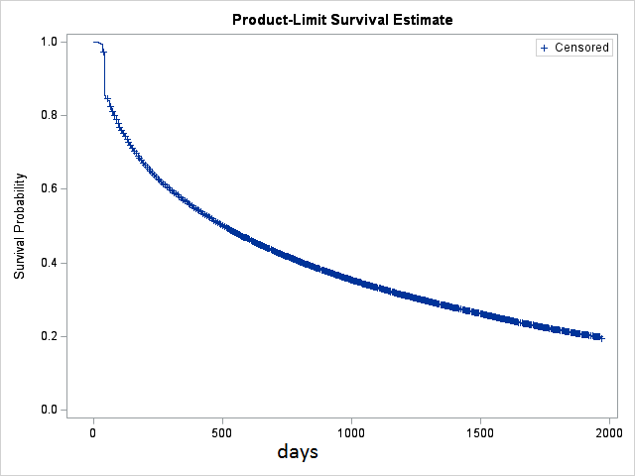
Figure 15. Time to switch or cessation from index PBS restricted HF medicine (limited to PBS restricted HF medicines only)

Time to addition of a second PBS restricted HF medicine or cessation
Overall, 10% of monotherapy initiators to a heart failure restricted therapy had an addition of second heart failure restricted therapy (the add-on may have occurred before a switch) within the follow-up period (up to 30 June 2023). 59% stopped (had a break in therapy), 28% continued index therapy until study end.
The median time to an addition of a second PBS restricted HF medicine or cessation was 15 months (454 days, 95% CI 447; 455) – Figure 16. Note, unrestricted HF medicines are not included in this analysis and this duration is affected by the cessation event, however, people were maintained on unrestricted therapies. The analysis that included unrestricted heart failure medicines is included in Appendix 2 Figure A3 and shows a longer median time to addition of 636 days (95% CI 629-648) because people did not cease unrestricted therapies.
Results were also stratified by the index therapy (i.e. individual PBS restricted HF medicine), with results shown in the Appendix 2: Figure A5 and in Table A2.
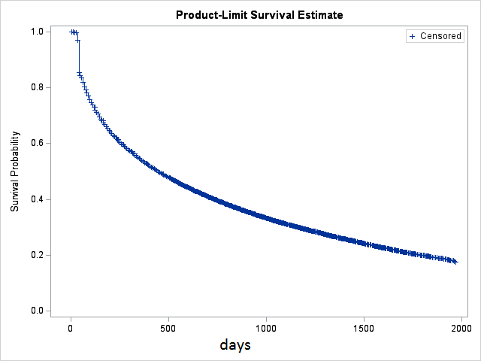
Figure 16. Time to addition or cessation from index PBS restricted HF medicine (limited to PBS restricted HF medicines only)

Cumulative treatment duration - from first to last treatment episode
Results from the Kaplan Meier survival analysis showed that the median duration from first treatment with any PBS restricted HF monotherapy to last treatment with any PBS restricted HF medicine was 3.4 years (1224 days, 95% CI 1210; 1231) – Figure 17. Note, unrestricted HF medicines are not included in this analysis and people were maintained on unrestricted therapies after cessation of PBS restricted therapies across the follow-up period (Appendix 2: Figure A1)
Results were also stratified by the index therapy (i.e. individual PBS restricted HF medicine), with results shown in the Appendix: Figure A6 and in Table A3.

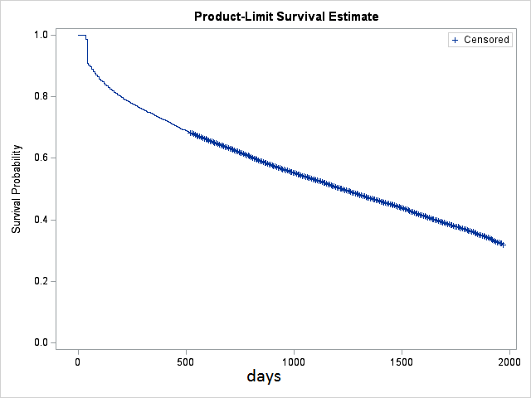
Figure 17. Kaplan Meier estimate for time from first (index) episode with any PBS restricted HF monotherapy to last treatment episode with any PBS restricted HF medicine

Survival analysis of 2020 and 2021 initiators of HF restricted medicines
Given that opportunity to switch or add has changed over time as new listings have been added to the PBS, two yearly cohorts on initiators of HF restricted medicines in 2020 and 2021 were created. The analysis below is limited to medicines restricted to HF only (Table 1 medicines). People in each cohort were followed for 12 months (data for 2023 was available only for 5 months, thus we did not examine 2022 initiators due to lack of sufficient follow-up). Kaplan Meier survival analysis was conducted to determine:

- time to first change in index therapy (switch or add-on or cessation, whichever came first)

People who continued index therapy at end of follow-up and died (using the proxy indicator) were censored.

Duration of first treatment episode to a change – either a switch or add-on or cessation (2020 and 2021 cohorts)
Results from the Kaplan Meier survival analysis with any HF restricted index monotherapy are shown in Figure 18a, Figure 18b. It can be noted that the time to a change in index therapy was 12 months for both the 2020 cohort (365 days, 95% CI 362; 365) and 2021 cohort (365 days, 95% CI 363; 365).
Note: The Kaplan Meier survival estimates from the secondary survival analysis when including medicines from Table 1 and Table 2 are presented in Appendix 2 (Figure A10a to Figure A12b).
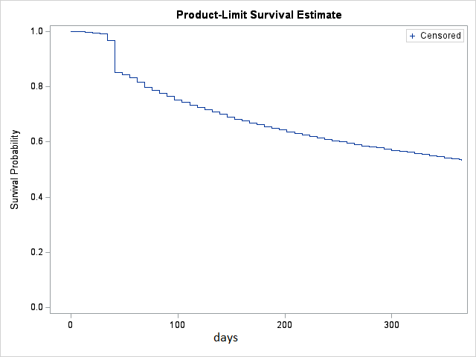  Figure 18.a Time to change (switch, addition or cessation) (2020 cohort) | 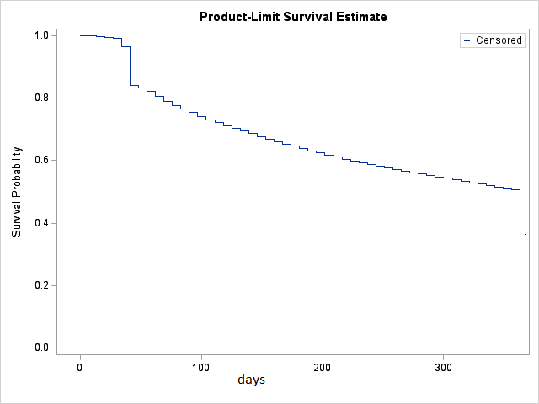  Figure 18.b Time to change (switch, addition or cessation) (2021 cohort)

Extent of use in accord and outside of PBS restrictions (2022)
This section of the report looks at use outside of PBS restrictions. This analysis examines whether initiation of therapy is in accord with PBS restrictions, thus, it has been undertaken in the incident HF population (incident to PBS restricted HF medicines) in the latest year of full data available (2022).
There were 81,343 people who initiated HF restricted medicine in 2022 (after no dispensing for any HF restricted medicine in the previous 12 months). Table 7 shows use recommended by PBS restrictions for subsidy according to the type of the initial HF restricted class of medicines and estimates of use in accord and outside PBS restrictions.
Overall, 67% of use of BB specific for heart failure was in persons who had previously been on an ACEi/ARB, although one third had not had a dispensing in the year prior.
The initiation of an ARNI was frequently not in accord with the PBS restrictions, with only 39% having concomitant use of a BB and only 36% having had an ACEi/ARB in the year prior.
Overall, 57% of SGLT2 inhibitor initiation was in persons already on at least one therapy that may be for heart failure. SGLT2 inhibitors are indicated for HF with preserved ejection fraction, which may account for a proportion of the 43% of the population that appear to have had the medicine outside of PBS restrictions as they had no add-on therapy of ACEi/ARB/ARNI or a beta-blocker. The majority (88%) of people initiated on an SGLT2 inhibitor were not on a second SGLT2 inhibitor. It is possible that incorrect selection of PBS item codes accounts for some dispensings appearing to be for indications other than heart failure.
The majority of HCN use, which is not a large proportion of the population, appears to be outside of PBS restrictions as 83% did not have concomitant use of a BB.
The sGC market is too new and data were not available to assess the PBS restrictions.

Table 7. Therapy use in accord and outside PBS restrictions for subsidy in the 2022 initiators of HF restricted medicines
Index HF class | PBS restrictions for medicine subsidy | Use in accord with the restrictions | Use outside the restrictions
BB specific for HF  (N=52202) | Moderate to severe HF indication: Patient must have stabilised on conventional therapy, which must include an ACEi/ARB, if tolerated. | 67% had prior use of ACEi/ARB | 33% had no prior use of ACEi/ARB
ARNI  (N=7995) | Patient must receive concomitant optimal standard chronic HF treatment, which must include a BB, unless at least one of the following is present in relation to the beta-blocker: (i) a contraindication listed in the Product Information, (ii) an existing/expected intolerance, (iii) local treatment guidelines recommend initiation of this drug product prior to a BB  Patient must have been stabilised on an ACEi/ARB at the time of initiation with this drug, unless such treatment is contraindicated  Concomitant ACEi/ARB not permitted. | 39% had concomitant use of any BB  36% had prior use of ACEi/ARB  94% had no co-use of ACEi/ARB | 61% had no concomitant use of any BB  64% had no prior use of ACEi/ARB  6% had co-use of ACEi/ARB
SGLT2 for HF  (N=17527) | Must be an add-on therapy to optimal standard chronic HF treatment, which must include a BB, unless contraindicated according to the TGA-approved PI or cannot be tolerated, AND  Must be an add-on therapy to optimal standard chronic HF treatment, which must include an ACEi/ARB/ARNI, unless contraindicated according to the TGA-approved PI or cannot be tolerated, AND  Patient must not be receiving treatment with another sodium-glucose co-transporter 2 (SGLT2) inhibitor. | 57% was add on therapy to at least one of BB/ACEi/ARB/ARNI)  11% had ACEi/ARB +any BB;  3% had ARNI + any BB  9% had any BB;  29% had ACEi/ARB;  5% had ARNI;  88% did not receive an SGLT2 listed for indications other than heart failure | 43% had no add-on therapy with any BB/ACEi/ARB/ARNI  12% received any other SGLT2 (not for HF)
MRA for HF  (N=1197) | No PBS requirement for prior/concomitant use of other medicines. | No restrictions | No restrictions
HCN  (N=1705) | Patient must receive concomitant optimal standard chronic HF treatment, which must include the maximum tolerated dose of a BB, unless contraindicated or not tolerated. | 17% had concomitant use of any BB | 83% had no concomitant use of any BB
Notes: Co-use: add on therapy, concomitant use (within 30 days prior or 30 days post initiation);
Prior use: stabilised on a given medicine at time of initiation (365 days prior to initiation);
Concomitant use not permitted/must not be receiving treatment with a given medicine: No
co-use within 30 days post initiation:
Legend:
BB – Beta-Blockers
ACEi – Angiotensin-converting enzyme inhibitor (including in FDC)
ARB – Angiotensin receptor blocker (including in FDC)
SGLT2 – Sodium-glucose co-transporter 2 inhibitors
ARNI – angiotensin receptor neprilysin inhibitor
MRA - Mineralocorticoid receptor antagonist
HCN – HCN channel blocker
sGC - soluble Guanylate Cyclase
Proportion of people on heart failure medicines (listed in Table 1) who are dispensed SGLT2 inhibitors not subsidised for heart failure and were not dispensed any other diabetes medicines.
SGLT2 inhibitors are listed on the PBS for indications other than heart failure. These are dapagliflozin for diabetes or chronic kidney disease (CKD), empagliflozin for diabetes, and ertugliflozin for diabetes. As SGLT2 inhibitors dapagliflozin and empagliflozin were only PBS listed for heart failure in January and April 2022 respectively, it was hypothesised that a proportion of patients may be receiving SGLT2 inhibitor add-on therapy for HF under a different PBS indication.
Figure 19a shows that 8% (N=19,100) of prevalent users of PBS restricted HF medicines were being treated with SGLT2 (not for HF) in June 2023, and that 12% (N=26,842) of the prevalent use of PBS restricted HF medicines were being supplied SGLT2 for heart failure.

Figure 19a. Proportion of prevalent PBS restricted HF medicine population who are dispensed SGLT2 inhibitors by indication of restriction

Data for comorbidity profile was considered until December 2022. When the analysis was stratified by whether patients were on other medicines for diabetes or CKD, it can be seen that by December 2022, 2.6% (N=6,045) of the prevalent PBS restricted HF medicine population were supplied an SGLT2 for diabetes or CKD and were not on other medicines indicative of diabetes (Figure 19b).

Figure 19b. Proportion of prevalent PBS restricted HF medicine population supplied SGLT2 medicines not indicated for heart failure and diabetes status.

Monthly number of people dispensed dapagliflozin/empagliflozin and what proportion of them are also dispensed ARNI (Sacubitril+Valsartan) as part of standard care or ACEi/ARB.
When dapagliflozin was assessed by the PBAC for PBS listing for heart failure, the comparator was standard of care, which was considered to be ACEi/ARB with a beta-blocker for the majority of the population, but between 11% and 20% of the standard of care population likely to be ARNI with a beta-blocker [7]. For this reason, we examined concomitant use of SGLT2 inhibitors restricted to HF with ARNI. This combination is consistent with the PBS listing, but was considered that it would not represent the majority of SGLT2 add-on therapy, with more of the population adding on to ACEi/ARB. The two SGLT2 inhibitors (dapagliflozin and empagliflozin) were listed on the PBS for use in HF in 2022 (January and April, respectively).

Figure 20 shows that among all people who had SGLT2 for HF, approximately 40% were supplied an ARNI, with between 25% and 30% supplied an ACEi/ARB concurrently. This compares with the estimates that between 11% and 20% of the standard of care population would likely be supplied an ARNI and the remainder would be on ACEi/ARB concurrently when dapagliflozin was assessed by the PBAC for PBS listing for heart failure.

Figure 20. Proportion of people dispensed dapagliflozin or empagliflozin for HF who were also dispensed ARNI or ACEi/ARB concomitantly.

Discussion
This report presents an analysis of contemporary medicine treatment patterns in patients with heart failure (HF) in Australia.
In 2022, PBS restricted HF medicines were supplied to 12 per 1,000 people in Australia (N=318,028), an increase from 8 per 1,000 in 2017. Beta blockers were the most frequently supplied class of PBS restricted HF medicines. The monthly number of people who received PBS restricted HF medicines in June 2017 was 122,727 increasing to 228,190 in June 2023. The mid-2017 monthly prevalence was 199,100 which is slightly higher than the self-reported heart failure numbers of 143,700 from the 2022 Australian National Health Survey [6].
In 2022, the incident HF population, defined as initiation of PBS restricted HF medicine, was 3 per 1,000 people (N=81,343). The mean age at initiation was 70 years and 42% of initiators were females.
Standard treatment of HF involves the concurrent use of multiple medicines. Among PBS restricted HF medicines, the medicine classes including ARNI, SGLT2, HCN, and sGC, all have restrictions that require they are add on therapy to optimal chronic heart failure treatment which includes a beta-blocker. HCNs were first listed on the PBS in 2013, ARNIs in 2017, and SGLT2 inhibitors and SGCs in 2022. Thus, the opportunity for dual therapy for PBS restricted HF medicines has increased over time.
When considering only PBS restricted HF medicines in the prevalent population, over 80% of people were treated with a single class of PBS restricted medicine in June 2023. Consistent with increased listings of PBS restricted HF medicines over time and requirements within the restrictions for concomitant use, the proportion of patients receiving dual combination therapy has risen from 6% in 2017 to 15% in June 2023. The most frequently supplied combination of PBS restricted HF medicines was BB restricted for HF and ARNI.
Analysis of concurrent therapy with the inclusion of unrestricted PBS medicines likely to be used for heart failure, found that in the prevalent population in June 2023:
- 22% of patients were receiving monotherapy (most commonly BB, followed by ARNI which was also considered as monotherapy as sacubitril is only available in combination with valsartan),
- 34% of patients were receiving dual therapy (most commonly BB + ACEi or BB + ARB),
- 28% of patients were receiving triple therapy (most commonly BB + ACEi + loop diuretic or BB + ARB + loop diuretic); and,
- 17% of patients were receiving four or more therapies.
For 33% of the prevalent HF population, the combination therapies supplied met the definition of standard of care for HF with reduced ejection fraction in June 2023. The proportion of the population on standard of care was highest amongst people aged 65 to 84 years (37% in June 2023) and lowest amongst people aged 85 years and above (25% in June 2023) The lower rates of standard of care amongst the elderly may reflect challenges of managing competing health risks in a frail elderly population.
Among the incident HF population in 2022 (n=81,343), 40% of people who initiated PBS restricted HF medicines were initiated on standard of care. The combinations most frequently representing standard of care were a beta-blocker for HF and an ACEi (39%), and a beta-blocker for HF and an ARB (36%).
Treatment sequences with PBS restricted HF medicines were examined over time for people who initiated PBS restricted HF therapies between 2018-2021 (n=215,873). Over the follow-up period (up to June 2023), the majority of people (79%) received monotherapy only with the PBS restricted HF index medicine (i.e., did not add or switch to other PBS restricted HF medicines); 20% had a change in PBS restricted HF therapy – of which 6% switched to HF restricted medicine different to the index one, 10% had addition of second PBS restricted HF therapy and 4% stepped down from index HF restricted therapy. One percent of people were initiated on a combination therapy and stayed on it for the duration of the follow-up.
Amongst people who initiated monotherapy with HF restricted medicines between 2018 and 2021:
- The median time to a switch to a PBS restricted HF medicine different to the index one or break in therapy was 17 months.
- The median time to addition of a PBS restricted HF medicine or break in therapy was 15 months.
- The median cumulative duration of all treatment episodes was 3.4 years.
Consistent with the need for ongoing therapy, when the analyses include all medicines for heart failure, people stayed on at least one medicine that could be used for heart failure (restricted or unrestricted) for the duration of the study.
Analyses were undertaken to determine if initiation of PBS restricted HF medicines was in accord with PBS restrictions using an incident population in 2022 (n= 81,343):
- Overall, 67% of use of BB specific for heart failure was in persons who had previously been on an ACEi/ARB, although one third had not had a dispensing in the year prior;
- The initiation of an ARNI was frequently not in accord with the PBS restrictions, with only 39% having concomitant use of a BB and only 36% having had an ACEi/ARB in the year prior;
- Overall, 57% of SGLT2 initiation was in persons already on at least one therapy that may be for heart failure. SGLT2 inhibitors are indicated for HF with preserved ejection fraction [2], which may account for a proportion of the 43% of the population that appear to have had the medicine outside of PBS restrictions as they had no add-on therapy of ACEi/ARB/ARNI or a beta-blocker. The majority (88%) of people initiated on SGLT2 were not on a second SGLT2 inhibitor. It is possible that incorrect selection of PBS item codes accounts for some dispensings appearing to be for indications other than heart failure;
- The majority of HCN use, which is not a large proportion of the population, appears to be outside of PBS restrictions as 83% did not have concomitant use of a BB;
- The sGC market is too new and data were not available to assess the PBS restrictions.

SGLT2 inhibitors, dapagliflozin and empagliflozin, were listed on the PBS for heart failure in January and April 2022, respectively. It was hypothesised there may be a proportion of people with heart failure receiving PBS subsidised treatment with an SGLT2 inhibitor under a non-HF indication (e.g. type 2 diabetes, chronic kidney disease). The analysis found that in December 2022, 3% of prevalent users of PBS restricted HF medicines received a PBS subsidised SGLT2 inhibitor under a non-HF indication and were not dispensed any other medicines for diabetes. It is possible this use may represent SGLT2 inhibitor use for HF or use outside of PBS restrictions for diabetes (PBS restrictions do not currently allow monotherapy with an SGLT2 inhibitor for type 2 diabetes).
Among all people who had an SGLT2 inhibitor for HF, approximately 40% were supplied an ARNI, with between 25% and 30% supplied an ACEi/ARB concurrently. This compares with the estimates that between 11% and 20% of the standard of care population would likely be supplied an ARNI and the remainder would be on ACEi/ARB concurrently when dapagliflozin was assessed by the PBAC for PBS listing for heart failure.
This analysis shows less than half the PBS restricted HF population appear to be on standard of care and there appears to be significant use of PBS restricted HF medicines outside of the restrictions. In the absence of diagnostic data on disease severity and frailty, it is difficult to conclude the extent to which these analyses represent inappropriate or suboptimal use. It is possible that challenges in implementing quadruple therapy due to frailty or comorbidity are contributing to some of the observed results. The full extent of the influence of age, frailty, and comorbidity, as well as medicine intolerance and contraindications cannot be determined from the PBS data alone. The analysis does suggest that PBS restricted HF medicines are being used interchangeably more frequently than as add-on therapy, which may have implications for the realisation of the cost-effectiveness benefits of the listings.

References
- Australian Medicines Handbook. Adelaide. Australian Medicines Handbook Pty Ltd. 2020.
- Atherton J, Sindone A, De Pasquale C, et al. National Heart Foundation of Australia and Cardiac Society of Australia and New Zealand: Guidelines for the prevention, detection, and management of heart failure in Australia 2018. Heart Lung Circ. 2018; 27 (10): 1123-1208.
- Pratt N, Kerr M, Barratt J, Kemp-Casey A, Kalisch Ellett L, Ramsay E, Roughead E. The validity of the Rx-Risk Comorbidity Index using medicines mapped to the Anatomical Therapeutic Chemical (ATC) Classification System. BMJ Open. 2018 Apr 13;8(4): e021122. doi: 10.1136/bmjopen-2017-021122. Erratum in: BMJ Open. 2020 Sep 6;10(9): e021122corr1. PMID: 29654048; PMCID: PMC5905736.
- Vitry A, Wong S, Roughead E, Ramsay E, Barratt J. Validity of medication-based co-morbidity indices in the Australian elderly population. Aust N Z J Public Health. 2009 Apr; 33(2): 126-30. doi: 10.1111/j.1753-6405.2009.00357
- Australian Bureau of Statistics Estimated Australian resident population. Available from www.abs.gov.au/population
- Australian Bureau of Statistics. Heart, stroke and vascular disease. National Health Survey; 2022 Available from: https://www.abs.gov.au/statistics/health/health-conditions-and-risks/heart-stroke-and-vascular-disease/2022
- Australian Government Department of Health and Aged-Care. Public Summary Document – July 2021 PBAC Meeting. 7.01 Dapagliflozin Tablet 10mg. Canberra: DoHA; 2021 Available from: https://www.pbs.gov.au/industry/listing/elements/pbac-meetings/psd/2021-07/files/dapagliflozin-HF-psd-july-2021.pdf

Appendix 1: Rx Risk medicines list and codes
List of medicines and codes to determine comorbidity index Rx Risk (excluding heart failure medicines)
Alcohol dependency N07BB01–N07BB99
Allergies R01AC01–R01AD60, R06AD02–R06AX27, R06AB04
Anticoagulants B01AA03–B01AB06, B01AE07, B01AF01, B01AF02, B01AX05
Antiplatelets B01AC04–B01AC30
Anxiety N05BA01–N05BA12, N05BE01
Arrhythmia C01AA05, C01BA01–C01BD01, C07AA07
Benign prostatic hyperplasia G04CA01–G04CA99, G04CB01, G04CB02*
Bipolar disorder N05AN01
Chronic airways disease R03AC02–R03DC03, R03DX05
Dementia N06DA02–N06DA04, N06DX01
Depression N06AA01–N06AG02, N06AX03–N06AX11, N06AX13–N06AX18, N06AX21–N06AX26
Diabetes A10AA01–A10BX99
Epilepsy N03AA01–N03AX99
Glaucoma S01EA01–S01EB03, S01EC03–S01EX99
Gastroesophageal reflux disease A02BA01–A02BX05
Gout M04AA01–M04AC01
Hepatitis B J05AF08, J05AF10, J05AF11
Hepatitis C J05AB54, L03AB10, L03AB11, L03AB60, L03AB61, J05AE14, J05AE11–J05AE12, J05AX14, J05AX15, J05AX65, J05AB04
HIV J05AE01–J05AE10, J05AF12–J05AG05, J05AR01–J05AR99, J05AX07–J05AX09, J05AX12, J05AF01–J05AF07, J05AF09
Hyperkalaemia V03AE01
Hyperlipidaemia A10BH03, C10AA01–C10BX09
Hypertension C03AA01–C03BA11, C03DB01-C03DB99, C03EA01, C09BA02–C09BA09, C09DA02–C09DA08, C02AB01–C02AC05, C02DB02–C02DB99 (C03CA01–C03CCO1 or C09CA01–C09CX99)§
Hyperthyroidism H03BA02, H03BB01
Hypothyroidism H03AA01–H03AA02
Irritable bowel syndrome A07EC01–A07EC04, A07EA01–A07EA02, A07EA06, L04AA33
Ischaemic heart disease: angina C01DA02–C01DA14, C01DX16, C08EX02
Ischaemic heart disease: hypertension C07AA01–C07AA06, C07AA08–C07AB01, C07AB02—if PBS item code is not 8732N, 8733P, 8734Q, 8735R, C07AG01, C08CA01–C08DB01, C09DB01–C09DB04, C09DX01, C09BB02–C09BB10, C07AB03, C09DX03, C10BX03
Incontinence G04BD01–G04BD99
Inflammation/pain M01AB01–M01AH06
Liver failure A06AD11, A07AA11
Malignancies L01AA01–L01XX41
Malnutrition B05BA01–B05BA10
Migraine N02CA01–N02CX01
Osteoporosis/Paget’s M05BA01–M05BB05, M05BX03, M05BX04, G03XC01, H05AA02
Pain N02AA01–N02AX02, N02AX06, N02AX52, N02BE51
Pancreatic insufficiency A09AA02
Parkinson’s disease N04AA01–N04BX02
Psoriasis D05AA01–D05AA99, D05BB01 D05BB02, D05AX02, D05AC01–D05AC51, D05AX52
Psychotic illness N05AA01–N05AB02, N05AB06–N05AL07, N05AX07–N05AX13
Pulmonary hypertension C02KX01–C02KX05, PBS item code 9547L, 9605M
Renal disease B03XA01–B03XA03, A11CC01–A11CC04, V03AE02, V03AE03, V03AE05
Smoking cessation N07BA01–N07BA03, N06AX12
Steroid-responsive disease H02AB01–H02AB10
Transplant L04AA06, L04AA10, L04AA18, L04AD01, L04AD02
Tuberculosis J04AC01–J04AC51, J04AM01–J04AM99

Appendix 2: Additional survival analysis

Survival analysis of 2018-2021 initiators of HF restricted medicines, when considering HF restricted and unrestricted medicines
Overall duration
Consistent with treatment guidelines, analysis of overall duration shows after starting a PBS restricted HF medicine, individuals did not cease heart failure treatment and stayed on at least one PBS medicine potentially indicated for heart failure (restricted or unrestricted listing).
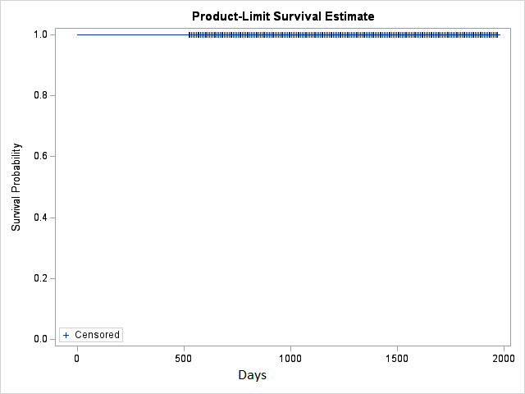
Figure A1. Time from first (index) episode with HF therapy to last treatment episode with any HF medicine (restricted or unrestricted)

Time to switch or cessation
The time to switch or cessation when considering both restricted and unrestricted medicines was shorter than when considering restricted medicines only, with a median duration 293 days (95% CI 292-300). This is to be expected as given a wider range of therapies were included, there is more opportunity to switch. It should be noted that the “index” HF therapy contained at least one HF restricted medicine and that 40% started on PBS restricted HF med only, and 60% started on PBS restricted heart failure medicine and an unrestricted heart failure medicine.

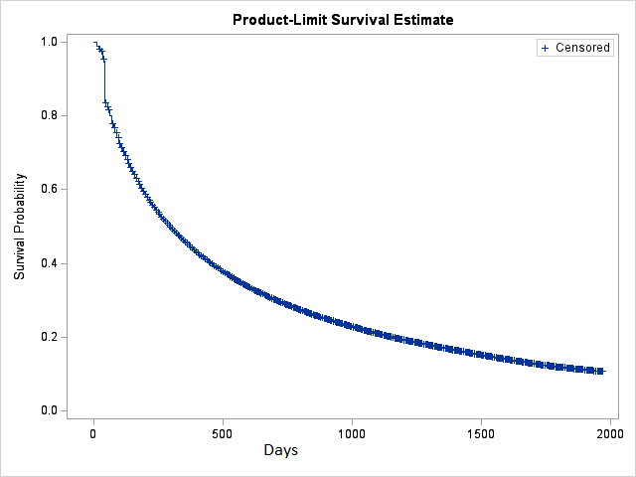
Figure A2. Time to switch or cessation from index PBS restricted HF therapy with the analysis including unrestricted medicines.

Time to addition or cessation
The time to addition or cessation when considering both PBS restricted and unrestricted HF medicines was longer than when considering restricted medicines only, with a median duration 636 days (95% CI 629-648). This result is to be expected as given a wider range of therapies were included, there is less opportunity to cease.

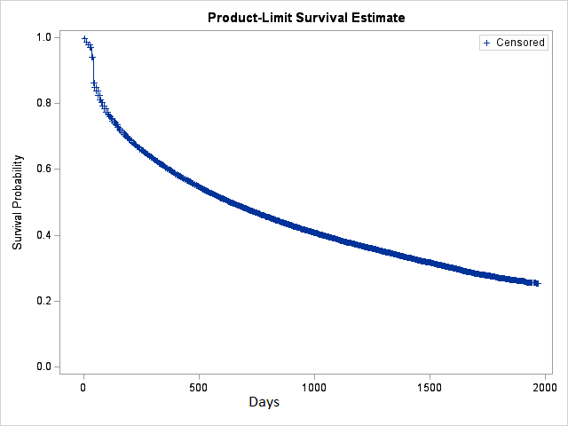
Figure A3. Time to addition or cessation from index PBS restricted HF therapy with the analysis including unrestricted medicines.

Survival analyses of 2018-2021 initiators of HF restricted medicines, when considering HF restricted medicines only, stratified by the individual index medicine
Time to switch or cessation stratified by individual index PBS restricted HF medicine
Results stratified by the individual HF restricted index monotherapy are shown in the Figure A4 and in Table A1. The median duration until switch or cessation for sacubitril + valsartan initiators was 23 months, bisoprolol initiators 19 months and ivabradine initiators was 5 months. Note ivabradine is restricted to a sub-population that in addition to having HF must be in sinus rhythm and must have a resting heart rate at or above 77 beats per minute and a LVEF of 35% or less, which likely accounts for its shorter duration. Similarly, eplerenone is limited to a sub-population post myocardial infarction, which likely accounts for its shorter duration.
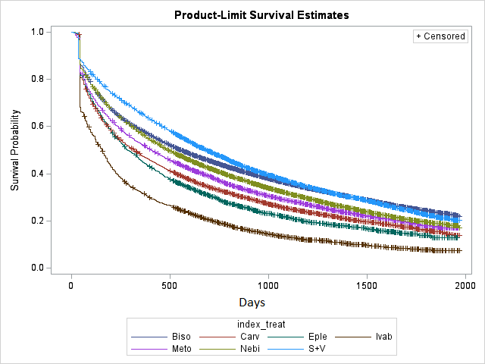
Figure A4 Kaplan Meier estimate for time from first (index) episode to a switch or cessation, stratified by index HF restricted mono therapy
Legend:
Biso – Bisoprolol (BB); Nebi – Nebivolol (BB); Meto – Metoprolol (BB); Carv – Carvedilol (BB); S+V – Sacubitril+Valsartan (ARNI); Eple – Eplerenone (MRA for HF); Ivab - Ivabradine (HCN channel blocker)

Table A1. Model summary for Figure A4 (time from index therapy to switch or cessation)
Index HF restricted mono therapy | Number of people | Median duration in days  (95% CI) | Adjusted HR (age at initiation is used primary time scale),  (95% CI)
Bisoprolol | 114444 | 559 (552-566) | Reference
Carvedilol | 12057 | 321 (300-335) | 1.37 (1.34-1.40)
Metoprolol | 13920 | 405 (391-424) | 1.19 (1.17-1.22)
Nebivolol | 40006 | 494 (482-502) | 1.11 (1.09-1.13)
Eplerenone | 3220 | 286 (265-321) | 1.35 (1.30-1.41)
Ivabradine | 5023 | 153 (146-160) | 1.79 (1.74-1.85)
Sacubitril + Valsartan | 15773 | 685 (669-705) | 0.84 (0.82-0.86)

Time to addition or cessation stratified by individual index PBS restricted HF medicine
Results stratified by the individual HF restricted index monotherapy are shown in Figure A5 and in Table A2. The duration for time to addition for bisoprolol initiators was 17 months, nebivolol initiators 16 months and ivabradine initiators was 5 months. Note ivabradine is restricted to a sub-population that in addition to having HF must be in sinus rhythm and must have a resting heart rate at or above 77 beats per minute and a LVEF of 35% or less, which likely accounts for its shorter duration. Similarly, eplerenone is limited to a sub-population post myocardial infarction, which likely accounts for its shorter duration.
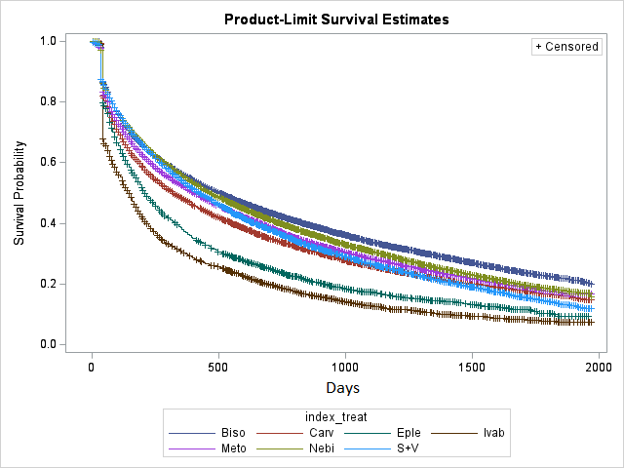
Figure A5 Kaplan Meier estimate for time from first (index) episode to addition of a second line therapy restricted for HF or cessation, stratified by index HF restricted mono therapy
Legend:
Biso – Bisoprolol (BB); Nebi – Nebivolol (BB); Meto – Metoprolol (BB); Carv – Carvedilol (BB); S+V – Sacubitril+Valsartan (ARNI); Eple – Eplerenone (MRA for HF); Ivab - Ivabradine (HCN channel blocker)

Table A2. Model summary for Figure A5 (time from index therapy to add-on or cessation)
Index HF restricted mono therapy | Number of people | Median duration in days  (95% CI) | Adjusted HR (age at initiation is used primary time scale),  (95% CI)
Bisoprolol | 114444 | 503 (496-517) | Reference
Carvedilol | 12057 | 308 (307-342) | 1.27 (1.25-1.30)
Metoprolol | 13920 | 405 (384-419) | 1.14 (1.13-1.61)
Nebivolol | 40006 | 468 (461-482) | 1.09 (1.07-1.10)
Eplerenone | 3220 | 209 (202-223) | 1.52 (1.46-1.59)
Ivabradine | 5023 | 146 (139-153) | 1.76 (1.70-1.82)
Sacubitril + Valsartan | 15773 | 426 (412-440) | 1.08 (1.05-1.10)

Cumulative duration of use of PBS restricted HF medicines stratified by individual index PBS restricted HF medicine
Results stratified by the individual HF restricted index medicine are shown in Figure A6 and in Table A3. Overall duration for sacubitril + valsartan initiators was > 5.5 years, and ivabradine initiators was 1.5 years.
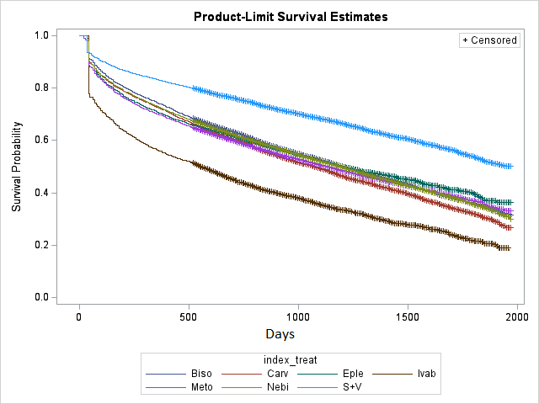
Figure A6. Kaplan Meier estimate for time from first (index) episode with a heart failure restricted medicine to last treatment episode with any HF restricted medicine, stratified by index HF restricted mono therapy
Legend:
Biso – Bisoprolol (BB); Nebi – Nebivolol (BB); Meto – Metoprolol (BB); Carv – Carvedilol (BB); S+V – Sacubitril+Valsartan (ARNI); Eple – Eplerenone (MRA for HF); Ivab - Ivabradine (HCN channel blocker)

Table A3. Model summary for Figure A6 (time from index HF restricted therapy to last therapy with any HF restricted medicine)
Index HF restricted mono therapy | Number of people | Median duration in days  (95% CI) | Adjusted HR (age at initiation is used primary time scale),  (95% CI)
Bisoprolol | 114444 | 1203 (1189-1217) | Reference
Carvedilol | 12057 | 1077 (1035-1112) | 1.13 (1.10-1.16)
Metoprolol | 13920 | 1133 (1091-1175) | 1.07 (1.04-1.09)
Nebivolol | 40006 | 1189 (1168-1210) | 0.98 (0.97-1.00)
Eplerenone | 3220 | 1196 (1112-1294) | 1.03 (0.98-1.08)
Ivabradine | 5023 | 559 (517-601) | 1.49 (1.43-1.54)
Sacubitril + Valsartan | 15773 | > 2000 days (5.5 years) | 0.64 (0.59-0.62)

Survival analyses of 2020 and 2021 initiators of HF restricted medicines, when considering HF restricted medicines only, stratified by the individual index medicine
Time to switch or cessation by individual medicine: 2020 and 2021 cohorts
Results from the Kaplan Meier survival analysis stratified by the individual HF restricted index mono therapy are shown in Figure A7a, Figure A7b and in Table A4. It can be noted that the time to a switch was slightly shorter for some of the HF medicines (carvedilol, metoprolol, eplerenone and ivabradine) in the 2021 cohort of initiators compared to 2020.
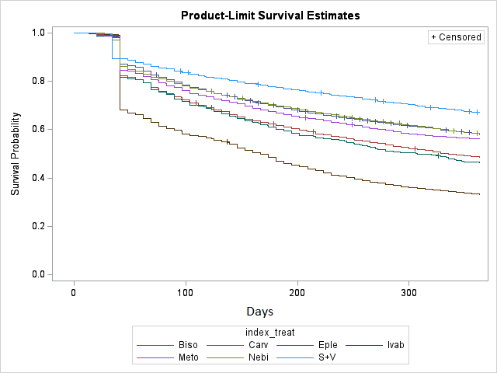  Figure A7a Time to switch (2020 cohort), by index HF restricted mono therapy | 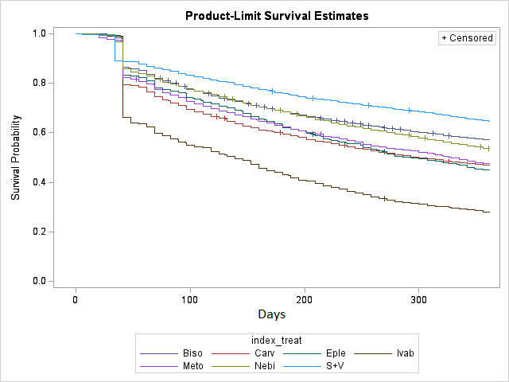  Figure A7b Time to switch (2021 cohort), by index HF restricted mono therapy
Legend: Biso – Bisoprolol (BB); Nebi – Nebivolol (BB); Meto – Metoprolol (BB); Carv – Carvedilol (BB); S+V – Sacubitril+Valsartan (ARNI); Eple – Eplerenone (MRA for HF); Ivab - Ivabradine (HCN channel blocker)

Table A4. Model summary for Figure A7b and A7b (time from index therapy to a switch or cessation)
 | 2020 initiators |  | 2021 initiators
Index HF restricted mono therapy | Number of people | Median time to switch in days (95% CI) | Number of people | Median time to switch in days (95% CI)
Bisoprolol | 30349 | Over 365 days | 30222 | Over 365 days
Carvedilol | 3023 | 350 (307-365) | 2966 | 307 (272-335)
Metoprolol | 3539 | Over 365 days | 3690 | 328 (313-349)
Nebivolol | 9950 | Over 365 days | 10573 | Over 365 days
Eplerenone | 844 | 307 (263-362) | 868 | 293 (258-342)
Ivabradine | 1282 | 167 (146-181) | 1417 | 139 (118-153)
Sacubitril + Valsartan | 3887 | Over 365 days | 4643 | Over 365 days

Time to add-on or cessation by individual medicine: 2020 and 2021 cohorts
Results from the Kaplan Meier survival analysis stratified by the individual HF restricted mono therapy are shown in Figure A8a, Figure A8b and in Table A5 It can be noted that the time to an addition to index therapy was slightly shorter for some of the HF restricted medicines (carvedilol, metoprolol, ivabradine and sacubitril + valsartan) in the 2021 cohort of initiators.
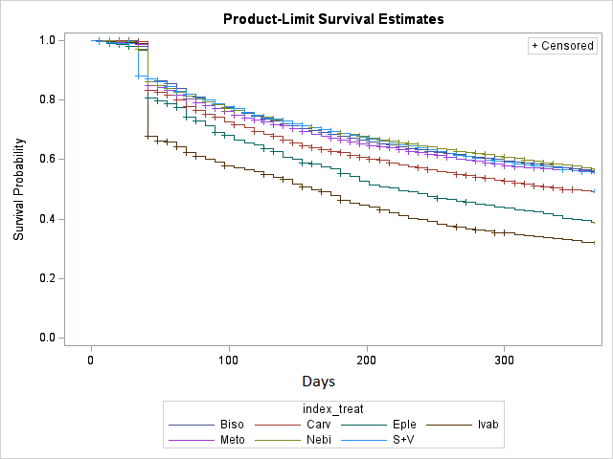Figure A8a Time to add-on (2020 cohort), by index Hf restricted mono therapy | 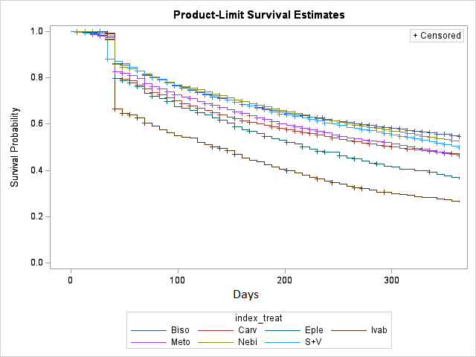  Figure A8b Time to add-on (2021 cohort), by index HF restricted mono therapy
Legend:
Biso – Bisoprolol (BB); Nebi – Nebivolol (BB); Meto – Metoprolol (BB); Carv – Carvedilol (BB); S+V – Sacubitril+Valsartan (ARNI); Eple – Eplerenone (MRA for HF); Ivab - Ivabradine (HCN channel blocker)

Table A5. Model summary for Figure A8a and Figure A8b (time from index therapy to an add-on or cessation)
 | 2020 initiators |  | 2021 initiators
Index HF restricted mono therapy | Number of people | Median time to add-on in days (95% CI) | Number of people | Median time to add-on in days (95% CI)
Bisoprolol | 30349 | Over 365 days | 30222 | Over 365 days
Carvedilol | 3023 | 349 (321-365) | 2966 | 300 (279-342)
Metoprolol | 3539 | Over 365 days | 3690 | 321 (300-342)
Nebivolol | 9950 | Over 365 days | 10573 | Over 365 days
Eplerenone | 844 | 223 (195-265) | 868 | 223 (195-251)
Ivabradine | 1282 | 160 (146-180) | 1417 | 139 (118-152)
Sacubitril + Valsartan | 3887 | Over 365 days | 4643 | 363 (349-365)

Time to change (switch, add-on or cessation, whichever is first) by individual medicine: 2020 and 2021 cohorts
Results stratified by the individual HF restricted mono therapy are shown in Figure A9a, Figure A9b and in Table A6. It can be noted that the time to a change in index therapy was slightly shorter for some of the HF medicines (carvedilol, metoprolol, ivabradine and sacubitril + valsartan) in the 2021 cohort of initiators.
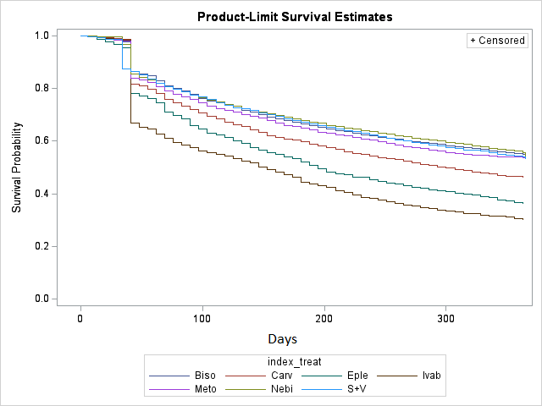  Figure A9a Time to change (2020 cohort), by index HF restricted mono therapy | 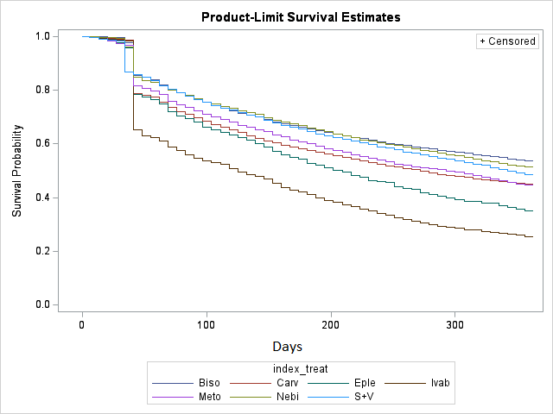  Figure A9b Time to change (2021 cohort), by index HF restricted mono therapy
Legend:
Biso – Bisoprolol (BB); Nebi – Nebivolol (BB); Meto – Metoprolol (BB); Carv – Carvedilol (BB); S+V – Sacubitril+Valsartan (ARNI); Eple – Eplerenone (MRA for HF); Ivab - Ivabradine (HCN channel blocker)
Table A6. Model summary for Figure A9a and Figure A9b (time from index therapy to first change (either a switch or add-on or cessation))
 | 2020 initiators |  | 2021 initiators
Index HF restricted mono therapy | Number of people | Median time to change in days (95% CI) | Number of people | Median time to change in days (95% CI)
Bisoprolol | 30349 | Over 365 days | 30222 | Over 365 days
Carvedilol | 3023 | 300 (279-328) | 2966 | 272 (251-300)
Metoprolol | 3539 | Over 365 days | 3690 | 296 (265-314)
Nebivolol | 9950 | Over 365 days | 10573 | Over 365 days
Eplerenone | 844 | 205 (181-223) | 868 | 209 (181-230)
Ivabradine | 1282 | 153 (132-174) | 1417 | 125 (111-146)
Sacubitril + Valsartan | 3887 | Over 365 days | 4643 | 342 (328-363)

Survival analysis of 2020 and 2021 initiators of HF restricted medicines, when considering HF restricted and unrestricted medicines, stratified by the individual index medicine.
Duration of first treatment episode with HF restricted therapy (+/- unrestricted (Table2) medicine) to a switch (defined as a therapy not containing the index HF restricted medicine) or cessation
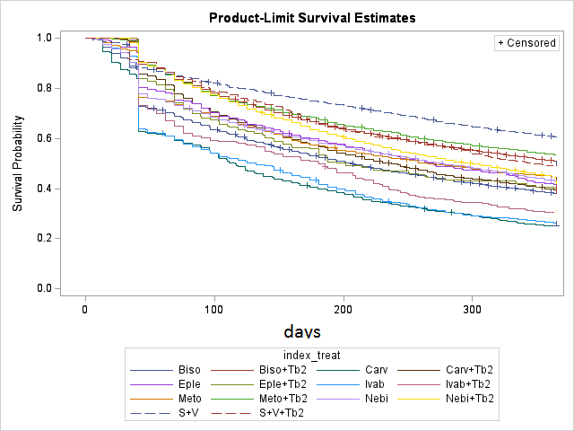  Figure A10a Time to switch (2020 cohort) | 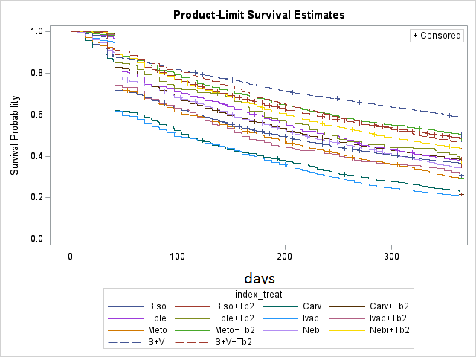  Figure A10b Time to switch (2021 cohort)
Legend:
Biso – Bisoprolol (BB); Nebi – Nebivolol (BB); Meto – Metoprolol (BB); Carv – Carvedilol (BB); S+V – Sacubitril+Valsartan (ARNI); Eple – Eplerenone (MRA for HF); Ivab - Ivabradine (HCN channel blocker)
Tb2 – any medicine from Table 2 (unrestricted)

Duration of first treatment episode with HF restricted therapy (+/- unrestricted (Table 2) medicine) to an add-on (either a HF restricted medicine from Table 1 or unrestricted medicine from Table 2) or cessation
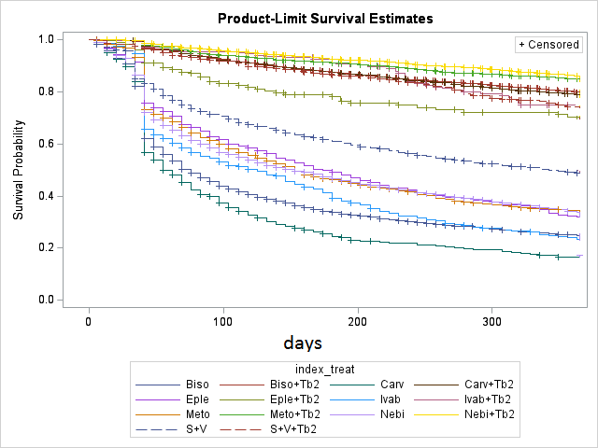  Figure A11a Time to add-on (2020 cohort) | 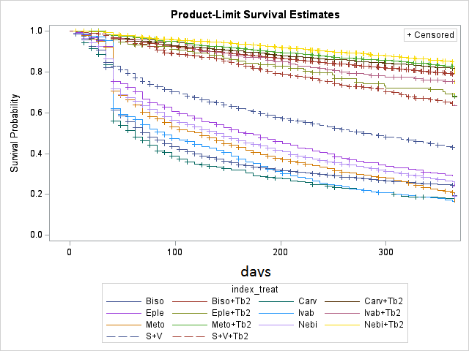  Figure A11b Time to add-on (2021 cohort)
Legend:
Biso – Bisoprolol (BB); Nebi – Nebivolol (BB); Meto – Metoprolol (BB); Carv – Carvedilol (BB); S+V – Sacubitril+Valsartan (ARNI); Eple – Eplerenone (MRA for HF); Ivab - Ivabradine (HCN channel blocker)
Tb2 – any medicine from Table 2 (unrestricted)

Duration of first treatment episode with HF restricted therapy (+/- unrestricted (Table 2) medicine) to a change – either a switch (defined as a therapy not containing the index HF restricted medicine) or add-on (of either a HF restricted medicine from Table 1 or unrestricted medicine from Table 2) or cessation.
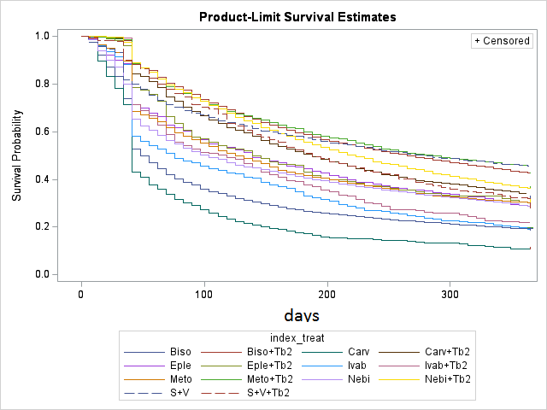  Figure A12a Time to change (2020 cohort) | 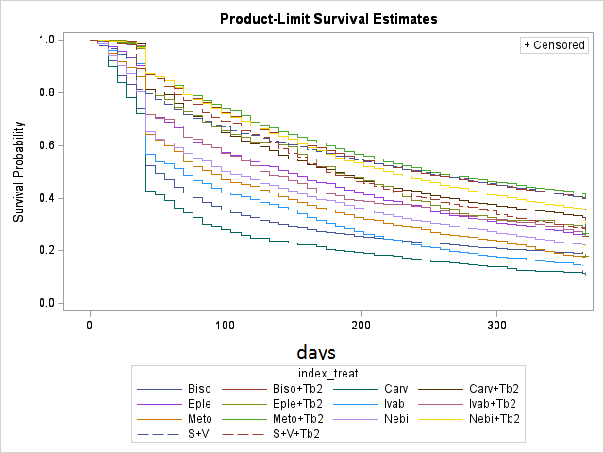  Figure A12b Time to change (2021 cohort)
Legend:
Biso – Bisoprolol (BB); Nebi – Nebivolol (BB); Meto – Metoprolol (BB); Carv – Carvedilol (BB); S+V – Sacubitril+Valsartan (ARNI); Eple – Eplerenone (MRA for HF); Ivab - Ivabradine (HCN channel blocker)
Tb2 – any medicine from Table 2 (unrestricted)

Although ARNI is a FDC of sacubitril and valsartan, it was treated as a single agent in the analysis because sacubitril is only available in this combination.

