Executive Summary – Review of the Minimum Stockholding Requirements
24-month evaluation

Executive Summary
From 1 July 2023, certain medicines listed on the Pharmaceutical Benefits Scheme (PBS) referred to as ‘Designated Brands’ are subject to a Minimum Stockholding Requirement (MSR).
Under the MSR, companies (referred to as ‘Responsible Persons’ (RPs)) are required to hold a minimum of either 4 or 6 months of stock that is ‘available for sale’ in Australia by the RP. These supply buffers are intended to ensure better continuity of supply in the Australian market. They also allow additional time for global supply disruptions to be resolved including through identifying alternative sources of supply wherever possible.
In 2024, the Department of Health, Disability and Ageing (the department) undertook a 12-month review of the early progress and outcomes of the MSR. An Executive Summary of the 12-month Review was published in August 2024. The review signalled that the policy has had positive impacts. The medicines industry made changes to increase their stock levels and early data indicated a reduction in medicine shortages of designated brands. The 12-month review recommended that a 24-month review be undertaken to further evaluate the effectiveness of the MSR.
The 24-month review included consultation with a wide range of relevant stakeholders. Feedback was provided through a written submission from peak bodies Medicines Australia (MA) and the Generic and Biosimilar Medicines Association (GBMA), survey responses from RPs and via an industry roundtable.
Concerns were raised in both the peak body submission and through the RP survey around the use of historical usual demand to calculate minimum stockholdings. The peak bodies suggested that stockholdings could be based on forecasts. Concerns were also raised about the linking of price increases and the requirement to hold 6 months stock, with the suggestion to delink price increases from the MSR. The peak body submission also suggests that the current reporting requirements (likely and actual breach notifications) could be simplified. This would reduce the administrative burden for industry, remove issues of interpretation and create a more efficient approach to reporting supply disruptions. The peak bodies suggested to remove likely breach notifications and introduce ‘batched monthly reporting for actual breaches’.
Extensive data analysis was also undertaken, of medicine shortage data from the Therapeutic Goods Administration (TGA) and departmental data on MSR breach notifications and stockholding disclosures, PBS pricing and Ministerial determinations. Data was sought from industry on compliance costs, wastage and cost of goods for the evaluation of regulatory burden, wastage and viability. This data was not made available and so this review has been unable to fully evaluate the impact of the MSR on these outcomes.

Key findings
The 24-month review indicates that the MSR policy:
  - reduced the number and severity of shortages of designated brands,
  - is stronger where the 6 months of stockholdings is required (rather than a lesser amount),
  - is stronger where the RP has higher compliance with the policy,
  - when combined with price increases, appears to effectively reduce the rate of shortages of brands that are facing pricing related viability issues.
Effect of the MSR on medicine shortages of designated brands
Overall, the review provides evidence of a positive impact of the MSR on medicine shortages of designated brands. Improvements were seen in shortage rates and duration of designated brand shortages. Strong evidence was seen where brands were more compliant and where brands held a
6-month stockholding compared to a lower amount. The review also demonstrated that the MSR has improved the severity of designated brand shortages, with improved product availability through periods of supply disruptions.
  - Impact of MSR on frequency of shortages:
Between the 2022–23 and 2023–24 financial years, the percentage of brands in shortage (‘shortage rate’) reduced by 4% for brands that have been subject to the MSR since the policy began (‘first cohort designated brands’), but increased by 21% for brands that were never subject to the MSR (‘non-designated brands’). When considering only new shortages (excluding pre-existing shortages) there was a 21% reduction in new shortages for designated brands post-MSR, while rates for non-designated brands slightly increased.
Figure 1: Shortages of designated brands and non-designated brands from January 2019 to March 2025
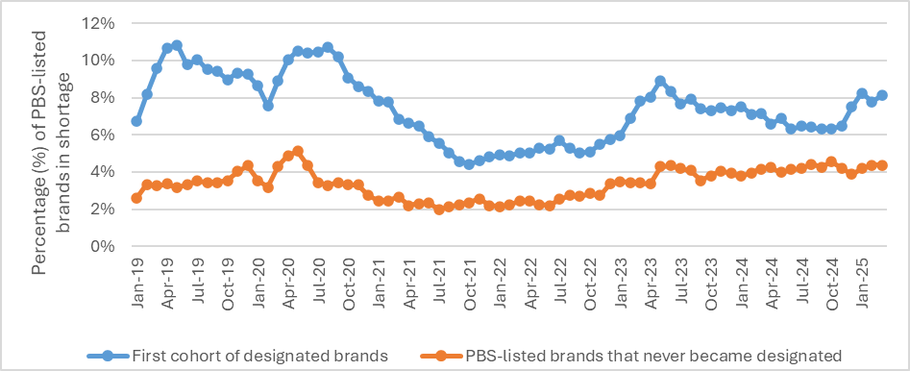
  - Impact of MSR compliance on shortages:
There was stronger evidence of the impact of the MSR when taking into account whether the brand was compliant with the MSR prior to a shortage occurring. Among the first cohort of designated brands that were ‘mostly compliant’ (compliant for 11+ out of 21 months) with their MSR, shortage rates fell by 81% between May 2023 and June 2024.
Having been subject to, and mostly compliant with, their MSR for 1 year at that point, only 2% of these brands were in shortage. Highly compliant brands that complied with their MSR for more than 16 out of 21 months had a mean monthly shortage rate of just 1%.
Brands with low compliance rates (compliant with MSR for fewer than 7 out of 21 months) had a mean monthly shortage rate of 13%.
  - Impact on duration of shortages:
For the first cohort of designated brands, resolved shortages lasted for an average of 95 days in the 21 months post-MSR, a reduction from an average of 126 days in the 21 months pre-MSR.
For first cohort designated brands, there were small decreases in the proportion of short-term shortages (2 percentage point decrease for shortages of 2 months or less) and long-term shortages (1 percentage point decrease for 11–12-month shortages; 3 percentage point decrease for 13+ month shortages).
  - Comparison of 6-month stockholding and 4-month stockholding:
Since the MSR began, the average monthly shortage rate for designated brands with a
6-month MSR has been:
- 20% lower than the average monthly shortage rate for designated brands with a
4-month MSR, and
- 57% lower than the average monthly shortage rate for non-designated brands in the same time period.
For 4-month MSR brands, the rate is 45% lower than for non-designated brands.
This analysis supports the MSR’s program logic, that larger stockholding requirements help buffer against short-to-medium-term disruptions, though they may not prevent longer-term shortages.
  - Impact on severity of shortages:
Since July 2023, the proportion of shortages of first cohort designated brands with fully unavailable supply throughout the shortage decreased from 52% to 32%, a 38% reduction.
In July 2023, shortages of the first cohort of designated brands had fully unavailable supply for an average of 65% of their total durations. By June 2024, this had decreased to an average of 49% of their total durations, marking the first instance that this average proportional unavailability period fell below that of non-designated brand shortages (50%).
Figure 2: Supply levels of first cohort of designated brands during new since-resolved shortages
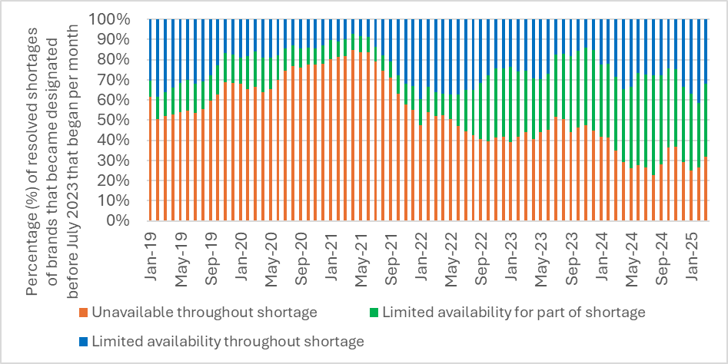
  - Impact on multi-brand and patient-level shortages:
The severity of multi-branded shortages during periods of overlap reduced significantly (by 12%) for overlaps under 30 days. Improvement was also seen for overlaps between 30 and 90 days (reduced by 3%).
The proportion of overlap days with at least 50% of brands available increased by 6% (from 65% to 69%). The proportion of overlap days with 50% or more of brands unavailable fell significantly, declining by 27% overall (from 25% to 19%).
Patient-level shortages (i.e. when all brands of a multi-branded pharmaceutical item (PI) are simultaneously in shortage) occurred on average for less than 1% of PIs with designated brands, in the first 21 months after the MSR began. The proportion of overlap days with all brands in shortage almost halved (from 20% of overlap days, to 11%). Availability during patient-level shortages also improved, with the proportion of those days when all brands were unavailable reducing from 71% to 39%.
Analysis suggests that the MSR has shifted the duration of brand shortages involved in these patient-level shortages away from longer timeframes, with a notable reduction in brand shortages in the 13+ month and 7–8-month categories. There was also a small decrease in brand shortages lasting 2 months or less, likely due to a combination of avoided shortages and reduced durations of what may otherwise have become medium-term shortages.
A single-PI case study demonstrated how greater security of supply for patients is provided. This is seen through all RPs contributing towards minimum stockholdings that collectively are adequate to supply the whole market and underpin the market’s resilience to supply disruptions. Despite out-of-stocks of individual brands and reported shortages for some brands, stockholding buffers across multiple brands helped maintain supply. Aggregate stock across all brands fell below the minimum in three instances, but only once by more than 50%.
Stockholding buffers delayed or mitigated the severity of shortages, even when half the brands were out-of-stock. In the case study, the lowest stockholding levels coincided with a sustained shortage of one brand and successive shortages of others, underscoring the importance of maintaining buffer stock.
Impact of the MSR on medicines wastage
The review has found limited evidence that wastage is not being adequately addressed through the determinations process or the non-compliance framework.
However, RPs and the peak bodies raised concerns regarding wastage arising from demand variation and the MSR being calculated based on historical demand. This indicates existing processes may not be fully utilised to address these issues.
Expanded guidance specifying demand variation in conjunction with shelf-life causing wastage risk as a circumstance where an RP may seek a Ministerial determination for a reduced stockholding quantity, may assist to address these concerns.
Impact of price increases on shortages and designated brand viability
Of first cohort designated brands that received a one-off price increase on 1 October 2022, 19% began a shortage in the 12 months before the MSR took effect, but only 9% of them began a shortage in the 12 months after the MSR began, representing a 54% decrease in shortage rates.
Of first cohort of designated brands that received a price increase (i.e. following an RP’s price increase request), 17% began a shortage in the pre-MSR year, compared to 7% in the first year of the MSR’s operation, constituting a 56% decrease in shortage rates.
The higher shortage rates for these brands with previous viability issues that received price increases, are indicative of a need for improved supply security. Price increases coupled with a
6-month minimum stockholding have been effective for reducing shortages of these brands.
Almost all (86% total) surveyed RPs who received a one-off 1 October 2022 price increase indicated this either improved viability (43%) or supported minimum stockholdings while assisting to maintain viability (50%).
The department has been unable to obtain any viability data (e.g. margins/cost of goods) from the medicines industry to be able to fully evaluate the impacts of the 1 October 2022 price increases on medicine viability. Thus, the intention to assess viability of designated brands in the 24-month review has not been possible.
Implementation and operation of the MSR
The department has developed effective processes to facilitate the implementation and operation of the MSR. The department implemented recommendations from the 12-month review that assist industry in meeting their requirements. Including publishing additional guidance materials (Fact Sheets), updated MSR Guidelines, and launching an online Portal for RPs to submit breach notifications. Survey feedback indicated that RPs have a good understanding of the requirements, but raised some concerns and suggested potential improvements, including:
- The threshold for breach notifications is too low and the number of notifications required is excessive, especially for those with limited time and/or resources
- Concerns around calculating minimum stockholdings based on historical sales (‘usual demand’). If demand declines and an RP reduces stockholdings to align more closely to current demand, this was perceived to result in ‘immaterial breaches’ which ‘trigger unnecessary compliance concerns’ even when products are not in shortage
- Changing the amount of stock required to be held under the MSR, for example by:
  - Basing stockholdings on forward forecasts rather than historical sales volumes
  - Reducing the number of months of usual demand to 2 or 3, rather than 4 or 6
  - Reducing or removing the MSR for locally manufactured brands
- Removing breach notification requirements and submitting stockholding disclosures and reasons for MSR breaches on a monthly basis, to better align with existing internal processes and long lead times.
Compliance with stockholding requirements
- Rate of compliance with MSR: there was continued satisfactory baseline compliance. Of all brands subject to the MSR, from 1 April 2024 to 30 September 2024 and 1 October 2024 to 31 March 2025:
  - 96% reported a compliant stockholding for at least one month during the 12 months
  - On average each month, 79% of brands had a compliant stockholding
  - 80% were compliant for the majority of the period
  - 38% were fully compliant for the full 12-month period
These rates represent minor improvements on the rates reported in the 12-month review.
- Reasons for non-compliance: supply chain issues leading to non-compliance with the MSR have been identified by survey responses as well as by RPs when submitting an actual breach notification. Manufacturing capacity constraints dominate the causative factors reported in notifications, alongside active pharmaceutical ingredient (API) shortages, batch failures and quality concerns. Input material delays and logistic disruptions – particularly transit and freight challenges – are also commonly reported, underscoring systemic vulnerabilities that individual corrective actions cannot fully resolve.
- Actions taken by RPs to avoid non-compliance: notification and survey results provide a broad variety of corrective actions RPs implement to avoid being non-compliant with substantive stockholding requirements. These include expediting manufacturing timelines, prioritising production or seeking alternative manufacturing sites, and airfreighting stock. Increasing or bringing forward shipments, triaging orders to ensure continuity of supply to pharmacies and patients, and seeking supplies from other markets were also undertaken.
- Compliance with the disclosure requirements was 98% for the third and fourth disclosure periods (1 April 2024 to 30 September 2024 and 1 October 2024 to 31 March 2025 respectively).
- Compliance with breach notification requirements:
  - Notification compliance: across the third and fourth disclosure periods, the department estimates the notification rate is 32–39%. This range indicates an improvement in compliance since the 12-month review, which reported a rate of 30%.
  - Likely breaches resulting in actual breaches: 33% of likely breaches were connected to a subsequent actual breach notification with under 3% of actual breaches preceded by a likely breach. This represented a small reduction, in absolute terms, from the 12-month review rates (35% and 7% respectively).
  - Lodging notifications on time: the department has measured the average rate of timeliness of likely and actual breach notifications in relation to when the breach occurred as:
  - Likely breaches notifications (LBNs) were submitted on average only 3 days before an actual breach occurred.
  - Actual breach notifications were submitted an average of 30 days after a breach occurred.
  - The value-add of likely breach notifications: the review of LBNs found that they do not operate effectively as an early warning mechanism. Across multiple disclosure periods, more than 90% of actual breaches were not preceded by an LBN. Where LBNs were submitted, only around one-third converted to actual breaches, and the average lead time of 3 days was insufficient to support meaningful intervention. The administrative burden associated with LBNs is significant for both RPs and the department. Despite improvements introduced through the Portal, including structured fields and automated prompts, feedback from industry indicates that the process is duplicative and resource-intensive, particularly when combined with other reporting obligations. These findings together with higher conversion rates for likely breach notifications submitted in the Portal point to both regulatory design and compliance issues.
- Enforcement actions taken: No Ministerial enforcement powers have been utilised to date, reflecting the strong compliance rates and the department’s focus on encouraging compliance through education and support to RPs.
Changes in inventory management
Many RPs have made significant changes to their stock levels and inventory management in response to the MSR. Across 101 sample brands that RPs provided survey responses for, there was an average increase of 2 months’ worth of stock held after the MSR. Excluding brands that already held safety stock levels equal to or exceeding the applicable MSR, there was an average increase of 3 months’ worth of stock. Approximately half of RPs (13 out of 23 respondents; 57%) reported an increase in overseas production levels as a result of the MSR.
Regulatory burden for industry
Data on the administrative costs associated with preparing and submitting breach notifications indicated a reduced administrative burden for this activity following introduction of an online Portal for breach notifications.
The review was otherwise not able to fully assess regulatory burden for industry, as the department was unable to obtain sufficient data from the medicines industry to support this assessment.
Administrative efficiency
- The department has implemented a range of improvements to enhance the efficiency and effectiveness of MSR administration, many of which were recommended in the 12-month review. These included the publication of fact sheets and updates to the PBS Stockholding Guidelines, which have improved RP understanding and reduced the need for further guidance.
- Significant gains have been made in streamlining notification processing. Manual handling of over 4,000 notifications was resource intensive. The introduction of automated tools and the launch of the online Portal in April 2025 have reduced processing time by over 80%. The Portal has also improved accessibility and functionality for RPs, with further enhancements launched to enable stockholding and price disclosures.
- To support shortage analysis, the department is developing a PBS shortages reporting tool that links Therapeutic Goods Administration and PBS datasets.
- Ministerial determinations continue to be administered efficiently, with most initiated by the department. While automation has supported some administrative tasks, manual oversight remains essential.
- Survey feedback from RPs and other stakeholders indicates strong understanding of MSR obligations, and general satisfaction with guidance materials and departmental support. These improvements collectively reflect meaningful progress in strengthening the administrative foundations of the MSR.

Recommendations
Medicine shortages, reducing supply risk and improving supply chain resilience
Recommendation 1 – The development of an Australian ‘critical medicines list’ to guide ongoing strategies and polices for managing supply chain risk and medicine shortages.
Recommendation 2 – Consideration is given to extending the MSR criteria to PBS listed medicines that are included on the Australian ‘critical medicines list’ in consultation with the medicines industry. This is based on the findings regarding the effectiveness of the MSR in mitigating medicine shortages.’
Compliance and reporting requirements
Recommendation 3 – Likely breach notifications do not provide sufficient forewarning of an actual breach or shortage, but add a significant administrative burden. As well as the findings and feedback on actual breach reporting, the review recommends that consideration is given to amending the legislative MSR reporting requirements. Potential improvements that would achieve the MSR policy intent whilst reducing administrative burden could include:
- Removing likely breach notifications; and
- Adding thresholds for actual breach reporting e.g. notifications are required where breach is >10% of MSR, or lasting longer than 2 weeks; and
- More regular stockholding disclosures e.g. monthly or quarterly
Recommendation 4 – The department explore with industry options for additional data sharing to support shortages management.
Wastage and demand variation
Recommendation 5 – The department provide expanded guidance regarding Ministerial determinations, to specify that where an RP is subject to significant changes in demand as the result of shortage/out-of-stock of another brand, or the loss of a contract/tender, and this:
  - results in greater than 30% difference between usual demand calculated using historical data and an RP’s current/forecast demand in the stockholding period; and
  - is likely to result in wastage (e.g. due to short shelf-life)
RPs may seek Ministerial determination of a reduced quantity for a period of time until usual demand more closely aligns to forecasted demand in the stockholding period.
In such circumstances, the Minister may have regard to supply security for the market and make Ministerial determinations of their own volition as well as in response to an application by an RP.

Administrative efficiency
Recommendation 6 – The department investigate opportunities for further streamlining of the processes that support day-to-day administration of the MSR, including:
- processing department-initiated Ministerial determinations for brands delisting from the PBS and rebrands
- further automation of processes to identify designated brands, and embed designated brand status within databases
- calculation of usual PBS demand
Recommendation 7 – The department continue to invest in the development of a data solution to align TGA and PBS data and develop a fit-for-purpose database and analytical tools to enable efficient and effective ongoing administration of the MSR.

Designated brands meet one of the following criteria under s99ADHC of the Act: - the drug and manner of administration of the brand’s pharmaceutical item has been on F2 for at least 42 months, and at least 30 months have passed since the first price disclosure price reduction for any brand of pharmaceutical item with the same drug and manner of administration (42-month clock) (s99ADHC(1)(a)); - the approved ex-manufacturer price (AEMP) of the brand is $4 or less (s99ADHC(1)(b)); - the AEMP of a brand of a pharmaceutical item has been increased on and after 1 July 2022 through a new price agreement and the Minister has determined that the brand be designated (s99ADHC(1)(c)); and/or - the AEMP of the brand has received a one-off, automatic price increase on 1 October 2022 under s104B of the Act (s99ADHC(1)(d)).
TGA-PBS matched shortages data was not available for the complete 2024–25 financial year at the time that this shortage analysis was undertaken.
Based upon a Weighted Shortage Severity Score (WSSS) which accounted for availability of brands during overlapping shortages.
For a sample of multi-branded PIs which had designated brands as at 1 July 2023, where those brands were also listed in the 21 months before the MSR began, for comparison. In the 21 months pre-MSR, patient level shortages occurred on average for 1.0% of those PIs. Average is based on the monthly proportion of those PIs which had all brands in shortage at some point during each month.
These statistics are based upon responses from the 14 RPs with low-cost medicines (AEMP less than $3.50) which received a one-off price increase on 1 October 2022, and who answered the survey. Percentages do not total 86% as one RP selected both options.

