5.04 ENCORAFENIB,
Capsule 75 mg,
Braftovi®,
BINIMETINIB,
Tablet 15 mg,
Tablet 45 mg,
Mektovi®,
PIERRE FABRE AUSTRALIA PTY LTD.
- Purpose of submission
  - The Category 2 submission requested a General Schedule, Authority Required (STREAMLINED) listing for encorafenib for use in combination with binimetinib (hereafter E+B) for the treatment of advanced or metastatic non-small cell lung cancer (mNSCLC) with a BRAF V600E mutation (BRAF V600E-MT) who have not received prior systemic treatment in the metastatic setting.
  - Listing was requested on the basis of a cost-utility analysis versus pembrolizumab in combination with platinum-based doublet chemotherapy (hereafter pembrolizumab+PDC).
Table 1: Key components of the clinical issue addressed by the submission
Component | Description
Population | Patients with advanced or metastatic (Stage IV) NSCLC with a BRAF V600E mutation who have not received prior systemic treatment in the metastatic setting.
Intervention | Encorafenib in combination with binimetinib (E+B) administered orally until disease progression or unacceptable toxicity.  The recommended dose is:  - encorafenib 450 mg (six 75 mg capsules) once daily; PLUS  - binimetinib 45 mg (three 15 mg tablets or one 45 mg tablet) twice daily (corresponding to a total dose of 90 mg)
Comparator | Primary comparator: Pembrolizumab in combination with platinum-based doublet chemotherapy (pembrolizumab+PDC)ª, administered intravenously for up to 24 months or until disease progression or unacceptable toxicity.  The recommended dose is:  Cycles 1-4: pembrolizumab 200mg + pemetrexed 500mg/m² + cisplatin 75mg/m² or carboplatin 5 mg/mL/min AUC once every 3 weeks (21 days)  Cycle 5-35: pembrolizumab 200mg + pemetrexed 500mg/m² once every 3 weeks (21 days)  Near-market comparator: Dabrafenib in combination with trametinib (D+T) administered orally until disease progression or unacceptable toxicity.  - dabrafenib 150 mg twice daily; PLUS  - trametinib 2 mg once daily
Outcomes | ORR, PFS, OS, disease control rate, duration of response, time to response.  Safety
Clinical claim | In adult patients with mNSCLC with a BRAF V600E mutation who have not received prior treatment in the metastatic setting:  Compared to the primary comparator  - E+B has superior efficacy and a different, but clinically manageable safety profile compared to pembrolizumab+PDC  - E+B has superior efficacy compared to pembrolizumab+PDC in terms of ORR, PFS and OS.  - E+B has a different safety profile to pembrolizumab+PDC, which is not significantly worse than pembrolizumab+PDC in terms of grade 3-5 AEs, SAEs or discontinuations due to AEs.  Compared to the near-market comparator  - E+B has superior efficacy and safety compared to D+T  - E+B has superior efficacy compared to D+T in terms of PFS and OS, with a trend to increased odds (>80%) of achieving ORR.  - E+B was superior to D+T on SAEs and was favoured for Grade 3-4 AEs and discontinuations due to AEs.
Source: Table 1.1, p20 of the submission.
AE = adverse event; AUC = area under curve; D+T = dabrafenib and trametinib; E+B = encorafenib and binimetinib; mNSCLC = metastatic non-small cell lung cancer; ORR = overall response rate; OS = overall survival; pembrolizumab+PDC = pembrolizumab in combination with platinum-based doublet chemotherapy; PFS = progression-free survival; SAE = serious adverse event.
ª Pemetrexed with either cisplatin or carboplatin.

  - As the recommended dosing is the same, the submission also requested a listing of the new 45 mg strength of binimetinib for the treatment of melanoma as clinicians have highlighted the need to reduce pill burden in this population (daily dose would be 2 x 45 mg tablets instead of 6 x 15 mg tablets).
- Background

Registration status
  - The submission was made under the TGA/PBAC Parallel Process. At the time of PBAC consideration, the TGA Delegate’s Overview was available. The TGA Delegate proposed to approve E+B for the treatment of adult patients with metastatic non-small cell lung cancer with a BRAF V600E mutation.

Previous PBAC consideration
  - E+B is listed on the PBS for the treatment of unresectable or metastatic melanoma with a B-Raf proto-oncogene (BRAF) V600-MT. Additionally, encorafenib in combination with cetuximab is PBS-listed for the treatment of patients with BRAF V600 variant metastatic colorectal cancer, who have received prior systemic therapy.
  - Dabrafenib in combination with trametinib (hereafter D+T) was recommended for listing at the March 2025 PBAC meeting for the ‘treatment of adult patients with BRAF V600E mutation positive advanced or metastatic (Stage IV) NSCLC’. The PBAC considered that D+T would be acceptably cost effective if it was cost-minimised against pembrolizumab+PDC (paragraph 7.1, D+T, Public Summary Document [PSD], March 2025 PBAC meeting). The ESC noted that D+T listed on the PBS on 1 October 2025. The ESC noted that both E+B and D+T have the same mechanism of action, i.e. they are BRAF and mitogen activated protein kinase (MEK) inhibitors.

- Requested listing
MEDICINAL PRODUCT  medicinal product pack | DPMQ | Max. qty packs | Max. qty units | №. of  Rpts | Available brands
ENCORAFENIB
encorafenib 75 mg capsule, 42 | $6,863.68 published price  $&&&& effective price | 4 | 168 | 5 | Braftovi
BINIMETINIB
binimetinib 15 mg tablet, 84 | $7,216.30 published price  $&&&& effective price | 2 | 168 | 5 | Mektovi
binimetinib 45 mg tablet, 56ª | $7,216.30 published price  $&&&& effective price | 1 | 56 | 5 | Mektovi
binimetinib 45 mg tablet, 28ª | $7,216.30 published price  $&&&& effective price | 2 | 56 | 5 | Mektovi
^{b} Binimetinib 45 mg is a new strength, currently not PBS-listed.

Category / Program: General Schedule
Prescriber type: Dental Medical Practitioners Nurse practitioners Optometrists
Restriction type: Authority Required (STREAMLINED)
Indication: Stage IV (metastatic) non-small cell lung cancer (NSCLC)
Clinical criteria:
The condition must be positive for a BRAF V600E mutation
AND
Clinical criteria:
Patient must be receiving encorafenib and binimetinib concomitantly for this condition
AND
Clinical criteria:
Patient must have/have had a WHO performance status of no greater than 2 at treatment initiation with this drug for this condition.
AND
Clinical criteria:
Patient must be undergoing initial treatment with this drug; or
Patient must be undergoing continuing treatment with this drug, with an absence of further disease progression while being treated with this drug; or
Patient must be undergoing non-PBS subsidised treatment with this drug for this PBS indication, with an absence of further disease progression since commencing non-PBS subsidised supply.
Administrative Advice: No increase in the maximum amount or number of units may be authorised.
Administrative Advice: No increase in the maximum number of repeats may be authorised.
Administrative Advice: Special Pricing Arrangements apply.
  - A single, line agnostic restriction criteria for initial, continuing and grandfathered treatment that allows patients to transition from non-PBS subsidised treatment was requested by the submission. The proposed line-agnostic use of E+B aligns with the recommendations from the European Society for Medical Oncology (ESMO) and the National Comprehensive Cancer Network (NCCN) NSCLC (v7.2025) guidelines, and was also consistent with the restriction for D+T for BRAF V600E-MT mNSCLC.
  - The requested restriction was for patients with World Health Organization (WHO) performance status (PS) of 0-2; however, the clinical evidence for E+B (PHAROS trial) only included patients with ECOG PS of 0-1. The WHO PS in the requested restriction was consistent with the D+T listing for BRAF V600E-MT mNSCLC.
  - The requested restriction would not preclude patients who have previously received treatment with a BRAF inhibitor from accessing E+B. This was inconsistent with the inclusion criteria of the key clinical trial (PHAROS), which excluded patients with prior exposure to any BRAF or MEK inhibitor therapy. As D+T is now listed on the PBS, there is a potential for patients to switch between treatments due to intolerance or toxicity. Given that there is no evidence of sequential use of BRAF inhibitors, the evaluation suggested incorporating the following clinical criteria, consistent with the restriction for encorafenib for unresectable Stage III or IV malignant melanoma:
- “The condition must not have been treated previously with PBS-subsidised BRAF inhibitor therapy for Stage IV disease” OR
- “Patient must have developed intolerance to other BRAF inhibitors of a severity necessitating permanent treatment withdrawal”.
The Pre-Sub-Committee Response (PSCR) agreed with the additional clinical criteria proposed by the evaluation.
For more detail on PBAC’s view, see section 7 PBAC outcome.
- Population and disease
  - Lung cancer is the fifth most diagnosed cancer in Australia and remains the leading cause of cancer-related mortality, with a median age at diagnosis of 72 years. NSCLC accounts for approximately 85-90% of lung cancer cases, with 30-40% of patients presenting with Stage IV disease at diagnosis. The prognosis of Stage IV lung cancer is poor, with a five-year relative survival rate of 3.2%. Patients experience a significantly reduced quality of life and a high disease burden due to severe symptoms.
  - BRAF mutations are genetic alterations identified in approximately 3-5% of NSCLC cases, with the BRAF V600E variant found in approximately half of these cases. The PBAC has previously considered that BRAF mutations are not strongly prognostic in NSCLC (paragraph 6.15, D+T, PSD, March 2025 PBAC meeting).
  - Encorafenib and binimetinib are oral, selective, reversible, and potent inhibitors of BRAF and MEK, respectively. The double inhibition of BRAF and MEK kinases suppresses the mitogen-activated protein kinase (MAPK) signalling pathway involved in aggressive manifestations of BRAF V600E-MT mNSCLC.
  - The submission claimed that encorafenib has a prolonged on-target binding time of >30 hours compared to other BRAF inhibitors (dabrafenib: 2.0 hours; vemurafenib: 0.5 hour),, while binimetinib has a shorter elimination half-life (8.7 hours) compared to the other MEK inhibitors (trametinib: 90 hours; cobimetinib: 44 hours). The submission suggested that longer binding time may support sustained clinical activity and broader therapeutic selectivity, and that shorter half-life may aid in managing adverse events. However, the cited evidence was general to drug design, and the submission did not present evidence to support this correlation in BRAF or MEK inhibition in NSCLC.
  - The ESC noted that the recommended doses for encorafenib (6 x 75 mg capsules once daily) and binimetinib (3 x 15 mg or 1 x 45 mg tablet twice daily) resulted in a high pill burden for patients.
  - The ESC considered that there was a need for further reimbursed targeted therapies for patients with BRAF V600E MT in patients with metastatic NSCLC.
For more detail on PBAC’s view, see section 7 PBAC outcome.
- Comparator
  - The submission nominated pembrolizumab+PDC as the main comparator. The main argument provided in support of this nomination was that pembrolizumab+PDC is the most commonly used PBS-listed standard of care for mNSCLC in the absence of a subsidised targeted treatment for BRAF V600E-MT. Additionally, PBAC has previously accepted pembrolizumab+PDC as an appropriate comparator for other targeted therapies in mNSCLC, including selpercatinib (paragraph 7.5, selpercatinib, PSD, July 2023) and D+T (paragraph 7.4, D+T, PSD, March 2025).
  - The submission also nominated D+T, another BRAF and MEK inhibitor, as a near market comparator. In March 2025, the PBAC considered that, despite the uncertainties associated with the indirect comparisons, on balance, it was likely that D+T provided similar health outcomes to pembrolizumab+PDC in the proposed population (paragraph 7.1, D+T, PSD, March 2025 PBAC meeting). Additionally, the PBAC noted that while D+T would replace pembrolizumab in combination with chemotherapy in the first line setting, it considered it likely that immunotherapy would be displaced to second-line treatment (paragraph 7.4, D+T PSD, March 2025 PBAC meeting). The ESC, noting that D+T has the same mechanism of action as E+B and D+T was listed on the PBS on 1 October 2025, considered that D+T was the appropriate comparator. The pre-PBAC Response agreed with the ESC, stating that the nominated near-market comparator D+T should become the main comparator.
For more detail on PBAC’s view, see section 7 PBAC outcome.
- Consideration of the evidence

Sponsor hearing
  - The sponsor requested a hearing for this item. The clinician discussed the updated results from the PHAROS trial which were presented in the PSCR, and their experience with, and preference for, using E+B first-line in patients who would qualify for E+B under the proposed PBS restriction due to the results of the PHAROS trial and the perceived improved safety profile compared to D+T, including reduced pyrexia (fever) and cutaneous toxicities (e.g. rash). The clinician noted that it would also be appropriate for E+B to be available for the small number of prevalent patients who haven’t yet received a targeted therapy.

Consumer comments
  - The PBAC noted and welcomed the input from individuals (1), health care professionals (2) and organisations (4) via the Consumer Comments facility on the PBS website. The comments from the health care professionals noted the good overall response rate observed with E+B and familiarity with the adverse effect profile from its current use in the melanoma and colorectal cancer settings. Comments from the individual noted the high burden of NSCLC on patients and their families and the high financial cost of E+B.
  - The PBAC noted the Lung Foundation Australia, the Thoracic Group of Australasia and Rare Cancers Australia commented on the importance of having access to targeted therapies for NSCLC. The Lung Foundation Australia and Rare Cancers Australia highlighted the benefit of oral therapy in allowing patients to be treated at home and noted the high burden of NSCLC. Additionally, the Thoracic Group of Australasia noted the modest overall benefit of non-targeted therapies and stated that some patients may not be well and ambulant enough to receive intravenous chemo-immunotherapy.
  - The Medical Oncology Group of Australia (MOGA) expressed its strong support for the E+B submission, categorising it as one of the therapies of “high priority for PBS listing” on the basis of the PHAROS trial. The PBAC noted that the MOGA presented a European Society for Medical Oncology Magnitude of Clinical Benefit Scale (ESMO-MCBS) for E+B, which was limited to 3 (out of a maximum of 5, where 5 and 4 represent the grades with substantial improvement), based on single arm data.

Clinical studies
  - The submission presented an indirect single arm comparison between E+B and D+T using the following trials:
  - PHAROS (N=98): An ongoing, open-label, single-arm, phase II trial of E+B in adult patients (≥18 years of age) with BRAF V600E-MT mNSCLC, given as first-line (N=59) or second-line treatment (N=39). The submission stated that cohort of patients receiving E+B as first-line therapy (hereafter untreated patients) was the population of interest for this submission. The presentation of E+B data for treatment naïve patients did not align with line-agnostic restriction requested in the submission.
  - BRF113928 (N=93): A completed, open-label, single-arm, phase II trial of D+T in adult patients with BRAF V600E-MT mNSCLC. The BRF113928 trial enrolled both untreated and previously treated patients; however, the cohort of untreated patients (Cohort C; N=36) was the population of interest for this submission and is the population used in the indirect comparisons. The PBAC had previously considered the results of BRF113928 (referenced as E2201 study) in the March 2025 consideration of D+T for BRAF V600E-MT mNSCLC.
  - To inform comparative efficacy and safety versus pembrolizumab+PDC, the submission presented an indirect comparison using the PHAROS trial and the KN-189 (N=616) trial. KN-189 is a double-blind, randomised, controlled, phase III trial comparing pembrolizumab+PDC versus PDC in adult patients with Stage IV non-squamous (NSQ) NSCLC. The PBAC had previously considered the results of KN-189 in the July 2019 consideration of pembrolizumab+PDC for mNSCLC.
  - Details of the trials presented in the submission are provided in Table 2.
Table 2: Trials and associated reports presented in the submission
Trial ID | Protocol title/ Publication title | Publication citation
PHAROS  (NCT03915951) | Clinical Study Report: A phase 2, open-label study of encorafenib + binimetinib in patients with BRAF V600-mutant NSCLC. | 22 September 2022  Recent DCO: 1 April 2024
PHAROS  (NCT03915951) | Riely, G. et al. Phase II, Open-Label Study of Encorafenib Plus Binimetinib in Patients With BRAF V600-Mutant Metastatic Non-Small-Cell Lung Cancer. | Journal of Clinical Oncology, 2023; 41(21): 3700-3711
PHAROS  (NCT03915951) | Riely, G. et al. LBA56 Updated efficacy and safety from the phase II PHAROS study of encorafenib plus binimetinib in patients with BRAF V600E-mutant metastatic NSCLC (mNSCLC). | Annals of Oncology, 2024; 35(2 Supplement): S1246-S1247
PHAROS  (NCT03915951) | Riely, G. et al. Efficacy and safety of encorafenib (enco) plus binimetinib (bini) in patients with BRAF V600E-mutant (BRAF V600E) metastatic non-small cell lung cancer (NSCLC) from the phase 2 PHAROS study. | Journal of Clinical Oncology, 2023; 41(16 Supplement): 9018
PHAROS  (NCT03915951) | Smit, E. et al. Updated Safety Analysis of Encorafenib Plus Binimetinib in Patients with BRAF V600e-Mutant Metastatic NSCLC from PHAROS Study. | Journal of Thoracic Oncology, 2024; 19(10 Supplement): S77-S78
BRF113928  (NCT01336634) | Planchard, D. et al. Dabrafenib plus trametinib in patients with previously treated BRAFV600E-mutant metastatic non-small cell lung cancer: an open-label, multicentre phase 2 trial. | The Lancet Oncology 2016; 17: 984-993
BRF113928  (NCT01336634) | Planchard, D. et al. An open-label phase II trial of dabrafenib (D) in combination with trametinib (T) in patients (pts) with previously treated BRAF V600E-mutant advanced non-small cell lung cancer (NSCLC; BRF113928). | Journal of Clinical Oncology 2016; 34 (Supplement 15)
BRF113928  (NCT01336634) | Planchard, D. et al. Dabrafenib plus trametinib in patients with previously untreated BRAFV600E-mutant metastatic non-small-cell lung cancer: an open-label, phase 2 trial. | The Lancet Oncology 2017; 18: 1307-1316
BRF113928  (NCT01336634) | Planchard, D. et al. Phase 2 trial (BRF113928) of dabrafenib (D) plus trametinib (T) in patients (pts) with previously untreated BRAF V600E-mutant metastatic non-small cell lung cancer (NSCLC). | Annals of Oncology, 2017; 28(Supplement 5): v637
BRF113928  (NCT01336634) | Planchard, D. et al. Phase 2 Study of Dabrafenib Plus Trametinib in Patients With BRAF V600E-Mutant Metastatic NSCLC: Updated 5-Year Survival Rates and Genomic Analysis. | Journal of Thoracic Oncology, 2022; 17(1):103-115
KN-189  (NCT02578680) | Gandhi, L. et al. Pembrolizumab plus chemotherapy in metastatic non-small cell lung cancer. | New England Journal of Medicine 2018; 378(22):2078-2092.
KN-189  (NCT02578680) | Garassino, M. et al. Pembrolizumab plus pemetrexed and platinum in non-squamous non-small cell lung cancer: 5-year outcomes from the Phase 3 KEYNOTE-189 study. | Journal of Clinical Oncology 2023; 41(11):1992-1998.
KN-189  (NCT02578680) | Gadgeel, S. et al. Updated analysis from KEYNOTE-189: pembrolizumab or placebo plus pemetrexed and platinum for previously untreated metastatic non squamous non-small cell lung cancer. | Journal of Clinical Oncology 2020; 38(14):1505-1517.
KN-189  (NCT02578680) | Rodríguez-Abreu, D. et al. Pemetrexed plus platinum with or without pembrolizumab in patients with previously untreated metastatic nonsquamous NSCLC: protocol-specified final analysis from KEYNOTE-189 | Annals of Oncology, 2021; 32(7): 881-895
Source: Table 2.8, pp64-65 of the submission.
  - The key features of the included evidence are summarised in Table 3.
Table 3: Key features of the included evidence
Trial | N | Design/  Median duration of follow-up at recent DCO | Risk of bias | Patient population | Outcome(s) | Use in modelled evaluation
E+B
PHAROS | N=98;  Untreated patients: 59 | Single arm, OL, MC, Phase II;  33.3 months | High^{c} | Patients with BRAF V600E-MT Stage IV (metastatic) NSCLC | ORR, PFS, OS, TTR, DOR, DCR, and safety | OS, PFS, TTD
D+T
BRF113928 | N=93;  Untreated patients: 36 | Single arm, OL, MC, Phase II;  16.3 months  (range: 0.4, 80)^{b} | High^{c} | Patients with BRAF V600E-MT Stage IV (metastatic) NSCLC | ORR, PFS, OS, DOR, and safety | Not used^{d}
Pembrolizumab+PDC
KN-189 | N=616;  Pembrolizumab+  PDC=410 | R, DB, MC,  Phase III;  64.6 monthsª | Low | Patients with NSQ Stage IV (metastatic) NSCLC | ORR, PFS, OS, DOR, DCR, and safety | Not used^{d}
Source: Section 2.4, pp78-88 of the submission.
CI = confidence interval; D+T = dabrafenib and trametinib; DB = double blind; DCO = data cut-off; DCR = disease control rate; DOR = duration of response; E+B = encorafenib and binimetinib; MC = multi-centre; MT = mutation positive; N = total number of participants; NSCLC = non-small cell lung cancer; NSQ = non-squamous; OL = open label; ORR = objective response rate; OS = overall survival; PDC = platinum-based doublet chemotherapy; PFS = progression-free survival; R = randomised; TTD = time to treatment discontinuation; TTR = time to response.
ª Median time from random assignment at recent data cut-off of March 2022.
^{b} Median duration of treatment at the recent data cut-off of February 2021.
^{c} The risk of bias was considered high, as the study was single-arm and open-label.
^{d} The submission applied hazard ratio from the matching-adjusted indirect comparison to the E+B curves to estimate the curves for the comparators.
  - The eligibility criteria and baseline characteristics of the PHAROS trial were generally aligned with the proposed PBS population; however, the trial excluded patients with ECOG PS of 2, whereas the proposed PBS population included individuals with ECOG PS 0–2.
  - The key differences across the E+B (PHAROS) and D+T (BRF113928) trials that may affect the transitivity assumptions are summarised below:
- The median follow-up duration was 33.3 months (April 2024 data cut-off) in the PHAROS trial compared to 16.3 months (February 2021 data cut-off) in the BRF113928 trial.
- In terms of patient characteristics, E+B arm had a higher proportion of patients who were male (44% vs. 39%), White (90% vs 83%), non-smokers (31 vs. 28%), had adenocarcinoma histology (97% vs. 89%), and had an ECOG PS of 1 (68% vs. 61%) compared to the D+T arm. Notably, these variables were included as prognostic variables and adjusted for in the matching-adjusted indirect comparison (refer to paragraph 6.23).
- The ESC noted that the PHAROS study included patients with small brain metastases (< 5 mm), whereas these BRF113928 excluded these patients.
  - The key differences across the E+B (PHAROS) and pembrolizumab+PDC (KN-189) trials that may affect the transitivity assumptions are summarised below:
- The PHAROS trial is an ongoing phase II, single-arm trial of E+B, with a median follow-up of 33.3 months (April 2024 data cut-off). In contrast, the KN-189 trial was a randomised, double-blind, phase III study of pembrolizumab+PDC, reporting a median time from random assignment of 64.6 months (March 2022 data cut-off).
- While the PHAROS trial specifically enrolled patients with BRAF V600E-MT, the KN-189 trial included patients irrespective of their mutation status. The clinical impact of this difference is likely to be minimal, given that the PBAC considered BRAF mutations were not strongly prognostic in NSCLC and treatment with immunotherapy was not a treatment effect modifier (paragraph 6.15, D+T, PSD, March 2025 PBAC Meeting).
- In terms of patient characteristics, the E+B arm had a higher proportion of patients aged ≥65 years (61% vs. 52%) and with an ECOG PS of 1 (68% vs. 54%) compared to pembrolizumab+PDC arm. Conversely, a lower proportion of patients were male (44% vs. 62%), current or former smoker (69% vs 88%), and had brain metastases (7% vs. 18%) in the E+B arm compared to pembrolizumab+PDC arm. Notably, these variables were included as prognostic variables and adjusted for in the matching-adjusted indirect comparison (refer to paragraph 6.23).

Comparative effectiveness
  - A claim of superior efficacy over both pembrolizumab+PDC and D+T was based on improvements in objective response rate (ORR), progression-free survival (PFS), and overall survival (OS). While definitions of key clinical outcomes were generally well aligned across the trials, the methods of assessment for ORR and PFS varied: PHAROS used independent radiological review (IRR) with investigator assessment as supportive evidence; KN-189 employed blinded independent committee review (BICR); and BRF113928 relied on an independent review committee (IRC), supported by investigator assessment.

Objective response rate
  - Table 4 summarises the ORR results from PHAROS, KN-189, and BRF113928 trials.
Table 4: Summary of ORR across the studies
 | PHAROSª | KN-189^{b} |  | BRF113928^{c}
 | 1st Line (untreated)  E+B  N=59 | PEMBRO+  PDC  N=410 | PDC  N=206 | 1st Line (untreated)  D+T  N=36
Best response, n (%)
CR | 9 (15.3%) | 10 (2.4%) | 1 (0.5%) | 2 (6%)
PR | 35 (59.3%) | 188 (45.9%) | 40 (19.4%) | 21 (58%)
SD | 10 (16.9%) | 149 (36.3%) | 104 (50.5%) | 4 (11%)
PD | 2 (3.4%) | 37 (9.0%) | 36 (17.5%) | 5 (14%)
Not evaluable | 3 (5.1%) | 12 (2.9%) | 8 (3.9%) | 4 (11%)
No assessment | - | 14 (3.4%) | 17 (8.3%) | -
Objective Response Rate, n (%)
CR+PR  [95% CI] | 44 (74.6%)  [61.6%, 85.0%] | 198 (48.3%)  [43.4%, 53.2%] | 41 (19.9%)  [14.7%, 26.0%] | 23 (63.9%)  [46.2%, 79.2%]
Source: Table 2.29, p94 and Table 2.30, p96 of the submission.
CI = confidence interval; CR = complete response; D+T = dabrafenib and trametinib; E+B = encorafenib and binimetinib; n = number of participants with event; N = total participants in group; ORR = objective response rate; PEMBRO = pembrolizumab; PDC = platinum-based chemotherapy; PR = partial response; PD = progressive disease; SD = stable disease.
ª By independent radiographic review; median follow-up duration of 33.3 months
^{b} By Blinded Independent Central Review per RECIST v 1.1; median follow-up duration of 64.6 months
^{c} By investigator-assessed ORR; median follow-up duration of 16.30 months
  - In the PHAROS trial, the ORR with E+B was 75% (95% confidence interval [CI]: 62%, 85%) based on IRR, while investigator-assessed ORR was lower at 64%. In comparison, the KN-189 trial reported an ORR of 48% (95% CI: 43%, 53%) for the pembrolizumab+PDC arm, assessed by BICR. The BRF113928 trial reported an ORR of 64% (95% CI: 46%, 79%) with D+T, based on investigator assessment (with similar results reported based on IRC assessment).

Progression-free survival
  - Table 5 summarises the PFS results from PHAROS, KN-189, and BRF113928 trials. The corresponding Kaplan-Meier (KM) curves are presented in Figure 1 to Figure 3.
Table 5: Summary of PFS across studies
 | PHAROSª | KN-189^{b} |  | BRF113928^{c}
 | E+B  N=59 | PEMBRO+PDC  N=410 | PDC  N=206 | D+T  N=36
Events, n (%) | 28 (47.5%) | 369 (90.0%) | 201 (97.6%) | 28 (77.7%)
Median PFS, months (95% CI) | 30.2 (15.7, NE) | 9.0 (8.1, 10.4) | 4.9 (4.7, 5.5) | 10.8 (7.0, 14.5)
HR (95% CI) | NA | 0.50 (0.42, 0.60) |  | NA
Source: Table 2.33, p98 of the submission.
CI = confidence interval; D+T = dabrafenib + trametinib; DCR = disease control rate; E+B = encorafenib + binimetinib; HR = hazard ratio; n = number of participants with event; N = total participants in group; NA = not applicable; NE = not evaluable; pembro+PDC = pembrolizumab + platinum doublet chemotherapy; PFS = progression-free survival.
ª By independent radiographic review; median follow-up duration of 33.3 months
^{b} By Blinded Independent Central Review per RECIST v 1.1; median follow-up duration of 64.6 months
^{c} By investigator-assessed; median follow-up duration of 16.30 months.
  - In the PHAROS trial, the median PFS with E+B was 30.2 months (95% CI: 15.7, not estimable [NE]) based on IRR, while investigator-assessed median PFS was lower at 24.8 months. In comparison, the KN-189 trial reported a median PFS of 9.0 months (95% CI: 8.1, 10.4) in the pembrolizumab+PDC arm, assessed by BICR. The BRF113928 trial reported a median PFS of 10.8 months (95% CI: 7.0, 14.5) for D+T, based on investigator assessment (and 14.6 months (95% CI: 7.0, 22.1) based on IRC assessment).
Figure 1: Kaplan-Meier curves for PFS for first-line E+B (untreated patients) in PHAROS trial
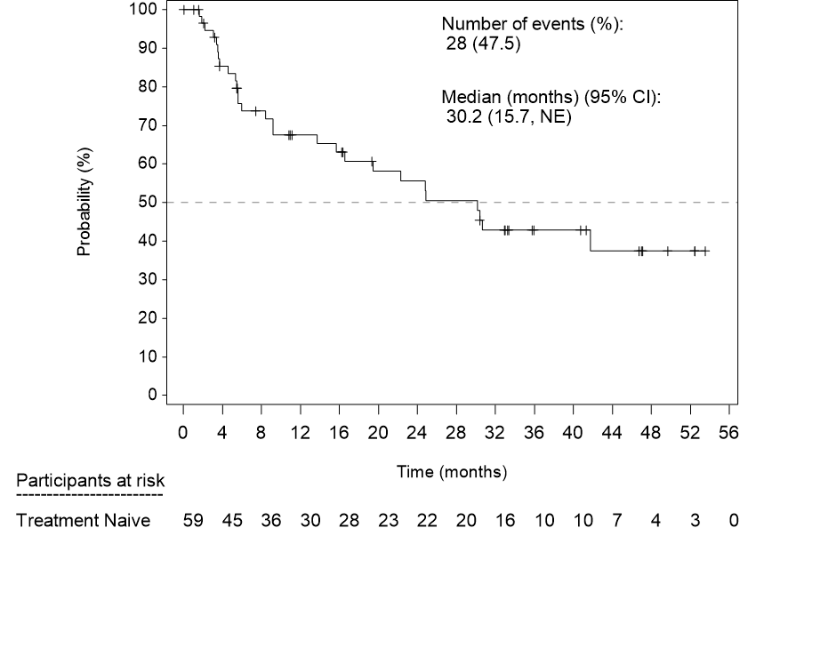
Source: Figure 2.9, p99 of the submission.
CI = confidence interval; E+B = encorafenib and trametinib; NE = not estimable; PFS = progression-free survival.

Figure 2: Kaplan-Meier curves for PFS for pembrolizumab+PDC in KN-189 trial
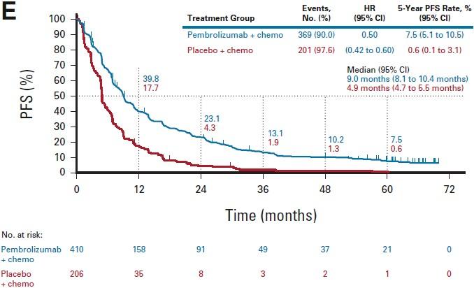
Source: Figure 2.10, p100 of the submission.
CI = Confidence interval; chemo = chemotherapy; HR = Hazard ratio; PDC = platinum-doublet chemotherapy; PFS = progression-free survival.
Figure 3: Kaplan-Meier curves for PFS for first-line D+T (untreated patients) in BRF113928 trial
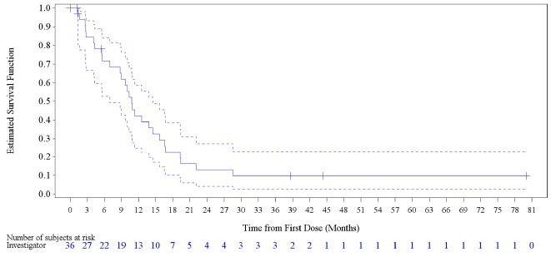
Source: Figure 2.11, p100 of the submission.
D+T = dabrafenib and trametinib; PFS = progression-free survival.
Note: Lines represent Kaplan-Meier estimate with 95% confidence interval.
  - Based on the KM PFS curves for E+B in the PHAROS trial, the reported median of 30.2 months appears to be uncertain. The median PFS was reached when only 48% of patients had experienced events, indicating immature data. This resulted in heavy censoring, clustering of events near the median, a wide CI (15.7 months, NE), and high sensitivity to small changes in event timing.

Overall survival
  - Table 6 summarises the OS results from PHAROS, KN-189, and BRF113928 trials. The corresponding KM curves are presented in Figure 4 to Figure 6.
Table 6: Summary of OS across studies
 | PHAROSª | KN-189^{b} |  | BRF113928^{c}
 | E+B  N=59 | PEMBRO+PDC  N=410 | PDC  N=206 | D+T  N=36
Events, n (%) | 26 (44.1%) | 329 (80.2%) | 183 (88.8%) | 27 (75%)
Median OS, months (95% CI) | NE  (31.3, NE) | 22.0  (19.5 to 24.5) | 10.6  (8.7 to 13.6) | 17.3  (12.3, 40.2)
HR (95% CI) | NA | 0.60 (0.50, 0.72) |  | NA
Source: Section 2.5.1.1.6, pp100-102 of the submission.
CI = confidence interval; D+T = dabrafenib + trametinib; DCR = disease control rate; E+B = encorafenib + binimetinib; NA = not applicable; pembro+PDC = pembrolizumab + platinum doublet chemotherapy; OS = overall survival.
ª Median follow-up duration of 33.3 months
^{b} Median follow-up duration of 64.6 months
^{c} Median follow-up duration of 16.30 months.
  - In the PHAROS trial, the median OS was not reached for E+B. In comparison, the KN-189 trial reported a median OS of 22.0 months (95% CI: 19.5, 24.5) in the pembrolizumab+PDC arm while the BRF113928 trial reported a median OS of 17.3 months (95% CI: 12.3, 40.2) with D+T. The PSCR presented updated OS data from the PHAROS trial from the March 2025 data cut (as compared to April 2024) which included 4 additional events (30 as compared to 26). Median OS for the treatment naïve population was 47.6 months (95% CI: 31.3, NE).
Figure 4: Kaplan-Meier curves for OS for first-line E+B (untreated patients) in PHAROS trial
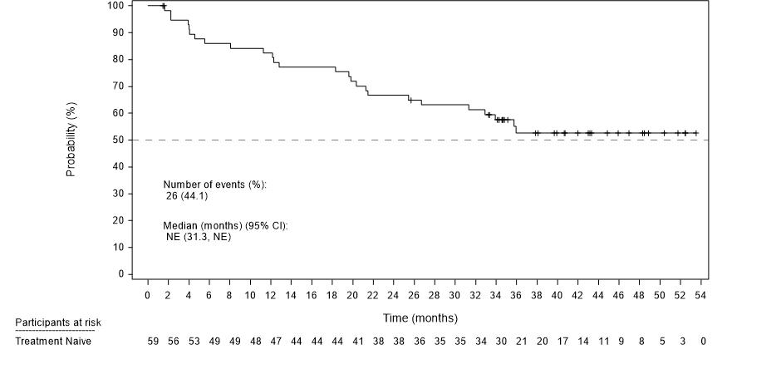
Source: Figure 2.12, p101 of the submission.
CI = confidence interval; E+B = encorafenib and trametinib; NE = not estimable; OS = overall survival.
Figure 5: Kaplan-Meier curves for OS in KN-189 trial
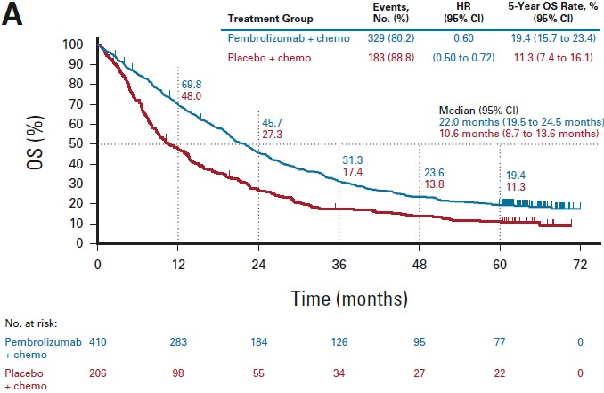
Source: Figure 2.13, p102 of the submission.
CI = Confidence interval; chemo = chemotherapy; HR = Hazard ratio; OS = overall survival.
Figure 6: Kaplan-Meier curves for OS for first-line D+T (untreated patients) in BRF113928 study
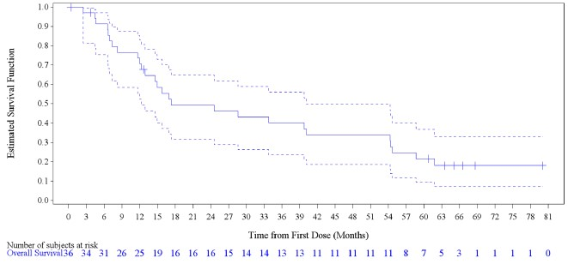
Source: Figure 2.14, p102 of the submission.
D+T = dabrafenib and trametinib; OS = overall survival.
Note: Lines represent Kaplan-Meier estimate with 95% confidence interval
  - The KM curve for E+B in Figure 4 appears to plateau after approximately 34 months; however, this is unreliable due to a sharp decline in the number of patients at risk from around 30 patients at 34 months to 3 patients at 52 months. The clustering of censoring ticks and the drop in at-risk counts without corresponding KM steps suggests end-of-study right-censoring.

Disease control rate (DCR), duration of response (DOR), and time to response (TTR)
  - While E+B demonstrated favourable outcomes in DCR, DOR, and TTR, the reliability of these comparisons is limited due to differences in trial design and assessment methods (i.e., investigator-assessed versus centrally reviewed):
- DCR with E+B was 64% at 24 weeks and 91.5% by best overall response, compared to 84.6% for pembrolizumab+PDC in KN-189 and 75% for D+T in BRF113928.
- Patients treated with E+B in PHAROS had a median DOR of 40.0 months (95% CI: 23.1, NE). This compares to a median DOR of 12.7 months [range: 1.1+, 68.3+] in KN-189 for pembrolizumab+PDC and 10.2 months (95% CI: 8.3, 15.2) in BRF113928 for D+T.
- In the PHAROS trial, the median TTR with E+B was 1.86 months (range: 1.1 to 19.1). For pembrolizumab+PDC in KN-189, TTR was 2.4 months (range: 1.1 to 19.3), while this was not reported in BRF113928.

MAIC between E+B and D+T
  - The submission presented an unanchored MAIC, comparing first-line E+B (PHAROS trial; median follow-up of 33.3 months) with first-line D+T (BRF113928 trial). For D+T, the submission used PFS and ORR from previous data cut-off (median follow-up 15.9 months), reported by IRR, consistent with PHAROS trial methods, and OS estimates from the recent data cut-off (median follow-up 16.3 months).
  - The submission identified potential confounding factors through a review of interventional trials, observational studies, and National Institute of Care and Excellence (NICE) assessment of D+T for BRAF V600-MT mNSCLC (TA898). However, ECOG PS, smoking status, age, gender, race, histology, and brain metastases were included in the MAIC based on data availability, literature, and clinical relevance.
  - As discussed in paragraph 6.106.9, imbalances were observed between the two studies primarily on gender, race and histology, as well as, to a lesser extent, on ECOG and smoking status. For comparison with D+T, the submission presented two analyses, one using all adjustment factors (base-case) and one restricted to ECOG PS and smoking status (sensitivity analysis 1). The characteristics of the two populations, before and after weighting are presented in Table 7 below.
Table 7: Population adjustment for PHAROS and BRF113928 trials
Trial name | Original data |  | Matched data for PHAROS 1L
Trial name | PHAROS 1L  (N=59) | BRF113928  (Cohort C)  (N=36) | Matched on all factors  (ESS=44) | Matched on ECOG and smoking status  (ESS=58)
Age | 68 | 67 | 67 | 66
Gender - % Male | 44 | 39 | 39 | 45
ECOG - % ECOG=0 | 32 | 36 | 36 | 36
Smoking status - % Never smoked | 31 | 28 | 28 | 28
Race - % White | 90 | 83 | 83 | 90
Histology - % Adenocarcinoma | 97 | 89 | 89 | 97
Brain metastases - % Yes | 7 | 6 | 6 | 7
Source: Table 2.69, p135 of the submission.
1L = first-line; ECOG = Eastern Cooperative Oncology Group; ESS = Estimated Sample Size after weighting; N = total participants in group.
  - After matching on all adjustment factors, the characteristics in the weighted PHAROS population were aligned with those of the BRF113928 cohort. However, the ESC noted that this resulted in a loss of sample size of 25%, with the weighted population representing 44 patients from the original 59. It is recognised that adjusting for all relevant factors inherently leads to a reduction in effective sample size.
  - Results of the unanchored MAICs for PFS and OS are summarised in Table . Unadjusted results are included for comparison. The PFS and OS KM curves for MAICs are presented in Figure and Figure , respectively.
Table 8: Indirect comparison of PFS and OS – unadjusted analysis and MAICs
Model | 1L PHAROS  E+B (N=59)  (median follow up of 33.3 months)  Median (95% CI) | BRF113928 (Cohort C)  D+T (N=36)  (median follow-up of 15.9 months for PFS and 16.3 months for OS)  Median (95% CI) | E+B versus D+T;  HR (95% CI)
PFS
Unadjusted (non-matching) | 30.2 (15.7, NE) | 14.6 (7.0, 22.1) | 0.48 (0.27, 0.87)
Adjusted (base case) |  |  | 0.47 (0.26, 0.85)
Adjusted (sensitivity analysis 1) |  |  | 0.49 (0.27, 0.86)
OS
Unadjusted (non-matching) | NE (31.3, NE) | 17.3 (12.3, 40.2) | 0.60 (0.34, 1.07)
Adjusted (base case) |  |  | 0.55 (0.30, 1.01)
Adjusted (sensitivity analysis 1) |  |  | 0.60 (0.34, 1.07)
Source: Table 2.56, pp124-125; Table 2.70, p137; and Table 2.71, p138 of the submission
1L = first line; CI = confidence interval; D+T = dabrafenib and trametinib; ECOG PS = Eastern Cooperative Oncology Group Performance Status; E+B = encorafenib + binimetinib; HR = hazard ratio; MAIC = matching-adjusted indirect comparison; N = total participants in group; OS = overall survival; PFS = progression-free survival.
Base case = using all adjustment factors (ECOG PS, smoking status, age, gender race, histology, presence of brain metastases); sensitivity analysis 1 = using only ECOG PS and smoking status.
Bold indicate statistical significance.
Figure 7: Kaplan-Meier curves for MAIC for PFS (E+B versus D+T) - base-case (left), sensitivity analysis 1 (right)
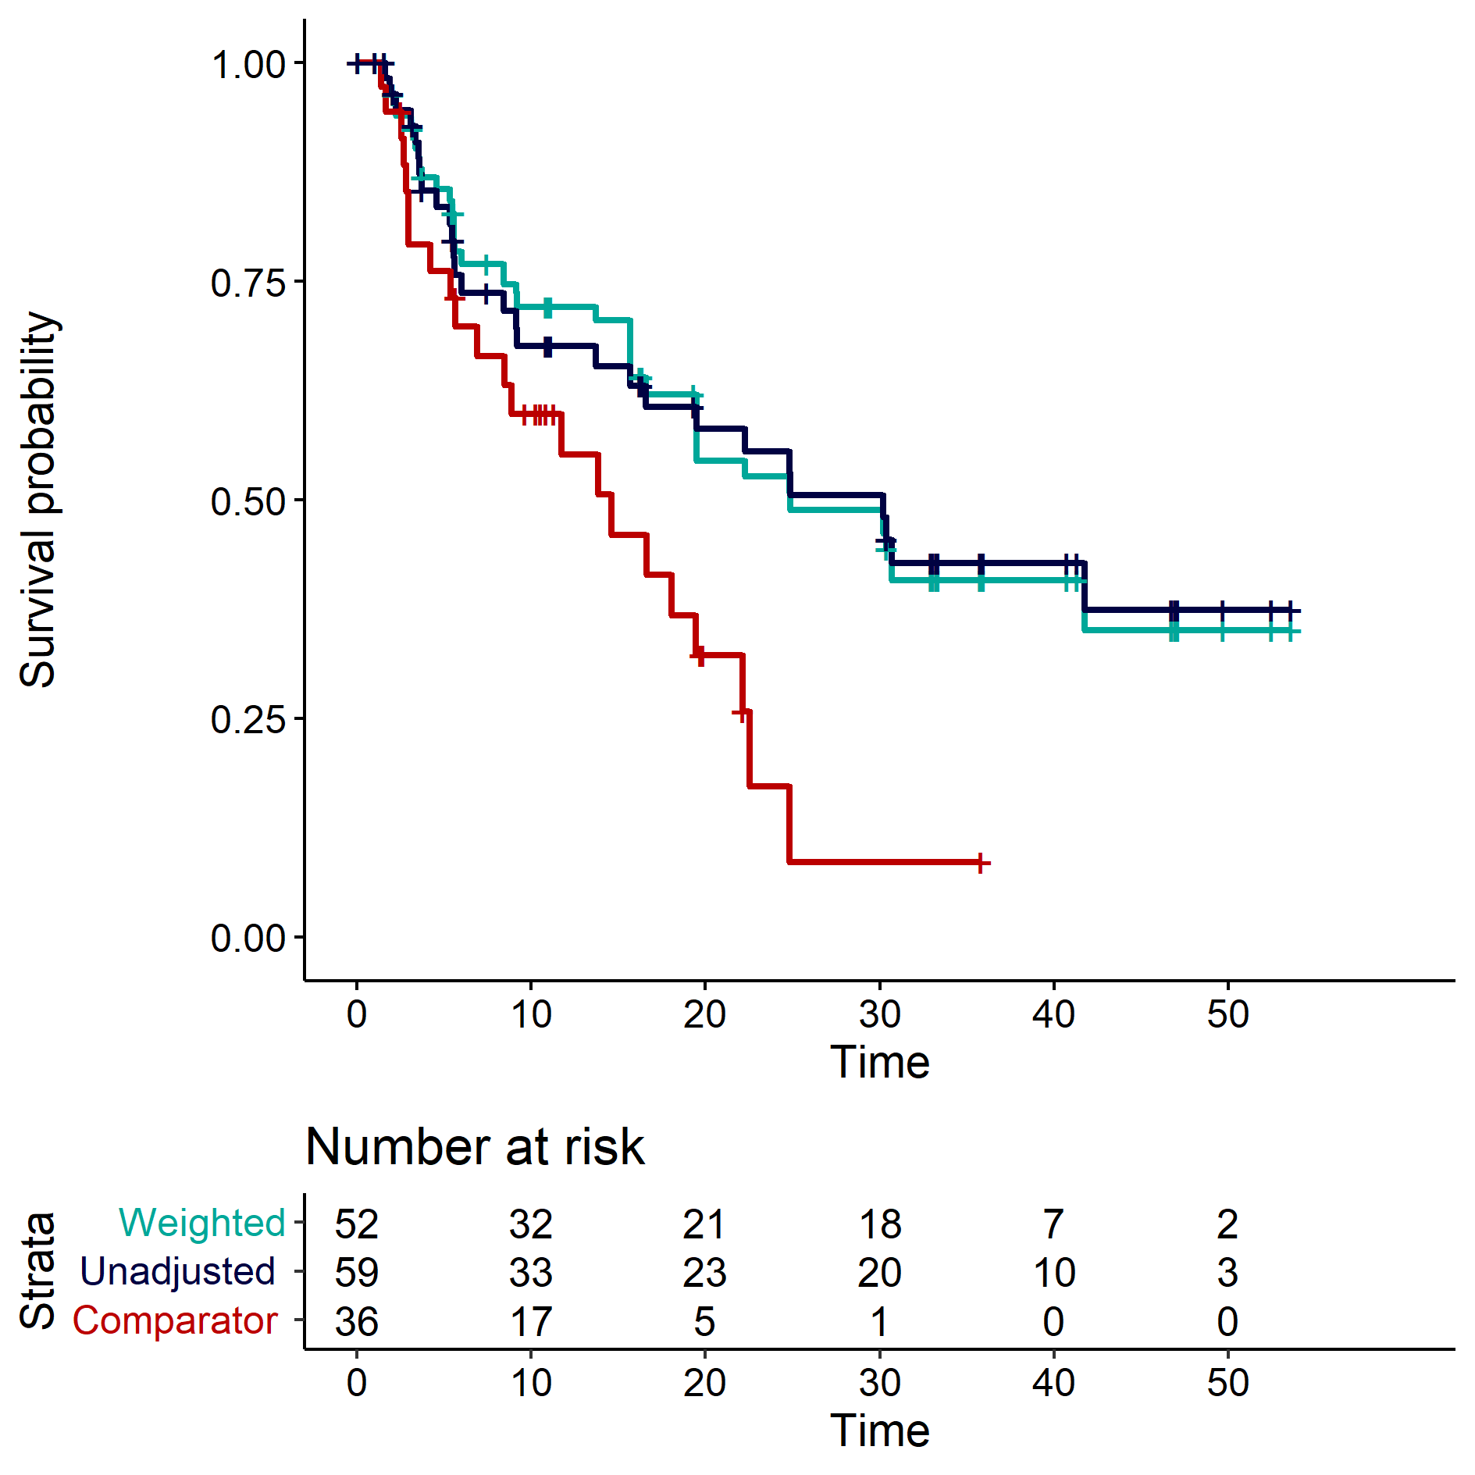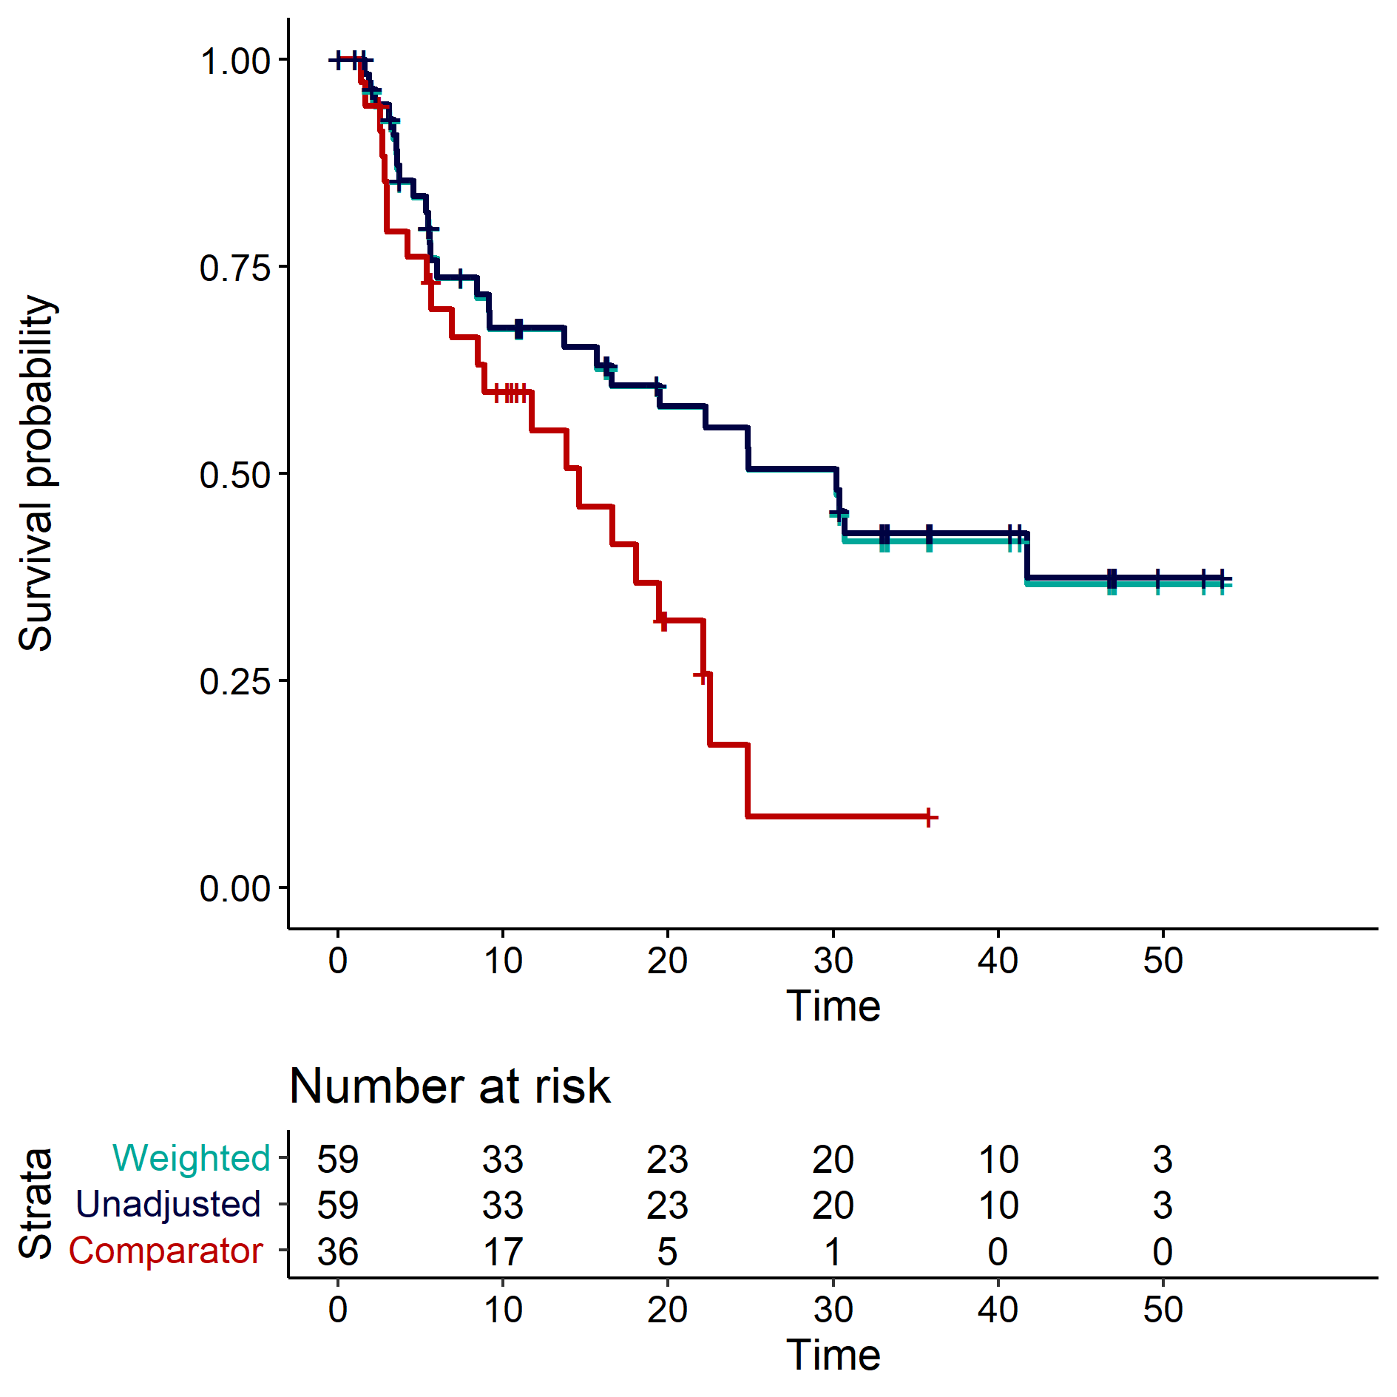
Source: Figure 2.18, p138 of the submission.
Navy/unadjusted curves = E+B (unadjusted/non-matching); Aqua/weighted curves = E+B (adjusted, base case); Red/comparator curves = Pembrolizumab+PDC
E+B = encorafenib and trametinib; D+T = dabrafenib and trametinib; PFS = progression-free survival; Comparator = D+T.
Figure 8: Kaplan-Meier curves for MAIC for OS (E+B versus D+T) - base-case (left), sensitivity analysis 1 (right)
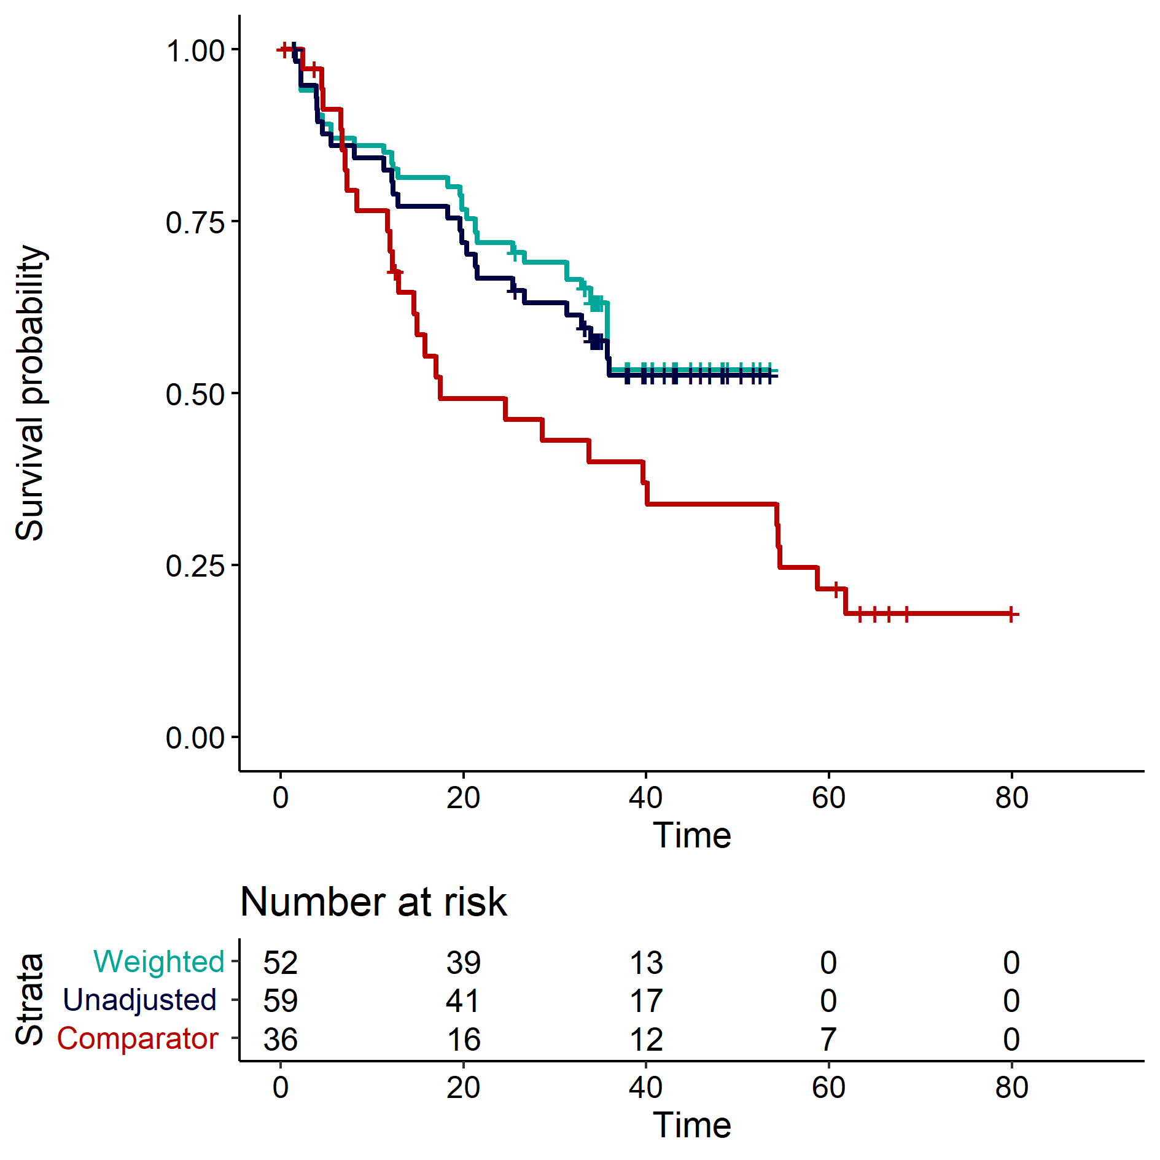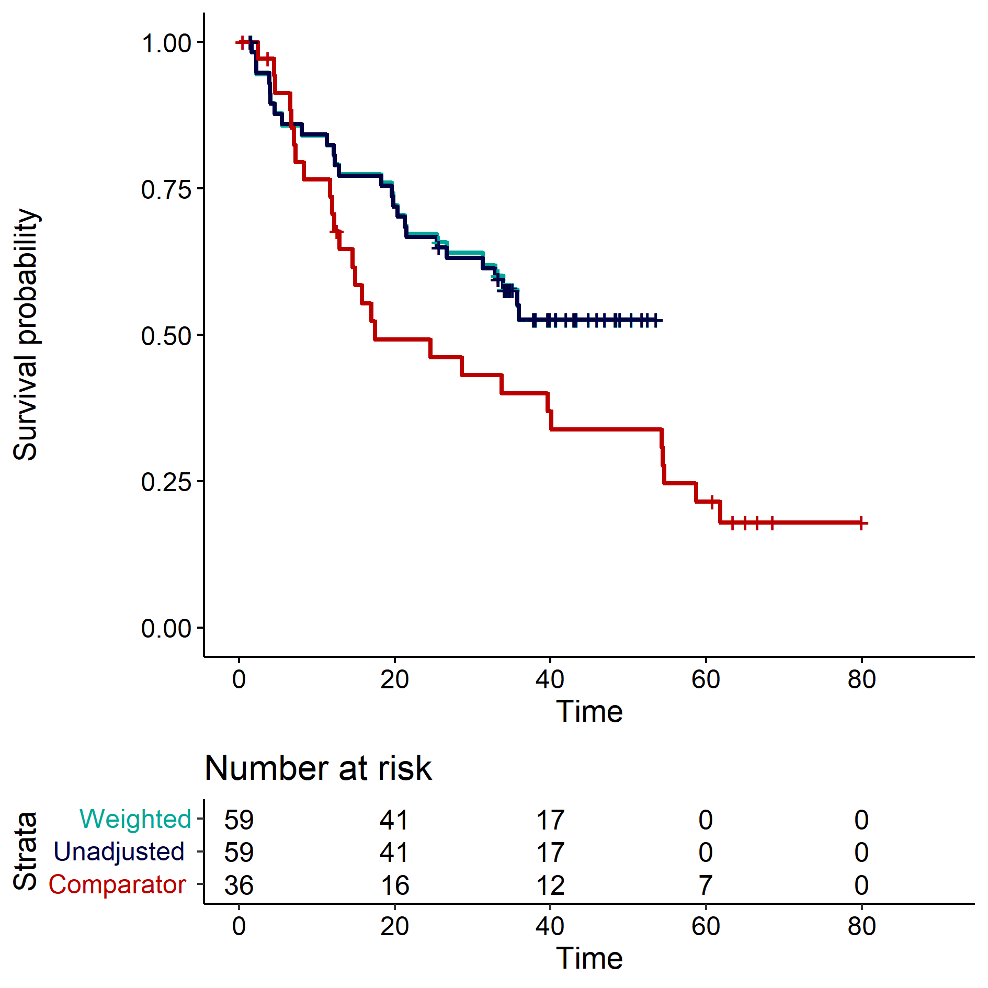
Source: Figure 2.17, p136 of the submission.
Navy/unadjusted curves = E+B (unadjusted/non-matching); Aqua/weighted curves = E+B (adjusted, base case); Red/comparator curves = Pembrolizumab+PDC
E+B = encorafenib and trametinib; D+T = dabrafenib and trametinib; OS = overall survival; Comparator = D+T.
  - While there was a significant improvement in PFS with E+B compared to D+T across both unadjusted and adjusted models, the improvement in OS was non-significant. These results should be interpreted with caution. The ESC noted that median PFS for E+B was derived from heavily censored data with an inestimable upper confidence interval. Median OS for E+B was not reached, with inestimable upper CI and heavy censoring toward the end of the curve. The immature survival curves may affect the proportional hazard assumption. Furthermore, the small sample size of both the trials reduces precision, and differences in trial design, median duration of follow-up and mean treatment duration, together with the lack of adjustment for key prognostic variables, may introduce residual confounding, despite the use of adjusted models.
  - The PSCR presented an updated MAIC that incorporated the E+B OS data from the March 2025 data cut-off which had a longer follow up. The PSCR noted that the point estimate for the adjusted (base case) was statistically significant (HR = 0.54; 95% CI: 0.31, 0.94).
  - Results of the unanchored MAICs for ORRs is summarised in Table 9. Unadjusted results are included for comparison.

Table 9: Indirect comparison of ORR – unadjusted analysis and MAICs
Model | 1L PHAROS  E+B (N=59)  (median follow-up of 33.3 months) | BRF113928 (Cohort C)  D+T (N=36)  (median follow-up of 15.9 months) | E+B versus D+T;  OR (95% CI)
Unadjusted (non-matching) | 44/59  (74.6%) | 23/36  (63.9%) | 1.66 (0.68, 4.07)
Adjusted (base case) | 44/59  (74.6%) | 23/36  (63.9%) | 1.81 (0.71, 4.59)
Adjusted (sensitivity analysis 1) | 44/59  (74.6%) | 23/36  (63.9%) | 1.61 (0.66, 3.95)
Source: Table 2.51, p120 and Table 2.72, p139 of the submission.
1L = first line; CI = confidence interval; D+T = dabrafenib and trametinib; ECOG PS= Eastern Cooperative Oncology Group Performance Status; E+B = encorafenib + binimetinib; MAIC = matching-adjusted indirect comparison; N = total participants in group; OR = odds ratio; ORR = objective response rate.
Base case = using all adjustment factors (ECOG PS, smoking status, age, gender race, histology, presence of brain metastases); sensitivity analysis 1 = using only ECOG PS and smoking status.
  - There was non-significant improvement in ORR with E+B compared with D+T across both unadjusted and adjusted models.

MAIC between E+B and pembrolizumab+PDC
  - The submission also presented an unanchored matching-adjusted indirect comparison (MAIC), comparing E+B (PHAROS trial; median follow-up of 33.3 months) with pembrolizumab+PDC (KN-189 trial; median follow-up of 64.6 months). This is not presented as it was not considered by the PBAC.

Intergroupe Francophone de Cancérologie Thoracique [IFCT] (Planchard et al, 2024)
  - The submission identified an ongoing, open-label, single-arm phase II study of E+B (IFCT), aimed to collect additional data on the efficacy and safety of E+B in patients with advanced BRAF-MT NSCLC (untreated [n= 64] and pretreated), as well as on QoL. The study reported an investigator-assessed ORR of 67% (95% CI: 55%, 78%), median PFS was 11 months (95% CI: 7, 17), and median OS was not reached (95% CI: 21, NR). However, this study was excluded as it was stated to be only available as a conference abstract with insufficient methodological detail and incomplete results.
  - The IFCT study reported a lower ORR compared to PHAROS when assessed by IRR (67% vs. 75%), but a slightly higher ORR than the investigator-assessed ORR in PHAROS (67% vs. 64%). The median PFS was lower in the IFCT compared to the PHAROS trial (11 months vs. 30 months [IRR] and 25 months [investigator-assessed]). Although median OS was not reached in either study, the lower bound of the confidence interval was shorter in IFCT compared to PHAROS (21 months vs. 31 months).
  - These differences may be partly attributed to variations in patient characteristics, such as a slightly older, predominantly male population, a higher proportion of brain metastases in the IFCT study (17% vs 8%), and a shorter median follow-up duration in IFCT compared to PHAROS (18 months vs 33 months).
  - Comparisons of median ORR, PFS, and OS across the IFCT (E+B), PHAROS (E+B), KN-189 (pembrolizumab+PDC), and BRF113928 (D+T) trials are summarised in Table 10.
Table 10: Comparison of median ORR, PFS, and OS across studies
Trial | IFCT | PHAROSª | KN-189^{b} | BRF113928^{c}
Treatment | E+B  (IA) | E+B  (IRR) | Pembrolizumab + PDC (BICR) | D+T  (IA)
Median follow-up | 18 months | 33.3 months | 64.6 months | 16.3 months
Median ORR (95% CI) | 67% (55, 78) | 75% (62, 85) | 48% (43, 53) | 64% (46, 79)
Median PFS (95% CI) | 11.1 months  (7.1, 16.7) | 30.2 months  (15.7, NE) | 9.0 months  (8.1, 10.4) | 10.8 months  (7.0, 14.5)
Median OS (95% CI) | NE  (20.7, NE) | NE  (31.3, NE) | 22.0 months  (19.5, 24.5) | 17.3 months  (12.3, 40.2)
Source: Table 6, p9; Table 2.51, p120; Table 2.56, p124 to the submission; and Planchard et al. (2024)
BICR = blinded independent central review; CI = confidence interval; D+T = dabrafenib and trametinib; E+B = encorafenib and binimetinib; IA = investigator-assessed; IFCT = Intergroupe Francophone de Cancérologie Thoracique (French Cooperative Thoracic Intergroup); IRR = independent radiology review; NE = not evaluable; PFS = progression-free survival; ORR = objective response rate; OS = overall survival; PDC = platinum doublet chemotherapy.
ª Median duration of treatment at the recent data cut-off of April 2024.
^{b} Median time from random assignment at recent data cut-off of March 2022.
^{c} Median duration of treatment at the recent data cut-off of February 2021.
  - To reduce uncertainty in the results of the base case MAIC, the PSCR pooled data from PHAROS and IFCT trials in a scenario analysis. The additional analyses showed that the statistically significant differences between E+B and pembrolizumab+PDC and D+T remained when data from IFCT were included. The ESC noted that the PSCR did not describe the methodology used to pool the data, despite notable differences in patient characteristics. The ESC also noted that the inclusion of the IFCT study results reduced the comparative efficacy of E+B to both pembrolizumab+PDC (HRs of 0.45 to 0.49) and D+T (HRs of 0.54 to 0.62).

Comparative harms
  - Table 11 summarises the key AEs across all the trials.
Table 11: Summary of key adverse events in the PHAROS, KN-189, and BRF113928 trials
Category, n (%) | PHAROS  April 2024  N=59 | KEYNOTE-189  March 2022  N=405 | BRF113928-Cohort C  (Planchard et al. 2017)  N=36
AEs (all cause) | 59 (100) | 404 (99.8) | 36 (100)
Grade 3 or 4 TEAEs | 41 (69.5) | NR | 25 (69)
Grade 5 TEAEs | 5 (8.5) | 29 (7.2) | 1 (3)
Grade 3-5 AEs (all cause) | 46 (77.9) | 295 (72.8) | 26 (72)
Treatment-related AEs | 58 (98.3) | 377 (93.1) | NR
Treatment-related Grade 3 or 4 TEAEs | 32 (54.2) | NR | NR
Treatment-related Grade 5 TEAEs | 1 (1.7) | 8 (2.0) | NR
Treatment related Grade 3-5 AEs | 33 (55.9) | 212 (52.3) | NR
SAEs | 28 (47.5) | 233 (57.53)ª | 24/36 (67)^{b}
AEs leading to discontinuation | 10 (16.9) | 145 (35.8) | 8 (22)
AEs leading to dose reduction | 16 (27.1) | NR | 14 (39)
AEs leading to dosing interruption | 41 (69.5)^{c} | NR | 27 (75)
AEs leading to death | 1 (1.7) | 29 (7.2) | 0 (0)
Source: Table 2.52, p121 and Table 2.57, p125 of the submission.
AE = adverse events; N = total number of participants; n = number of participants reporting data; SAE = serious adverse events; TEAE = treatment emergent adverse event.
ª Source: Extracted from the USCTR entry for NCTNCT02578680 at https://clinicaltrials.gov/study/NCT02578680?term=KEYNOTE-189&rank=5&tab=results#adverse-events
^{b} Source: https://www.clinicaltrials.gov/study/NCT01336634#study-plan
^{c} Data from cutoff July 2023 (not available from cutoff April 2024)
  - Almost all patients across the three trials experienced at least one AE. The highest proportion of Grade 3–5 AEs was observed in the PHAROS trial. Serious adverse events (SAEs) were more frequent in BRF113928 than in KN-189 and PHAROS. AEs resulting in dose reduction and interruption occurred more frequently in BRF113928 compared to PHAROS, with no data reported for KN-189.
  - In the PHAROS trial (untreated cohort), the most common treatment-related Grade 3 AEs (≥5%) were increased lipase (12%), elevated aspartate aminotransferase (AST; 10%), elevated alanine aminotransferase increased (ALT; 5%), diarrhoea (5%), and nausea (5%). The ESC noted that the high pill burden associated with E+B is difficult to manage when patients are experiencing gastrointestinal AEs. Grade 4 AEs included hyponatraemia, disseminated intravascular coagulation, colitis, and elevated blood creatine phosphokinase (each 1%). Colitis was the most frequent treatment-related SAE (5%). AEs leading to permanent discontinuation of E+B most commonly included diarrhoea, decreased ejection fraction, nausea, and vomiting (each 2%). One patient (1%) died due to a Grade 5 intracranial haemorrhage, assessed as treatment-related by the investigator.
  - Among the untreated patients in the BRF113928 trial, the most common Grade ≥3 AEs were hypertension, pyrexia, elevated ALT (11% each), followed by neutropenia (8%), dyspnoea (6%), hyponatraemia (6%), and anaemia (3%).

MAIC of safety outcomes
  - Similar to the efficacy analysis, the submission presented unanchored MAICs comparing E+B with both pembrolizumab+PDC and D+T. Results for the unanchored MAICs comparing E+B with D+T are presented.
  - Safety data for E+B were drawn from the PHAROS trial (median follow-up of 33.3 months). An earlier data cut-off was used for D+T (BRF113928; median follow-up of 15.9 months), as the more recent cut-off did not provide outcomes specifically for untreated patients.
  - The results of the unanchored and unadjusted comparison, and of the unanchored MAICs between E+B and D+T are presented in the Table 12.

Table 12: Indirect comparison of safety – unadjusted analysis and MAICs (E+B vs. D+T)
E+B vs. D+T | Unadjusted  (non-matching) | Adjusted  (base case) | Adjusted  (sensitivity analysis 1)
Grade 3-4 AE
Mean OR (95% CI) | 1.00 (0.41, 2.47) | 0.93 (0.37, 2.32) | 0.99 (0.40, 2.43)
SAE
Mean OR (95% CI) | 0.45 (0.19, 1.07) | 0.35 (0.14, 0.85) | 0.45 (0.19, 1.07)
Discontinuation due to AE
Mean OR (95% CI) | 0.71 (0.25, 2.02) | 0.71 (0.24, 2.06) | 0.75 (0.27, 2.11)
Source: Table 2.73, p140, Table 2.74, p140, and Table 2.75, p141 of the submission.
AE = adverse event; CI = confidence interval; ECOG PS= Eastern Cooperative Oncology Group Performance Status; E+B = encorafenib + binimetinib; MAIC = matching-adjusted indirect comparison; OR = odds ratio; PDC = platinum doublet chemotherapy; SAE = serious adverse event.
Base case = using all adjustment factors (ECOG PS, smoking status, age, gender race, histology, presence of brain metastases); sensitivity analysis 2 = using only ECOG PS and smoking status.
Bold indicate statistical significance.
  - The unadjusted comparison showed an equivalence between E+B and D+T in the incidence of grade 3-4 AEs, while favouring E+B over D+T with respect to SAE and discontinuations due to AEs. After adjustment, there was no statistically significant difference in proportion of patients experiencing grade 3-4 AEs (adjusted OR=0.93; 95% CI: 0.37, 2.32) and discontinuations due to AEs (adjusted OR=0.71; 95% CI: 0.24, 2.06). There was a statistically significant difference in proportion of patients experiencing SAEs (adjusted OR=0.35; 95% CI: 0.14, 0.85).

Benefits/harms
  - The unanchored MAIC presented in the submission did not allow for a quantitative comparison of the benefits and harms of E+B and pembrolizumab+PDC or D+T. Accordingly, a benefits/harms table has not been presented.

Clinical claim
  - Only the claims compared to D+T were considered by the PBAC.
  - The submission described E+B as superior in terms of effectiveness compared with D+T. The ESC considered that the therapeutic conclusions presented in the submission were uncertain as:
- The submission relied on unanchored MAICs comparing E+B (PHAROS study) with D+T (cohort C of BRF113928 study). There were differences in the median duration of follow-up as well as treatment duration as described in paragraph 6.10 and 6.11.
- The results of the MAICs should be interpreted with caution as:
  - Matching to the BRF113928 trial reduced the effective sample size of the PHAROS trial by 25%.
  - Median OS for E+B could not be estimated (based on the data presented and evaluated in the submission, using the April 2024 data cut off) due to immature data and heavy censoring toward the end of the curve, limiting comparison with more mature data from the BRF113928 trial.
  - Median PFS for E+B was derived from heavily censored data with an inestimable upper CI.
  - The submission excluded the ongoing study of E+B (IFCT), citing differences between the trials (refer to paragraph 6.34). The ESC noted that the PSCR presented pooled data from the PHAROS and IFCT trials in a scenario analysis. The ESC noted that the inclusion of the IFCT study results reduced the comparative efficacy of E+B to D+T, but that the methodology used to pool the data was not described and the comparisons were not evaluated.
- The submission did not adequately justify the superior efficacy of E+B compared to D+T despite both combinations sharing the same mechanism of action. The submission suggested that E+B has a longer on-target binding time compared to other BRAF inhibitors, which may enable persistent MAPK pathway suppression; however, the studies presented to support this claim were not specific to BRAF inhibitors. Furthermore, the ESMO and NCCN guidelines recommend E+B or D+T as the first line treatment option for patients with mNSCLC and BRAF V600E-MT, with no clear indication or treatment preference for E+B over D+T, or vice versa.
- Additional data from the March 2025 data cut-off from the PHAROS trial was presented in the PSCR. Although these data (and the additional MAICs presented in the PSCR) were largely supportive of the results presented in the submission, there were uncertainties given the small sample size and heavy censoring. The pre-PBAC Response maintained that a claim of superior effectiveness versus D+T was appropriate given the updated analyses provided in the PSCR.
  - The submission described E+B as having superior safety compared to D+T based on the incidence of Grade 3-5 AEs, SAEs and treatment discontinuations due to AEs. Although the MAIC indicated there were statistically significant fewer SAEs associated with E+B, none of the other analyses demonstrated a difference. The ESC considered this claim was partially supported given there was a higher incidence of serious adverse events, and adverse events leading to dose discontinuation, interruption or reduction with D+T compared to E+B (Table 14).
  - The PBAC considered that the clinical claim of superior comparative effectiveness against D+T was not adequately supported by the data. The PBAC considered that the MAICs were highly uncertain due to low matched numbers and noted that international guidelines, such as ESMO and NCCN, do not preference E+B over D+T. Overall, the PBAC considered that E+B was non-inferior in terms of efficacy compared to D+T.
  - The PBAC considered that the clinical claim of superior comparative safety against D+T was reasonable.

Economic analysis
  - The submission presented a stepped economic evaluation of E+B with pembrolizumab+PDC as first-line treatment of BRAF V600E-MT mNSCLC, based on the MAIC results between PHAROS and KN-189 trials. An additional analysis was presented against D+T, based on the result of a MAIC between the PHAROS and BRF113928 trials. The pre-PBAC response stated that D+T should be the comparator.
  - Given that the PBAC did not accept the claim of superior effectiveness compared to D+T the PBAC considered that a cost-minimisation approach against D+T would be a more appropriate approach.
  - A cost-minimisation approach comparing E+B with D+T, which assumed a similar duration of treatment in practice and was based on drug costs only is presented in Table 13.
Table 13: Cost-minimisation approach for E+B versus D+T (using published price of D+T)
 | Dabrafenib and trametinib |  | Encorafenib and binimetinib
Dose | Dabrafenib | 150 mg twice daily | Encorafenib | 450 mg once daily
Dose | Trametinib | 2 mg once daily | Binimetinib | 45 mg twice daily
Ex-manufacturer price | Dabrafenib 75 mg (120) | $6,995.23 | Encorafenib 75 mg (168) | $6,700.68
Ex-manufacturer price | Trametinib 2 mg (30) | $7,363.40 | Binimetinib 45 mg (56) | $6,700.68
Drug cost per day | Dabrafenib | $233.17 | Encorafenib | $239.31
Drug cost per day | Trametinib | $245.45 | Binimetinib | $239.31
Drug cost per day | Total | $478.62 | Total | $478.62
Source: constructed during preparation of the ESC Advice.
D+T = dabrafenib plus trametinib; E+B = encorafenib plus binimetinib
  - The key components of the economic evaluation are summarised in Table 14.
Table 14: Summary of model structure, key inputs and rationale
Component | Summary
Treatments | E+B versus pembrolizumab+PDC  E+B versus D+T
Time horizon | 15 years in the model base case versus 4.4 years follow-up in the PHAROS trial
Outcomes | Life-years gained, and quality-adjusted life years gained
Methods used to generate results | Partitioned survival model (i.e. area under the curve)
Health states | Progression free survival, Progressed disease, Death
Cycle length | 7 days
Allocation to health states | Health state allocation over time in the E+B arm was determined by the PFS and OS data from the untreated cohort of the PHAROS trial up to median follow-up (33 months). The submission included observed time-to-event data until it became unreliable, and parametric extrapolation of PFS and OS curves were subsequently applied to 15 years.  Health state allocation over time in pembrolizumab+PDC and D+T arms was derived by applying the hazard ratios from the MAIC (after matching for all adjustment factors) to the PFS and OS survival curves of E+B.  TTD data from E+B was derived post-hoc from the untreated cohort of the PHAROS trial. However, TTD data for the comparators (pembrolizumab+PDC and D+T) were not available. To estimate TTD for these arms, the submission applied hazard ratios to their respective PFS curves, adjusting them so that the area under the curve aligned with the mean treatment duration derived from D+T November 2024 PBAC submission for pembrolizumab+PDC (10.26 months) and D+T (18.315 months)
Extrapolation method | Parametric model fitted to E+B arm with exponential distribution selected in the base case for OS, PFS, and TTD based on goodness of fit, visual inspection, and clinical expert opinion.  66% of LYGs (undiscounted) and 36% of costs (undiscounted) occur in the extrapolated period.
Health related quality of life | Health state utility values of 0.776 for the progression-free state and 0.714 for the progressed disease state were sourced from the July 2019 PBAC submission for pembrolizumab+PDC in advanced NSCLC. These were applied to all treatment arms.
Costs | The model included drug costs, including those associated with administration and monitoring, resource use costs associated with managing the disease, and terminal care costs.  Costs associated with monitoring liver and renal function and repeat ophthalmic monitors for E+B were not included.  Costs for managing AEs and subsequent treatments were excluded.
Source: Table 3.1, pp163-164 of the submission and Section 3 of the submission.
AE = adverse event; D+T = dabrafenib and trametinib; E+B = encorafenib and binimetinib; OS = overall survival, PDC = platinum-based doublet chemotherapy; MAIC = matching-adjusted indirect comparison; NSCLC = non-small cell lung cancer; PFS = progression free survival; LYG = life years gained; TTD = time to treatment discontinuation.
  - The submission used a partitioned survival model, with three health states: progression-free, progressed disease, and death. For E+B, allocation to the health states was informed by KM OS and PFS data from the PHAROS trial (median follow-up of 33.3 months), up to the point where the data were deemed unreliable. Beyond that, parametric survival distributions were applied over a 15-year time horizon (see paragraphs 6.57 and 6.59). For the comparator arms, health state allocation was derived by applying the HR from the base case MAIC to the E+B curves (see paragraph 6.63).
  - The economic model applied a 15-year time horizon, with patients entering the model at an average age of 67 years. Based on the extrapolation adopted in the submission, an estimated 7% of E+B patients were alive at 15 years, compared to 57% observed in the PHAROS trial at a median three-year follow-up. The limited median follow-up duration of the PHAROS trial may not provide a reliable basis for the long-term extrapolations. Given the relatively short survival in this population, the PBAC previously accepted a 7.5-year time horizon in the economic model for pembrolizumab+PDC for first-line advanced NSCLC (Pembrolizumab, PSD, November 2018 and July 2019 PBAC meeting).
  - The submission stated that selection of the distributions was based on visual inspection, clinical plausibility, and statistical fit (Akaike information criterion [AIC] and Bayesian information criterion [BIC]).
  - In the base case, the submission applied the exponential distribution to extrapolate OS. All extrapolated models projected five-year survival exceeding 40%, which the ESC considered optimistic for this population. Variations in the distributions used to model the OS curve had a moderate effect, with the exponential distribution yielding the highest estimate of the ICER.
  - In the base case, the submission applied the exponential distribution to extrapolate PFS to maintain consistency with the OS extrapolation and to adopt a conservative approach. This choice was further justified by its prediction of the shortest progression-free rates. Variations in the distributions used to model the PFS curve had minimal impact on the ICER, with the exponential distribution yielding the highest estimate of the ICER.
  - The submission incorporated time on treatment to estimate the duration and associated costs for E+B. A post-hoc analysis was conducted by the submission to derive the time to treatment discontinuation for E+B from the PHAROS trial. The TTD KM curve was extrapolated using exponential distribution, similar to the OS and PFS curves. The model calculated a mean TTD of 25 months for E+B, compared to the median TTD of 17 months in the PHAROS trial.
  - Figure 9 presents a comparison of OS, PFS, and TTD curves between the trial data and model predictions.
Figure 9: Model predictions versus the trial estimates for E+B
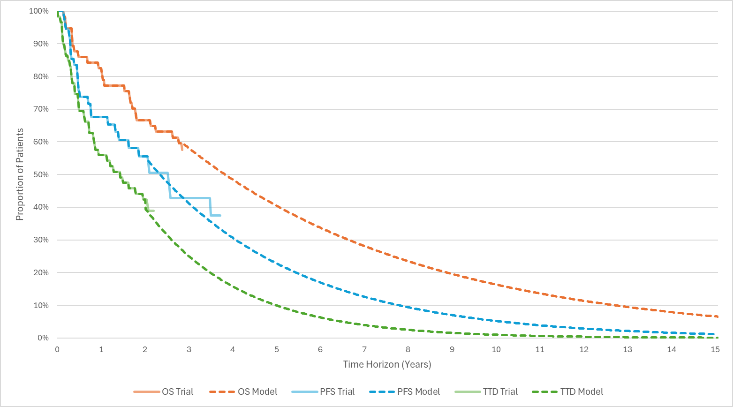
Source: Constructed during evaluation using data from ‘Data Curves’ worksheet in the ‘Attachment 5.1 CUA Enco+Bini for BRAF V600E-MT NSCLC’ worksheet.
E+B = encorafenib and binimetinib; OS = overall survival, PFS = progression-free survival; TTD = time-to-treatment discontinuation.
  - The ESC noted the following uncertainties in the modelling:
- The long-term projections appear clinically implausible for mNSCLC, with approximately 3% of patients remaining progression free and approximately 7% of patients still alive at 15 years.
- The smoothed hazard curves for OS and PFS declined over time, indicating a non-constant hazard function. This violates the assumptions of the exponential distribution, which requires a constant hazard rate.
- These patterns likely reflect the use of a single-shape parametric model, which fails to capture the initial steep decline followed by a slower hazard rate for all the curves. A more appropriate approach would involve flexible modelling techniques that allow for treatment effect waning over time.
  - For the comparator arms, the submission modelled OS and PFS by applying the HRs from the base case MAICs to the OS and PFS curves of E+B.
  - Given the inherent uncertainty in the MAIC results (as detailed in paragraph 6.46), the ESC noted that the resulting OS and PFS curves for the comparator arms are also subject to similar uncertainty. Further, the use of HRs from the MAICs, rather than the observed trial data, resulted in discrepancies in the proportions of patients alive at five years. For D+T, the model estimated 19% survival at five years, while the trial reported 22%.
  - Additionally, as no treatment waning effect was applied to the extrapolated curves, the submission assumed an ongoing treatment benefit associated with E+B over pembrolizumab+PDC and D+T until the end of the time horizon (i.e. 15 years).
  - TTD data for pembrolizumab+PDC and D+T were unavailable from their respective trials. To estimate the TTD, the submission applied a HR of 0.7161 to the generated PFS curve for pembrolizumab+PDC and an HR of 1.03155 for D+T, adjusting them to align the area under the curve with the mean treatment duration reported in the March 2025 PBAC submission for D+T (paragraph 6.53 and 6.54, D+T, PSD, March 2025 PBAC meeting). Additionally, a stopping rule was applied in the economic model to pembrolizumab+PDC, capping treatment at two-years in the absence of disease progression (as per the restriction). No time-based stopping rules were applied for E+B or D+T.
  - The submission applied a relative dose intensity (RDI) of 85.78% for encorafenib and 84.73% for binimetinib. The RDIs for pembrolizumab+PDC (95% for pembrolizumab, 98% for carboplatin, and 81% for pemetrexed) and D+T (83% dabrafenib and 90% for trametinib) were based on the RDIs considered by the PBAC in the D+T March 2025 PBAC submission.
  - A summary of the key drivers of the model is presented in Table 15.
Table 15: Key drivers of the model
Description | Method/Value | Impact  Base case: $&&&&¹/QALY gained.
OS in comparator arm | OS in the pembrolizumab+PDC arm was derived by applying a HR of 0.41 (95% CI: 0.23, 0.73) from the adjusted MAIC to the OS curve of E+B. | High, favours E+B  Varying the HR applied for OS based on the unadjusted and adjusted sensitivity analyses (range: 0.48 to 0.53) resulted in a &&&&% to &&&&% increase in the ICER.
Time horizon | 15 years in the base case. | High, favours E+B  Use of a time horizon of 8 years increased the ICER by &&&&% to $&&&&²/QALY gained.
Extrapolation for TTD | Exponential distribution in the base case. | High, favours E+B.  Use of Weibull extrapolation increased the ICER by &&&&% to $&&&&¹/QALY gained.
Source: Table 3.30, pp204-205 and Table 3.31, p206 of the submission.
CI = confidence interval; E+B = encorafenib and binimetinib; HR = hazard ratio; ICER = incremental cost-effectiveness ratio; OS = overall survival; PDC = platinum-based doublet chemotherapy; QALY = quality-adjusted life years; TTD = time-to-treatment discontinuation.
The redacted values correspond to the following ranges:
¹ $55,000 to < $75,000
² $75,000 to < $95,000
  - A stepped economic evaluation against pembrolizumab+PDC is presented in Table 16. Table 17 summarises the results of the economic analysis against D+T.
  - The submission halved the published prices of pembrolizumab to estimate the effective price for this drug.
  - For D+T, the submission used placeholder DPMQs that resulted in approximately the same monthly cost for D+T as for pembrolizumab+PDC, given that D+T was recommended by the PBAC on a cost-minimisation basis versus pembrolizumab+PDC but was not listed on the PBS at the time of the submission.
Table 16: Results of the stepped economic evaluation
Step and component | E+B | Pembrolizumab+PDC | Increment
Step 1: Based on the PFS and OS data represented with parametric functions. Time horizon of 4 years (OS follow-up time in PHAROS).
Costs: Drug acquisition and drug administration.
Outcomes: LYs gained
Costs | $&&&& | $67,931 | $&&&&
LYG | 2.827 | 1.868 | 0.959
Incremental cost/extra LYG gained |  |  | $&&&&¹
Step 2: PFS and OS data extrapolated with parametric functions until 15 years. 5% discount applied to costs and outcomes.
Costs: as in Step 1+ disease management and monitoring and terminal care.
Outcomes: LYs gained over the modelled time horizon
Costs | $&&&& | $116,558 | $&&&&
LYG | 4.300 | 2.077 | 2.223
Incremental cost/extra LYG gained |  |  | $&&&&²
Step 3: As above but Kaplan-Meier data used for PFS and OS until unreliable, then data extrapolated with parametric functions until 15 years
Costs: As in Step 3
Outcomes: LYs over the modelled time horizon
Costs | $&&&& | $116,661 | $&&&&
LYG | 4.248 | 1.990 | 2.259
Incremental cost/extra LYG gained |  |  | $&&&&²
Step 4: Transformation of LYs to QALYs.
Costs: As in Step 3
Outcomes: QALYs over the modelled time horizon of 15 years
Costs | $&&&& | $116,661 | $&&&&
QALYs | 3.211 | 1.480 | 1.730
Incremental cost/extra QALY gained (base case) |  |  | $&&&&³
Source: Table 3.23, p200 of the submission and Table 4, p6 of the PSCR
E+B = encorafenib and binimetinib; OS = overall survival; LY = life-years; PDC = platinum-doublet chemotherapy; PFS = progression-free survival; QALY = quality-adjusted life years.
Note: the submission applied a 50% discount to the published DPMA for pembrolizumab.
Table 17: Incremental cost per QALY of E+B versus D+T
Parameter | Encorafenib + binimetinib | Dabrafenib + trametinib | Incremental
Cost | $&&&& | $137,749 | $&&&&
QALYs | 3.211 | 1.951 | 1.260
Incremental cost per QALY |  |  | $&&&&³
Source: Table 3.29, p203 of the submission and Table 5, p6 of the PSCR
D+T = dabrafenib and trametinib; E+B = encorafenib and binimetinib; PDC = platinum doublet chemotherapy; QALYs = quality adjusted life year.
The redacted values correspond to the following ranges:
¹ $95,000 to < $115,000
² $45,000 to < $55,000
³ $55,000 to < $75,000

  - The economic model estimated that E+B would result in a survival benefit of 2.93 life-years gained (LYG, undiscounted) compared to pembrolizumab+PDC and 2.16 LYG (undiscounted) compared to D+T. The model estimated that E+B would also result in 2.22 additional QALYs (undiscounted) compared to pembrolizumab+PDC and 1.68 additional QALYs (undiscounted) compared to D+T.

Drug cost/patient/course
  - The drug costs per patient per course for E+B are summarised in Table 18.
Table 18: Drug cost per patient for E+B (using proposed effective DPMQ of E+B and)
 | Encorafenib and binimetinib
 | Trial dose and duration | Economic model | Financial estimates
Mean dose | E: 391 mg/dayª  B: 76 mg/dayª | E: 386 mg/day  B: 76.2 mg/day | E: 386 mg/dayª  B: 76.2 mg/dayª
Mean duration (months) | E: 20.81^{b}  B: 20.54^{b} | 25.03 | 25.03
RDI | E: 86.83%  B: 84.71% | E: 85.78%  B: 84.73% | E: 85.78%  B: 84.73%
Scripts/course | E: 19.58ª  B: 18.85ª | E: 23.26  B: 22.97 | E: 23.26  B: 22.97
Cost/patient/course | $&&&&^{c} | $&&&&^{d} | $&&&&^{c}
Source: Section 2.4.2.2, p86; Section 4.3.2.1, pp218-219; Attachment 5.1, Attachment 6.1, Attachment 6.2 to the submission
B= binimetinib; DPMQ = dispensed price for maximum quantity; E = encorafenib; RDI =relative dose intensity
a Calculated during the evaluation based on the recommended dose, RDIs and mean duration.
b Sourced from Table 2.24, p86 of the submission, truncated mean (April 2024 cut off)
c Calculated during evaluation using the requested effective DPMQ for E+B and the estimated scripts per course.
d Derived from the economic model using the weekly acquisition costs of $&&&& for E+B multiplied by 108.45 weeks as calculated by the submission.

Estimated PBS usage & financial implications
  - This submission was not considered by DUSC.
  - The submission used an epidemiological approach to estimate the utilisation and financial impact of listing E+B on the PBS for the treatment of BRAF V600E-MT mNSCLC. As the PBAC considered that a cost minimisation approach between E+B and D+T was appropriate and as E+B is likely to primarily replace D+T rather than pembrolizumab+PDC, the financial estimates will need to be revised.
  - Table 19 summarises the key inputs and data sources to estimate the utilisation of E+B.
Table 19: Key inputs for financial estimates
Parameter | Value applied |  | Source | Comment
Eligible population
Lung cancer population | 15,878 in Yr 1 increasing to 16,989 in Yr 6 |  | Based on ABS statistics and AIHW age-standardised incidence rate in 2024 (55.7 cases per 100,000 persons) | -
% NSCLC | 86.6% |  | Mitchell et al. (2013) | This was consistent with the March 2025 D+T submission.
% ECOG PS  0-1  0-2 | 78.98%  96.05% |  | Estimated from Hess et al. (2022) | The ESC considered that the proportions applied in the submission were overestimated. The ESC noted that the March 2025 D+T submission assumed 80.1% of the patients had ECOG PS 0-2. The Queensland NSCLC Quality Index 2017-2021, reported that 83.3% of NSCLC patients had ECOG PS 0-2.ª
% diagnosed at Stage IV | 51.50% |  | Estimated from Mitchell et al. (2013) | This was slightly different from the recent Queensland NSCLC Quality Indexª and the Victorian Lung Cancer Registry^{b,} which reported 54% and 56%, respectively. However, the proportion was consistent with the March 2025 D+T submission.
% BRAF V600E-MT | 1.75% |  | Estimated from Litvak et al (2014) | The PBAC noted that the D+T submission applied a prevalence rate of 1.13%.
% diagnosed at Stage I-IIIA and progressed | 30.00% |  | Sponsor’s assumption based on D+T PSD March 2025. | This was consistent with the selpercatinib PSD, July 2024 PBAC meeting.
% of pretreated Stage IV patients alive and eligible for E+B | 70.00% |  | Sponsor’s assumption based on selpercatinib PSD July 2024. | The D+T PSD, March 2025 stated that prevalence rates in 2 Australian studies were 1.5% to 2.9%.
Incident patients | &&&&¹ in Yr 1 increasing to &&&&¹ in Yr 6 |  | Calculated in the submission | Based on the recent data available for proportion of patients with ECOG PS 0-2 (83.3%ª) and stage IV (55%^{a,b}), the number of incident patients changes to 110 in Yr 1, increasing to 118 in Yr 6. The PBAC considered this was reasonable.
Prevalent patients | &&&&¹ in Yr 1 increasing to &&&&¹in Yr 6 |  | Calculated in the submission | Derived from the lung cancer population, assuming 86.6% had NSCLC; 58.5% Stage I-III; 30% progressed to Stage IV within a year; 70% were eligible for E+B; and 1.75% had BRAF V600E-MT. The PBAC considered this was reasonable.
Treatment utilisation
Uptake rate | &&&&% |  | Sponsor’s assumption | The ESC considered this was an overestimate, particularly following the 1 October 2025 PBS listing of D+T. The pre-PBAC Response stated it was likely that E+B would have a dominant market share over D+T based on experience in melanoma. The PBAC agreed that E+B and D+T would have a high market share over pembrolizumab+PDC.
Treatment duration for E+B (mean) | 108.45 weeks (~25 months) |  | Based on the economic model | The PBAC considered this was uncertain as it was derived from the extrapolated curve over 15-year time horizon.
RDI | Encorafenib: 85.78%  Binimetinib: 84.73% |  | Based on the economic model | Based on the CSR report, the RDI for E+B was 86.83% and 84.71%, respectively.
Cost | Encorafenib 75 mg  (42 capsules X 4)  $ &&&& (AEMP)  $ &&&& (DPMQ)  Binimetinib 45 mg  (56 capsules)  $ &&&& (AEMP)  $ &&&& (DPMQ) |  | Requested effective price | The effective price was derived based on an assumed effective price for pembrolizumab.
MBS costs | Blood test  CT scan  Echocardiogram  IV administration Insertion of CVAD  Removal of CVAD  Cleaning of CVAD  Liver and renal function test  Thyroid function test | $ 8.05  $ 630.15  $ 264.90  $ 126.00  $ 317.80  $ 238.20  $ 61.25  $ 17.70  $ 34.80 | MBS items | The MBS costs for eye examination, liver and renal function tests associated with E+B were not included (MBS item 116 and 66512). Based on the FDA and draft TGA PI for E+B, ophthalmic evaluation at regular intervals for any visual disturbances due to ocular toxicities are performed. Based on eviQ for E+B, liver and renal function test should be conducted at baseline and repeat monthly. The PBAC considered MBS impacts were underestimated given the need for monitoring, but that that the overall impact of this was low. The PBAC noted that costs associated with CVAD would not be relevant if E+B substituted for D+T.
Source: Table 4.1, p209; Table 4.3, p211; Table 4.8, p214; Attachment 6.1 of the submission.
ABS = Australian Bureau of Statistics; AEMP = authorised ex-manufacturer price; AIHW = Australian Institute of Health and Welfare; BRAF V600E-MT = mutation positive; CSR = clinical study report; CT = computed tomography; CVAD = central venous access device; DUSC = Drug Utilisation Sub Committee; D+T = dabrafenib and trametinib; DPMQ = dispensed price for maximum quantity; ECOG PS = Eastern Cooperative Oncology Group Performance Status; E+B = encorafenib and binimetinib; FDA = Food and Drug Administration; ICER = incremental cost-effectiveness ratio; IV = intravenous; MBS = Medicare Benefits Scheme; NSCLC = non-small cell lung cancer; PBS = Pharmaceutical Benefits Scheme; PI = product insert; PSD = Public Summary document; RDI = relative dose intensity; RPBS = Repatriation Pharmaceutical Benefits Scheme; SPA = Special pricing arrangement; TGA = Therapeutic Goods Administration; Yr = year.
ª Based on the Queensland NSCLC Quality Index 2012-2021 https://cancerallianceqld.health.qld.gov.au/reports/lung20122022website-lungreport20122021/#tab3
^{b} Based on the Victorian Lung Cancer Registry 2022 Annual Report https://vlcr.org.au/wp-content/uploads/2018/05/VLCR-2022-Annual-Report.pdf
The redacted values correspond to the following ranges:
¹ < 500

  - The estimated financial implications of listing E+B are presented in Table 20.
Table 20: Estimated use and financial implications (proposed effective price for E+B, and assumed effective priceª for pembrolizumab)
 | Year 1 | Year 2 | Year 3 | Year 4 | Year 5 | Year 6
Estimated extent of use
Number of patients treated | &&&&¹ | &&&&¹ | &&&&¹ | &&&&¹ | &&&&¹ | &&&&¹
Number of scripts dispensed^{b} | &&&&² | &&&&³ | &&&&³ | &&&&³ | &&&&³ | &&&&³
Estimated financial implications of E+B
Cost to PBS/RPBS less copayments | $&&&&⁴ | $&&&&⁵ | $&&&&⁵ | $&&&&⁵ | $&&&&⁵ | $&&&&⁵
Estimated financial implications for pembrolizumab+PDC
Cost to PBS/RPBS less copayments^{c} | -$&&&&⁶ | -$&&&&⁴ | -$&&&&⁴ | -$&&&&⁴ | -$&&&&⁴ | -$&&&&⁴
Net financial implications
Net cost to PBS/RPBS^{c} | $&&&&⁶ | $&&&&⁶ | $&&&&⁶ | $&&&&⁶ | $&&&&⁶ | $&&&&⁶
Net cost to MBS | -$&&&&⁶ | -$&&&&⁶ | -$&&&&⁶ | -$&&&&⁶ | -$&&&&⁶ | -$&&&&⁶
Net cost to PBS/RPBS/MBS^{c} | $&&&&⁶ | $&&&&⁶ | $&&&&⁶ | $&&&&⁶ | $&&&&⁶ | $&&&&⁶
Source: Table 4.7, p214; Table 4.11, p216; Table 4.21, p223; Attachment 6.1; Attachment 6.2 of the submission.
E+B = encorafenib and binimetinib; MBS = Medicare Benefits Scheme; PBS = Pharmaceutical Benefits Scheme; RPBS = Repatriation Pharmaceutical Benefits Scheme.
ª Based on the economic model, the submission halved the published prices of pembrolizumab to estimate the effective price for this drug.
^{b} Assuming 11.15 scripts for encorafenib and 11.01 for binimetinib per year as estimated by the submission.
^{c} Costs were updated during the evaluation using the updated published DPMA for cisplatin 4319H ($140.20), 7224F ($186.56) and assumed effective price of pembrolizumab.
The redacted values correspond to the following ranges:
¹ < 500
² 500 to < 5,000
³ 5,000 to < 10,000
⁴ $10 million to < $20 million
⁵ $20 million to < $30 million
⁶ $0 to < $10 million

  - The total cost to the PBS/RPBS/MBS of listing E+B was estimated to be $0 to < $10 million in Year 6, and a total of $40 million to < $50 million in the first 6 years of listing, using the assumed effective price of pembrolizumab.
  - Overall, the ESC considered that the utilisation of E+B was uncertain due to the following:
- The submission assumed a &&&&% uptake rate, which the ESC considered was an overestimate, particularly given the PBS listing of D+T which has the same mechanism of action and is also an oral formulation.
- The mean treatment duration of 108.45 weeks was uncertain as it was derived from the economic model.
- The PBAC considered that the costs to the MBS in the E+B arm might be underestimated, as the draft TGA PI recommends monitoring liver and renal function test and repeat ophthalmic monitoring. These costs were considered for the pembrolizumab+PDC arm but were omitted for E+B. However, the net impact of including these costs was minimal (0.7%).
  - Additionally, given the submission requested a line-agnostic listing for E+B, some patients treated with pembrolizumab+PDC in the first-line setting may receive treatment with E+B in a later treatment setting. Furthermore, patients may receive pembrolizumab+PDC as second-line treatment following disease progression on E+B.
For more detail on PBAC’s view, see section 7 PBAC outcome.
- PBAC Outcome
  - The PBAC recommended a General Schedule, Authority Required (STREAMLINED) listing of encorafenib in combination with binimetinib (E+B) for the treatment of patients with BRAF V600E mutation positive metastatic (Stage IV) non-small cell lung cancer (NSCLC). The PBAC considered that, despite the uncertainties associated with the indirect comparisons presented in the submission, on balance, it was likely E+B provided similar health outcomes to dabrafenib in combination with trametinib (D+T) in the proposed population. The PBAC considered that E+B would be acceptably cost effective if it were cost-minimised against D+T, assuming the same duration of treatment and relative dose intensity. The PBAC advised that a &&&& price premium for E+B would be reasonable given the potential reduction in serious adverse events and improved tolerability compared to D+T.
  - The PBAC noted that the submission requested listing of the new strength of binimetinib, 45 mg tablet for the treatment of NSCLC. The PBAC considered that this was reasonable if the 45 mg tablet was listed at the same price per mg as the 15 mg tablet noting that it would reduce pill burden in this population. The PBAC noted the submission requested to extend the listing of the new strength to the existing listing of malignant melanoma as the recommended dosing is the same as NSCLC. The PBAC considered that this was also reasonable based on the positive the TGA Delegate’s Overview, pending full TGA approval.
  - The PBAC noted the small population of patients with BRAF V600E mutations and the moderate clinical need for additional therapies for NSCLC, which was supported by the consumer comments received.
  - The PBAC advised a single, line agnostic restriction criteria for initial, continuing and grandfather treatment that allows patients to transition from non-PBS subsidised treatment would be appropriate. The PBAC considered it was appropriate for E+B to be listed only for patients with BRAF V600E mutations, consistent with clinical guidelines including NCCN.
  - The PBAC noted that the inclusion criteria of the key clinical trial (PHAROS) excluded patients with prior exposure to any BRAF or mitogen-activated protein kinase (MEK) inhibitor therapy and considered it would be appropriate for the restriction to preclude patients who have previously received treatment with a BRAF inhibitor (such as D+T) from accessing E+B. However, the PBAC considered it would be appropriate for patients to be able to switch between E+B and D+T due to intolerance or toxicity. The PBAC considered it would be appropriate to add the following as clinical criterion and to flow-on these to the restriction for D+T:
  - “Patient must not have received PBS-subsidised treatment with each of (i) BRAF inhibitor, (ii) MEK inhibitor for Stage IV NSCLC prior to commencing PBS-subsidised treatment with this drug for this condition; OR
  - Patient must have developed intolerance to another BRAF inhibitor or MEK inhibitor of a severity necessitating permanent treatment withdrawal”
  - The PBAC recalled that at the May 2025 meeting in consideration of repotrectinib for Stage IIIB (locally advanced) or Stage IV (metastatic) non-small cell lung cancer (NSCLC), it has considered that flow-on changes to other immunotherapy listings for the same condition were required to allow the use of immunotherapies if the condition progressed after targeted therapies. The PBAC noted that prior targeted therapies should include E+B and the relevant criterion should change to:
‘The condition must have progressed after treatment with any of the prior targeted therapies that are PBS listed for this condition.’
  - The PBAC noted the submission nominated pembrolizumab in combination with platinum-based doublet chemotherapy (PDC) as the comparator, with D+T nominated as a near market comparator. The PBAC noted that D+T, which has the same mechanism of action as E+B, was listed on the PBS on 1 October 2025 for the same indication and that the pre-PBAC response stated that D+T should be the comparator. The PBAC considered that D+T was the appropriate comparator.
  - The PBAC noted the clinical evidence for E+B was from one single arm trial (PHAROS) in patients with BRAF V600E positive metastatic NSCLC receiving either first line treatment (N=59) or second line treatment (N=39). The PBAC noted the median progression free survival (PFS) was 30.2 months and median overall survival (OS) was not estimable in the first line treatment setting. Based on updated OS data provided in the Pre-Sub-Committee Response, the PBAC noted the median OS was 47.6 months.
  - The PBAC noted the submission claimed E+B was superior to D+T in terms of comparative effectiveness. The PBAC noted the submission presented unanchored unadjusted and an unanchored matching-adjusted indirect comparisons (MAIC) of the E+B trial (PHAROS, first line patients only) and the results from the D+T trial (BRF113928, first line patients only) to support the clinical claim. The PBAC noted the hazard ratios for PFS and OS favoured E+B (see Table 8 and Table 11) and that while statistically significant, considered that the MAICs were highly uncertain due to low matched numbers (44 matched patients between BRF113928 and PHAROS). The PBAC also noted the results of the Intergroupe Francophone de Cancérologie Theoracique (IFCT) study which was a single arm study which reported overall response rate and PFS data that more closely aligned with the response seen in the BRF113928 trial (see Table 10). The PBAC considered that the evidence presented in the submission did not adequately support the claim that E+B was superior to D+T in patients treated first line. Overall, based on the evidence presented and the fact that E+B and D+T have the same mechanisms of action, the PBAC considered that E+B was non-inferior in terms of efficacy compared to D+T.
  - The submission presented unanchored unadjusted and unanchored MAICs comparing safety outcomes for E+B with D+T. The PBAC noted the unadjusted comparison against D+T showed no significant difference between E+B and D+T in the incidence of grade 3-4 AEs, serious adverse events and discontinuations due to adverse events. After adjustment, there was a statistically significant difference in proportion of patients experiencing serious adverse events (adjusted OR=0.35; 95% CI: 0.14, 0.85) in favour of E+B. The PBAC noted that the ESC considered there was a higher incidence of serious adverse events, and adverse events leading to dose discontinuation, interruption or reduction with D+T compared to E+B (Table 14). Further, although unanchored, the PBAC noted that E+B was associated with less pyrexia (11.9%) and rash (11.9%) compared to D+T (53% and 19%, respectively). Overall, the PBAC considered that E+B had superior comparative safety compared to D+T.
  - The PBAC noted the submission had presented a cost utility analysis of E+B against pembrolizumab + PDC and D+T; however, considered that a cost minimisation approach (CMA) against D+T was more appropriate. The PBAC considered that a CMA should be based on the effective price of D+T and that it would be appropriate to assume no difference in treatment duration or relative dose intensity. The PBAC advised that the equi-effective doses were:
Encorafenib 450 mg/day + binimetinib 90 mg/day =
Dabrafenib 300 mg/day + trametinib 2 mg/day
  - Noting that it considered that E+B was superior compared to D+T in terms of safety, the PBAC advised that a &&&& price premium could be applied to E+B in accordance with the PBAC Guidelines, September 2016 v5.0, which allow a price advantage over the comparator on the basis of reduced cost offsets, which in this case would be reduced costs associated with pyrexia, cutaneous toxicities and the management of serious adverse events.
  - The PBAC noted the submission presented financial estimates that assumed that E+B would replace pembrolizumab+PDC. However, the PBAC considered that E+B was likely to replace D+T and, noting the cost minimisation approach outlined above, considered that the financial implications of listing E+B would be small.
  - The PBAC advised, under Section 101 (4AACD) of the National Health Act, that the different pack sizes of binimetinib, 45 mg tablet, should be considered equivalent for the purposes of substitution.
  - The PBAC noted that its recommendation was on a cost-minimisation basis and advised that, because E+B is not expected to provide a substantial and clinically relevant improvement in efficacy over D+T, or not expected to address a high and urgent unmet clinical need given the presence of an alternative therapy, the criteria prescribed by the National Health (Pharmaceuticals and Vaccines – Cost Recovery) Regulations 2022 for Pricing Pathway A were not met.
  - The PBAC noted that this submission is not eligible for an Independent Review as it received a positive recommendation.
Outcome:
Recommended
- Recommended listing
  - Add new items as follows:

Encorafenib – single listing (for initial+ continuing + grandfather)
MEDICINAL PRODUCT  medicinal product pack |  |  | PBS item code | Max. qty packs | Max. qty units | №. of  Rpts | Available brands
ENCORAFINIB
encorafenib 75 mg capsule, 42 |  |  | NEW | 4 | 168 | 5 | Braftovi
Restriction Summary NEW1 / Treatment of Concept: NEW1A
Concept ID (for internal Dept. use) |  | Category / Program: GENERAL - General Schedule (Code GE)
 |  | Prescriber type: Medical Practitioners
 |  | Restriction type: Authority Required (Streamlined) (new code)
Prescribing rule level |  | Administrative Advice: No increase in the maximum quantity or number of units may be authorised.
Prescribing rule level |  | Administrative Advice: No increase in the maximum number of repeats may be authorised.
Prescribing rule level |  | Administrative Advice: Special Pricing Arrangements apply.
 |  | Episodicity: BLANK
 |  | Severity: Stage IV (metastatic)
 |  | Condition: Non-small cell lung cancer (NSCLC)
 |  | Indication: Stage IV (metastatic) non-small cell lung cancer (NSCLC)
 |  | Clinical criteria:
 |  | The condition must be positive for a BRAF V600E mutation
 |  | AND
 |  | Clinical criteria:
 |  | Patient must be receiving encorafenib and binimetinib concomitantly for this condition
 |  | AND
 |  | Clinical criteria:
 |  | Patient must have/have had a WHO performance status of no greater than 2 at treatment initiation with this drug for this condition.
 |  | AND
 |  | Clinical criteria:
 |  | Patient must not have received PBS-subsidised treatment with each of (i) BRAF inhibitor, (ii) MEK inhibitor therapy for Stage IV NSCLC prior to commencing PBS-subsidised treatment with this drug for this condition; OR
 |  | Patient must have developed intolerance to another BRAF inhibitor or MEK inhibitor of a severity necessitating permanent treatment withdrawal
 |  | Treatment criteria:
 |  | Patient must be undergoing initial treatment with this drug; or
 |  | Patient must be undergoing continuing treatment with this drug, with an absence of further disease progression while being treated with this drug; or
 |  | Patient must be undergoing non-PBS subsidised treatment with this drug for this PBS indication, with an absence of further disease progression since commencing non-PBS subsidised supply.
Binimetinib – single listing (for initial, continuing and grandfather)
MEDICINAL PRODUCT  medicinal product pack |  |  | PBS item code | Max. qty packs | Max. qty units | №.of  Rpts | Available brands
BINIMETINIB
binimetinib 15 mg tablet, 84 |  |  | NEW | 2 | 168 | 5 | Mektovi
binimetinib 45 mg tablet, 56 |  |  | NEW | 1 | 56 | 5 | ªMektovi
binimetinib 45 mg tablet, 28 |  |  | NEW | 2 | 56 | 5 | ªMektovi
Restriction Summary NEW1 / Treatment of Concept: NEW1A
Concept ID (for internal Dept. use) |  | Category / Program: GENERAL - General Schedule (Code GE)
 |  | Prescriber type: Medical Practitioners
 |  | Restriction type: Authority Required (Streamlined) (new code)
Prescribing rule level |  | Administrative Advice: No increase in the maximum quantity or number of units may be authorised.
Prescribing rule level |  | Administrative Advice: No increase in the maximum number of repeats may be authorised.
Prescribing rule level |  | Administrative Advice: Special Pricing Arrangements apply.
Prescribing rule level |  | Administrative Advice: Pharmaceutical benefits that have the form binimetinib 45 mg tablet, 56 and pharmaceutical benefits that have the form binimetinib 45 mg tablet, 28 are equivalent for the purposes of substitution.
 |  | Episodicity: BLANK
 |  | Severity: Stage IV (metastatic)
 |  | Condition: Non-small cell lung cancer (NSCLC)
 |  | Indication: Stage IV (metastatic) non-small cell lung cancer (NSCLC)
 |  | Clinical criteria:
 |  | The condition must be positive for a BRAF V600E mutation
 |  | AND
 |  | Clinical criteria:
 |  | Patient must be receiving encorafenib and binimetinib concomitantly for this condition
 |  | AND
 |  | Clinical criteria:
 |  | Patient must have/have had a WHO performance status of no greater than 2 at treatment initiation with this drug for this condition.
 |  | AND
 |  | Clinical criteria:
 |  | Patient must not have received PBS-subsidised treatment with each of (i) BRAF inhibitor, (ii) MEK inhibitor therapy for Stage IV NSCLC prior to commencing PBS-subsidised treatment with this drug for this condition; OR
 |  | Patient must have developed intolerance to another BRAF inhibitor or MEK inhibitor of a severity necessitating permanent treatment withdrawal
 |  | Treatment criteria:
 |  | Patient must be undergoing initial treatment with this drug; or
 |  | Patient must be undergoing continuing treatment with this drug, with an absence of further disease progression while being treated with this drug; or
 |  | Patient must be undergoing non-PBS subsidised treatment with this drug for this PBS indication, with an absence of further disease progression since commencing non-PBS subsidised supply.

  - Should this item’s recommendation proceed before repotrectinib, May 25 recommendation, add flow-on changes to 1L and 2L immunotherapy PBS listings for Stage IIIB (locally advanced) or Stage IV (metastatic) non-small lung cancer (NSCLC) to allow access to patients who progressed after targeted treatment:
- Amend the clinical criterion that currently exists in pembrolizumab (11492W, 12121Y, 12119W).
Amend 33176  Add New CC | Clinical criteria:  The condition must have progressed after treatment with only one of (i) tepotinib, (ii) selpercatinib (Iii)dabrafenib in combination with trametinib, any of the prior targeted therapies that is PBS listed for this condition.

- Amend the clinical criterion that currently exists in nivolumab (11158G, 11143L, 12315E, 12323N) and atezolizumab (11284X, 11309F, 11940K, 14250B, 14247W, 11792P, 11807K, 14266W, 14298M) and cemiplimab (13160P, 13169D).
Amend 29775  Add New CC | Clinical criteria:  The condition must have progressed after treatment with tepotinib any of the prior targeted therapies that is PBS listed for this condition.

  - Flow on changes to dabrafenib and trametinib listings for Stage IV (metastatic) non-small lung cancer (NSCLC), PBS item codes: (15055J, 15056K) and (15051E, 15057L):

Add the following clinical criteria that prevents prior treatment with BRAF and MEK inhibitors:

Clinical criteria:
Patient must not have received PBS-subsidised treatment with each of (i) BRAF inhibitor, (ii) MEK inhibitor therapy for Stage IV NSCLC prior to commencing PBS-subsidised treatment with this drug for this condition; OR
Patient must have developed intolerance to another BRAF inhibitor or MEK inhibitor of a severity necessitating permanent treatment withdrawal

  - Add binimetinib 45 mg strength to the existing ‘Unresectable Stage III or Stage IV malignant melanoma’ listings as follows (pending TGA approval):

MEDICINAL PRODUCT  medicinal product pack |  |  | PBS item code | Max. qty packs | Max. qty units | №.of  Rpts | Available brands
BINIMETINIB
binimetinib 15 mg tablet, 84 |  |  | 11948W | 2 | 168 | 3 | Mektovi
binimetinib 45 mg tablet, 56 |  |  | NEW | 1 | 56 | 3 | ªMektovi
binimetinib 45 mg tablet, 28 |  |  | NEW | 2 | 56 | 3 | ªMektovi
Restriction Summary 10289 / Treatment of Concept: 10328
Concept ID (for internal Dept. use) |  | Category / Program: GENERAL - General Schedule (Code GE)
 |  | Prescriber type: Medical Practitioners
 |  | Restriction type: Authority Required (Streamlined)
Prescribing rule level |  | Administrative Advice: No increase in the maximum quantity or number of units may be authorised.
Prescribing rule level |  | Administrative Advice: No increase in the maximum number of repeats may be authorised.
Prescribing rule level |  | Administrative Advice: Special Pricing Arrangements apply.
Prescribing rule level |  | Administrative Advice: Pharmaceutical benefits that have the form binimetinib 45 mg tablet, 56 and pharmaceutical benefits that have the form binimetinib 45 mg tablet, 28 are equivalent for the purposes of substitution.
 |  | Indication: Unresectable Stage III or Stage IV malignant melanoma
 |  | Treatment Phase: Initial treatment

MEDICINAL PRODUCT  medicinal product pack |  |  | PBS item code | Max. qty packs | Max. qty units | №.of  Rpts | Available brands
BINIMETINIB
binimetinib 15 mg tablet, 84 |  |  | 11961M | 2 | 168 | 5 | Mektovi
binimetinib 45 mg tablet, 56 |  |  | NEW | 1 | 56 | 5 | ªMektovi
binimetinib 45 mg tablet, 28 |  |  | NEW | 2 | 56 | 5 | ªMektovi
Restriction Summary 10269 / Treatment of Concept: 10306
Concept ID (for internal Dept. use) |  | Category / Program: GENERAL - General Schedule (Code GE)
 |  | Prescriber type: Medical Practitioners
 |  | Restriction type: Authority Required (Streamlined)
Prescribing rule level |  | Administrative Advice: No increase in the maximum quantity or number of units may be authorised.
Prescribing rule level |  | Administrative Advice: No increase in the maximum number of repeats may be authorised.
Prescribing rule level |  | Administrative Advice: Special Pricing Arrangements apply.
Prescribing rule level |  | Administrative Advice: Pharmaceutical benefits that have the form binimetinib 45 mg tablet, 56 and pharmaceutical benefits that have the form binimetinib 45 mg tablet, 28 are equivalent for the purposes of substitution.
8676 |  | Indication: Unresectable Stage III or Stage IV malignant melanoma
 |  | Treatment Phase: Continuing treatment

These restrictions may be subject to further review. Should there be any changes made to the restriction the sponsor will be informed.

9 Context for Decision
The PBAC helps decide whether and, if so, how medicines should be subsidised through the Pharmaceutical Benefits Scheme (PBS) in Australia. It considers applications regarding the listing of medicines on the PBS and provides advice about other matters relating to the operation of the PBS in this context. A PBAC decision in relation to PBS listings does not necessarily represent a final PBAC view about the merits of the medicine or the circumstances in which it should be made available through the PBS. The PBAC welcomes applications containing new information at any time.

10 Sponsor’s Comment
The sponsor is pleased that the PBAC has acknowledged the superior safety of encorafenib in combination with binimetinib (E+B), compared to dabrafenib in combination with trametinib and looks forward to working with the Department to provide patient access to E+B for the treatment of patients with BRAF V600 mutation positive metastatic non‑small cell lung cancer.

Cancer Australia, (2019), ‘Relative survival by stage at diagnosis (lung cancer)’, Available at: https://ncci.canceraustralia.gov.au/outcomes/relative-survival-rate/relative-survival-stage-diagnosis-lung-cancer
Dummer, R., Ascierto, P.A., et al. (2018), Encorafenib plus binimetinib versus vemurafenib or encorafenib in patients with BRAF-mutant melanoma (COLUMBUS): a multicentre, open-label, randomised phase 3 trial. Lancet Oncology, 19(5):603-615. doi: 10.1016/S1470-2045(18)30142-6
Trojaniello, C., Festino, L., et al. (2019), Encorafenib in combination with binimetinib for unresectable or metastatic melanoma with BRAF mutations, Expert Review of Clinical Pharmacology, 12(3), 259–266. doi: 10.1080/17512433.2019.1570847
Heinzerling, L., Eigentler, T.K., et al (2019). Tolerability of BRAF/MEK inhibitor combinations: adverse event evaluation and management, ESMO Open, 23;4(3):e000491. doi: 10.1136/esmoopen-2019-000491
Cherny NI, Dafni U, Bogaerts J, et al: ESMO-Magnitude of Clinical Benefit Scale version 1.1. Annals of Oncology 28:2340-2366, 2017]

