6.01 DAPAGLIFLOZIN,
Tablet 10 mg,
Forxiga®,
AstraZeneca Pty Ltd.
- Purpose of submission
  - The Category 3 submission requested an expanded PBS restriction for dapagliflozin in chronic kidney disease (CKD), consistent with the broadened CKD population recommended for empagliflozin at the May 2025 Pharmaceutical Benefits Advisory Committee (PBAC) meeting.
  - At its May 2025 meeting, the PBAC recommended expanding the eligible population for the current General Schedule, Authority Required (STREAMLINED) PBS listing for empagliflozin for the treatment of adult patients with CKD to include a larger population that is in line with the population from the pivotal clinical trial,
EMPA-KIDNEY. The additional population for the expanded listing included 4 distinct subgroups of patients with:
- estimated Glomerular Filtration Rate (eGFR) 20 to <25 mL/min/1.73m² regardless of urinary albumin to creatinine ratio (UACR)
- eGFR 25 to <45 mL/min/1.73 m² with UACR <200 mg/g
- eGFR 25 to 75 mL/min/1.73 m² with UACR >5,000 mg/g
- eGFR >75 to 90 mL/min/1.73 m² with UACR ≥200 mg/g
  - The PBAC recommended there be no flow-on changes to the PBS listing for dapagliflozin for the treatment of CKD to maintain alignment with its current Therapeutic Goods Administration approved indication. However, given that international guidelines consider benefits of sodium-glucose co-transporter-2 (SGLT2) inhibitors as a class effect, the PBAC advised further consideration of a flow-on to dapagliflozin would be welcome with updated available evidence (paragraph 7.4 empagliflozin Public Summary Document (PSD), May 2025 PBAC meeting).
  - This submission’s rationale to expand the PBS restriction for dapagliflozin in CKD included:
- Consistent class effect and precedents: the class effect of SGLT2 inhibitors has been acknowledged by PBAC in CKD (paragraphs 4.11 and 7.7, empagliflozin PSD, November 2023 PBAC meeting); a recent meta-analysis of SGLT2i in kidney outcomes (Baigent 2022); and the international Kidney Disease: Improving Global Outcomes (KDIGO) recommends initiating SGLT2 inhibitors (as a class) in a broad range of CKD patients in its Clinical Practice Guideline for the Evaluation and Management of Chronic Kidney (KDIGO 2024)
- Evidence available is robust: recent trials (e.g., DAPA-CKD), updated TGA indications, and observational studies showing parity with empagliflozin
- Minimising clinician and patient confusion: clinicians have advised that it is confusing and potentially disruptive to patient care if PBS criteria for dapagliflozin and empagliflozin are exclusive to different subgroups of the CKD patient population. For this reason, alignment of the two restriction criteria as quickly as possible, will minimise complexity for prescribers and disruption to equitable access for patients.
- Promoting quality use of medicines: expediting PBS harmonisation is in line with PBAC’s objective to promote the quality use of medicines and ensuring Australians have consistent access to guideline-supported therapies.
- Background
Registration status
  - Prior to April 2025, dapagliflozin was indicated to reduce the risk of progressive decline in kidney function in adults with proteinuric chronic kidney disease (CKD Stage 2, 3 or 4 and urine ACR ≥ 30 mg/g). The TGA indication for dapagliflozin was updated in April 2025 to remove the UACR minimum requirement. The current approved TGA indication for dapagliflozin is: “FORXIGA is indicated to reduce the risk of progressive decline in kidney function in adults with proteinuric chronic kidney disease (CKD Stage 2,3 or 4).” The submission stated that with the revised indication, the consideration of clinical characteristics defining proteinuric CKD is left to clinical judgement, which brings the indication in line with current clinical practice and evidence of treatment effect in CKD. Additionally, the submission noted the approved CKD indications for dapagliflozin and empagliflozin cover a similar and broad patient population, and in so far as the empagliflozin indication includes the expanded eligible PBS population, so too does the dapagliflozin indication.
- Requested listing
  - The submission requested alignment of dapagliflozin restrictions for CKD with empagliflozin restrictions. The Secretariat proposes the following restriction flow-ons to apply to the listing for dapagliflozin:
Flow-ons to dapagliflozin (13106T)
 | Clinical criteria:
29341  New | Patient must have an estimated glomerular filtration rate of between 25 to 75 mL/min/1.73 m² inclusive prior to initiating treatment with this drug  Patient must have an estimated glomerular filtration rate of between 20 to 90 mL/min/1.73 m² inclusive prior to initiating treatment with this drug
 | AND
 | Clinical criteria:
29343  New | Patient must have a urinary albumin to creatinine ratio of between 200 to 5000 mg/g (22.6-565 mg/mmol) inclusive prior to initiating treatment with this drug  Patient must have a urinary albumin to creatinine ratio of at least 200 mg/g (22.6mg/mmol) if the patient has an estimated glomerular filtration rate of between 45 to 90 mL/min/1.73 m² inclusive prior to initiating treatment with this drug
- Consideration of the evidence

Sponsor hearing
  - There was no hearing for this item.

Consumer comments
  - Following the publication of the empagliflozin PBAC recommendation, the PBAC received inputs from health professionals (2) and organisations (1) to support the expansion of dapagliflozin restrictions to align with CKD populations recommended for empagliflozin at the May 2025 PBAC meeting.
  - The PBAC noted the Australian Diabetes Society stated the clinical evidence to date supports a class effect for renal benefit in a range of patients with CKD. The input stated both the DAPA-CKD and EMPA-KIDNEY clinical trials showed significant improvements in renal outcomes in people with and without type 2 diabetes. These studies are supported by real world evidence (RWE) and international clinical practice guidelines which consider both dapagliflozin and empagliflozin to be equally effective. Additionally, the input from health professionals noted the design and patient population in the aforementioned trials were somewhat different, however, there is now compelling evidence and recommendations from clinical trials, real-world data and international guidelines, that the benefits of SGLT2 inhibitors extend to a broader CKD population. The RWE for dapagliflozin included the recent OPTIMISE-CKD study which indicated efficacy of dapagliflozin in individuals with CKD, including those with lower eGFR and varying UACR (Svensson et al. 2024). Overall, the inputs suggested there is a clear rationale for equitable access across this class of medications.
  - The inputs considered the divergence in PBS criteria between dapagliflozin and empagliflozin is problematic and risks introducing unnecessary complexity and barriers to patient care. Additionally, the nephrology community encourage health care practitioners to apply guideline-based therapy consistently and equitably.
  - Overall, the inputs supported the alignment of dapagliflozin with empagliflozin to improve quality use of SGLT2i medicines, equitable access for patients, and clinical clarity for prescribers.

Clinical evidence
  - The submission noted that, in the expanded CKD population, there is no available comparative evidence from a direct head-to-head RCT of dapagliflozin and empagliflozin and such a trial is unlikely to be conducted in the future.
  - Details of the evidence presented in the submission are provided in Table 1.
Table 1: Evidence presented in the submission
Source | Protocol title/ Publication title | Publication citation
Lin et al. | Renal and glucose-lowering effects of empagliflozin and dapagliflozin in different chronic kidney disease stages | Front Endocrinol (Lausanne) 2019, 10: 820
Nakhleh et al. | Real-world effectiveness of sodium-glucose cotransporter-2 inhibitors on the progression of chronic kidney disease in patients without diabetes, with and without albuminuria | Diabetes, Obesity and Metabolism 2024, 26(8): 3058-3067
Svensson et al. | Dapagliflozin treatment of patients with chronic kidney disease without diabetes across different albuminuria levels (OPTIMISE-CKD) | Clinical Kidney Journal 2024, 17(8)
Tangri et al. | Dapagliflozin utilization in chronic kidney disease and its real-world effectiveness among patients with lower levels of albuminuria in the USA and Japan | Adv Ther 2024, 41(3): 1151-1167
  - The submission was based on observational studies to support the request to align the dapagliflozin and empagliflozin restrictions. This included non-comparative data on dapagliflozin:
- 2 observational studies (Svensson 2024; Tangri 2024) of dapagliflozin use in clinical practice from OPTIMISE-CKD, a large multinational, observational, longitudinal cohort study in patients with CKD, with and without type 2 diabetes across the UACR spectrum (from 30 April 2021 to 31 March 2023).
  - Svensson (2024) (n=1,480) included data from the US to compare estimated eGFR trajectories, eGFR slopes and cardiorenal and all-cause mortality outcomes of dapagliflozin 10 mg in patients with CKD without T2D, with low (30-200 mg/g) versus high (≥200 mg/g) uACR.
  - Tangri (2024) (n=20,407) included data from the US and Japan to describe the real-world utilisation of dapagliflozin following its approval for the CKD indication, and to assess the effect of initiating versus not initiating dapagliflozin on kidney function decline in patients with uACR <22.6 mg/mmol (<200 mg/g).
- 1 retrospective observational study (n=354) from Israel that evaluated SGLT2 inhibitors real-world effectiveness on CKD progression in non-diabetic patients with varying albuminuria levels (from September 2020 and November 2022) (Nakhleh (2024)).
The submission also included retrospective analyses of claims databases to inform an indirect treatment comparison of dapagliflozin versus empagliflozin:
- 1 retrospective analysis of a US claims database of CKD patients to investigate the consistency and robustness of median eGFR slope, time to hospitalisation for HF and time to hospitalisation for CKD between dapagliflozin and empagliflozin (from 22 September 2023 to 31 December 2024) (Optum – subgroups presented in Table 2 below).
- 1 retrospective cohort study from Taiwan examining renal outcomes (>40% eGFR decline, acute kidney injury (AKI) hospitalisation) across dapagliflozin 10mg (n=3,274) and empagliflozin 10mg (n=1,696) groups, using matched non-users as a common reference in patients with T2DM (from May 2016 to December 2017) (Lin (2019)).
Table 2: Analysis groups in Optum
Analysis group | eGFR and UACR criteria | Sample size
Analysis group | eGFR and UACR criteria | Dapagliflozin | Empagliflozin
Overall cohort (EMPA-KINDEY) | eGFR 20 to <45 mL/min/1.73m² (any UACR)  OR  eGFR 45 to <90 and UACR >200 mg/g | 2,605 | 3,632
Incremental populations in the expanded CKD listing | eGFR 20 to 45 mL/min/1.73m² and UACR <200 mg/g | 1,239 | 1,761
Incremental populations in the expanded CKD listing | eGFR 75 to 90 mL/min/1.73m² and UACR ≥200 mg/g | 127 | 177
Current PBS listing for SGLT2i in CKD | eGFR 25 to 75 mL/min/1.73m² and UACR ≥200 mg/g | 4,796 | 7,346
Additional subgroup analysis by eGFR | eGFR 20 to 90 mL/min/1.73m² | 1,868 | 2,610
Additional subgroup analysis by eGFR | eGFR 20 to 45 mL/min/1.73m² | 1,868 | 2,610
Additional subgroup analysis by eGFR | eGFR 45 to 75 mL/min/1.73m² | 2,465 | 3,847
Additional subgroup analysis by eGFR | eGFR 75 to 90 mL/min/1.73m² | 463 | 889
Abbreviations: CKD, chronic kidney disease; eGFR, estimated glomerular filtration rate; PBS, Pharmaceutical Benefits Scheme; SGLT2i, sodium-glucose co-transporter 2 inhibitor; UACR, urinary albumin to creatine ratio
Source: Table 2 of submission, p16
  - Of note, OPTIMISE-CKD data analyses demonstrated similar efficacy of dapagliflozin in reducing the slope of eGFR decline in those with higher and lower albuminuria (see Figure 1 below).
Figure 1: eGFR change from baseline over time following dapagliflozin initiation in patients with CKD and without T2D, all UACR
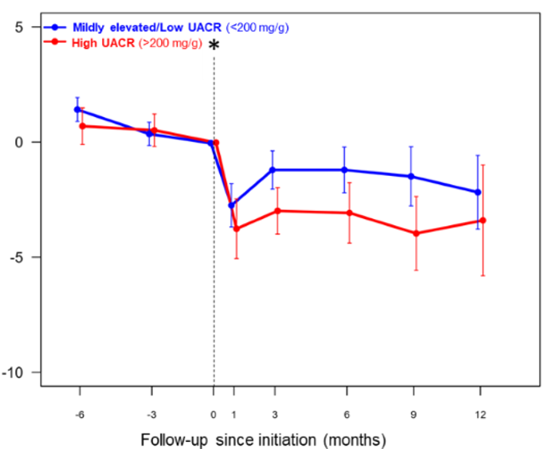
Footnote: * Initiation of dapagliflozin.
Abbreviations: CKD: chronic kidney disease; eGFR: estimated glomerular filtration rate; T2D: type 2 diabetes; UACR: urine albumin-creatinine ratio.
Source: Svensson et al., 2024. Supplementary material; Figure 1 of submission, p11
Note that the results presented in Figure 1 is derived from retrospective RWE analyses of Optum claims data conducted by the applicant specifically for the purposes of informing PBAC consideration. Interpretation of the results and their application should therefore be limited to understanding the basis for the PBAC outcome and should not be used for any other purpose.
  - For the comparative data from Optum, dapagliflozin and empagliflozin showed similar benefits in eGFR slope (Figure 2), no difference in eGFR slope across different eGFR categories and degrees of albuminuria (Figure 3) and similar time to hospitalisation (Figure 4).
Figure 2: Median eGFR slope (ml/min/1.73m2) for patients receiving dapagliflozin and empagliflozin (PS weighted) - overall population (overall cohort)
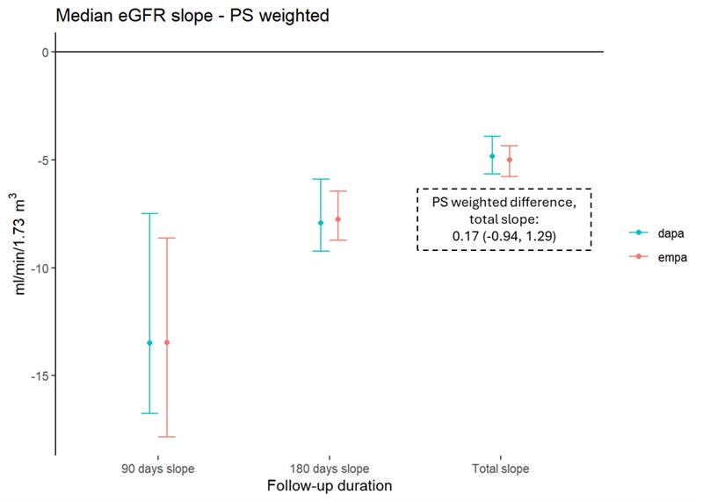
A higher value indicates a greater treatment benefit. Dapagliflozin patient numbers (n=2,650): 90 days: 360; 180 days: 996 total period, 1,320. Empagliflozin patient numbers (n=3,632): 90 days: 519; 180 days: 1,317; total period, 1,702.
Abbreviations: dapa, dapagliflozin; eGFR, estimated glomerular filtration rate; empa, empagliflozin; PS, propensity score.
Source: Figure 6 of the submission, p19.
Note that the results presented in Figure 2 is derived from retrospective RWE analyses of Optum claims data conducted by the applicant specifically for the purposes of informing PBAC consideration. Interpretation of the results and their application should therefore be limited to understanding the basis for the PBAC outcome and should not be used for any other purpose.

Figure 3: Forest plot for subgroup analyses of median eGFR slope and 95% CIs
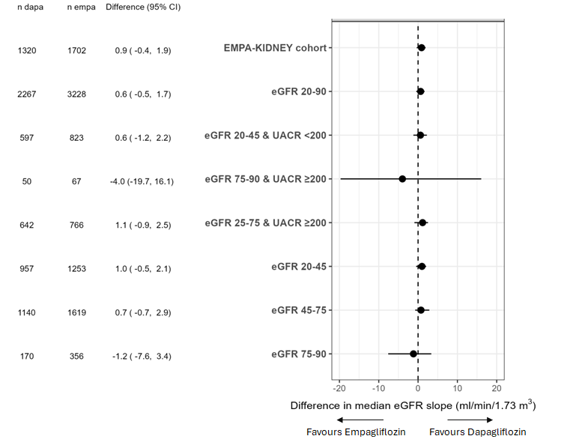
Abbreviations: CI, confidence interval; eGFR, estimated glomerular filtration rate; UACR, urinary albumin to creatine ratio
Source: Figure 10 of the submission, p23
Note that the results presented in Figure 3 is derived from retrospective RWE analyses of Optum claims data conducted by the applicant specifically for the purposes of informing PBAC consideration. Interpretation of the results and their application should therefore be limited to understanding the basis for the PBAC outcome and should not be used for any other purpose.

Figure 4: KM plot for time to hospitalisation for CKD for dapagliflozin and empagliflozin (PS weighted) – overall population (overall cohort)
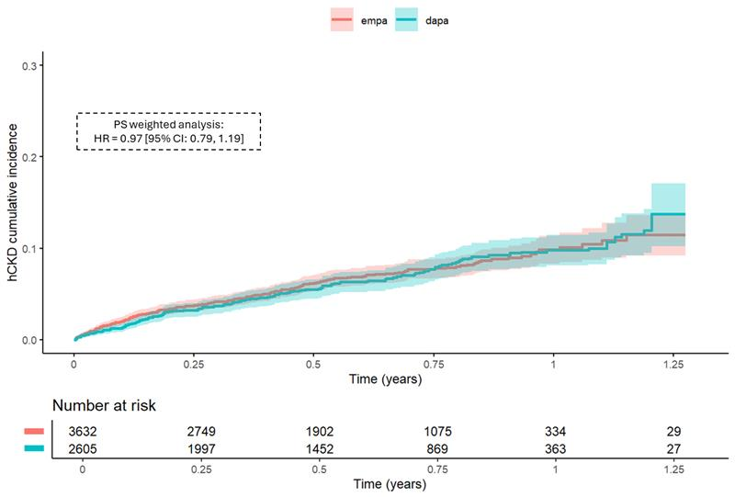
Abbreviations: CKD, chronic kidney disease; dapa, dapagliflozin; empa, empagliflozin
Note: A KM plot is not available for the PS weighted and adjusted analysis
Source: Figure 8 of the submission, p21
Note that the results presented in Figure 4 is derived from retrospective RWE analyses of Optum claims data conducted by the applicant specifically for the purposes of informing PBAC consideration. Interpretation of the results and their application should therefore be limited to understanding the basis for the PBAC outcome and should not be used for any other purpose.
  - Inputs from health professionals were also provided with the submission in support of the proposed flow-on changes to dapagliflozin. Overall, the points raised in the inputs were aligned with the consumer comments provided above. One of the contributors noted they provided support for the empagliflozin submission from May 2025. This contributor stated that SGLT2 inhibitors have class specific benefits, rather than molecule specific benefits, including lowering glucose as well as reducing cardiovascular (CV) events in patients with established atherosclerotic disease or those at risk of CV events; those with heart failure (with reduced or preserved ejection fraction), and those with CKD. Additionally, the contributor noted that they reviewed the real-world data in the Optum data base, which in essence reduces the impact of selected study populations in randomised controlled studies, and saw no significant difference in the impact of empagliflozin and dapagliflozin in huge numbers of real-world data bases. Statistical benefits are seen in some domains, generally in favour of dapagliflozin, but overall their view is these drugs have equivalence and should be viewed as such by the PBS.
  - As a Category 3 submission, no evaluation of the clinical evidence was undertaken.

Clinical claim
  - Based on the results of Optum, the submission considered dapagliflozin to be non-inferior in terms of effectiveness compared to empagliflozin as treatment for patients with CKD in the expanded population. The submission noted non-inferiority between dapagliflozin and empagliflozin has been established by the PBAC in other indications (T2DM, HF) and the current PBS listing in CKD. The submission noted at the November 2023 PBAC meeting, the PBAC previously evaluated an indirect treatment comparison (ITC) of empagliflozin and dapagliflozin via placebo for the current CKD PBS cohort, with the PBAC considering “the treatment effects of empagliflozin were likely non-inferior to those for dapagliflozin” given no statistically significant differences in the results of the ITC, the class effect of SGLT2 inhibitors having been confirmed in other indications, and the recent meta-analysis presented in Nuffield et al. 2022 (paragraphs 4.11 and 7.7, empagliflozin PSD, November 2023 PBAC meeting).
  - No additional comparative safety data of dapagliflozin versus empagliflozin for the treatment of CKD were presented in this submission beyond that already reviewed by the PBAC in prior assessments. The submission noted the PBAC previously deemed that empagliflozin was non-inferior to dapagliflozin in terms of effectiveness and safety for the treatment of CKD in the November 2023 PBAC submission for empagliflozin, as well as for HF (empagliflozin PSD, November 2021 PBAC meeting, dapagliflozin PSD, July 2023 PBAC meeting) and T2DM (empagliflozin PSD, July 2014 PBAC meeting). On that basis, the submission considered dapagliflozin to be non-inferior to empagliflozin in terms of safety, assuming that the currently listed CKD population is applicable to an expanded CKD population.
  - The PBAC considered that the claim of non-inferior comparative effectiveness and safety of dapagliflozin to empagliflozin across the expanded CKD population was reasonable and adequately supported by the evidence provided in the submission.

Economic analysis
  - The submission requested updating the listing on a cost-minimisation basis to empagliflozin, with no change to the current prices.

Estimated PBS usage and financial implications
  - The submission stated expanding the CKD listing to include dapagliflozin is expected to have a negligible net financial impact, except for minor differences in co-payments and dispensing fees due to differing pack sizes (dapagliflozin 28-day pack, empagliflozin 30-day pack).
Table 3: Net financial impact of listing dapagliflozin in the expanded CKD population
 | Year 1 | Year 2 | Year 3 | Year 4 | Year 5 | Year 6
Estimated extent of use
Dapagliflozin scripts | ||||² | ||||² | ||||² | ||||² | ||||² | ||||²
Cost to PBS/RPBS less patient co-payment | ||||³ | ||||³ | ||||³ | ||||³ | ||||³ | ||||³
Cost-offsets – substitution of empagliflozin
Empagliflozin scripts | ||||¹ | ||||¹ | ||||² | ||||² | ||||² | ||||²
Savings to PBS/RPBS less patient co-payment | ||||³ | ||||³ | ||||³ | ||||³ | ||||³ | ||||³
Net financial impact
Total cost to PBS/RPBS less patient co-payment | ||||⁵ | ||||⁵ | ||||⁵ | ||||⁵ | ||||⁵ | ||||⁵
Source: See UCM workbook (Attachment 7) for details; Table 8 Attachment 2 of the submission, p24.
Abbreviations: PBS, Pharmaceutical Benefits Scheme; RPBS, Repatriation Pharmaceutical Benefits Scheme
The redacted values correspond to the following ranges:
¹ 200,000 to < 300,000
² 300,000 to < 400,000
³ $10 million to < $20 million
⁴ $200 million to < $300 million
⁵ $0 to < $10 million
  - The submission stated that if a risk sharing arrangement (RSA) is established for empagliflozin, AstraZeneca is amenable to a similar arrangement for dapagliflozin. There is an existing RSA for the SGLT2 inhibitor class of medications (empagliflozin and dapagliflozin) across two separate indications: chronic heart failure with left ventricular ejection fraction ≤40%; and chronic kidney disease.
For more detail on PBAC’s view, see section 5 PBAC outcome.
- PBAC Outcome
  - The PBAC recommended the extension of the current General Schedule Authority Required (STREAMLINED) listing of dapagliflozin (Forxiga®) for chronic kidney disease (CKD) to be consistent with the broadened CKD population recommended for empagliflozin at the May 2025 PBAC meeting. The PBAC’s recommendation for the listing was based on its assessment that the cost-effectiveness of dapagliflozin would be acceptable if it were cost-minimised against empagliflozin.
  - The PBAC advised the equi-effective doses to be empagliflozin 10 mg once per day and dapagliflozin 10 mg once per day.
  - The PBAC supported the proposed amendments to the existing dapagliflozin restriction to allow treatment in the aggregated incremental subgroups recently recommended for empagliflozin:
  - eGFR 20 to <25 mL/min/1.73 m², regardless of UACR.
  - eGFR 25 to <45 mL/min/1.73 m² with UACR <200 mg/g.
  - eGFR 25 to 75 mL/min/1.73 m² with UACR >5,000 mg/g.
  - eGFR >75 to 90 mL/min/1.73 m² with UACR ≥200 mg/g.
  - The PBAC noted and welcomed the consumer input from health care professionals and the Australian Diabetes Society that were received after the publication of the empagliflozin outcome from the May 2025 meeting. The PBAC acknowledged that the benefits of SGLT2 inhibitors extend to a broader CKD population and the support for the alignment of the dapagliflozin with empagliflozin restrictions was based on evidence from clinical trials, real-world data and international clinical practice guidelines. The input noted that the evidence includes the recent OPTIMISE-CKD study which indicated efficacy of dapagliflozin in individuals with CKD, including those with lower eGFR and varying UACR. Additionally, the PBAC noted the input highlighted that the alignment of dapagliflozin with empagliflozin restrictions would improve quality use of SGLT2i medicines, provide equitable access for patients and give clinical clarity for prescribers.
  - The PBAC reiterated its view from May 2025 that the increasing prevalence of CKD in the Australian population and the higher burden of disease in Aboriginal and Torres Strait Islander people, indicated the clinical need for effective intervention to preserve residual kidney function for patients at significant risk of kidney disease progression. The PBAC recalled the support from health professionals, Kidney Health Australia and the Australian Diabetes Society for broader access to SGLT2 inhibitors in CKD, particularly for patients with eGFR 20 - 45 mL/min/1.73 m², regardless of UACR levels (paragraph 7.2 empagliflozin PSD, May 2025 PBAC meeting). The PBAC noted that the risk of CKD progression in the expanded population ranged from moderately increased risk to very high risk, similar to the population currently eligible for PBS treatment with an SGLT2 inhibitor.
  - The PBAC noted the TGA indication for dapagliflozin was updated in April 2025 to remove the UACR minimum requirement, whereby the consideration of clinical characteristics defining proteinuric CKD is now left to clinical judgement.
  - The PBAC recalled that it had previously considered dapagliflozin and empagliflozin to have non-inferior comparative effectiveness in the CKD population where the clinical trial populations were overlapping, with no signal of any difference (paragraph 7.7 empagliflozin PSD, November 2023 PBAC meeting). The PBAC considered the OPTIMISE-CKD data showed dapagliflozin demonstrated similar efficacy based on eGFR change, cardiorenal and mortality risk development in those with higher and lower albuminuria. The PBAC considered the results from Optum demonstrated similar eGFR slope changes and no differences across various eGFR categories and degrees of albuminuria for time to hospitalisation for CKD, and time to death in hospital between dapagliflozin and empagliflozin. The PBAC acknowledged the limitations associated with observational data. The PBAC also noted the differences in trial design and eligibility criteria across the available evidence. However, the PBAC considered the identified observational studies were relevant and supported by clinical guidelines and practice and were therefore a sufficient source of comparative evidence of dapagliflozin and empagliflozin for this submission. The PBAC considered that, on balance, the evidence provided in the submission were supportive of the clinical claim that dapagliflozin is non-inferior in terms of comparative effectiveness to empagliflozin in the expanded CKD population.
  - The PBAC maintained its view that dapagliflozin is non-inferior in terms of comparative safety to empagliflozin in the expanded CKD population. This was based on the Committee’s view for CKD (empagliflozin PSD, November 2023 meeting), as well as for HF (empagliflozin PSD, November 2021 PBAC meeting; dapagliflozin PSD, July 2023 PBAC meeting) and T2DM (empagliflozin PSD, July 2014 PBAC meeting).
  - The PBAC noted that aligning the dapagliflozin and empagliflozin restrictions would make the listings consistent with the Australian and international guidelines (KDIGO, 2024; UK Kidney Association, 2023; European Kidney Association, 2023) which were recently updated to include the use of SGLT2 inhibitors in the treatment of CKD. The PBAC also considered there was a risk of confusion arising if the PBS had different restrictions for dapagliflozin and empagliflozin for the same indication, and therefore aligning the restrictions for dapagliflozin and empagliflozin would minimise clinician and patient confusion and allow for equitable access across the two drugs.
  - The PBAC considered that the change to the listing of dapagliflozin would not result in a net cost to the PBS as it would substitute for empagliflozin and not increase the overall market utilisation.
  - The PBAC noted the current risk sharing arrangement (RSA) for the SGLT2 inhibitor class of medications (empagliflozin and dapagliflozin) across two indications: chronic heart failure with left ventricular ejection fraction ≤40%; and CKD. In May 2025, the PBAC had considered that an increase to the current RSA expenditure caps to account for the incremental population was appropriate (paragraph 7.14 empagliflozin PSD, May 2025 PBAC meeting). The PBAC maintained that the increase to the joint subsidisation caps as recommended for empagliflozin in May 2025 should apply with the change in dapagliflozin restrictions, with no further adjustment with the PBS listing update for dapagliflozin.
  - The PBAC noted its recommendation was on a cost-minimisation basis and advised that, because dapagliflozin is not expected to provide a substantial and clinically relevant improvement in efficacy, or reduction of toxicity over empagliflozin, or to address a high and urgent unmet clinical need, the criteria prescribed by the National Health (Pharmaceuticals and Vaccines – Cost Recovery) Regulations 2022 for Pricing Pathway A were not met.
  - The PBAC noted this submission is not eligible for an Independent Review as it received a positive recommendation.
Outcome:
Recommended
- Recommended listing
  - Amend existing listing as follows:
MEDICINAL PRODUCT  medicinal product pack | PBS item code | Max. qty packs | Max. qty units | №.of  Rpts | Available brands
DAPAGLIFLOZIN
dapagliflozin 10 mg tablet, 28 | 13106T | 1 | 28 | 5 | Forxiga
Restriction Summary 13230 / Treatment of Concept 13230
Category / Program: GENERAL - General Schedule (Code GE)
Prescriber type: Medical Practitioners Nurse practitioners
Restriction type: Authority Required (Streamlined) [new/existing code]
Administrative Advice: No increase in the maximum quantity or number of units may be authorised.
Administrative Advice: No increase in the maximum number of repeats may be authorised.
Episodicity: Chronic
Severity: n/a
Condition: Kidney disease
Indication: Chronic kidney disease
Treatment Phase: n/a
Clinical criteria:
Patient must have a diagnosis of chronic kidney disease, defined as abnormalities of at least one of: (i) kidney structure, (ii) kidney function, present for at least 3 months, prior to initiating treatment with this drug
AND
Clinical criteria:
Patient must have an estimated glomerular filtration rate of between 20 to 90 mL/min/1.73 m2 inclusive prior to initiating treatment with this drug
AND
Clinical criteria:
Patient must have a urinary albumin to creatinine ratio of at least 200 mg/g (22.6mg/mmol) if the patient has an estimated glomerular filtration rate of between 45 to 90 mL/min/1.73 m² inclusive prior to initiating treatment with this drug
AND
Clinical criteria:
Patient must discontinue treatment with this drug prior to initiating renal replacement therapy, defined as dialysis or kidney transplant
AND
Clinical criteria:
Patient must not be receiving treatment with another sodium-glucose co-transporter 2 (SGLT2) inhibitor
AND
Clinical criteria:
Patient must be stabilised, for at least 4 weeks, on either: (i) an ACE inhibitor or (ii) an angiotensin II receptor antagonist, unless medically contraindicated, prior to initiation of combination therapy with this drug
Prescribing Instructions: Patients with polycystic kidney disease, lupus nephritis or ANCA-associated vasculitis; patients requiring or with a recent history of cytotoxic or immunosuppressive therapy for kidney disease; and patients with an organ transplant are not eligible for treatment with this drug.
These restrictions may be subject to further review. Should there be any changes made to the restriction the sponsor will be informed.
- Context for Decision
The PBAC helps decide whether and, if so, how medicines should be subsidised through the Pharmaceutical Benefits Scheme (PBS) in Australia. It considers applications regarding the listing of medicines on the PBS and provides advice about other matters relating to the operation of the PBS in this context. A PBAC decision in relation to PBS listings does not necessarily represent a final PBAC view about the merits of the medicine or the circumstances in which it should be made available through the PBS. The PBAC welcomes applications containing new information at any time.
- Sponsor’s Comment
The sponsor had no comment.

