7.10 VENETOCLAX,
Tablet 100 mg, 50 mg,
Venclexta®,
AbbVie Pty Ltd.
- Purpose
  - The early re-entry resubmission requested an Authority Required (Telephone/Online) listing for venetoclax (VTX) in combination with azacitidine (AZA), for the treatment of patients with newly diagnosed acute myeloid leukaemia (AML), ineligible for standard intensive remission induction chemotherapy.
  - The resubmission was based on the PBAC recommendation from March 2021. This resubmission partially addressed the issues raised by PBAC (see Table 1 summary below, with further details discussed in economics and financial sections and in the PBAC Outcome section).
  - In addition to the 100 mg strength requested in the previous submission, the resubmission also requested listing for a 50 mg strength, which would be used by patients requiring a reduced dose, due to the increased risk for Tumour Lysis Syndrome (TLS) at initiation and ramp-up when taking concomitant VTX and strong or moderate CYP3A inhibitors. The previous submission had assumed that patients requiring this dose reduction would receive it via a hospital, however the resubmission indicated that, “while the dosing recommendation after the three day ramp up period is for 100 mg or less, clinicians have indicated that they intend to reduce the dose in these patients to 50 mg per day and that this dose could be used for two months or more, with much of that time spent with the patient receiving treatment in the community rather than the hospital setting”. Hence, PBS listing was requested. The 50 mg strength was not accounted for in the economic model or financial estimates, and its impact was therefore unclear. The Pre-PBAC response claimed that the inclusion of the 50 mg strength would improve cost effectiveness and reduce the budget impact.
Table 1: Summary of key matters to be addressed
Matter of concern | Response | Addressed?
Economic model
PBAC scenario (para 7.13, VTX, PBAC Public Summary Document (PSD), March 2021 PBAC meeting):  - An average of 1.9 AZA vials per infusion  - Revised extrapolations for EFS and OS  - 10-year time horizon  - ICER weighted towards the LoDAC comparison  - An ICER of approximately $''''''''''''''''¹/QALY | Resubmission scenario:  - An average of 1.9 AZA vials per infusion  - Alternative extrapolations for EFS and OS  - 10-year time horizon  - No change to ICER weightings  - An ICER of < $''''''''''''''''¹/QALY | Partially
Financial estimates
Revisions to the estimated financial implications (para 7.13, VTX, PBAC Public Summary Document, March 2021 PBAC meeting):  - Apply the lower price from the revised model scenario.  - Amend the dose intensity of AZA when used in combination with VTX to reflect trial evidence.  - Reduce the estimate of the proportion of patients unfit for intensive regimens who receive treatment (from 80% in the submission). | Resubmission:  - Lower price (AEMP reduced from $''''''''''''''''''' to $'''''''''''''''''''', 4.2% reduction)  - An average of 1.9 AZA vials per infusion  - No changes to the proportion of patients unfit for intensive regimens who receive treatment  - Reduced treatment duration of each therapy to reflect changes made to the model with regards to the parametric extrapolation of EFS. | Partially
Risk-sharing arrangement
- Outline an RSA to manage risk of use in patients previously considered fit for standard intensive remission reduction regimens. | - Proposed RSA consists of financial caps based on estimated net PBS/RPBS cost for VTX and a rebate of ''''''% for use beyond the annual caps. | Yes
Source: para 7.13, VTX, PBAC Public Summary Document, March 2021 PBAC meeting, and Table 9, p16 and Table 15, p26 of the resubmission.
AZA = azacitidine, EFS = event-free survival, ICER = incremental cost-effectiveness ratio, LoDAC = low-dose cytarabine, OS = overall survival, RSA = risk-sharing arrangement, VTX = venetoclax.
The redacted values correspond to the following ranges:
¹ $75,000 to < $95,000

  - For the scenario presented in the resubmission, the base case incremental cost-effectiveness ratio (ICER) was $75,000 to < $95,000 per quality-adjusted life year (QALY) gained. For the PBAC scenario, the ICER was $95,000 to < $115,000 per QALY.
  - For the scenario presented in the resubmission, the estimated drug cost/patient per course would be $'''''''''''''' (VTX: $''''''''''''; AZA: $40,586). For the PBAC scenario, it would be $'''''''''''''' (VTX: $''''''''''''; AZA: $35,097), based on a treatment duration of 1.5 years.
  - The resubmission estimated a net cost to the PBS of $40 million to < $50 million in Year 6 of listing, with a total net cost to the Pharmaceutical Benefits Scheme (PBS) of $200 million to < $300 million over the first 6 years of listing; see Table 8 and Table 9 below, in the ‘Estimated PBS usage & financial implications’ section.
- Background
  - VTX was granted provisional approval by the TGA for the treatment of newly diagnosed AML in adults who are ineligible for intensive chemotherapy as part of combination therapy with low-dose cytarabine (LoDAC) (28 January 2020) and with AZA (5 February 2020).
  - The regulatory submission to transition the provisional registration to full approval was being conducted under a collaborative review initiative with the US Food and Drug Administration (FDA). The US FDA multi-discipline review was available (in lieu of a TGA-branded Clinical Evaluation Report). The requested final indication for VTX was consistent with the provisionally approved indication. The PBAC noted that the provisional registration fulfils the PBS listing requirement of inclusion in the Australian Register of Therapeutic Goods (ARTG).
  - AZA has an ARTG and PBS listing for patients with myelodysplastic syndromes (MDS), chronic myelomonocytic leukaemia (CMML), and AML with 20-30% blasts and multi-lineage dysplasia.
  - The previous submission requested PBS listing for use in combination with AZA only (not with LoDAC). The PBAC considered there would be a patient population in Australia who would use the LoDAC combination if it were available (paragraph 7.2, VTX, PBAC Public Summary Document (PSD), March 2021 PBAC meeting). The resubmission advised that the sponsor will not seek reimbursement for the LoDAC combination due to the higher dose of VTX required and the smaller incremental improvements in OS compared to VTX+AZA.
  - The PICO from the previous submission is presented below. It does not include the addition of the 50 mg strength.
Table 2: Key components of the clinical issue addressed by the March 21 submission (as stated in the submission)
Component | Description
Population | Patients with newly diagnosed acute myeloid leukaemia ineligible for standard intensive induction chemotherapy.
Intervention | Venetoclax 400 mg tablet orally once daily on Days 1-28 each 28 day cycle, following dose ramp-up on Days 1-3 of Cycle 1 (i.e. 100 mg, 200 mg, 400 mg); plus azacitidine 75 mg/m² by subcutaneous or intravenous injection once daily on Days 1-7 each 28 day cycle; until disease progression or unacceptable toxicity.
Comparator | Primary: Azacitidine 75 mg/m² by subcutaneous or intravenous injection once daily on Days 1-7 each 28 day cycle; until disease progression or unacceptable toxicity.  Secondary: Low-dose cytarabine 20 mg by subcutaneous injection twice daily on Days 1-10 each 28 day cycle; until disease progression or unacceptable toxicity.
Outcomes | Overall survival, complete remission, transfusion independence, event free survival, minimal residual disease, and safety.
Clinical claim | Venetoclax with azacitidine is associated with superior efficacy and inferior safety compared to azacitidine monotherapy.  Venetoclax with azacitidine is associated with superior efficacy and inferior safety compared to low-dose cytarabine monotherapy.
Source: Table 1-1, p.3 of the March 2021 submission.
- Requested listing
  - The resubmission accepted the previously considered PBS restriction, and proposed the same wording and Telephone/Online Authority for the 50 mg strength (with a maximum quantity of four packs of seven tablets, with one repeat, to supply 56 days’ treatment). For the 100 mg strength, the previous submission requested a maximum quantity of one pack, with five repeats. However, the PBAC noted that two repeats would provide for three months’ supply, which it considered was more in line with the timeframe in which patients should be reviewed (paragraph 6.14, VTX, PSD, March 2021 PBAC meeting). The Secretariat noted that the restriction would require further refinement to meet the electronic requirements for listing.
  - The resubmission again noted that the restriction for AZA would require amendment to allow use with VTX if recommended. No restriction was proposed. At the time of PBAC consideration, AZA was a Written Authority for initial treatment and a Telephone/Online Authority for continuation. In November 2020, the PBAC had recommended the Authority level for AZA for AML be decreased to Authority Required (Telephone) for initial treatment and Authority Required (Streamlined) for continuing (PBAC Outcomes, Other Matters, November 2020 PBAC meeting). Thus, at its March 2021 meeting, the PBAC had no concern with the proposed VTX and AZA combination listings both being Authority Required (Telephone/Online) (paragraph 7.4, VTX, PSD, March 2021 PBAC meeting). For this resubmission, the PBAC was asked to confirm that a new separate AZA listing should be implemented for combination use with VTX (rather than amendments to existing AZA listings).
  - The previous submission had requested grandfathering provisions for patients receiving non-PBS subsidised VTX prior to PBS listing. The PBAC had noted that no further details were provided (paragraph 3.7, VTX, PSD, March 2021 PBAC meeting). The Pre-PBAC response clarified that the sponsor is not supplying VTX with AZA via any trials or access programs. However, the sponsor stated it was anecdotally aware of a small number of patients receiving VTX with AZA in the hospital setting. Although reliable estimates could not be provided, it considered that fewer than 20 patients would require grandfathering.
- Consideration of the evidence

Sponsor hearing
  - There was no hearing for this item.

Consumer comments
  - The PBAC noted and welcomed the input from individuals (1), health care professionals (9) and organisations (1) via the Consumer Comments facility on the PBS website. The comments described a range of benefits of treatment with VTX and AZA including the induction of meaningful responses in patients with poor prognosis, especially in older age groups where patients may be otherwise unfit for treatment. The comments also considered that the oral form would be beneficial for use in rural settings, and that it would help preserve quality of life by reducing hospitalisation needs in older patients.
  - The PBAC again noted and appreciated the comments received from the Leukaemia Foundation, which described individual patient experiences of the benefits of treatment with VTX.

Comparative effectiveness
  - The March 2021 PBAC submission was based on a head-to-head randomised trial of VTX+AZA versus AZA (M15-656); and an indirect treatment comparison of VTX+AZA (M15-656) versus LoDAC (AZA-AML-001) with AZA as a common reference. No additional clinical data were presented in the resubmission.

Economic analysis
  - A comparison of the PBAC specified model revisions and those included in the resubmission is summarised in Table 3. The model time horizon and number of vials of AZA were revised as specified by the PBAC. Alternative approaches were presented in the resubmission for the extrapolation of the event-free survival (EFS) and overall survival (OS) data, and for the weighting of the ICER across the AZA and LoDAC comparisons.
Table 3: Comparison of PBAC advised model parameters with those used in the resubmission
Model parameter | PBAC advice, March 2021 | Resubmission model | Addressed?
Time horizon | Reduce from 20 years to 10 years | 10 years | Yes
Parametric functions used to extrapolate EFS time-to-event data | VTX+AZA (and LoDACª): Weibull  AZA: Exponential | VTX+AZA (and LoDACª): Generalised Gamma  AZA: Exponential | No
Parametric functions used to extrapolate OS time-to-event data | VTX+ AZA (and LoDACª): Weibull  AZA: Exponential  No adjustment for Australian mortality rate | VTX+AZA (and LoDACª): Lognormal  AZA: Exponential  No adjustment for Australian mortality rate | No
Vials of AZA per infusion | 1.9 vials for VTX+AZA and AZA monotherapy | 1.9 vials for VTX+AZA and AZA monotherapy | Yes
Percentages used in weighted ICER | ICER weighted towards the LoDAC comparison | 55.6% for AZA, 44.4% for LoDAC | No
Effective ex-manufacturer price of VTX | Price reduction to achieve an ICER of approximately $'''''''''''''''¹/QALY | Reduced from $'''''''''''''''''''' to $''''''''''''''''''' | No, for PBAC scenario
Source: para 7.13, VTX, PBAC Public Summary Document, March 2021 PBAC meeting; Table 9 of the July 2021 resubmission.
AZA = azacitidine, EFS = event-free survival, ICER = incremental cost-effectiveness ratio, LoDAC = low-dose cytarabine, OS = overall survival, VTX = venetoclax.
a LoDAC is modelled by applying a HR to the VTX+AZA curve and therefore follows the same functional form as for VTX+AZA
The redacted values correspond to the following ranges:
¹ $75,000 to < $95,000

Extrapolation of time to event data
  - At its March 2021 meeting, the PBAC noted (paragraph 6.71 and Table 12, PBAC PSD):
- the lognormal function was selected to extrapolate OS beyond the duration of the key trials and that this resulted in per cycle mortality rates that were lower than Australian general population mortality estimates (for a cohort of patients aged 75-79 years); and
- the extrapolated OS and EFS curves suggested a relatively long duration in the post-event state which may not be reasonable as the time between treatment failure, progression and death is generally very short in AML patients.
  - The PBAC considered that the base-case ICER should be informed by more conservative extrapolations (see Table 3 for parameters) and a 10-year time horizon in view of the inherent uncertainty associated with the indirect treatment comparison versus LoDAC, as well as the other unaddressed issues with the model (i.e. costings and utilities) (paragraph 7.11, PBAC PSD, March 2021 PBAC meeting).
  - The resubmission argued that the requirement to use both a 10-year horizon and more conservative extrapolations double counted the correction in the long-term mortality rate. It was noted when extrapolating OS using the loglogistic, lognormal and generalised gamma functions that the mortality rate was only lower than the general population rate from Year 11 onwards, and this was beyond the 10-year model time horizon. With use of the Weibull function, as advised by the PBAC, the mortality rate remained above that for the general population for more than 20 years.
  - In the resubmission, the choice of the parametric extrapolation function was based on best fit as assessed by visual inspection and Akaike’s information criterion (AIC):
- OS VTX+AZA and LoDAC: The best fit was the lognormal function. The Weibull function (as per PBAC advice) had the second-worst and worst fit for VTX+AZA and LoDAC, respectively.
- OS AZA: The best fit was the exponential function.
- EFS VTX+AZA and LoDAC: The best fit was the Gompertz function, however this was considered to have an implausibly high plateau of the tail and so the second-best fit, the generalised gamma function, was selected. The best fit for LoDAC was the generalised gamma function. The Weibull function had the second-worst fit for both VTX+AZA and LoDAC.
- EFS AZA: The best fit was the exponential function.
  - The Commentary for the March 2021 submission also included Bayesian information criterion (BIC) to assess fit. The relative fit of the different functions was consistent using either AIC or BIC, with the exception of EFS for VTX+AZA where the generalised gamma function had the second-best fit based on AIC and the worst fit based on BIC. This function was used in the resubmission’s model scenario.
  - The modelled extrapolations as per the PBAC’s advice and as presented in the resubmission are compared in Figure 1 for OS and Figure 2 for EFS.
Figure 1: Modelled OS as per PBAC’s advice (solid lines) and presented in resubmission (dotted lines)
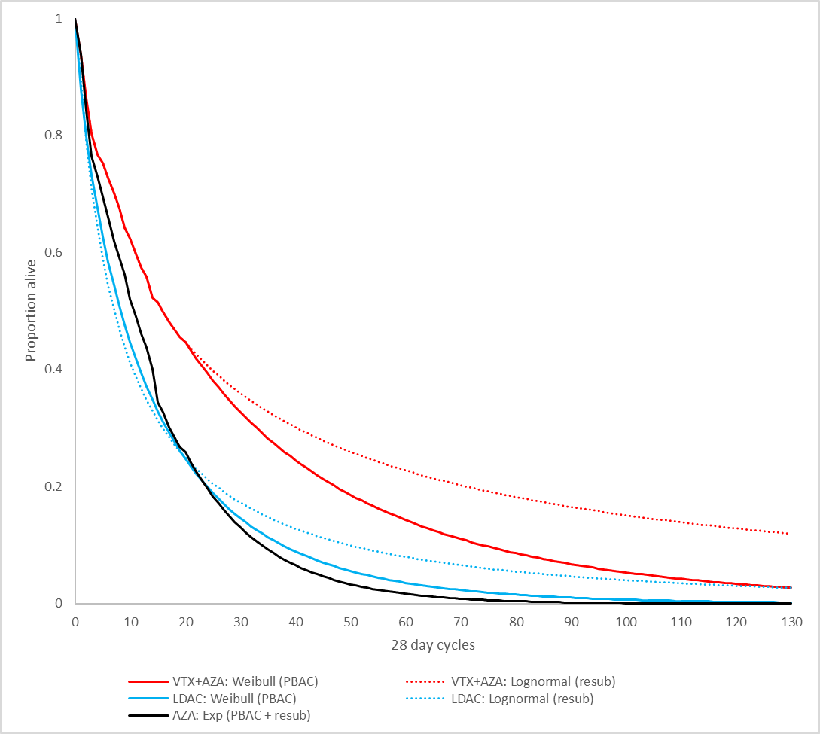
Source: ‘VTX AZA CEA April 2021 final’ spreadsheet provided with the July 2021 resubmission.
AZA = azacitidine, Exp = exponential, LDAC = low-dose cytarabine, OS = overall survival, resub = resubmission, VTX = venetoclax

Figure 2: Modelled EFS as per PBAC’s advice (solid lines) and presented in resubmission (dotted lines)
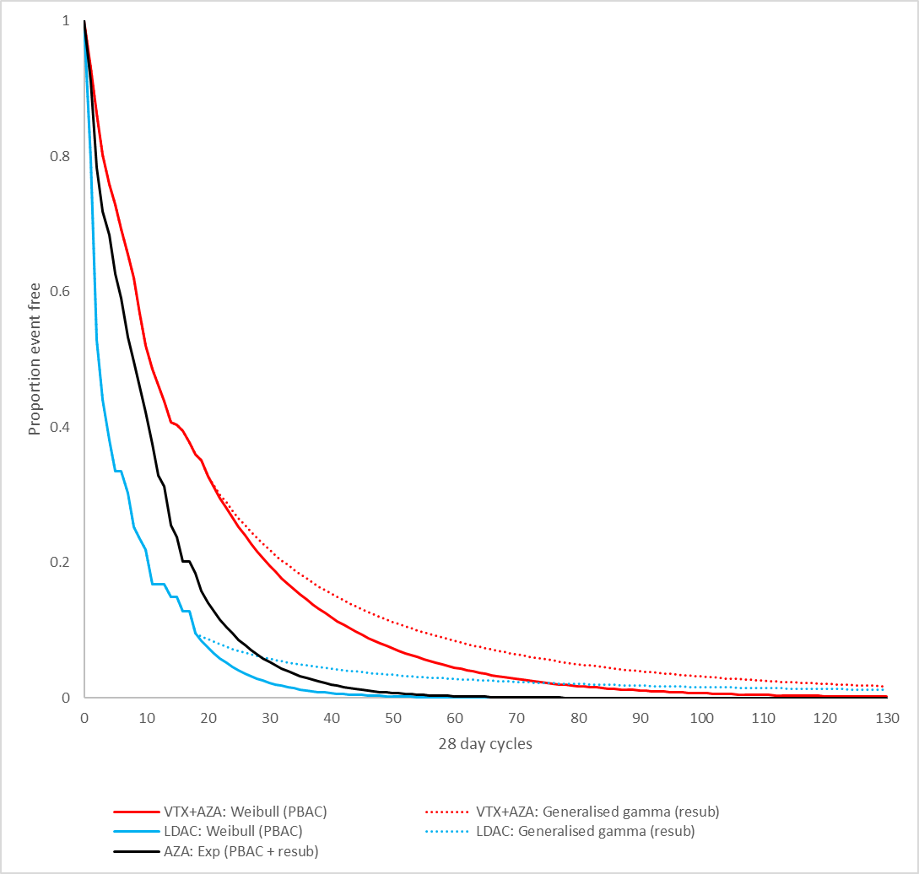
Source: ‘VTX AZA CEA April 2021 final’ spreadsheet provided with the July 2021 resubmission.
AZA = azacitidine, EFS = event-free survival, Exp = exponential, LDAC = low-dose cytarabine, resub = resubmission, VTX = venetoclax

Weighting of AZA and LoDAC comparisons
  - The March 2021 submission calculated a weighted ICER with weightings of 55.6% for the AZA comparison and 44.4% for the LoDAC comparison. The PBAC considered the current AZA PBS listing for AML (for patients with 20-30% bone marrow blasts and multi-lineage dysplasia) had limited overlap with the requested PBS population, and consequently LoDAC was likely to be the PBS therapy most replaced in practice (paragraph 7.6, VTX, PSD, March 2021 PBAC meeting). The PBAC therefore considered the ICER should be weighted towards the LoDAC comparison (paragraph 7.13, VTX, PSD, March 2021 PBAC meeting).
  - The resubmission maintained the 55.6%/44.4% weightings on the basis of the results of the CURRENT study. This was a non-interventional real-world retrospective chart review of patients diagnosed with AML who were unfit to receive intensive chemotherapy who initiated treatment (or Best Supportive Care (BSC)) between 1 January 2015 and 31 December 2018. The study included data from 138 Australian patients. Of these patients, 75 (54%) received first-line systemic therapy and 63 (46%) received BSC. A total of 69 patients were treated with either AZA or LoDAC and the observed weighting was 54%:46% (i.e. 37:32; Table 9 CURRENT Study Results Australia.pdf, Attachment 1 of resubmission). The CURRENT study did not contain a breakdown of AZA use by subgroups based on blast cell counts (i.e. < 20%, 20-30%, > 30%).

Results
  - The results from the economic model are summarised in Table 4 for the scenario based on the PBAC advice and the scenario included in the resubmission. The ICERs for both the AZA and LoDAC comparisons have been presented however, alternative weightings to that used in the resubmission (55.6% AZA, 44.4% LoDAC) have not been presented.
Table 4: Economic model results for PBAC and resubmission scenarios
Comparison | Weight | Discounted costs |  |  | Discounted QALYs |  |  | ICER
Comparison | Weight | VTX arm | Comparator arm | Incremental costs | VTX arm | Comparator arm | Incremental QALYs | ICER
PBAC scenario (VTX AEMP $''''''''''''''' as per March 2021 submission)
VTX+AZA versus AZA | 55.6% | $''''''''''''''''' | $34,399 | $''''''''''''''''' | 1.438 | 0.784 | 0.653 | $''''''''''''''''¹
VTX+AZA versus LoDAC | 44.4% | $''''''''''''''' | $18,631 | $''''''''''''''''' | 1.425 | 0.740 | 0.686 | $'''''''''''''''''''²
Weighted costs and QALYs |  | $''''''''''''''' | $27,391 | $'''''''''''''''''' | 1.432 | 0.765 | 0.668
Weighted ICER |  | $''''''''''''²
PBAC scenario (VTX AEMP $''''''''''''''''' as per resubmission)
VTX+AZA versus AZA | 55.6% | $'''''''''''''''' | $34,399 | $''''''''''''''' | 1.438 | 0.784 | 0.653 | $'''''''''''''''''¹
VTX+AZA versus LoDAC | 44.4% | $'''''''''''''''' | $18,631 | $'''''''''''''''''' | 1.425 | 0.740 | 0.686 | $'''''''''''''''''''''²
Weighted costs and QALYs |  | $'''''''''''''''' | $27,391 | $'''''''''''''''''' | 1.432 | 0.765 | 0.668
Weighted ICER |  | $''''''''''''''²
PBAC scenario (VTX AEMP $'''''''''' required for weighted ICER of approximately $'''''''''''''''¹/QALY)
VTX+AZA versus AZA | 55.6% | $''''''''''''''''' | $34,399 | $'''''''''''''''' | 1.438 | 0.784 | 0.653 | $''''''''''''''''³
VTX+AZA versus LoDAC | 44.4% | $''''''''''''''''' | $18,631 | $'''''''''''''''''' | 1.425 | 0.740 | 0.686 | $''''''''''''''''¹
Weighted costs and QALYs |  | $''''''''''''''' | $27,391 | $'''''''''''''''''' | 1.432 | 0.765 | 0.668
Weighted ICER |  | $''''''''''''''¹
Resubmission scenario (VTX AEMP $''''''''''''''' as per resubmission)
VTX+AZA versus AZA | 55.6% | $''''''''''''''''' | $34,399 | $'''''''''''''''' | 1.781 | 0.784 | 0.997 | $'''''''''''''''³
VTX+AZA versus LoDAC | 44.4% | $''''''''''''''''''''' | $19,780 | $'''''''''''''''''' | 1.779 | 0.881 | 0.897 | $'''''''''''''''¹
Weighted costs and QALYs |  | $'''''''''''''''''''' | $27,902 | $'''''''''''''''' | 1.780 | 0.827 | 0.953
Weighted ICER |  | $'''''''''''''''¹
Source: ‘VTX AZA CEA April 2021 final’ spreadsheet provided with the July 2021 resubmission; Table 14 of the July 2021 resubmission.
Figures in italics were calculated by the PBAC Secretariat for the overview presented to the PBAC.
AEMP = approved ex-manufacturer price, AZA = azacitidine, ICER = incremental cost-effectiveness ratio, LoDAC = low-dose cytarabine, QALY = quality-adjusted life year, VTX = venetoclax.
The redacted values correspond to the following ranges:
¹ $75,000 to < $95,000
² $95,000 to < $115,000
³ $55,000 to < $75,000

  - Based on the proposed price for VTX in the resubmission (approved ex-manufacturer price (AEMP) $''''''''''''''''), the ICER for the PBAC scenario was $95,000 to < $115,000 /QALY. A reduction in the price of VTX of approximately 28% (AEMP $''''''''') would be required for the ICER to be approximately $75,000 to < $95,000 /QALY. If the weighting for the LoDAC comparison was increased to be higher than 44.4%, the price reduction required for VTX for the ICER to be $75,000 to < $95,000 /QALY would be larger.
  - Based on the proposed price for VTX in the resubmission (AEMP $'''''''''''''''), the ICER for the resubmission scenario was $75,000 to < $95,000/QALY. The resubmission noted for the comparison of VTX+AZA versus AZA that '''''% of the total incremental cost was due to either co-administered AZA (which is PBS listed and subject to price disclosure) or the intravenous (IV) administration costs associated with AZA. For the comparison of VTX+AZA versus LoDAC, '''''% of the total incremental cost was due to either co-administered AZA or the IV administration costs associated with AZA.
  - The pre-PBAC response noted that from 1 October 2021, the PBS price of AZA is likely to decrease by 38.61%, which would improve the cost effectiveness and reduce the budget impact of the VTX with AZA listings, with revised results shown in the table below.
Table 5: Recalculated ICERs using the likely AZA price (October 2021 Price Disclosure Cycle)
 | ICER vs AZA | ICER vs LoDAC | Weighted ICER
Resubmission scenario | $''''''''''''''''¹ | $''''''''''''''''² | $'''''''''''''''''¹
PBAC scenario | $''''''''''''''''² | $''''''''''''''''² | $''''''''''''''''''²
Source: Table 1, p3 of pre-PBAC response.
AZA = azacitidine, ICER = incremental cost-effectiveness ratio, LoDAC = low-dose cytarabine, QALY = VTX = venetoclax.
The redacted values correspond to the following ranges:
¹ $55,000 to < $75,000
² $75,000 to < $95,000

Drug cost/patient/course
  - The cost per patient for VTX+AZA and the comparator treatments based on the economic model are summarised in Table 6 for the PBAC and resubmission scenarios. The cost per patient was higher based on the resubmission scenario (compared with the PBAC scenario) due to the use of the generalised gamma function for the extrapolation of EFS which resulted in a small proportion of patients remaining on treatment for a long duration (refer to Figure 2).
Table 6: Drug cost per patient per course for VTX+AZA and comparator treatments
Scenario | VTX+AZA vs AZA |  |  | VTX+AZA vs LoDAC
Scenario | VTZ +AZA | AZA | VTX+AZA |  | LoDAC
PBAC scenario
Treatment duration (number of 28-day cycles) | 16.7 | 9.29 | 16.7 |  | 5.2
Cost per patient | VTX: $'''''''''''''''  AZA: $35,097  Total: $'''''''''''''''''' | AZA: $19,507 | VTX: $''''''''''''''''''  AZA: $34,947  Total: $'''''''''''''''''' |  | LoDAC: $1,115
Resubmission scenario
Treatment duration (number of 28-day cycles) | 19.3 | 9.29 | 19.3 |  | 6.84
Cost per patient | VTX: $''''''''''''''''''  AZA: $40,686  Total: $''''''''''''''''' | AZA: $19,507 | VTX: $'''''''''''''''  AZA: $40,767  Total: $''''''''''''''''' |  | LoDAC: $1,479
Source: ‘VTX AZA CEA April 2021 final’ spreadsheet provided with the July 2021 resubmission.
Figures in italics were calculated by the PBAC Secretariat for the overview presented to the PBAC.
AZA = azacitidine, LoDAC = low-dose cytarabine, VTX = venetoclax.

Estimated PBS usage & financial implications
  - A comparison of the PBAC-specified revisions for the calculation of the financial estimates and those included in the resubmission is summarised in Table 7. The dose intensity of AZA was revised as specified by the PBAC. The proportion of patients unfit for intensive regimens who receive treatment was not reduced. The treatment durations were revised to reflect the economic model scenario presented in the resubmission.
Table 7: Comparison of PBAC advised parameters for estimating financial impact and those used in the resubmission
Parameter for estimating financial impact | PBAC advice, March 2021 | Resubmission financial estimates | Addressed?
VTX price | Apply lower price calculated from economic model (based on PBAC scenario AEMP of approx. $'''''''''''', Table 4) | Based on resubmission scenario, AEMP of $'''''''''''''''''''' | Partially
Dose intensity of AZA when used in combination with VTX | 1.9 vials per infusion | 1.9 vials per infusion (increased from 1 vial in March 2021 submission) | Yes
Proportion of unfit patients who receive treatment | Reduction from 80% | No change from 80% | No
Additional parameter changes
Treatment duration to reflect economic model, number of 28-day cycles | PBAC model scenario  VTX+AZA: 16.7  AZA: 9.29  LoDAC: 5.2 | Resubmission model scenario (March 2021 model scenario in parentheses)  VTX+AZA: 19.32 (20.1)  AZA: 9.29 (8.9)  LoDAC: 6.84 (7.4) | NA
Source: paragraph 7.13, VTX, PSD, March 2021 PBAC meeting; Table 15 of the July 2021 resubmission.
AEMP = approved ex-manufacturer price, AZA = azacitidine, LoDAC = low-dose cytarabine, VTX = venetoclax.
  - The estimated use and financial implications are summarised in Table 8. The estimated number of patients initiating treatment each year were the same as in the March 2021 submission and were based on (i) an incidence of 4.3 cases per 100,000 population based on Australian Institute of Health and Welfare (AIHW) 2020 Cancer Data; (ii) 50% of patients being ineligible for intensive chemotherapy; (iii) 80% of patients receiving low intensity treatment and (iv) 90% uptake of VTX+AZA for years 1 to 6.
  - Paragraph 6.82 of the March 2021 PBAC PSD noted DUSC’s concern that the proportion of patients unfit for standard intensive remission induction chemotherapy who receive treatment was overestimated (80%, inconsistent with Australian data provided in the submission that suggested a much lower proportion of patients going on to treatment (54%, CURRENT study)). The PBAC advised that a resubmission should reduce the estimate of the proportion of patients unfit for intensive regimens who receive treatment (paragraph 7.13, VTX, PSD, March 2021 PBAC meeting). The resubmission claimed that many patients receiving BSC may do so due to limited access to AZA or the lack of effective therapies, therefore it is likely a greater proportion of these patients would seek treatment with VTX + AZA if PBS listed. On this basis the 80% estimate was retained in the resubmission.
  - The time on treatment for VTX+AZA, AZA monotherapy and LoDAC was revised in the resubmission to be consistent with the durations in the economic model. This resulted in a reduction in the treatment durations (Table 7). Based on the PBAC scenario for the economic model, the treatment durations would be further reduced.
Table 8: Estimated use and financial implications, based on proposed effective price of venetoclax
 | Year 1 | Year 2 | Year 3 | Year 4 | Year 5 | Year 6
Estimated extent of use
Number of initiating patients treated | ''''''''''¹ | ''''''''¹ | ''''''''¹ | ''''''''¹ | ''''''''''¹ | ''''''''¹
Number of scripts dispensed – VTX | ''''''''''''² | '''''''''''''''³ | ''''''''''''³ | '''''''''''''³ | '''''''''''''³ | '''''''''''''³
Estimated financial implications
Net cost to PBS/RPBS – VTX | $''''''''''''''''''''''''⁴ | $''''''''''''''''''''''''''⁴ | $'''''''''''''''''''''''''''''⁴ | $''''''''''''''''''''''''''⁵ | $'''''''''''''''''''''''''''⁵ | $'''''''''''''''''''''''''''⁵
Net cost to PBS/RPBS – AZA for use with VTX, AZA monotherapy offset, LoDAC offset | $''''''''''''''''''''''''⁴ | $''''''''''''''''''''''''''⁵ | $'''''''''''''''''''''''''⁵ | $'''''''''''''''''''''''''⁵ | $''''''''''''''''''''''''⁵ | $'''''''''''''''''''''''''''⁵
Net cost to PBS/RPBS – total | $''''''''''''''''''''⁶ | $''''''''''''''''''''⁷ | $''''''''''''''''''''''''⁷ | $'''''''''''''''''''''''⁷ | $''''''''''''''''''''⁷ | $''''''''''''''''''''''⁷
Cost to MBS | $'''''''''''''''''''⁸ | $'''''''''''''''''''''''⁸ | $''''''''''''''''''''''''⁸ | $'''''''''''''''''''''''''⁸ | $'''''''''''''''''''''''''⁸ | $'''''''''''''''''''''''''⁸
Previous submission March 2021 PBAC meeting
Net cost to PBS/RPBS – VTX | $'''''''''''''''''''''''''''⁴ | $'''''''''''''''''''''''''''''⁵ | $'''''''''''''''''''''''''⁵ | $'''''''''''''''''''''''''''''⁵ | $''''''''''''''''''''''''''''⁵ | $''''''''''''''''''''''''⁵
Net cost to PBS/RPBS – AZA for use with VTX, AZA monotherapy offset, LoDAC offset | $'''''''''''''''''''''''''⁸ | $''''''''''''''''''''''⁸ | $''''''''''''''''''''''''''⁸ | $'''''''''''''''''''''''⁸ | $''''''''''''''''''''''⁸ | $''''''''''''''''''''''⁸
Net cost to PBS/RPBS | $'''''''''''''''''''⁴ | $'''''''''''''''''''''⁵ | $'''''''''''''''''''''⁵ | $''''''''''''''''''''⁵ | $''''''''''''''''''''''''⁵ | $''''''''''''''''''''''''⁵
Source: ‘VTX PBAC BIA April 2021’ spreadsheet provided with the July 2021 resubmission; Table 20, VTX, PBAC Public Summary Document, March 2021 PBAC meeting.
AZA = azacitidine, LoDAC = low-dose cytarabine, VTX = venetoclax.
The redacted values correspond to the following ranges:
¹ < 500
² 500 to < 5,000
³ 5,000 to < 10,000
⁴ $10 million to < $20 million
⁵ $20 million to < $30 million
⁶ $30 million to < $40 million
⁷ $40 million to < $50 million
⁸ $0 to < $10 million

  - The VTX+AZA listing is estimated to be associated with potential VTX costs of $10 million to < $20 million in Year 1 increasing to $20 million to < $30 millionin Year 6, with a total cost of $100 million to < $200 millionover the first 6 years (effective prices). The reduced cost compared with the March 2021 submission ($100 million to < $200 million over the first 6 years) reflects the lower proposed price for VTX and the reduction in the treatment duration.
  - The net financial implications for the PBS/RPBS is estimated to be $30 million to < $40 millionin Year 1 increasing to $40 million to < $50 million in Year 6, with a total cost of $200 million to < $300 million over the first 6 years (effective prices). The resubmission noted that the incremental use of AZA represents a substantial proportion of the additional costs and that this will decrease over time as AZA is subject to price disclosure. The pre-PBAC response provided revised estimates using the likely reduced price of AZA from 1 October 2021. The increased cost compared with the March 2021 submission ($100 million to < $200 millionover the first 6 years) reflects the additional cost for AZA when used in combination with VTX due to assuming 1.9 vials per infusion rather than 1 vial.
  - Table 9 presents the estimated financial impact using the treatment durations from the economic model for the PBAC scenario. The net PBS/RPBS cost is reduced from $200 million to < $300 millionover 6 years ($100 million to < $200 millionfor VTX) to $200 million to < $300 million ($100 million to < $200 million for VTX).
Table 9: Estimated use and financial implications, based on proposed effective price of venetoclax and treatment durations from PBAC economic model scenario
 | Year 1 | Year 2 | Year 3 | Year 4 | Year 5 | Year 6
Estimated extent of use
Number of initiating patients treated | '''''''''¹ | ''''''''''¹ | '''''''''¹ | ''''''''¹ | '''''''''¹ | ''''''''¹
Number of scripts dispensed – VTX | ''''''''''''² | '''''''''''''² | '''''''''''''² | ''''''''''''''² | ''''''''''''''² | ''''''''''''''³
Estimated financial implications
Net cost to PBS/RPBS – VTX | $''''''''''''''''''''''''''⁴ | $''''''''''''''''''''''''''⁴ | $''''''''''''''''''''''''⁴ | $''''''''''''''''''''''''''''⁴ | $''''''''''''''''''''''''''⁴ | $''''''''''''''''''''''''''⁴
Net cost to PBS/RPBS – AZA for use with VTX, AZA monotherapy offset, LoDAC offset | $'''''''''''''''''''''''''''''⁴ | $''''''''''''''''''''''''''⁵ | $''''''''''''''''''''''''⁵ | $'''''''''''''''''''''''''''⁵ | $''''''''''''''''''''''''''⁵ | $''''''''''''''''''''''''''''⁵
Net cost to PBS/RPBS – total | $''''''''''''''''''''''⁶ | $'''''''''''''''''''''⁶ | $'''''''''''''''''''''⁶ | $''''''''''''''''''''⁷ | $'''''''''''''''''''''''⁷ | $'''''''''''''''''''''⁷
Source: ‘VTX PBAC BIA April 2021’ spreadsheet provided with the July 2021 resubmission.
Figures in italics were calculated by the PBAC Secretariat for the overview presented to the PBAC.
AZA = azacitidine, LoDAC = low-dose cytarabine, VTX = venetoclax.
The redacted values correspond to the following ranges:
¹ < 500
² 500 to < 5,000
³ 5,000 to < 10,000
⁴ $10 million to < $20 million
⁵ $20 million to < $30 million
⁶ $30 million to < $40 million
⁷ $40 million to < $50 million

Financial Management – Risk Sharing Arrangements
  - The PBAC advised in March 2021 that a resubmission should outline a Risk-Sharing Arrangement (RSA) to manage the risk of use in patients previously considered fit for standard intensive remission reduction regimens (paragraph 7.13, VTX, PSD, PBAC PSD, March 2021 PBAC meeting). The resubmission proposed an RSA with expenditure caps based on the net PBS/RPBS cost for VTX as outlined in Table 8 ($10 million to < $20 million in year 1 increasing to $20 million to < $30 millionin year 6) with a rebate of '''''% applied to use beyond the annual cap.
- PBAC Outcome
  - The PBAC recommended the listing of venetoclax (VTX) in combination with azacitidine (AZA), for the treatment of patients with newly diagnosed acute myeloid leukaemia, who are ineligible for standard intensive remission induction chemotherapy. The PBAC is satisfied that venetoclax in combination with azacitidine provides, for some patients, a significant improvement in efficacy over low-intensity azacitidine or low-dose cytarabine. The PBAC recommended that AZA should remain available only under special arrangements under the Section 100 Highly Specialised Drugs Program, while the VTX listing should remain available through the General Schedule.
  - The PBAC’s recommendation for listing was based on, among other matters, its assessment that the cost effectiveness of VTX would be acceptable at an ICER of $82,664 per QALY or lower, for the PBAC model scenario. The PBAC noted that this ICER was presented in the pre-PBAC response and relied on inclusion of the expected 38.61% price reduction for AZA on 1 October 2021 (Table 5). The PBAC noted that implementation of the listings could only proceed based on actual prices.
  - The PBAC recalled that the March 2021 submission had nominated AZA monotherapy as the main comparator, and LoDAC as a secondary comparator. The PBAC recalled that it had considered that the combination of VTX with AZA offered a meaningful clinical improvement for the proposed PBS patient population, but that the ICER was high, and for the comparison with LoDAC uncertain, and that a price reduction would be needed to achieve a cost-effective listing. In addition, the PBAC recalled that it had considered that patients whose eligibility for a standard intensive remission induction chemotherapy regimen was currently “borderline” would likely seek treatment with VTX once listed on the PBS and so an RSA would be necessary to manage the risk of uptake in these patients where cost-effectiveness had not been established. The PBAC recalled it had considered that these outstanding issues could be addressed in a simple resubmission if the changes outlined in paragraph 7.13 of the previous PSD were made, without any additional amendments to the economic evaluation or financial implications (see Table 1 for details).
  - However, the PBAC noted that the resubmission had not made all changes outlined in the previous PSD, and instead had made additional amendments:
- Although the resubmission offered a price reduction to achieve an ICER of less than $75,000 to < $95,000 per QALY for a scenario with an average of 1.9 AZA vials per infusion and a 10-year time horizon, the resubmission did not apply the extrapolations requested by the PBAC and did not weight the ICER towards the LoDAC comparison.
- While the resubmission had applied the lower price to the financial estimates, and amended the dose intensity of AZA when used in combination with VTX to reflect the trial evidence, the resubmission did not reduce the proportion of patients unfit for intensive regimens who will receive treatment. Additionally, the time on treatment for VTX+AZA, AZA monotherapy and LoDAC was revised in the resubmission to be consistent with the durations in the revised economic model, which, as noted above, were not based on extrapolations requested by the PBAC.
  - In terms of the economic model, the PBAC disagreed with the resubmission’s claim that the requirement to use both a 10-year time horizon and more conservative extrapolations double counted the correction in the long-term mortality rate. The PBAC noted that with the use of the Weibull function, as it had previously advised, the long-term mortality rate was more clinically plausible than that estimated using the lognormal function. In addition, the PBAC recalled that it had considered a conservative approach was necessary in the context of the inherent uncertainty associated with the ITC for LoDAC and other unaddressed issues with the model (i.e. costings and utilities). Thus, it remained of the view that both a 10-year time horizon and more conservative extrapolations were appropriate. The PBAC also did not accept that AZA was the appropriate main comparator for the weighted ICER. However, it noted that with a likely price reduction for AZA from 1 October 2021, that even a 100% weighting towards the LoDAC comparison had only a modest impact on the ICER (~5% increase from $75,000 to < $95,000to $75,000 to < $95,000per QALY). In view of this, the PBAC considered that the combination regimen would be cost effective even with the comparator weighting as proposed in the resubmission.
  - Consistent with its previous recommendations about the economic model, the PBAC considered that PBAC model scenario treatment durations shown in Table 7 should be used to inform the treatment durations applied in the financial estimates. The PBAC noted that this would reduce the net impact to $30 million to < $40 million in year 1 increasing to $40 million to < $50 million in year 6 (not accounting for the expected price reduction of AZA from 1 October 2021). Moreover, the PBAC also considered that the resubmission had still overestimated the proportion of patients unfit for standard intensive remission induction chemotherapy who will receive treatment (80%, inconsistent with Australian data provided in the submission that suggested a much lower proportion of patients going on to treatment (54%, CURRENT study)). The PBAC agreed that some patients may be receiving BSC due to limited access to AZA or alternative effective therapies but considered that no evidence was presented to support the 80% assumption. At the same time, the 54% in the CURRENT study may not necessarily be reflective of Australian practice, and so the PBAC made a pragmatic recommendation that an assumption of 65% should be used to inform the financial estimates. The PBAC also noted that fewer than < 500 “grandfathered” patients were expected and that although no reliable patient number estimates could be provided, these patients would need to be incorporated into the financial estimates.
  - To manage the risk of uptake in patients whose eligibility for a standard intensive remission induction chemotherapy regimen was currently “borderline”, the resubmission proposed an RSA based on the revised financials with a rebate of '''''% above the cap (noting that these “borderline” patients would experience some therapeutic benefit with VTX). The PBAC acknowledged that some benefit may be realised in these patients, but considered that the RSA should have a rebate of at least 75% for expenditure above the cap.
  - The PBAC recommended the listing of the 50 mg strength, which would be used by patients requiring a reduced dose, due to the increased risk for TLS at initiation and ramp-up when taking concomitant VTX and strong or moderate CYP3A inhibitors. The PBAC noted that the 50 mg strength was not accounted for in the economic model or financial estimates, but considered that use of the 50 mg strength would have minimal impact on cost effectiveness and reduce the budget impact. The PBAC noted the proportions of patients receiving anti-infective prophylaxis in M15-656 (82.5% in VTX + AZA arm) and M16-043 (67.1% in VTX + LoDAC arm). It considered that between 67.1%-82.5% would be a reasonable approximation of the proportion of patients expected to use the 50 mg tablets. It also considered that the 50 mg strength would generally not be used beyond 3 months.
  - The PBAC recommended Authority Required Telephone/Online (immediate/real-time assessment) listings for both VTX and AZA with the following parameters:
- For VTX, a maximum quantity of one pack with two repeats, consistent with its previous advice that two repeats would provide for approximately three months’ supply, which was in line with the timeframe in which patients should be reviewed.
- The listing of the VTX 50 mg tablet, priced at the same price per milligram as the 100 mg strength, and a maximum quantity of 4 packs (28 tablets) and 2 repeats.
- For AZA, a new separate restriction for the 100 mg powder for injection, with a maximum quantity of 14 packs and 2 repeats (to approximately align with 3 months’ supply). The PBAC considered the immediate/real-time assessment Authority level was appropriate, as this was in line with its previous recommendation that existing Written Authority levels for initiating AZA be amended to Telephone/Online (immediate/real-time assessment) (see paragraph 3.2). The PBAC noted that AZA sponsors would be consulted on the AZA listing prior to implementation.
- Grandfathering provisions for patients receiving non-PBS subsidised VTX prior to PBS listing, who would have been eligible under the PBS criteria at the time of initiation. The PBAC considered that these patients would likely be able to initiate therapy via the recommended listing and a separate “grandfathering” restriction was unlikely to be necessary.
  - The PBAC found that the criteria prescribed by the National Health (Pharmaceuticals and Vaccines – Cost Recovery) Regulations 2009 for Pricing Pathway A were not met. Specifically, the PBAC found that in the circumstances of its recommendation for VTX in combination with AZA:
  - The treatment is expected to provide a substantial and clinically relevant improvement in overall survival when compared with low-intensity AZA. (An improvement is also expected when compared with LoDAC, although the magnitude of benefit is uncertain);
  - The treatment is not expected to address a high and urgent unmet clinical need due to the availability of alternative therapies via the PBS;
  - It was not necessary to make a finding in relation to whether it would be in the public interest for the subsequent pricing application to be progressed under Pricing Pathway A because one or more of the preceding tests had failed.
  - The PBAC noted that this submission is not eligible for an Independent Review as it received a positive recommendation.
Outcome:
Recommended
- Recommended listing
  - Add new item:
MEDICINAL PRODUCT  medicinal product pack |  | PBS item code | Max. qty packs | Max. qty units | №.of  Rpts | Available brands
VENETOCLAX
venetoclax 100 mg tablet, 120 |  | NEW | 1 | 120 | 2 | Venclexta
venetoclax 50 mg tablet, 7 |  | NEW | 4 | 28 | 2 | Venclexta
Restriction Summary [new] / Treatment of Concept [new]
 | Category / Program: GENERAL – General Schedule (Code GE)
 | Prescriber type: Medical Practitioners
 | Restriction type: Authority Required – Telephone/Online PBS Authorities immediate assessment
 | Indication: Acute myeloid leukaemia (AML)
 | Clinical criteria:
 | The condition must be previously untreated at the time of initiation with this drug (except for essential treatment with hydroxyurea or leukapheresis),
 | AND
 | Clinical criteria:
 | Patient must not be considered eligible for standard intensive remission induction chemotherapy at the time of initiation with this drug,
 | AND
 | Clinical criteria:
 | The treatment must be used in combination with azacitidine (refer to Product Information for timing of azacitidine and venetoclax doses),
 | AND
 | Clinical criteria:
 | Patient must not have progressive disease while receiving PBS-subsidised treatment with this drug for this condition,
 | AND
 | Clinical criteria:
 | The condition must not be acute promyelocytic leukaemia.
Prescribing Instructions:
Progressive disease monitoring via a complete blood count must be taken at the end of each cycle.
If abnormal blood counts suggest the potential for relapsed AML, a bone marrow biopsy must be performed to confirm the absence of progressive disease for the patient to be eligible for further cycles.
 | Administrative advice: No increase in the maximum quantity or number of units may be authorised.
 | Administrative advice: No increase in the maximum number of repeats may be authorised.
 | Administrative advice: Special Pricing Arrangements apply.
 | Administrative Advice: Applications for authorisation under this restriction may be made in real time using the Online PBS Authorities system (see www.servicesaustralia.gov.au/HPOS) or by telephone by contacting Services Australia on 1800 888 333.

  - Add new item:
MEDICINAL PRODUCT  medicinal product pack |  | PBS item code | Max. qty packs | Max. qty units | №.of  Rpts | Available brands
AZACITIDINE
azacitidine 100 mg injection, 1 vial |  | NEW | 14 | 14 | 2 | AZACITIDINE DR.REDDY’S  Azacitidine Accord  Azacitidine June  Azacitidine-Teva  Azadine  Celazadine  Vidaza
Restriction Summary [new] / Treatment of Concept [new]
 | Category / Program: Section 100 – Highly Specialised Drugs Program
 | Prescriber type: Medical Practitioners
 | Restriction type: Authority Required – Telephone/Online PBS Authorities immediate assessment
 | Indication: Acute myeloid leukaemia (AML)
 | Clinical criteria:
 | The treatment must be used in combination with venetoclax (refer to Product Information for timing of azacitidine and venetoclax doses)
 | Administrative advice: No increase in the maximum quantity or number of units may be authorised.
 | Administrative advice: No increase in the maximum number of repeats may be authorised.
 | Administrative advice: Applications for authorisation under this restriction may be made in real time using the Online PBS Authorities system (see www.servicesaustralia.gov.au/HPOS) or by telephone by contacting Services Australia on 1800 700 270.

This restriction may be subject to further review. Should there be any changes made to the restriction the sponsors will be informed.

- Context for Decision
The PBAC helps decide whether and, if so, how medicines should be subsidised through the Pharmaceutical Benefits Scheme (PBS) in Australia. It considers applications regarding the listing of medicines on the PBS and provides advice about other matters relating to the operation of the PBS in this context. A PBAC decision in relation to PBS listings does not necessarily represent a final PBAC view about the merits of the medicine or the circumstances in which it should be made available through the PBS. The PBAC welcomes applications containing new information at any time.
- Sponsor’s Comment
AbbVie welcomes the decision of the PBAC and is working with the Department of Health on the earliest possible PBS listing.

Price Disclosure Reductions for 2021 October Cycle (last updated 23 June 2021), available via: https://www.pbs.gov.au/pbs/industry/pricing/price-disclosure-spd/price-disclosure-reductions-for-2021-october-cycle

