4.07 TENOFOVIR ALAFENAMIDE, EMTRICITABINE AND RILPIVIRINE FIXED DOSE COMBINATION,

Tablet containing tenofovir alafenamide 25 mg, emtricitabine 200 mg and rilpivirine 25 mg,

Odefsey®, Gilead Sciences Pty Ltd.
- Background
  - The sponsor made a submission to the July 2016 PBAC meeting to request a Section 100 Highly Specialised Drug Program (Community Access): Authority Required (Streamlined) listing for Odefsey® fixed-dose combination (rilpivirine 25mg + emtricitabine 200mg + tenofovir alafenamide 25mg tablet), for treatment of human immunodeficiency virus (HIV) for treatment-naïve patients and treatment-experienced patients.
  - The submission provided a cost-minimisation analysis of Odefsey® versus the nominated comparator Eviplera® based on drug cost only.
  - At the July 2016 meeting, the PBAC deferred making a recommendation on whether tenofovir alafenamide with emtricitabine and rilpivirine should be listed in the Pharmaceutical Benefits Schedule for the treatment of HIV infection in order to hear the Department’s views on matters relevant to the question of whether tenofovir disoproxil and tenofovir alafenamide should be declared as different drugs for the purposes of the Act.
  - The PBAC formed the view that Odefsey® (rilpivirine 25mg + emtricitabine 200mg + tenofovir alafenamide 25mg tablet) is non inferior Eviplera® (tenofovir disoproxil fumarate 300 mg + emtricitabine 200 mg + rilpivirine 25 mg tablet) in terms of effectiveness and safety. The equi-effective doses are one tablet of Odefsey® is equivalent to one tablet of Eviplera®.
  - The PBAC considered the sponsor’s request to have the restrictions for recently listed single tablet regimen antiretroviral treatments also apply to a listing of Odefsey® to be appropriate.
  - The PBAC formed the view that the Early Supply Rule should apply to Odefsey®, as recommended for all HIV treatments at the November 2015 meeting.
  - The PBAC decided it was not satisfied as required by subsection 101(4AC) and therefore would not provide advice to the Minister under that section.
- Current situation
  - It has been longstanding practice for Pharmaceutical Benefits Advisory Committee (PBAC) recommendations under section 101(3) of the National Health Act 1953 (the Act) and subsequent declarations under section 85(2) of the Act to be, in the most part, made at the level of the core active moiety, with salts, esters, and other groups determined as part of the form under section 85(3) of the Act.
  - The World Health Organisation’s International Non-proprietary Names (INN) list was identified as a source of guidance for identifying the core active moiety in a drug for sponsors, the PBAC, and the Minister. The INN may be useful in this regard as “An INN is usually designated for the active part of the molecule only, to avoid the multiplication of entries in cases where several salts, esters, etc. are actually used. In such cases, the user of the INN has to create a modified INN (INNM) himself; mepyramine maleate (a salt of mepyramine with maleic acid) is an example of an INNM.” (http://www.who.int/medicines/services/inn/innquidance/en/)
  - The PBAC or the Minister are not bound to follow INN conventions if a different approach is considered appropriate for particular drugs, taking into account chemical, structural, pharmacological, pharmacokinetic or other matters.
- Sponsor’s response
  - The sponsor asserted that the HIV fixed dose combinations (FDCs) Descovy®, Odefsey® and Genvoya® all contain the drug ‘tenofovir alafenamide’ as the fumarate salt. This is distinct from the drug ‘tenofovir disoproxil’ as the fumarate salt, which is present in the FDC Truvada®, Eviplera® and Stribild®. Further, the sponsor stated that whilst both ‘tenofovir disoproxil’ and ‘tenofovir alafenamide’ are each prodrugs, neither is a prodrug of the other. They are distinct from each other chemically, structurally, pharmacologically and thus clinically different, as shown in figure 1 below.
Figure 1. Summary of characteristics of tenofovir disoproxil fumarate and tenofovir alafenamide
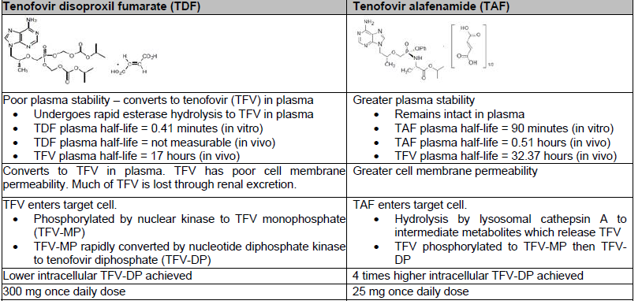
Source: Sponsor submission (p1)
  - The sponsor also claimed that the naming of tenofovir also has implications for Quality Use of Medicines (QUM) as TDF and TAF have different clinical indications with regard to age and renal impairment, and different dosing which could cause issues if confusion between the different drugs arises as a result of them both being named tenofovir.
- PBAC outcome
  - The PBAC recommended the listing of tenofovir alafenamide with emtricitabine and rilpivirine as a Section 100 (community access): Authority Required (STREAMLINED) listing for treatment-naïve and treatment-experienced patients with human immunodeficiency virus (HIV) on a cost-minimisation basis to Eviplera®.
  - The PBAC noted the evidence presented by the sponsor that indicated tenofovir alafenamide and tenofovir disoproxil fumarate had differences in relation to dose, plasma stability, and metabolism. On this basis, the PBAC considered that tenofovir alafenamide should be considered different drug to tenofovir for the purposes of section 85(2) of the Act.
  - The PBAC recalled its previous advice (see paragraphs 1.4-1.5), particularly that Odefsey® (rilpivirine 25mg + emtricitabine 200mg + tenofovir alafenamide 25mg tablet) is non inferior Eviplera® (tenofovir disoproxil fumarate 300 mg + emtricitabine 200 mg + rilpivirine 25 mg tablet) in terms of effectiveness and safety. The equi-effective doses are one tablet of Odefsey® is equivalent to one tablet of Eviplera®.
  - The PBAC considered that the Early Supply Rule should apply to Descovy®, as recommended for all HIV treatments at the November 2015 meeting.
  - The PBAC noted that this submission was not eligible for Independent Review as it received a positive recommendation.
- Recommended listing
  - Add new item:
Name, Restriction,  Manner of administration and form | Max.  Qty | №.of  Rpts | Proprietary Name and Manufacturer
rilpivirine + emtricitabine + tenofovir alafenamide  rilpivirine 25mg + emtricitabine 200mg + tenofovir alafenamide 25mg tablet, 30 | 2 | 5 | Odefsey® | Gilead Sciences Pty Ltd
Category/Program | Section 100 - Highly Specialised Drugs Program (Community Access)
Condition | HIV infection
Restriction | Authority Required (Streamlined)
Treatment criteria | Treatment Phase: Initial
Clinical criteria | Patient must be antiretroviral treatment naïve.
Category/Program | Section 100 – Highly Specialised Drugs Program (Community Access)
Condition | HIV infection
Restriction | Authority Required (Streamlined)
Treatment criteria | Treatment Phase: Continuing
Clinical criteria | Patient must have previously received PBS-subsidised therapy for HIV infection.
- Context for Decision
The PBAC helps decide whether and, if so, how medicines should be subsidised in Australia. It considers submissions in this context. A PBAC decision not to recommend listing or not to recommend changing a listing does not represent a final PBAC view about the merits of the medicine. A company can resubmit to the PBAC or seek independent review of the PBAC decision.
- Sponsor’s Comment
The sponsor had no comment.

