7.04 IDELALISIB

100 mg tablet, 60, 150 mg tablet, 60

Zydelig®, Gilead Sciences Pty Ltd

Purpose of Application

  - The resubmission requested Section 85, Authority Required listing for idelalisib for the second-line treatment of chronic lymphocytic leukaemia (CLL) and small lymphocytic lymphoma (SLL). The first submission was in March 2015.

Requested listing

  - The requested restriction is shown below. Suggestions and additions proposed by the Secretariat to the requested listing are added in italics and suggested deletions are crossed out with strikethrough.

Name, Restriction,  Manner of administration and form |  | Max.  Qty | №.of  Rpts | Dispensed Price for Max. Qty | Proprietary Name and Manufacturer
Idelalisib  Tablet, 150 mg, 60  Tablet, 100 mg, 60 |  | 1 | 5 | $'''''''''''''''''''''' (published)  $'''''''''''''''''''' (effective) | Zydelig® | Gilead
Category / Program | GENERAL – General Schedule (Code GE)
Prescriber type: | Dental Medical Practitioners Nurse practitioners Optometrists  Midwives
PBS Indication: | Chronic lymphocytic leukaemia (CLL) or small lymphocytic lymphoma (SLL)
Treatment phase: | Initial and continuing treatment
Restriction Level / Method: | Restricted benefit  Authority Required - In Writing  Authority Required - Telephone  Authority Required – Emergency  Authority Required - Electronic  Streamlined
Clinical criteria: | The treatment must be in combination with rituximab;  AND  The condition must have relapsed or be refractory after at least one therapy;  AND  Patient must have a total cumulative illness rating scale (CIRS) score of greater than 6 (excluding CLL-induced illness or organ damage);  AND  Patient must be inappropriate for chemo-immunotherapy
Prescriber Instructions | A patient is inappropriate for chemo-immunotherapy because of one or more of the following:  - Severe neutropenia; or  - Severe thrombocytopenia; or  - Presence of 17p deletion; or  - Presence of TP53 mutation.
Administrative Advice | Severe neutropenia defined as absolute neutrophil count ≤ 1.0 x 10⁹/L  Severe thrombocytopenia defined as platelet count ≤ 50 x 10⁹/L

  - The resubmission proposed that the PBAC consider whether the following criterion could also be included in the proposed restriction “or other clinical features or comorbidities that make patients inappropriate for chemotherapy”. This criterion was added by the resubmission to ensure all patients who would be inappropriate for chemo-immunotherapy were covered. The resubmission argued that the criteria proposed by the PBAC would exclude patients who had myelosuppression, adequate renal function and limited comorbidities. These patients were included in the clinical trial and according to the resubmission should be included in the proposed PBS population. It was unclear whether the proposed additional criterion would capture this specific patient population or would result in a larger proportion of patients being eligible for treatment than intended. The ESC noted that, although this patient group was eligible to enter the clinical trial, it was not well represented in the final population, noting that 85% of patients had a CIRS score of greater than 6. Therefore, the ESC considered that adding this additional statement would broaden the eligible patient pool beyond the clinical evidence provided in the submission.

  - The ESC noted that patients treated with idelalisib should be treated until progression, and that this should be incorporated into the restriction wording.

  - The ESC reiterated that it is appropriate for patients to receive 8 doses of rituximab as this is reflective of clinical trial data, noting that currently only 6 doses are subsidised.

  - The resubmission presented a cost-utility analysis of idelalisib plus rituximab compared to best supportive care.

For more detail on PBAC’s view, see section 7 “PBAC outcome”.

Background

  - Idelalisib was TGA registered on 9 February 2015 for the indication:
In combination with rituximab, for the treatment of patients with chronic lymphocytic leukaemia (CLL) / small lymphocytic lymphoma (SLL) for whom chemo-immunotherapy was not considered suitable, either:
- upon relapse after at least one prior therapy; or
- as first-line treatment in the presence of 17p deletion or TP53 mutation.

  - This item was previously considered at the March 2015 PBAC meeting.

Table 1: Summary of the previous submission and current resubmission
 | Idelalisib March 2015 | Current resubmission
Requested PBS listing | Patients with CLL who have progressive disease despite previous treatment.  PBAC Comment: The restriction was inconsistent with the clinical evidence provided, did not align with the indication proposed by ACPM and TGA, and should include SLL due to biological similarity (2.2). The patient inclusion criteria were too broad. | Section 85 Authority Required (STREAMLINED) for the treatment of CLL or SLL that was relapsed or refractory after at least one therapy. Administer idelalisib in combination with rituximab
Requested price | DPMQ: $'''''''''''''''''''''  Effective: $''''''''''''''''''''''' | DPMQ: $''''''''''''''''''''  Effective: $'''''''''''''''''''''
Main comparator | Rituximab monotherapy  PBAC Comment: This was not the appropriate comparator because rituximab monotherapy was not PBS-listed, TGA-approved or routinely used as a second-line treatment for CLL (5.1-2). | BSC was main comparator, with rituximab monotherapy as a proxy.
Clinical evidence | Trial 312-0116 (N=220) compared idelalisib plus rituximab to placebo plus rituximab.  PBAC Comment: The PBAC considered that the data from Trial 312-0116 would only be applicable if rituximab monotherapy was considered as a surrogate BSC. | No new trials were presented, but longer follow-up. The resubmission used the rituximab monotherapy as a proxy for BSC.  Further RPSFT methodology to adjust for switching was applied to OS.
Key effectiveness data | PFS, HR (95% CI): 0.18 (0.10, 0.32)  OS, HR (95% CI): 0.28 (0.11, 0.69)  Median follow-up:  Comparator – 4.4months  IR – 6.1 months  PBAC Comment: PBAC noted the gains in PFS and OS, although believes the trial data was immature with respect to overall survival. | PFS, HR (95% CI): 0.15 (0.09, 0.24)  OS, RPSFT HR (95% CI): 0.20 (0.10, 0.35)  OS, ITT HR (95% CI): 0.34 (0.19, 0.60)  Median follow-up:  BSC – 11.1 months  IR – 12.5 months
Key safety data | Neutropenia, RD (95% CI): 0.11 (0.00, 0.22)  Diarrhoea, RD (95% CI): 0.04 (-0.05, 0.14)  Pyrexia, RD (95% CI): 0.18 (0.07, 0.29)  Rash, RD (95% CI): 0.05 (-0.02, 0.12)  Infusion related reaction, RD (95% CI): -0.11 (-0.22, 0.01)  PBAC Comment: The trial data were immature with respect to long-term safety. Non-inferior safety profile not accepted. | Neutropenia, RD (95% CI): 0.06 (-0.05, 0.17)  Diarrhoea, RD (95% CI): 0.12 (0.00, 0.23)  Pyrexia, RD (95% CI): 0.22 (0.10, 0.33)  Rash, RD (95% CI): 0.10 (0.02, 0.18)  Infusion related reaction, RD (95% CI): -0.11 (-0.22, 0.01)
Clinical claim | Superior comparative effectiveness and non-inferior comparative safety  PBAC Comment: Claim not accepted. | Idelalisib plus rituximab as having superior comparative effectiveness and slightly inferior comparative safety over BSC.
Economic evaluation | Cost-utility model with cost/QALY  Model structure: 10 year time horizon, Alive with stable disease; alive with progressed disease; dead,  Parametric extrapolation: ITT analysis set  Comparator treatment costs: rituximab monotherapy  PBAC Comment: Rituximab monotherapy was an inappropriate comparator and the extrapolation of the 2nd interim data from Trial 312-0116 to the 10 year model length was inappropriate. | Cost-utility model with cost/QALY  Model structure: 8 year time horizon, Alive with stable disease; alive with progressed disease; dead,  Parametric extrapolation: RPSFT analysis set  Comparator treatment costs: $0
ICER | $'''''''''''''''/QALY | $'''''''''''''''''/QALY
Number of patients | ''''''' in Year 1 increasing to ''''''''' in Year 5.  PBAC Comment: PBAC considered the sponsor’s assumption in year five that one in ten patients would be new (initiating) inappropriate. It was imperative that robust estimates of the numbers of patients requiring second or subsequent line therapy for CLL were generated. | ''''''' in Year 1 increasing to ''''''''' in Year 5.  Prevalence and incidence approach: '''''''''' in Year 1, decreasing to '''''' in Year 5.
Estimated cost to PBS/RPBS | $''''''''''''''''''''''''''' in Year 5  $'''''''''''''''''''''''' over the first 5 years of listing.  PBAC Comment: The PBAC considered that the financial estimates should not include any cost-offsets for the use of rituximab as monotherapy because such use was outside the PBS restriction for rituximab | $''''''''''''''''''''''' in Year 5 for a total of $''''''''''''''''''''''''''''' over the first 5 years of listing. Rituximab monotherapy cost-offsets included.  Prevalence/incidence approach:  $''''''''''''''''''''' in Year 5 for a total of $''''''''''''''''''''''''' over the first 5 years of listing. Rituximab monotherapy cost-offsets excluded.
PBAC decision | Reject. | -
Source: compiled during the evaluation
QALY = quality-adjusted life year; RPSFT = rank preserving structural failure time; ICER = incremental cost-effectiveness ratio; CLL = chronic lymphocytic leukaemia; SLL = small lymphocytic lymphoma; HR = hazard ratio; RD = risk difference; PFS = progression free survival; OS = overall survival; ACPM = Advisory Committee on Prescription Medicines; TGA = Therapeutic Goods Administration; DPMQ = dispensed price for maximum quantity; BSC = best supportive care; IR = idelalisib plus rituximab; PBAC = Pharmaceutical Benefits Advisory Committee; PBS = Pharmaceutical Benefits Scheme; RPBS = Repatriation Pharmaceutical Benefits Scheme; CI = confidence interval; RPSFT = rank preserving structural survival failure time; Bold = statistically significant

  - At the November 2015 PBAC meeting, idelalisib monotherapy for the treatment of patients with relapsed/refractory follicular lymphoma will also be considered.

Clinical place for the proposed therapy

  - Idelalisib was evaluated as a second-line treatment for patients with relapsed CLL, who were unfit for chemotherapy. It should be used in combination with rituximab.

Comparator

  - The main comparator in the resubmission was best supportive care. This was recommended at the March 2015 PBAC meeting. The comparator from the previous submission, rituximab monotherapy, was used as a proxy for best supportive care in the clinical evaluation. This was appropriate for the clinical efficacy but might be inappropriate for clinical safety.

Consideration of the evidence

Sponsor hearing

  - There was no hearing for this item.

Consumer comments

  - The PBAC noted and welcomed the input from individuals (6) and organisations (1) via the Consumer Comments facility on the PBS website. The comments described a range of benefits of treatment with idelalisib for patients with CLL including increased survival with fewer adverse events compared to chemotherapy.

Clinical trials

  - The resubmission was based on one head-to-head trial comparing idelalisib plus rituximab to placebo plus rituximab (n=220). This was the same trial as presented in the previous submission. The resubmission presented the final analysis of data from Trial 312-0116, as opposed to the previous submission which presented the second interim analysis results of Trial 312-0116.

  - Details of the trial presented in the resubmission are provided in the table below.

Table 2: Trials and associated reports presented in the resubmission
Trial ID/First Author | Protocol title/ Publication title | Publication citation
Direct randomised trial
Trial 312-0116 | A phase III, randomised, double-blind, placebo-controlled study evaluating the efficacy and safety of idelalisib (GS-1101) in combination with rituximab for previously treated chronic lymphocytic leukaemia. | 25 November 2014; Final Clinical Study Report; Study No: GS-US-312-0116
Trial 312-0116 | Furman RR, Sharman JP, Coutre SE, et al. Idelalisib and rituximab in relapsed chronic lymphocytic leukaemia. | N Engl J Med; 2014; 370(11):997-1007.
Source: Table B-5, p58 of the resubmission

  - The key features of the direct randomised trial are summarised in Table 3.

Table 3: Key features of the included evidence – idelalisib plus rituximab vs. placebo plus rituximab
Trial | N | Design/ duration | Risk of bias | Patient population | Outcome(s) | Use in modelled evaluation
312-0116 | 220 | R, DB, MC, PC  Approx. 6 months | Low | Relapsed  Unfit for chemotherapy | PFS, OS | Yes
Source: compiled during the evaluation
Approx. = approximately; DB = double blind; MC = multi-centre; OS = overall survival; PC = placebo controlled; PFS = progression free survival; R = randomised

  - In the key trial, patients in the placebo plus rituximab arm who had progressive disease were switched to idelalisib treatment, while patients in the idelalisib plus rituximab arm were treated with a higher dose of idelalisib. The ESC noted that, in the active treatment arm, 70 patients who progressed on idelalisib received double the dose of idelalisib which may have provided them with an additional overall survival benefit. This was particularly relevant, as the resubmission did not include those costs of further idelalisib treatment for patients who progressed.

  - The trial was stopped after a median follow-up of 6.1 months for the idelalisib plus rituximab arm and 4.4 months for the placebo plus rituximab arm due to meeting predefined efficacy criteria. After this period, all patients from the placebo plus rituximab arm could switch to idelalisib treatment in the follow-up study 312-0117. The median follow-up in the final analysis was approximately 12 months. In the placebo plus rituximab arm, 48/110 (43.6%) patients switched to idelalisib due to disease progression and 39/110 (35.5%) due to reaching the time point when the trial was stopped.

  - The resubmission addressed the possible confounded overall survival using the rank preserving structural failure time (RPSFT) analysis set. The RPSFT analysis was explained in the resubmission, but the workings were not provided. Hence, the following concerns could not be answered:
  - The RPSFT method produced a new overall survival time for the placebo plus rituximab arm by accelerating the time with idelalisib treatment in the placebo plus rituximab arm by an accelerator factor stated as 0.31, with no variance around this point estimate provided. The ESC noted that the presentation of this acceleration factor, as the reciprocal, was incorrect, and should instead be the inverse of that presented (1/0.31), thus giving an acceleration factor of 3.2. The ESC interpreted the acceleration factor to mean that every 3.2 months of recorded survival time in the placebo + rituximab arm would be adjusted down to 1 month. As the same acceleration factor was applied to all patients who crossed over regardless of the reason for crossing over, this assumption was not supported. This method should bring increased uncertainty into the hazard ratio, due to uncertainty surrounding this acceleration factor. However, the confidence interval for the RPSFT hazard ratio was smaller than for the intention-to-treat (ITT) analysis.
  - The methodology for deriving the confidence intervals around the hazard ratio was not clearly described in the resubmission. The methodology included bootstrapping. The ESC considered that including bootstrapping to derive confidence intervals for the hazard ratio point estimates was a reasonable method, although confidence intervals around the point estimate of the acceleration factor were not presented for comparison. From the resubmission, it was unclear whether the confidence interval around the acceleration factor value was sampled in the bootstrapping method.
  - The proposed PBS restriction stated treatment must stop after disease progression. The RPSFT adjustment placed increased significance on the treatment provided after disease progression. This might possibly be a treatment benefit the PBS population will not receive.

Comparative effectiveness

  - Results of the primary outcome, progression free survival, from the final analysis are presented in Table 4.

Table 4: Results of progression free survival (primary outcome) and overall survival (secondary outcome) from Trial 312-0116 – final results
 | Idelalisib + rituximab  (n = 110) | Placebo + rituximab  (n = 110)
Median duration of follow-up (months) | 12.5 | 11.1
Progression free survival – ITT analysis
Patients with events; n/N (%) | 25 (22.7%) | 70 (63.6%)
Patients censored; n/N (%)  Ongoing  Discontinued without event | 85 (77.3%)  69 (62.7%)  16 (14.5%) | 40 (36.4%)  33 (30.0%)  7 (6.4%)
median PFS, months (95% CI) | 19.4 (12.3, NR) | 6.5 (4.0, 7.3)
Adjusted HR (95% CI) ª | 0.15 (0.09, 0.24)
Overall survival
ITT analysis
Patients who died; n (%) | 17 (15.5%) | 40 (36.4%)
Patients censored; n (%)  Ongoing  Discontinued without event | 93 (84.5%)  60 (54.5%)  33 (30.0%) | 70 (63.6%)  38 (34.5%)  32 (29.1%)
Median OS, months (95% CI) | NR (NR, NR) | 20.8 (14.8, NR)
Adjusted HR (95% CI) ª | 0.34 (0.19, 0.60)
RPSFT analysis
Median OS, months (95% CI) | NR (NR, NR) | 11.6 (8.2, NR)
Adjusted HR (95% CI) ª | 0.20 (0.10,0.36 ^{b})
Source: Table B-19, p73, Tables B-22 to B-25, pp77-79 of the resubmission; and Ghia (2015)
CI = confidence interval; ITT = intention-to-treat; NR = not reached; HR = hazard ratio; OS = overall survival; PFS = progression free survival; RPSFT = rank preserving structural failure time; IGHV = immunoglobulin heavy chain variable; Bold = statistically significant
ª Adjusted for randomisation stratification factors (17p deletion/TP53 mutation and IGHV mutation)
^{b} Value was updated as it was incorrectly reported in the resubmission

  - The median progression free survival for the idelalisib plus rituximab arm of Trial 312-0116 was 19.4 months (95% confidence interval (CI): 12.3 to not reached) and for the placebo plus rituximab arm 6.5 months (95% CI: 4.0 to 7.3). This resulted in a progression free survival hazard ratio of 0.15 (95% CI: 0.09, 0.24).

  - Figures 1 and 2 below show Kaplan-Meier curves of overall survival from the pooled ITT and RPSFT analysis set, respectively.

Figure 1: Kaplan-Meier curve of overall survival from Trials 312-0116 and 312-0117 (ITT analysis set)
N at risk (events)
IDELA + R 110 (0) 107 (2) 101 (4) 99 (5) 93 (9) 85 (10) 60 (11) 41 (13) 30 (13) 23 (15) 13 (17) 6 (17) 3 (17) 0 (17) 0 (17)
Placebo + R 110 (0) 99 (8) 93 (12) 90 (15) 84 (20) 66 (29) 42 (33) 27 (35) 19 (37) 13 (38) 8 (39) 4 (40) 1 (40) 0 (40) 0 (40)
Source: Figure B-3, p77 of the resubmission
IDELA = idelalisib; ITT = intention-to-treat; R = rituximab

Figure 2: Kaplan-Meier curve of overall survival from Trials 312-0116 and 312-0117 (RPSFT analysis set)
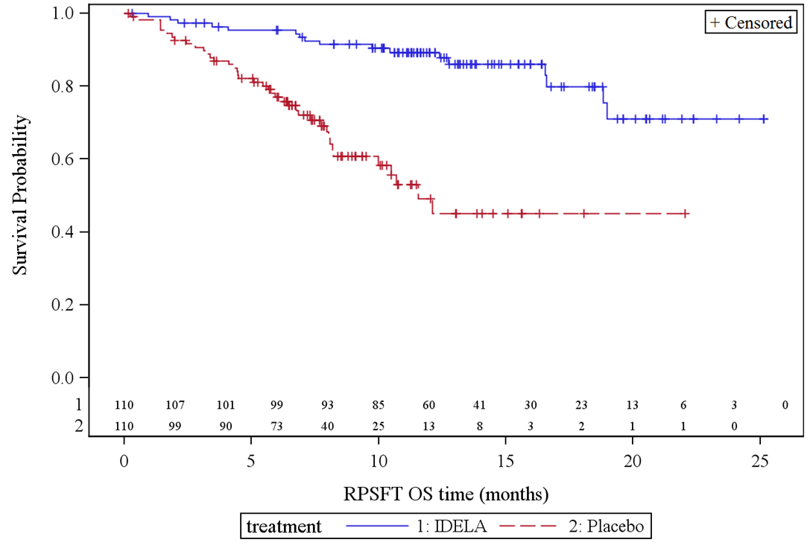
Source: Figure B-4, p78 of the resubmission
IDELA = idelalisib plus rituximab; Placebo = placebo plus rituximab; RPSFT = rank preserving structural failure time; OS = overall survival

  - The hazard ratio for overall survival was 0.34 (95% CI: 0.19 to 0.60) in the ITT analysis set and 0.20 (95% CI: 0.10 to 0.36) in the RPSFT analysis set. Neither the ITT nor RPSFT analyses sets reached the median overall survival in the idelalisib plus rituximab arm. For the placebo plus rituximab group, the calculated median overall survival was much shorter using the RPSFT methodology compared to the final ITT analysis (11.6 months vs. 20.8 months, respectively). While it might be appropriate to use a statistical method to adjust for cross-over, the RPSFT was not the appropriate model. This was because the RPSFT model assumed that patients who crossed over from placebo plus rituximab to idelalisib plus rituximab for any reason would have a similar life expectancy. This was not valid, as some patients switched after disease progression, while other patients switched when Trial 312-0116 was stopped and patients could move into the follow-up study 312-117. The Pre-Sub-Committee Response (PSCR) (p1) maintained that the RPSFT was the most appropriate methodology, and that as 39 of the patients who crossed over had not progressed, the common treatment effect assumption is valid. The ESC considered that this was not necessarily demonstrated as the majority of patients who had crossed over had progressed.

  - The ESC considered that the RPSFT overestimated the adjustment for cross-over and was not an appropriate method. In forming this view, ESC considered a range of factors including:
- the high degree of cross-over; with 79% of patients from the placebo arm of the trial crossing over to idelalisib
- the small number of patients upon which the adjustment methods are based, with only 23 of the 110 patients randomised to placebo who did not cross-over to idelalisib
- the acceleration factor was large (3.2) and was applied to the majority of patients who were randomised to the comparator arm, significantly biasing results. Further information around how the acceleration factor was derived and variance around the acceleration factor, is necessary to determine its appropriateness
- the ITT results did show a statistically significant improvement in OS, however the magnitude of this benefit was smaller than for the RPSFT results
- the confidence intervals around the RPSFT were much smaller than for the ITT analysis. Due to uncertainty introduced by the acceleration factor, it was unclear why the confidence intervals were smaller
- the assumptions underlying the presented adjustment methods were not shown to be fulfilled. The validity of the underlying assumption upon which RPSFT is based – the common treatment effect assumption – was not reasonably fulfilled or otherwise justified. That is, it was unclear whether patients have an equal likelihood of responding to idelalisib irrespective of whether or not they received placebo first. The ESC considered that the common treatment effect assumption was not likely to be clinically plausible. Although the RPSFT method is reasonably robust to small deviations from the common treatment effect assumption, the size of the bias fluctuates with the size of the treatment effect and thus bias is likely to be considerable given the relatively large treatment effect estimates in the submission.
Accordingly, it was unclear whether the RPSFT estimate would be less biased than the unadjusted survival estimate.

  - The ESC noted that two sensitivity analyses were presented in the resubmission to gauge the impact of the adjustment method on OS estimates. These are shown in Table 5 below.

Table 5: Results of overall survival sensitivity analysis from Trial 312-0116 – final results
Sensitivity analyses | HR (95% CI)
312-0116 only (ITT) | 0.41 (0.18, 0.95)
Ide + R: 312-0016 + 312-0117  PBO + R: Up to first dose of Ide if crossed over | 0.43 (0.20, 0.95)
Source: Table B.6.2 of the commentary.
ITT = intention-to-treat; Ide + R = idelalisib and rituximab; PBO + R = placebo and rituximab; HR = hazard ratio;
Bold = statistically significant

  - The ESC considered that these estimates are likely biased in favour of idelalisib given the use of post-progression treatment in the idelalisib arm.

Comparative harms

  - The incidence of treatment-emergent adverse events occurring in at least 10% of participants was fairly similar across both treatment arms of Trial 312-0116. Idelalisib plus rituximab resulted in significantly increased rates of neutropenia, increased transaminases and alanine aminotransferase and gastrointestinal disorders (diarrhoea and colitis).

  - Idelalisib has an FDA boxed warning based on longer-term analyses stating that treatment can result in fatal and serious toxicities including hepatotoxicity, severe diarrhoea or colitis, pneumonitis and intestinal perforation.

  - The Australian Product Information does not have a black box warning but recommends precaution in hepatic infection, anaphylaxis, intestinal perforation, progressive multifocal leukoencephalopathy and use in special patient populations. The PSCR (p2) considered hepatotoxicity to be transient and reversible, and considered that difference in US and Australian safety recommendations reflects registration approval timelines, the availability of additional safety data and the updated risk-benefit relationship at the time of respective registration. The ESC considered this reasonable, however reiterated that the harms presented in the submission are likely underestimated and favour idelalisib.

Benefits/harms

  - A summary of the comparative benefits and harms for idelalisib plus rituximab versus placebo plus rituximab is presented in Table 6 below.

Table 6: Summary of comparative benefits and harms for idelalisib plus rituximab and placebo plus rituximab from Trial 312-0116 – final results
BENEFITS
Final results |  | Idelalisib + rituximab |  | Placebo +  Rituximab |  | Absolute Difference |  | HR (95% CI)
Progression free survival ª
Progressed disease; n/N (%) |  | 25/110 (22.7%) |  | 70/110 (63.6%) |  | - |  | 0.15 (0.09, 0.3)
Median (months) |  | 19.4 (12.3, NR) |  | 6.5 (4.0, 7.3) |  | NC |  | -
Overall survival ª
Died; n/N (%) |  | 17/110 (15.5%) |  | 40/110 (36.4%) |  | - |  | ITT: 0.34 (0.19, 0.60)  RPSFT: 0.20 (0.10,0.36)
Median (months) |  | NR (NR, NR) |  | ITT: 20.8 (14.8, NR)  RPSFT: 11.6 (8.2, NR) |  | NC
HARMS
Grade ≥3 | Idelalisib + rituximab | Placebo + rituximab ^{b} | RR  (95% CI) |  | Event rate/100 patients |  |  |  | RD  (95% CI)
 |  |  |  |  | Idelalisib + rituximab |  | Placebo + rituximab |  | RD  (95% CI)
Neutropenia | 25/110 | 18/108 | 1.36 (0.79, 2.35) |  | 22.7 |  | 16.7 |  | 0.06 (-0.04, 0.17)
Pneumonia | 11/110 | 10/108 | 1.08 (0.48, 2.44) |  | 10.0 |  | 9.3 |  | 0.01 (-0.07, 0.09)
Febrile neutropenia | 5/110 | 5/108 | 0.98 (0.29, 3.30) |  | 4.5 |  | 4.6 |  | -0.0008 (-0.06, 0.06)
Sepsis | 6/110 | 3/108 | 1.96 (0.50, 7.65) |  | 5.5 |  | 2.8 |  | 0.03 (-0.03, 0.21)
Diarrhoea | 10/110 | 0/110 | 21 (1.25, 354.03) |  | 9.1 |  | 0 |  | 0.09 (0.04, 0.15)
Colitis | 5/110 | 0/110 | 11 (0.62, 196.57) |  | 4.5 |  | 0 |  | 0.05 (0.01, 0.08)
Source: Table B-19, p73; Tables B-22 to B-25, pp77-79; Table B-30, p89 of the resubmission; compiled during the evaluation; and B.6.1-2, p5.10.com.25-26 of the previous commentary
CI = confidence interval; HR = hazard ratio; NC = not reached; NR = not reported; RD = risk difference; RR = relative risk; ITT = intention-to-treat; RPSFT = rank preserving structural failure time; Bold = statistically significant
ª Median duration of follow-up: idelalisib plus rituximab = 12.5 months; placebo plus rituximab = 11.1 months
^{b} Two patients in this treatment arm did not receive the allocated intervention

  - On the basis of the head-to-head trial (ITT), the comparison of idelalisib plus rituximab and placebo plus rituximab after a median 12.5 months follow-up resulted in:
- approximately 12.9 months improvement in median progression free survival.

  - On the basis of direct comparison evidence presented by the resubmission, for every 100 patients treated with idelalisib plus rituximab in comparison to placebo plus rituximab over a median follow-up of 12.5 months:
- approximately 41 fewer patients would have progressed disease;
- approximately 21 fewer patients would have died;
- approximately 9 additional patients would have at least Grade 3 diarrhoea;
- approximately 5 additional patients would have at least Grade 3 colitis.

  - It should be noted that while the placebo plus rituximab arm might be a reasonable proxy for best supportive care that includes no effective anti-CLL therapy with regards to efficacy, it might be inappropriate for comparative safety, as rituximab has its own toxicity profile.

Clinical claim

  - The resubmission described idelalisib plus rituximab as having superior comparative effectiveness and slightly inferior comparative safety over best supportive care.

  - This superior comparative effectiveness claim might be reasonably supported:
- the PBAC considered that placebo plus rituximab might be a reasonable proxy for best supportive care in this patient group for overall survival (Item 7.8, March 2015 PBAC)
- idelalisib plus rituximab showed superior progression free survival and overall survival benefits compared to placebo plus rituximab, using the ITT analysis.

  - However, the duration of follow-up of Trial 312-0116 was short (12.5 months in the idelalisib plus rituximab arm) and overall survival results were immature (15.5% and 36.4% of patients had died in the idelalisib plus rituximab, and the placebo plus rituximab arm, respectively).

  - The ESC noted that the RPSFT methodology, used to adjust the overall survival estimate for treatment switching, might not be appropriate as the resubmission considered that the treatment effect across placebo plus rituximab patients who had switched before (n=39/110) and after (n=48/110) disease progression was the same. The ESC further noted that a large acceleration factor was applied to the majority of patients who were randomised to the rituximab + placebo arm, biasing results in favour of idelalisib.

  - The claim of slightly inferior comparative safety might not have been reasonable as:
  - the short duration of follow-up meant the identification of long-term adverse events with idelalisib was not possible;
  - the dosing regimen of rituximab in the trial differed to the approved Australian dosing regimen, making safety comparisons with the wider CLL rituximab population difficult;
  - long-term idelalisib treatment resulted for some patients in fatal and/or serious hepatotoxicity, severe diarrhoea or colitis, pneumonitis and intestinal perforation; and
  - the adverse event rate with best supportive care would be likely to be lower than for placebo plus rituximab.

Translation issues

  - The resubmission used parametric extrapolation of progression-free survival (ITT) and overall survival (RPSFT-adjusted) trial data beyond the end of the trial to the likely time horizon of CLL using independent and joint modelling. The model used the whole KM curve, which might be inappropriate as median follow up was 12.5 months for idelalisib plus rituximab and 11.1 months for placebo + rituximab.

  - The ESC noted that only Weibull and log logistic curves were provided in the progression free survival curves, which did not adjust for cross-over. While the Weibull had a better Akaike’s information criterion test (AIC) and appeared more conservative, a justification should have been given for why alternate curves were not presented.

  - The ESC noted that the accuracy of overall survival predictions may have been compromised as the tail was informed by a small proportion of patients, due to the high degree of cross-over. The ESC considered that OS should be extrapolated from an earlier time point, where patient numbers are greater. Use of the more flexible Royston & Parmar models would overcome this issue, by fitting curves to the KM curve using multiple points of inflexion.

Figure 3: Comparison of observed and fitted overall survival using the Weibull and exponential distributions
Idelalisib + rituximab  Median follow-up: 12.5 months | Best supportive care  Median follow-up: 11.1 months
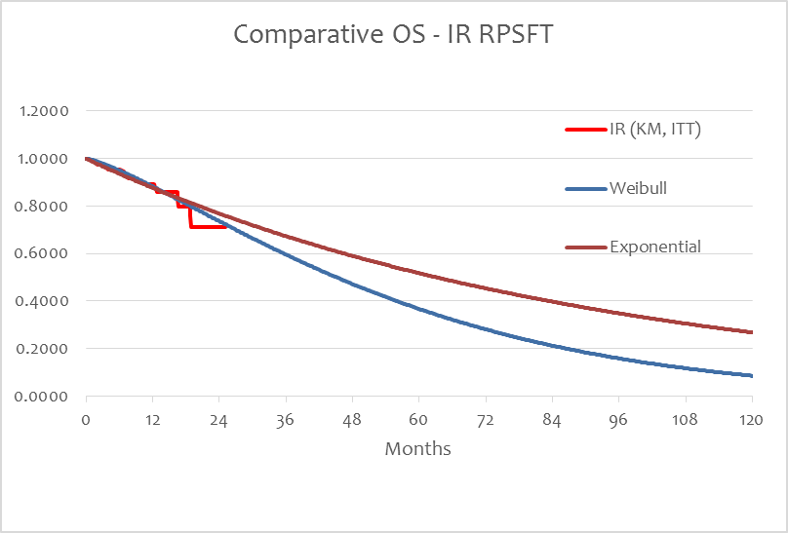 | 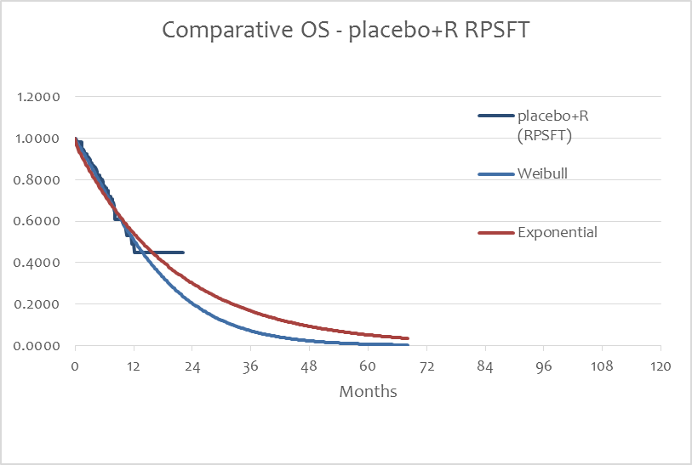
Source: Section D workbook of the resubmission
IR = idelalisib plus rituximab; R = rituximab; RPSFT = rank preserving structural failure time; KM = Kaplan-Meier; ITT = intention-to-treat

Economic analysis

  - The resubmission presented a cost-utility analysis, based on the results of Trial 312-0116. A comparison between the model presented in the resubmission and the previous submission is summarised in Table 7.

Table 7: Summary of model structure and rationale
Component | Idelalisib November 2015:  Current resubmission |  |  | Idelalisib March 2015:  Previous submission
Model structure | 3 health states  7-day cycles |  |  | 3 health states  7-day cycles
Idelalisib + Rituximab cost | Idelalisib average cost / week = $'''''''''''''''''  Total RTX cost (IR) = $'''''''''''''''''' |  |  | Idelalisib average cost / week = $''''''''''''''''  Total RTX cost (IR) = $''''''''''''''''
Comparator and costs | BSC = $0 |  |  | Rituximab = $29,181
Utility values |  |  | Idelalisib + rituximab |  | BSC
Utility values | Stable disease |  | 0.71 |  | 0.71
Utility values | Progressive disease |  | 0.59 |  | 0.59
Utility values | Utility decrement due to adverse events |  | Submission = -0.0026  Resubmission =-0.0034 |  | Submission = -0.0020  Resubmission = -0.0021
Weekly health state costs | Stable - IR = $178.07  Stable - BSC = $543.68^{b}  Progressive – both arms = $21.56 |  |  | Stable - IR = $23.20  Stable - rituximab = $23.20 ^{b}  Progressive – both arms = $69.61
Adverse event costs | IR = $4,565.22 ª  BSC = $3,164.51 ª |  |  | IR = $4,079  RM = $2,713
Model duration | 8 years |  |  | 10 years
 | IR | BSC | Increment | IR | RM | Increment
Cost | $''''''''''''''''''' | $22,668 | $'''''''''''''''''' | $'''''''''''''''''''' | $42,383 | $'''''''''''''''
QALYs | 2.38 | 0.81 | 1.57 | 3.76 | 1.96 | 1.80
ICER | $''''''''''''' |  |  | $''''''''''''
Source: compiled during the evaluation
QALY = quality-adjusted life year; ICER = incremental cost-effective ration; IR = idelalisib plus rituximab; BSC = best supportive care; RM = rituximab monotherapy; RTX = rituximab
ª Values presented in Section D workbook of the resubmission were incorrect.
^{b} The ESC noted that costs of stable disease were substantially altered in the current resubmission.

  - The time horizon and the overall survival analysis set were the key drivers of the model, and appeared to favour idelalisib (see Table 8).

Table 8: Key drivers of the model
Description | Method/Value | Impact
Time horizon | 8 years; assumed from ~ 12 month trial duration | High; favoured idelalisib
Overall survival analysis set | RPSFT method used to adjust for treatment cross-over | High; favoured idelalisib
Resource use and costs | Pragmatic selection from unconfirmed sources | Low; favoured idelalisib
Source: compiled during the evaluation
RPSFT = rank preserving structural failure time

  - The ESC noted that, in its March 2015 consideration of idelalisib, the PBAC recommended using a 7-year time horizon with a 5-year sensitivity analysis (Paragraph 7.11, PBAC minutes, March 2015). It is unclear what justification was given to the use of an 8-year time horizon in the resubmission.

  - Graphed traces of the predicted progression free survival and overall survival curves are presented in Figure 4.

Figure 4: Markov trace for (a) idelalisib plus rituximab and (b) best supportive care in the economic model
- Idelalisib + rituximab | - Best supportive care
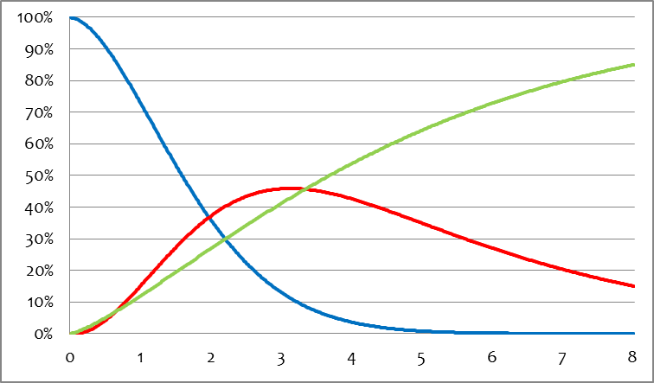  Years | 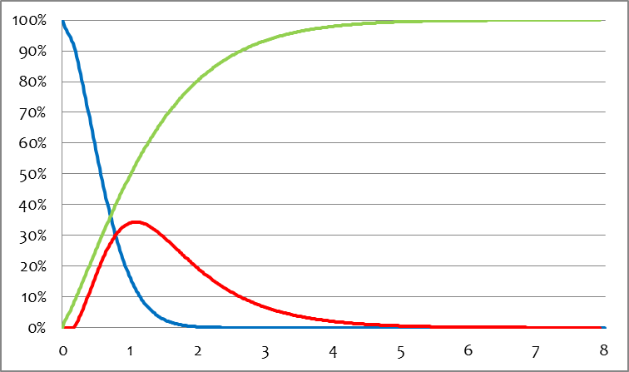  Years
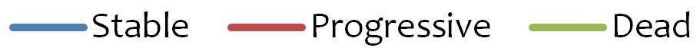
Source: Table D.5.1 of the Commentary. Constructed during the evaluation using the economic model

  - As per Figure 4, after approximately four years of treatment 50.0% of the idelalisib plus rituximab patients were expected to be alive, compared to eight years in the previous submission. The ESC noted that the Markov traces for idelalisib plus rituximab, and best supportive care, in the economic model are more clinically plausible in the current resubmission than in the original submission.

  - The results of the economic evaluation are presented in Table 9.

Table 9: Results of the economic evaluation (discounted at 5%)
 | Idelalisib + rituximab | Best supportive care | Increment
Costs | $''''''''''''''''''''' | $22,668 | $''''''''''''''''''
QALYs | 2.384 | 0.811 | 1.573
Incremental cost/extra QALY gained |  |  | $'''''''''''''''
Incremental cost/extra QALY gained – previous submission |  |  | $'''''''''''''
Source: Table D-8, p185 of the resubmission; and Section D workbook of the resubmission
QALY = quality-adjusted life year

  - The economic evaluation resulted in an incremental cost-effectiveness ration (ICER) of $75,000- $105,000 per quality-adjusted life year (QALY) for idelalisib plus rituximab versus best supportive care. This was compared to $45,000 – $75,000 per QALY for idelalisib plus rituximab versus rituximab monotherapy as presented in the previous submission. The ESC noted that this was largely driven by reduced overall survival and disease state costs. The evaluation and the ESC considered that the ICER was uncertain due to:
- questions surrounding the accuracy and appropriateness of using the RPSFT analysis set to estimate the overall survival. The ESC noted that using RPSFT over the ITT analysis resulted in an underestimate of the survival of patients in the placebo arm, thus a larger difference in overall survival beyond the trial duration, impacting the ICER. In addition to this, no hazard ratios were applied to the base case. The ESC was unclear how the inclusion of a large acceleration factor influenced the economic model
- the resubmission made changes in the health resource use compared to the previous submission. Specifically, it differentiated costs for the two treatment arms in the stable disease health state, with best supportive care patients having three times the costs of patients who would be treated with idelalisib plus rituximab. The PSCR (p3) argued that these costs are valid, referencing a US claims analysis of costs associated with BSC in a metastatic renal cell carcinoma population. The ESC considered that this reference was not comparable or supportive. The ESC considered that the validity of such a cost differential between groups who are both in the stable disease health state appears implausible, but noted that this did not substantially impact the ICER. Additionally the health resource use in progressive disease was reduced, but the costs were increased
- inappropriate model inputs which did not incorporate all-cause mortality. The ESC recalled that this was raised as an issue in the March 2015 submission, yet this had not been addressed in the resubmission. The ESC reiterated that all-cause mortality was important given the age of the likely cohort, with the inclusion of all-cause mortality likely to reduce the overall size of incremental benefit.

  - The PSCR (p5) recalculated the base case economic analysis to address issues surrounding treatment-emergent adverse events. The ESC considered that this incorrectly included rituximab monotherapy in the BSC arm. The PSCR revised base case results in an ICER of $75,000/QALY- $105,000/QALY. When adjusted for the inappropriate inclusion of rituximab monotherapy, the ICER increased to $75,000/QALY- $105,000/QALY.

  - The resubmission presented univariate sensitivity analyses and additional analyses were performed during evaluation. These sensitivity analyses indicated that the model was most sensitive to the time horizon and changes in the survival parameters (see Table 10).

Table 10: Results of sensitivity analyses (discounted at 5%)
 | Δ costs | Δ QALY | ICER
Base case | $''''''''''''''''' | 1.57 | $'''''''''''''
Time horizon (base case = 8 years)  3 years  5 years  7 years  10 years | $''''''''''''''''''''  $'''''''''''''''''  $'''''''''''''''''''''  $'''''''''''''''''' | 0.79  1.24  1.50  1.66 | $''''''''''''''''''''  $''''''''''''''''  $'''''''''''''''''  $'''''''''''''''''
ITT analysis set (base case = RPSFT) | $'''''''''''''''''' | 1.15 | $''''''''''''''''''
HR PFS and OS models, RPSFT set (base case = parametric)  HR  HR - lower 95% CI for both PFS and OS  HR - upper 95% CI for both PFS and OS  HR PFS and OS models, ITT set (base case = parametric)  HR  HR - lower 95% CI for both PFS and OS  HR - upper 95% CI for both PFS and OS | $'''''''''''''''''''  $'''''''''''''''''''''  $''''''''''''''''''  $'''''''''''''''''''  $''''''''''''''''''''  $''''''''''''''''''' | 1.57  2.34  0.90  1.22  1.87  0.56 | $'''''''''''''''  $'''''''''''''''''  $'''''''''''''''''''  $''''''''''''''''''''  $'''''''''''''''  $'''''''''''''''''''
Source: Section D Excel workbook; and calculated during evaluation
HR = hazard ratio; OS = overall survival; PFS = progression free survival; CI = confidence interval; QALY = quality-adjusted life year; ICER = incremental cost-effectiveness ratio; ITT = intention-to-treat; RPSFT = rank preserving structural failure time

  - During its reconsideration, the PBAC respecified the base-case economic evaluation with the following assumptions:
- ITT analysis using parametric extrapolation
- Accepting an 8 year time horizon
- Removing costs of rituximab in the BSC arm
- Removing costs and disutilities for rituximab treatment in the BSC arm
- Adjusting the cost of anaemia and thrombocytopenia (as per the PSCR)
- Corrected rate of pneumonia in idelalisib plus rituximab arm of 10% (as per the PSCR)
- Costs of stable and progressive disease as per original submission.

  - The results of the PBAC respecified base-case are shown in the table below.

Table 11: Results of the PBAC respecified base case (discounted at 5%)
 | Idelalisib + rituximab | Best supportive care | Increment
Costs | $'''''''''''''''''' | $5,581 | $''''''''''''''''''
QALYs | 2.384 | 1.237 | 1.147
Incremental cost/extra QALY gained |  |  | $'''''''''''''''
Source: Section D Excel workbook;
QALY = quality-adjusted life year

The redacted table above shows an ICER of $105,000/QALY - $200,000/QALY.

  - A sensitivity analysis of the PBAC respecified base-case is shown in the table below.

Table 12: Results of sensitivity analyses (discounted at 5%)
 | Δ costs | Δ QALY | ICER
PBAC respecified base case | $'''''''''''''''' | 1.15 | $'''''''''''''''''
HR PFS and OS models, ITT set (base case = parametric)  HR (PFS 0.15, OS 0.34)  HR - lower 95% CI for both PFS and OS (0.09, 0.19)  HR - upper 95% CI for both PFS and OS (0.24, 0.60) | $'''''''''''''''''''  $''''''''''''''''''''''  $''''''''''''''''''' | 1.22  1.87  0.56 | $'''''''''''''''''''''  $''''''''''''''''''  $'''''''''''''''''''''
RPSFT (base case = ITT)  Parametric extrapolation  HR for extrapolation (PFS 0.15, OS 0.20)  HR - lower 95% CI for both PFS and OS (0.09, 0.10)  HR - upper 95% CI for both PFS and OS (0.24, 0.36) | $'''''''''''''''''''  $'''''''''''''''''''''  $'''''''''''''''''''  $''''''''''''''''''' | 1.57  1.57  2.34  0.90 | $'''''''''''''''''  $'''''''''''''''  $''''''''''''''''  $''''''''''''''''''''
Idelalisib Effective DPMQs (base case = $'''''''''''''''''''')  $'''''''''''' (50% of base case)  $''''''''''''' (25% of base case)  $'''''''''' (12.5% of the base case)  $''''''''''''  $''''''''' | $''''''''''''''''  $'''''''''''''''  $''''''''''''''''  $''''''''''''''''  $''''''''''''''''' | 1.15  1.15  1.15  1.15  1.15 | $''''''''''''''''  $''''''''''''''''  $'''''''''''''''''  $'''''''''''''''  $'''''''''''''''''
Source: Section D Excel workbook; and calculated during evaluation
HR = hazard ratio; OS = overall survival; PFS = progression free survival; CI = confidence interval; QALY = quality-adjusted life year; ICER = incremental cost-effectiveness ratio; ITT = intention-to-treat; RPSFT = rank preserving structural failure time; DPMQ = dispensed price for maximum quantity

  - The PBAC considered that the RPSFT analysis presented in the sensitivity analysis estimated the lower bound of the ICER at $75,000/QALY - $105,000/ QALY.

Drug cost/patient/course: $'''''''''''''.

  - This was based on a mean duration of treatment of 21.6 months (mean progression free survival duration estimated in the economic model), 92.7% dose intensity (calculated from Trial 312-0116), and a pack cost of $''''''''''''''''''''''' (effective price).

Estimated PBS usage & financial implications

  - This resubmission was not considered by DUSC. The resubmission combined the epidemiological and market share approaches to assess utilisation and costs of idelalisib over a five year period. The financial estimate method was not altered from the previous submission. A number of issues presented in the March 2015 PBAC meeting were not appropriately addressed, such as:
- The inappropriate estimates used to calculate initiating and continuing patients (PBAC 7.12). This method was unchanged.
- The inappropriate use of rituximab monotherapy as a cost offset as it would not be in line with proposed PBS restrictions (PBAC 7.13). This was unchanged in the base case. The PSCR (p4) reaffirmed that rituximab monotherapy should be included in the financial estimates.

Table 13: Estimated use and financial implications
 | Year 1 | Year 2 | Year 3 | Year 4 | Year 5
Estimated extent of use
Number treated – Mar 2015 | '''''' | '''''''''' | '''''''''' | ''''''''' | '''''''''
Number treated | '''' | '''''''' | ''''''' | '''''''' | ''''''''
Market share – Mar 2015 | 25% | 55% | 80% | 80% | 80%
Market share | 25% | 55% | 60% | 60% | 60%
Scripts ª – Mar 2015 | ''''''''' | ''''''''''''''' | ''''''''''''' | '''''''''''''' | '''''''''''''
Scripts ª | ''''''''' | '''''''''''' | ''''''''''' | ''''''''''' | '''''''''''''
Estimated net cost to PBS/RPBS/MBS
Net cost to PBS/RPBS – Mar 2015 | $''''''''''''''''''''''' | $''''''''''''''''''''''' | $'''''''''''''''''''''''''' | $''''''''''''''''''''''' | $''''''''''''''''''''''''
Net cost to PBS/RPBS | $''''''''''''''''''''''''' | $'''''''''''''''''''''' | $'''''''''''''''''''''' | $'''''''''''''''''''''' | $''''''''''''''''''''''
Net cost to MBS – Mar 2015 | $''''''''''''''''' | $''''''''''''''' | $''''''''''''''''' | $'''''''''''''' | $''''''''''''
Net cost to MBS | $''''''''''''''''' | $''''''''''''''''' | $''''''''''''''' | $'''''''''''''' | $'''''''''''''''
Net cost to hospitals – Mar 2015 | $'''''''''''''''''' | $'''''''''''''''''''' | $'''''''''''''''''' | $'''''''''''''''''' | $'''''''''''''''''''''
Net cost to hospitals | $'''''''''''''''''''''' | $'''''''''''''''''''' | $''''''''''''''''' | $'''''''''''''''''' | $'''''''''''''''''''
Estimated total net cost
Total net cost – Mar 2015 | $'''''''''''''''''''' | $'''''''''''''''''' | $''''''''''''''''''''' | $'''''''''''''''''''' | $''''''''''''''''''''
Total net cost | $'''''''''''''''''''' | $'''''''''''''''''' | $''''''''''''''''''''' | $''''''''''''''''' | $''''''''''''''''''
Source: Section E Excel workbook of the resubmission
MBS = Medicare Benefits Schedule; PBS = Pharmaceutical Benefits Scheme; RPBS = Repatriation Pharmaceutical Benefits Scheme; Mar = March
ª Assuming 11.58 prescriptions per year as estimated by the resubmission

  - The net cost to government of idelalisib was estimated to be $'''''''''' $30 – $60 million over the first five years of listing.

  - The highest net cost was in Year 3 at $'''''''' less than $10 million. This was due to an inappropriate method to estimate initiating patients. The drop in overall costs in Year 4-5 was due to a decrease in initiating patients and their respective co-administered rituximab costs in the first year of treatment.

  - The overall cost to government could be higher or lower due to:
- inappropriate method to estimate patient number (overestimate);
- potential underestimate of idelalisib uptake (underestimate); and
- inclusion of rituximab monotherapy as a cost offset (underestimate).

  - An alternative financial estimates method was created which accounted for the issues raised above. The following assumptions were made:
- Estimating prevalence and incidence population;
- Uptake rate in eligible population 90% (for prevalence spread over five year);
- Exclusion of rituximab monotherapy as a cost offset; and
- The costs of the following adverse events were included in the alternative method:
  - neutropenia, diarrhoea, colitis, febrile neutropenia, pneumonia, sepsis, thrombocytopenia, anaemia.

  - Table 14 presents the results of the alternative financial results.

Table 14: Estimated use and financial implications using the alternative approach
 | Year 1 | Year 2 | Year 3 | Year 4 | Year 5
Estimated extent of use
Prevalence pool ª | '''''' | '''''' | ''''''' | '''''' | '''''''
Incidence pool ^{b} | ''''''' | '''''' | ''''''' | ''''''' | '''''''
Number initiating treatment | '''''''''' | ''''''' | '''''' | '''''' | ''''''
Continuing patients | 0 | ''''''''' | ''''''' | '''''' | ''''''
Market share | 90% | 90% | 90% | 90% | 90%
Scripts ^{c} | '''''''''''''' | ''''''''''''''' | ''''''''''''' | '''''''''''''' | ''''''''''''
Estimated net cost to PBS/RPBS/MBS
Net cost to PBS/RPBS | $''''''''''''''''''''''' | $''''''''''''''''''''''' | $''''''''''''''''''''''''' | $''''''''''''''''''''''''' | $''''''''''''''''''''''
Net cost to MBS | $'''''''''''''''' | $''''''''''''''''' | $''''''''''''''' | $'''''''''''''''''' | $''''''''''''''''''
Net cost to hospitals | $'''''''''''''''''''' | $'''''''''''''''''''' | $''''''''''''''''' | $''''''''''''''''''' | $''''''''''''''''''''''
Estimated total net cost
Total net cost | $'''''''''''''''''''' | $'''''''''''''''''''' | $'''''''''''''''''''' | $''''''''''''''''''''' | $'''''''''''''''''''
Source: Section E Excel workbook of the submission
MBS = Medicare Benefits Schedule; PBS = Pharmaceutical Benefits Scheme; RPBS = Repatriation Pharmaceutical Benefits Scheme
ª The prevalence pool was created from patients diagnosed prior to 2014 and still alive in 2016, they were spread across the first five years with a total market share of 90% (40%, 20%, 20%, 10%, 10%)
^{b} The incidence pool was created from patients who were diagnosed two years prior (e.g. the '''''' Year 1 patients were diagnosed in 2014.)
^{c} Assuming 11.58 prescriptions per full year and 9.27 prescriptions in 2nd year as estimated by the resubmission and 1.8 years of treatment.

  - While the number of scripts were substantially lower in the alternative approach compared to the approach presented in the resubmission (''''''''''''' vs. ''''''''''''''', respectively), the net cost to the government over the first five years of listing was reasonably similar ($''''''''''' million vs. $''''''''''' million, respectively). This similar cost to the government, while different script numbers, was due to the exclusion of cost offsets for rituximab monotherapy in the alternative approach. Within the alternative approach, the costs would decrease over time, as there would be reduced uptake in the prevalent population.

Financial Management – Risk Sharing Arrangements

  - The resubmission proposed a '''''''% discount on the dispensed price for maximum quantity (DPMQ) price.

PBAC Ouctome

  - The PBAC deferred its decision for the Authority Required listing of idelalisib in combination with rituximab for the second-line treatment of relapsed chronic lymphocytic leukaemia (CLL) and small lymphocytic leukaemia (SLL) in patients who are unfit for chemotherapy as idelalisib was not considered to be cost-effective at the price proposed. The PBAC therefore considered that the submission should be deferred to enable the Department to negotiate a reduced price, adopting a pragmatic approach that would reduce the ICER to a more appropriate range.

  - The PBAC reiterated that there is a high unmet clinical need for an effective treatment for this patient population, and that an oral medication is likely to be preferred for this group. The PBAC also noted with caution the significant toxicities that can be experienced by patients using this drug, and considered that the incidence of these in Australian practice should be closely monitored.

  - The PBAC advised that, once a price is negotiated, the Department should work with the sponsor to finalise an appropriate telephone Authority restriction. The PBAC agreed with the ESC that patients should be treated until progression and that this should be incorporated into the restriction wording.

  - The PBAC considered that best supportive care was the correct comparator as nominated by the resubmission.

  - The PBAC considered that the reliability of the data presented was improved in the resubmission by providing a the final analysis of data from Trial 312-0116, noting that the applicability of this data in the Australian context remains uncertain.

  - The PBAC reiterated as in the March 2015 consideration that there were statistically significant efficacy results indicating gains in OS and PFS for idelalisib in combination with rituximab over the comparator, noting that this is balanced against significant harms particularly in relation to diarrhoea and colitis which may occur late.

  - The PBAC disagreed with the ESC that the common treatment effect assumption should be rejected, considering that, overall it was plausible. In reaching that conclusion it noted that as rituximab has very little efficacy as a single agent in these patients, progression represents the natural history of the disease for patients randomised to the rituximab arm, and patients taking rituximab can be considered to be “off treatment” for the purposes of the RPSFT approach. As idelalisib works via a different mechanism to rituximab, there are no concerns with cross-resistence, and patients who subsequently cross over to idelalisib in the trials appeared to do approximately as well as patients originally randomised to the idelalisib arm. However, it did agree with ESC that the use of a higher dose of idelalisib in patients who crossed over from rituximab, did mean that accepting the common treatment effect assumption did favour idelalisib, and therefore created additional uncertainty about the ouput of the RPSFT approach.

  - The PBAC agreed with the ESC that the acceleration factor is likely to be overestimated, as it was calculated based on differential effect on the biologically worst disease and applied uniformly across the spectrum of disease. The PBAC noted that the high-degree of cross over means that the acceleration factor was applied to almost all patients randomised to the placebo plus rituximab arm.

  - Overall, the PBAC was not convinced that it could rely with confidence on either the ITT-based analysis of incremental OS gain or the RPSFT-adjusted analysis of incremental OS, and instead concluded that the true estimate of incremental OS gain would most likely fall between them.

  - The PBAC considered the revised 8 year time horizon was appropriate.

  - The PBAC noted the PSCR’s recalculated base case economic analysis that addressed issues surrounding treatment-emergent adverse events, agreeing with the ESC that this incorrectly included rituximab monotherapy in the BSC arm.

  - The PBAC did not accept the cost differential between best supportive care stable disease resource use and idelalisib treatment stable disease resource use, noting that this favours idelalisib and creates uncertainty.

  - The PBAC considered that the most realistic estimate of cost-effectiveness could be calculated using the assumptions in the PBAC respecified base case (paragraph 6.40). This resulted in the the ICER being $105,000/QALY – $200,000/ QALY. The Committee considered that this ICER was unacceptably high, and that a significant price reduction would be required in order to reduce this base case ICER to less than $45,000/QALY – $75,000/QALY. Given that the incremental OS gain contributing to this ICER is likely underestimated by its reliance on the ITT analysis, the PBAC also requested that the consequence of this price reduction be presented in the lower bound sensitivity analysis generated using the RPSFT analysis.

  - The PBAC noted that the pre-PBAC response expressed a willingness to negotiate the proposed treatment cost to account for uncertainty in the estimated survival benefit.

  - The PBAC considered that the total patient population remains uncertain, but that the alternative approach presented by the evaluation (Table 14 above) including both the incident and prevalent populations is more reasonable and should be the basis for any risk sharing arrangement.

  - The PBAC agreed that cost offsets for rituximab monotherapy should not be included in the estimated cost to the PBS.

Outcome:
Deferred.

Context for Decision

The PBAC helps decide whether and, if so, how medicines should be subsidised in Australia. It considers submissions in this context. A PBAC decision not to recommend listing or not to recommend changing a listing does not represent a final PBAC view about the merits of the medicine. A company can resubmit to the PBAC or seek independent review of the PBAC decision.

Sponsor’s Comment

The sponsor had no comment.

Latimer N. Survival analysis for economic evaluations alongside clinical trials – extrapolation with patient-level data: inconsistencies, limitations and a practical guide. Med Decis Making. 2013 Aug;33(6):743-54

