Analysis of the utilisation of treatments for chronic lymphocytic leukaemia or small lymphocytic lymphoma

Drug utilisation sub-committee (DUSC)

October 2025

Abstract

Purpose
To review the utilisation of currently listed Pharmaceutical Benefits Scheme (PBS) medications used in the treatment of chronic lymphocytic leukaemia (CLL) or small lymphocytic lymphoma (SLL).
At its November 2023 meeting, the PBAC considered the DUSC’s review of venetoclax for first-line therapy of CLL/SLL. The PBAC considered that another review of venetoclax utilisation for CLL/SLL in 24 months would be of value. At its June 2025 meeting the DUSC noted the listing of zanubrutinib for CLL/SLL in September 2023 and utilisation of other medicines for CLL/SLL and considered a market review could be undertaken.

Data Source / methodology
Authorities data and prescriptions data was extracted from the prescription database and
Authorities database maintained by the Department of Health, Disability and Ageing, processed by Services Australia from between 1 July 2021 and 30 June 2025, respectively. Data were extracted based on the date of supply.

Key Findings

Over the analysis period there has been an increase in the number of first-line incident and prevalent patients treated since the third quarter (Q3) of 2023.
- The number of second-line incident and prevalent patients treated has remained constant over the analysis period.
- The cost to government for first line therapy has increased largely as a result of the introduction of zanubrutinib, and to a lesser extent acalabrutinib and venetoclax in combination with ibrutinib and acalabrutinib in combination with obinutuzumab.
- The cost to government for second line therapy has generally been stable largely driven by the decreased use of ibrutinib, counterbalanced to some extent with the increased use of zanubrutinib and acalabrutinib.

Purpose of analysis
To review the utilisation of Pharmaceutical Benefits Scheme (PBS) listed medications currently listed used in the treatment of CLL/SLL.
At its November 2023 meeting, the PBAC considered the DUSC’s review of venetoclax for first-line therapy of CLL/SLL. The PBAC requested another review of venetoclax utilisation for CLL/SLL after 24 months. At its June 2025 meeting the DUSC noted the listing of zanubrutinib for CLL/SLL in September 2023 and utilisation of other medicines for CLL/SLL and considered a market review could be undertaken.

Background

Clinical situation
CLL/SLL is a slow-growing cancer in which immature B-lymphocytes (B-cells) are found in the blood and bone marrow and/or in the lymph nodes. CLL and SLL are the same disease, but in CLL cancer cells are found mostly in the blood and bone marrow. In SLL cancer cells are found mostly in the lymph nodes. CLL/SLL is a type of lymphoma. , The average age of diagnosis is 71 years.
Data from the Australian Institute of Health and Welfare (AIHW) indicates that in 2020:
- 1,942 cases of CLL/SLL were diagnosed in all persons (1,861 CLL and 81 SLL) (all years of age).
- The crude incidence rate for all CLL/SLL persons (all years of age) was 7.6 cases per 100,000 persons. The number of incident males was 1,216 (9.6 cases per 100,000 males) and the number of incident females was 726 (5.6 cases per 100,000).
- At the end of 2020 there were 13,846 (13,185 CLL and 661 SLL) persons alive, all ages, who were diagnosed between 2011 and 2020 with CLL/SLL.
- The relative survival 5 years after diagnosis persons all ages combined has increased over time: 2006-2010 78.8%, 2011-2015 83.9%; and 2016-2020 87.1%.
- The projections of CLL (IDC10 – C91.1) for incident persons of all ages (crude rate) for 2024 was 2,401 or 8.8 cases per 100,000 persons.

PBS listed treatments for CLL/SLL:

Fludarabine appropriate:
- First-line – fludarabine with cyclophosphamide and rituximab.
- Second-line for Relapsed or Refractory (RR) – fludarabine with cyclophosphamide and rituximab.

Fludarabine inappropriate:
- First-line – venetoclax and obinutuzumab, obinutuzumab and chlorambucil, rituximab and chlorambucil, acalabrutinib, acalabrutinib and obinutuzumab, ibrutinib and venetoclax, zanubrutinib.
- Second-line for RR – venetoclax, venetoclax and rituximab, ibrutinib, acalabrutinib, idelalisib and rituximab, zanubrutinib.

Pharmacology
Table 1: Pharmacology of PBS listed drugs for CLL/SLL
Drug | Pharmacology
ACALABRUTINIB | Acalabrutinib is a small-molecule inhibitor of Bruton’s tyrosine kinase (BTK) leading to inhibition of BTK enzymatic activity. BTK is a signalling molecule of the B-cell antigen receptor and cytokine receptor pathways. In B-cells, BTK signalling results in activation of pathways necessary for B-cell proliferation, trafficking, chemotaxis, and adhesion. Product information.
IBRUTINIB | Ibrutinib is a small molecule inhibitor of BTK. Product information.
IDELALISIB | Idelalisib, an isoform-selective, small-molecule inhibitor of  phosphatidylinositol 3-kinase p110δ (PI3Kδ) which is hyperactive in B-cell malignancies and is central to multiple signalling pathways that drive proliferation, survival, homing, and retention of malignant cells in lymphoid tissues and bone marrow. Idelalisib induces apoptosis and inhibits proliferation in cell lines derived from malignant B-cells and in primary tumour cells. Idelalisib inhibits homing and retention of malignant B-cells in the tumour  microenvironment including lymphoid tissues and the bone marrow. Product information.
OBINUTUZUMAB | Obinutuzumab specifically targets the extracellular loop of the CD20 transmembrane antigen on the surface of non-malignant and malignant pre B and mature B lymphocytes. Obinutuzumab induces direct cell death and mediates antibody dependent cellular cytotoxicity and antibody dependent cellular phagocytosis through recruitment of FcƔRIII positive immune effector cells. In addition, obinutuzumab mediates a low degree of complement dependent cytotoxicity. Product information.
VENETOCLAX | Venetoclax is a small-molecule inhibitor of B-cell lymphoma (BCL)-2, an anti-apoptotic protein. Overexpression of BCL-2 has been demonstrated in CLL, and has been implicated in resistance to certain therapeutic agents. Venetoclax helps restore the process of apoptosis by binding directly to the BCL-2 protein, displacing pro-apoptotic proteins like BIM, triggering mitochondrial outer membrane permeabilisation, the release of cytochrome c from mitochondria and the activation of caspases. Product information.
ZANUBRUTINIB | Zanubrutinib is a small-molecule inhibitor of BTK. Product information.
RITUXIMAB | Rituximab binds specifically to the antigen CD20. Product information.

Therapeutic Goods Administration (TGA) approved indications
Table 2: TGA listed indications and Australian Register of Therapeutic Goods (ARTG) listing dates of CLL/SLL drugs
Drug | TGA indications | Date of ARTG Listing
ACALABRUTINIB | CLL/SLL, Mantle cell lymphoma. | 21 November 2019.
IBRUTINIB | CLL/SLL, Mantle cell lymphoma, Waldenstrom macroglobulinaemia. | 20 April 2015.
IDELALISIB | CLL/SLL, Refractory follicular B-cell non-Hodgkin's lymphoma. | 9 February 2015.
OBINUTUZUMAB | CLL/SLL, Follicular lymphoma. | 15 May 2014.
VENETOCLAX | CLL/SLL, Acute Myeloid Leukaemia. | 5 January 2017.
ZANUBRUTINIB | CLL/SLL, Mantle cell lymphoma, Waldenstrom macroglobulinaemia, Marginal Zone lymphoma. | 7 October 2021.

Table 3: TGA listed indications of CLL/SLL drugs
Drug | TGA indication for CLL/SLL
ACALABRUTINIB | Either as monotherapy or in combination with obinutuzumab.
IBRUTINIB | As a single agent or in combination with rituximab or obinutuzumab or venetoclax for the treatment of previously untreated CLL/SLL. As a single agent or in combination with bendamustine and rituximab (BR) for the treatment of CLL/SLL who have received at least one prior therapy
IDELALISIB | In combination with rituximab for the treatment of CLL/SLL upon relapse in patients for whom chemo-immunotherapy is not considered suitable. In combination with ofatumumab for the treatment with CLL/SLL upon relapse in patients for whom chemo-immunotherapy is not considered suitable.
OBINUTUZUMAB | In combination with chlorambucil for the treatment of patients with previously untreated CLL.
VENETOCLAX | In combination with obinutuzumab for the treatment of patients with CLL/SLL. In combination with ibrutinib for the treatment of  previously untreated CLL/SLL. In combination with rituximab in patients with CLL who have received at least one prior therapy.  Monotherapy is indicated for the treatment of:  · patients with relapsed or refractory CLL with 17p deletion, or  · patients with relapsed or refractory CLL for whom there are no other suitable treatment options.
ZANUBRUTINIB | Indicated as monotherapy for the treatment of CLL/SLL, including patients with deletion 17p and/or TP53 mutation.

Table 4: TGA listed warnings on CLL/SLL drugs
Drug | Warnings
ACALABRUTINIB | Black triangle - This medicinal product is subject to additional monitoring in Australia.
IDELALISIB | A boxed warning was added to the Product Information in April 2017 to alert prescribers of the risk of serious infections with specific reference to Pneumocystis jirovecii pneumonia and cytomegalovirus infection and also pneumonitis.
OBINUTUZUMAB | Boxed warning in Product Information - Progressive Multifocal Leukoencephalopathy.
ZANUBRUTINIB | Black triangle - This medicinal product is subject to additional monitoring in Australia.
RITUXIMAB | Boxed warning in Product Information - Progressive Multifocal Leukoencephalopathy.

Dosage and administration
Table 5: Dosage and form of administration for CLL/SLL drugs
Drug | Dosage and frequency of administration
ACALABRUTINIB | The recommended dose is 100 mg (1 capsule) twice daily, either as monotherapy or in combination with obinutuzumab.
IBRUTINIB | The recommended dose is 420 mg once daily. In combination with venetoclax, ibrutinib should be administered as a single agent for an initial 3 cycles (1 cycle is 28 days), followed by 12 cycles of ibrutinib plus venetoclax.
IDELALISIB | The recommended dose of idelalisib for adults is 150 mg, taken orally, twice daily.
OBINUTUZUMAB | Cycle 1 - The recommended dosage of Gazyva is 1000 mg administered over Day 1 and 2, and on Day 8 and Day 15 of the first 28 day treatment cycle.  Cycles 2-6 - The recommended dosage of Gazyva is 1000 mg administered on Day 1 for each 28 day treatment cycle
VENETOCLAX | See below.
ZANUBRUTINIB | The recommended total daily oral dose of zanubrutinib is 320 mg. Zanubrutinib may be taken as either 320 mg (four 80 mg capsules) once daily, or as 160 mg (two 80 mg capsules) twice daily.
Source: Product Information Product Information (PI) | Therapeutic Goods Administration (TGA)
Venetoclax
First line CLL/SLL
Involves a 5-week ramp-up schedule.
The starting dose of venetoclax is 20 mg once daily for 7 days. The venetoclax dose must be administered according to a weekly ramp-up schedule to the daily dose of 400 mg over a period of 5 weeks.
Venetoclax in combination with obinutuzumab
Venetoclax should be given for a total of 12 cycles (28 days in each cycle): 6 cycles in combination with obinutuzumab, followed by 6 cycles of venetoclax as a single agent.
Cycle, Day | Cycle, Day | Venetoclax
Cycle 1, Day 1 | Day 1: 100 mg  Followed by 900 mg which may be administered on Day 1 or Day 2.
Cycle 1, Day 8 | 1000 mg
Cycle 1, Day 15 | 1000 mg
Cycle 1, Day 22 – 28 |  | 20 mg dailyª
Cycle 2, Day 1 – 7 | Day 1 only: 1000 mg | 50 mg dailyª
Cycle 2, Day 8 – 14 |  | 100 mg dailyª
Cycle 2, Day 15 – 21 |  | 200 mg dailyª
Cycle 2, Day 22 – 28 |  | 400 mg dailyª
Cycles 3 - 6, Day 1 - 28 | Day 1 only of each cycle: 1000 mg | 400 mg daily
Cycles 7 - 12, Day 1 – 28 |  | 400 mg daily
ª5 week ramp-up
Venetoclax in combination with ibrutinib
Start ibrutinib (420 mg once daily) as a single agent for 3 cycles (28 days in each cycle), followed by 12 cycles of venetoclax in combination with ibrutinib. Beginning on Cycle 4 Day 1, administer venetoclax according to the ramp-up schedule. After completing the ramp-up schedule, patients should continue venetoclax 400 mg once daily in combination with ibrutinib 420 mg orally once daily to the end of Cycle 15.
Previously treated CLL/SLL:
Venetoclax in combination with rituximab
Start rituximab administration after the patient has completed the ramp-up schedule with venetoclax and has received a daily 400 mg dose of venetoclax for 7 days.
Patients should continue venetoclax 400 mg once daily for up to 24 months from Cycle 1 Day 1 of rituximab in the absence of disease progression or unacceptable toxicity.
Venetoclax as monotherapy
The recommended dose of venetoclax is 400 mg once daily after the patient has completed the ramp-up schedule.
Treatment should continue until disease progression or venetoclax is no longer tolerated by the patient.

PBS listing details (as at 2 July 2025)
Details of the PBS listing see tables A1 to A6 at Appendix A.

Restriction
Table 6: Abridged PBS restriction for CLL/SLL drugs
Drug | Current abridged PBS restriction for CLL/SLL
ACALABRUTINIB | Treatment of relapsed/refractory disease must be the sole PBS-subsidised systemic anti-cancer therapy.
ACALABRUTINIB | First line drug treatment in combination with obinutuzumab.
ACALABRUTINIB | First line drug treatment as monotherapy.
IBRUTINIB | Treatment of relapsed/refractory disease must be the sole PBS-subsidised systemic anti-cancer therapy.
IBRUTINIB | First-line therapy in combination with venetoclax.
IDELALISIB | Treatment of relapsed/refractory disease in combination with rituximab for up to a maximum of 8 doses under this restriction, followed by monotherapy.
OBINUTUZUMAB | Previously untreated in combination use with chlorambucil.
VENETOCLAX | Patient must have previously received PBS-subsidised treatment with this drug for this condition, treatment must be in combination with rituximab for up to a maximum of 6 cycles, followed by monotherapy.
VENETOCLAX | Dose titration for relapsed/refractory disease, condition must have relapsed or be refractory to at least one prior therapy, treatment must be the sole PBS-subsidised therapy for this condition.
VENETOCLAX | Dose titration (weeks 1 to 4 of a 5-week ramp-up schedule), condition must be untreated with drug treatment at the time of the first dose of this drug; OR * Patient must have developed an intolerance of a severity necessitating permanent treatment withdrawal following use of another drug PBS indicated as first-line drug treatment of CLL/SLL, treatment must be in combination with obinutuzumab.
VENETOCLAX | First continuing treatment (treatment cycles 2 to 6 inclusive) of first-line therapy, treatment must be in combination with obinutuzumab.
VENETOCLAX | Second and final continuing treatment prescription (treatment cycles 7 to 12 inclusive) of first-line therapy, treatment must be in combination with obinutuzumab.
VENETOCLAX | Grandfather treatment - Transitioning from non-PBS to PBS-subsidised supply of first-line therapy. Patient must have received non-PBS-subsidised treatment with ibrutinib for this condition prior to 1 October 2024, in combination with ibrutinib. A patient may qualify for PBS-subsidised treatment under this restriction once only. For continuing PBS-subsidised treatment, a 'Grandfathered' patient must qualify under the next relevant treatment phase. A patient may also qualify for treatment under this listing if they have previously received non-PBS-subsidised treatment with venetoclax for this condition prior to 1 October 2024 from Cycle 4.
VENETOCLAX | Initial treatment in first-line therapy with ibrutinib - Dose titration (cycle 4), treatment must be in combination with ibrutinib.
VENETOCLAX | First continuing treatment (treatment cycles 5 to 9 inclusive) of first-line therapy, treatment must be in combination with ibrutinib.
VENETOCLAX | Second and final continuing treatment prescription (treatment cycles 10 to 15 inclusive) of first-line therapy, treatment must be in combination with ibrutinib.
ZANUBRUTINIB | First line drug treatment of this indication, condition must be untreated with drug treatment at the time of the first dose of this drug, or patient must have developed an intolerance of a severity necessitating permanent treatment withdrawal following use of another drug PBS indicated as first-line drug treatment, treatment must be the sole PBS-subsidised systemic anti-cancer therapy for this PBS indication, patient must be undergoing initial treatment with this drug - this is the first prescription for this drug, or patient must be undergoing continuing treatment with this drug - the condition has not progressed whilst the patient has actively been on this drug.
ZANUBRUTINIB | Treatment of relapsed/refractory disease, condition must have relapsed or be refractory to at least one prior therapy, treatment must be the sole PBS-subsidised systemic anti-cancer therapy for this PBS indication, patient must not be undergoing retreatment (second/subsequent treatment course) with this drug where prior treatment of CLL/SLL with this same drug was unable to prevent disease progression, patient must be undergoing treatment through this treatment phase listing for the first time (initial treatment), or patient must be undergoing continuing treatment through this treatment phase listing, with disease progression being absent.

For details of the current PBS listing refer to the Pharmaceutical Benefits Scheme (PBS) | Home.
Table 7: PBS restricted users for CLL/SLL drugs
Drug | PBS Restrictions
ACALABRUTINIB | CLL/SLL, Mantle cell lymphoma.
IBRUTINIB | CLL/SLL, Mantle cell lymphoma.
IDELALISIB | CLL/SLL, Refractory follicular B-cell non-Hodgkin's lymphoma.
OBINUTUZUMAB | CLL/SLL, Follicular lymphoma.
VENETOCLAX | CLL/SLL, Acute Myeloid Leukaemia.
ZANUBRUTINIB | CLL/SLL, Mantle cell lymphoma, Waldenstrom macroglobulinaemia.

Date of listing on PBS
Table 8: Date of PBS restrictions for CLL/SLL drugs
Drug | Date of PBS Restrictions for CLL/SLL
ACALABRUTINIB | 1 September 2020 for 2nd line.  1 January 2024 for 1st line as monotherapy or in combination with obinutuzumab.
IBRUTINIB | 1 December 2017 for 2nd line.  1 October 2024 for 1st line in combination with venetoclax.
IDELALISIB | 1 September 2017 for 2nd line in combination with rituximab.
OBINUTUZUMAB | 1 August 2015 for 1st line in combination with chlorambucil.  1 December 2020 for 1st line in combination with venetoclax.  1 Jan 2024 for 1st line in combination with acalabrutinib.
VENETOCLAX | 1 March 2019 monotherapy for 2nd line.  1 March 2019 for 2nd line in combination with rituximab.  1 December 2020 for 1st line in combination with obinutuzumab.  1 October 2024 for 1st line in combination with ibrutinib.
ZANUBRUTINIB | 1 September 2023 for 1st and 2nd line.

Changes to listing
At its March 2023 meeting the PBAC recommended extending the listing of zanubrutinib to include treatment naïve and relapsed or refractory chronic CLL or SLL. The PBAC considered that it would be appropriate to include the International Workshop on CLL (iwCLL) criteria for commencing treatment in the restriction for zanubrutinib, and to flow this change onto the restrictions for all treatments for CLL/SLL patients with both treatment naïve and relapsed/refractory disease. This removed the requirement for patients to be inappropriate for fludarabine based chemo-immunotherapy. These changes were reflected in the restrictions for the other medications for CLL/SLL on 1 September 2023.

Current PBS listing details are available from the Pharmaceutical Benefits Scheme (PBS) | Home.

Relevant aspects of consideration by the Pharmaceutical Benefits Advisory Committee (PBAC)
Table 9: Relevant PBAC considerations of CLL/SLL drugs
Drug | Date | PBAC Consideration
ACALABRUTINIB
 | March 2020 | The PBAC recommended the Authority Required listing of acalabrutinib, for the treatment of patients with relapsed or refractory CLL/SLL considered unsuitable for treatment or retreatment with a purine analogue.
 | July 2023 | The PBAC recommended extending the listing of acalabrutinib as monotherapy or in combination with obinutuzumab to include the treatment of patients with previously untreated CLL/SLL.
IBRUTINIB
 | November 2019 | The PBAC recommended the Authority Required listing of ibrutinib for first-line treatment of CLL/SLL  patients with deletion 17p (del17p).
 | March 2024 | The PBAC recommended extending the listing of ibrutinib, to include use in combination with venetoclax, for the treatment of patients with previously untreated CLL/SLL.
IDELALISIB | July 2016 | In July 2016 the PBAC recommended the Authority Required listing of idelalisib in combination with rituximab for the treatment of relapsed or refractory chronic CLL/SLL. At its special meeting in August 2016 the PBAC recommended the PBS restriction for idelalisib for relapsed/refractory CLL/SLL include the requirement for patients to have evidence of a 17p deletion. The PBAC also recommended including the TP53 mutation requirement for patients testing negative for the 17p deletion, if a test for TP53 mutation is made available  through the Medicare Benefits Schedule.
OBINUTUZUMAB | March 2015 | The PBAC recommended the listing of obinutuzumab in combination with chlorambucil on the PBS for the treatment of CLL in patients with comorbidities.
VENETOCLAX
 | July 2017 | The PBAC recommended the listing of venetoclax for the treatment of relapsed or refractory CLL in patients who have failed a kinase inhibitor, without necessarily requiring evidence that these patients have a 17p deletion.
 | November 2018 | The PBAC recommended the listing of venetoclax in combination with rituximab for the treatment of certain patients with relapsed or refractory CLL.
 | July 2020 | The PBAC recommended the Authority Required listing of venetoclax in combination with obinutuzumab for the first-line treatment of patients with CLL who have coexisting conditions and are unsuitable for fludarabine based chemo-immunotherapy.
ZANUBRUTINIB
 | March 2023 | The PBAC recommended extending the listing of zanubrutinib to include the treatment of relapsed or refractory CLL/SLL.
 | March 2023 | The PBAC recommended extending the listing of zanubrutinib to include treatment naïve CLL/SLL.

Previous reviews by the DUSC
October 2020
Ibrutinib for CLL and SLL: 24 month predicted versus actual analysis
Key Findings
- Since its listing in December 2017 the utilisation of ibrutinib had increased steadily. Data to June 2020 indicated approximately 1,000 prevalent patients and 40 incident patients were supplied ibrutinib per month.
- In the first year of listing, ibrutinib had 1,435 initiating patients. This was similar to the XXXXX patients that was estimated in agreed estimates model. There was a XXX XXXX in incident patients in 2019 compared to year 2 of the estimates model.
- In 2019 the number of initiating patients is substantially less than predicted and due to this expenditure on ibrutinib was less than anticipated.
- The addition of venetoclax onto the PBS in March 2019 was likely to be the cause of reduction in ibrutinib incident patients.
- XXXXXXXXXXXXXXXXXXXXXXXXXXXXXXXXXXXXXXXXXXXX The duration of ibrutinib was estimated to be 23.4 months, but median time on treatment was not reached in the first 942 days (~31 months) of PBS data with a mean time on ibrutinib of 21.75 months.
- There were negligible cases detected of ibrutinib use as first-line therapy. However there was some evidence to suggest that ibrutinib was potentially being used in combination with rituximab or venetoclax.
- Approximately 68% of incident patients did not have fludarabine in their dispensing history prior to starting ibrutinib, indicating that these patients may not have been suitable for treatment with a purine analogue. The sponsor estimated the number of patients who are not suitable for treatment or retreatment to be XXX. Since 68% does not include those patients who are not suitable for retreatment then in practice this number could be larger.
- A large portion of patients (19%) moved on to treatment with ibrutinib within six months of ceasing their previous line medications and 68% within 42 months. The group of patients starting treatment within six months were potentially refractory, followed by a consistent amount of potentially relapsing patients in the 7- 42 months group after which the rate of relapsing patients steadily declined.
For details of the DUSC consideration of Ibrutinib for CLL/SLL refer to the Public Release Document from the October 2020 DUSC meeting.
September 2023
Venetoclax for first-line treatment of chronic lymphocytic leukaemia or small lymphocytic lymphoma: predicted versus actual analysis

Key Findings
- The actual uptake of venetoclax in combination with obinutuzumab for first-line treatment of CLL/SLL was XXXXXXX over the first two years of listing than predicted.
- The actual substitution rate of chlorambucil in combination with obinutuzumab for venetoclax in first-line therapy is XXXXX than predicted over the first two years of listing.
- The overall use of second-line therapies for CLL/SLL appears to have remained stable since the listing of venetoclax for first-line therapy. However, there appears to be a shift away from the use of ibrutinib towards venetoclax (as either monotherapy or in combination with rituximab) and to a lesser extent acalabrutinib for second-line therapy.
- The median time on treatment including breaks in supply was estimated to be 360 days and excluding breaks was estimated to be 315 days.

For details of the DUSC consideration of venetoclax for CLL/SLL refer to the Public Release Document from the September 2023 DUSC meeting.

Methods
Patient level analysis
The number of incident patients, prevalent patients, and scripts dispensed was determined by counting the number of people supplied at least one PBS prescription using person specific numbers (non-identifying) in the data for the time period 1 July 2021 and 30 June 2025. Patient initiation was defined as the date of supply of the first PBS or RPBS prescription.
PBS prescription data also contains age and gender information as well as information on cost to government and supply settings. Patient age was derived as the age at first supply. This information was used to perform a breakdown of incident patients by age and gender, cost to government and the setting the therapy was supplied.
As treatments for fludarabine appropriate patients are unrestricted an analysis of these treatments has not been included.
Treatment sequence
To determine the therapy sequence from first line to second line treatment for CLL/SLL, prescription data for the first line medications were extracted from the start of June 2021 to the end of July 2025. These data were merged with patients who had been subsequently supplied with a second line medications during the same period.
The Kaplan-Meier method was used to determine the length of treatment for patients. A
break in treatment was defined as a gap of more than three times the median time
between supplies which was found to be 28-31 days depending on medication. A patient
was deemed to be continuing treatment (classified as censored in the Kaplan-Meier
analysis) at the end of the data period (i.e. the end of June 2025) if their last prescription
was within three times the median time to resupply of this end date. Otherwise, the patient
was deemed to have ceased treatment with the treatment coverage end date being the
supply date of their last prescription plus a median time to resupply. If a patient’s supply
was after a gap of more than three times the median time to resupply, then the patient was
deemed to have been re-treated.

Prescriber analysis
Number and proportion of prescriptions dispensed by prescriber type over time was derived by specialities.

Results

Analysis of drug utilisation

Overall utilisation

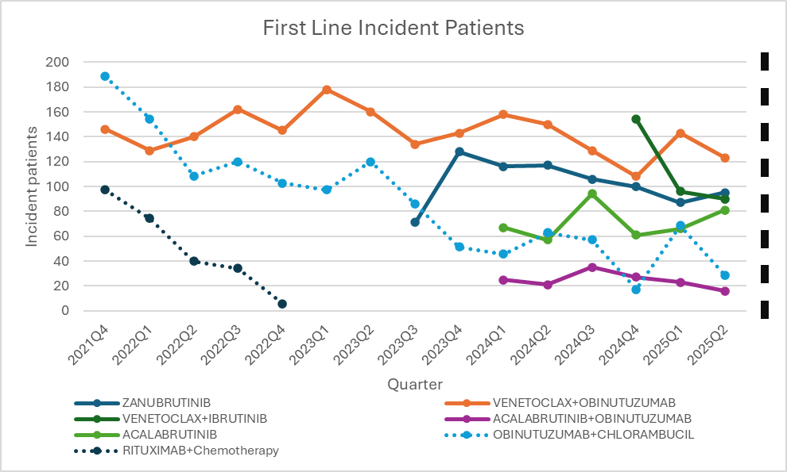
Figure 1: Number of treated first line incident patients by quarter
Note:
Patient numbers for obinutuzumab and chlorambucil and rituximab and chemotherapy (dotted line) are marked on the secondary axis. Patient numbers have been redacted as numbers are small.
Does not include numbers for venetoclax dose modification.
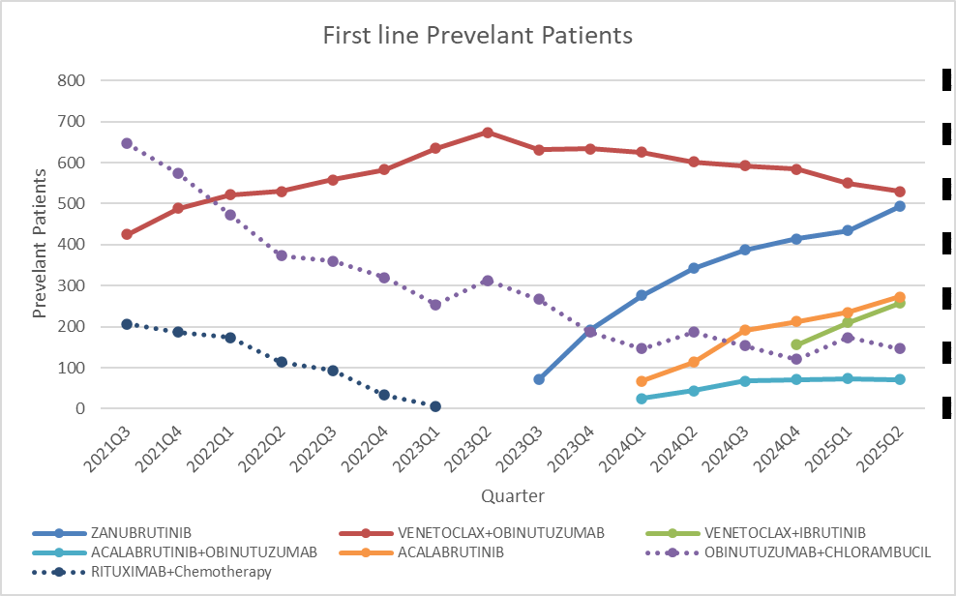
Figure 2: Number of treated first line prevalent patient by quarter
Note:
Patient numbers for obinutuzumab and chlorambucil and rituximab and chemotherapy (dotted line) are marked on the secondary axis. Patient numbers have been redacted as numbers are small.
Does not include numbers for venetoclax dose modification.

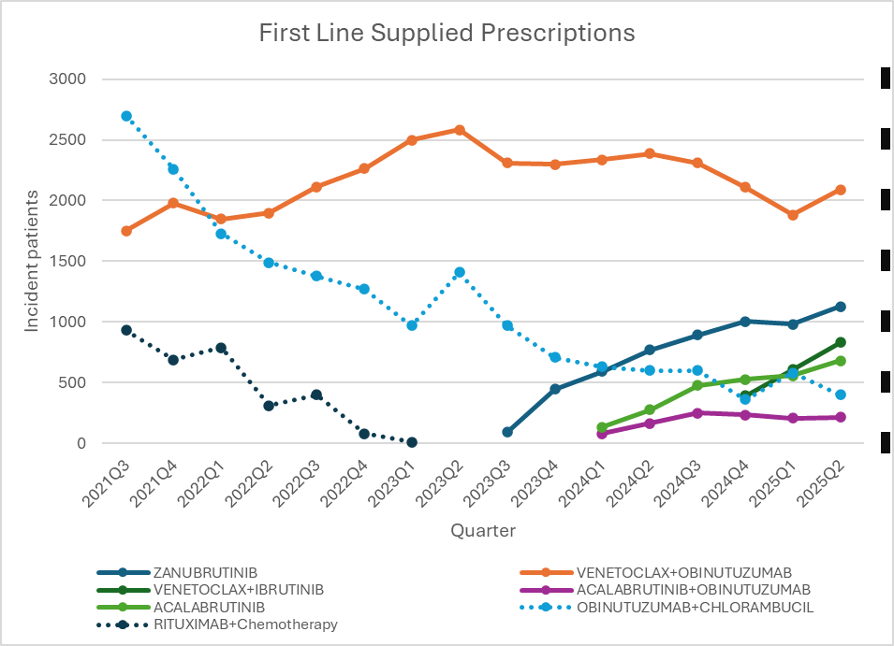
Figure 3: Number of first line prescriptions supplied by quarter
Note:
Script numbers for obinutuzumab and chlorambucil and rituximab and chemotherapy (dotted line) are marked on the secondary axis. Patient numbers have been redacted as numbers are small.
Does not include numbers for venetoclax dose modification.

Figure 4: Number of first line incident patients, prevalent patients and prescriptions supplied by quarter

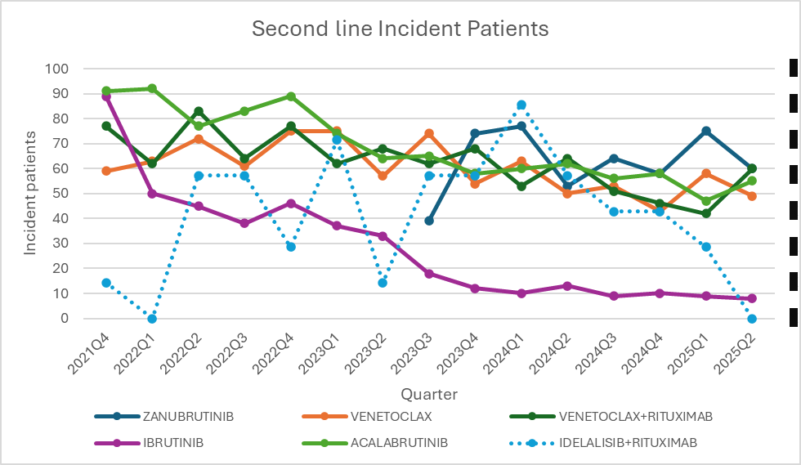
Figure 5: Number of treated second line incident patients by quarter
Note:
Patient numbers for idelalisib and rituximab (dotted line) are marked on the secondary axis. Patient numbers have been redacted as numbers are small.
Does include numbers for venetoclax dose modification.

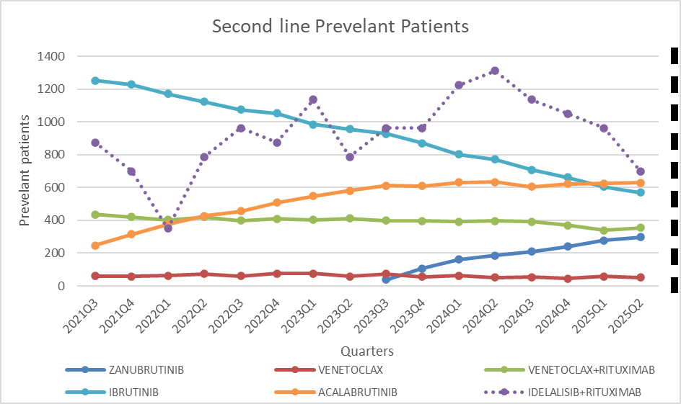
Figure 6: Number of treated second line prevalent patients by quarter
Note:
Patient numbers for idelalisib and rituximab (dotted line) are marked on the secondary axis. Patient numbers have been redacted as numbers are small.
Does include numbers for venetoclax dose modification.

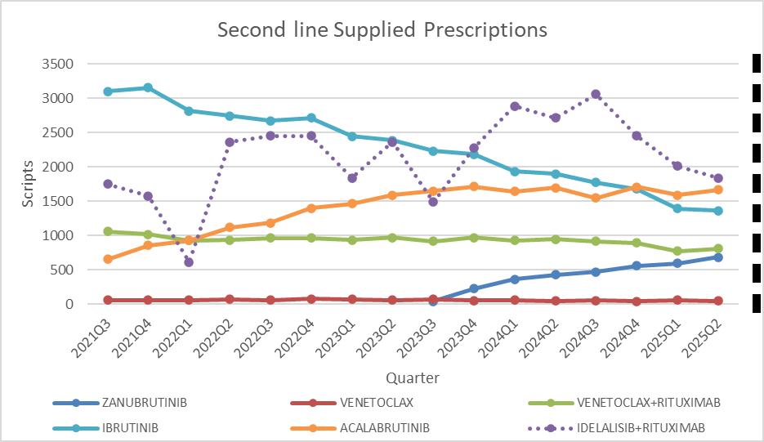
Figure 7: Number of second line prescriptions supplied by quarter
Note:
Script numbers for idelalisib and rituximab (dotted line) are marked on the secondary axis. . Patient numbers have been redacted as numbers are small.
Does include numbers for venetoclax dose modification.

Figure 8: Number of second line incident patients, prevalent patients and prescriptions supplied by quarter
Table 10: Venetoclax dose modification for first line therapy incident, prevalent patients, and prescriptions supplied

Financial year | Incident patients | Prevalent patients | Supplied prescriptions
2021-22 | 27 | 27 | 37
2022-23 | 50 | 52 | 99
2023-24 | 55 | 61 | 140
2024-25 | 50 | 56 | 112

Utilisation by relevant sub-populations/regions or patient level analysis
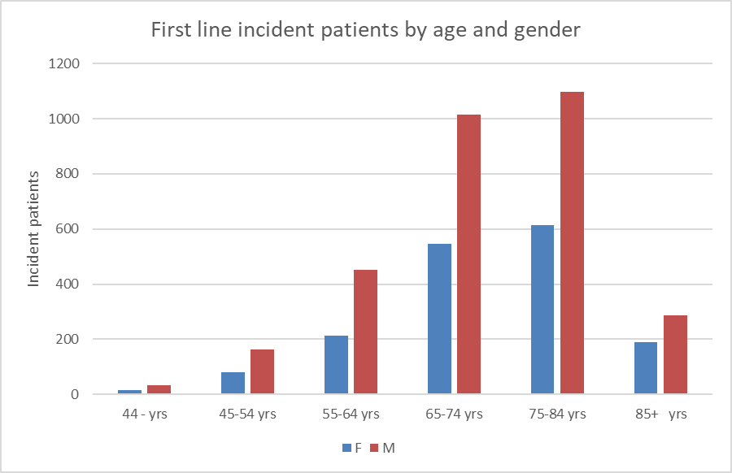
Figure 9: Incident patients supplied first line CLL/SLL drugs by gender and 10-year age group for the period 1 July 2021 to 30 June 2025
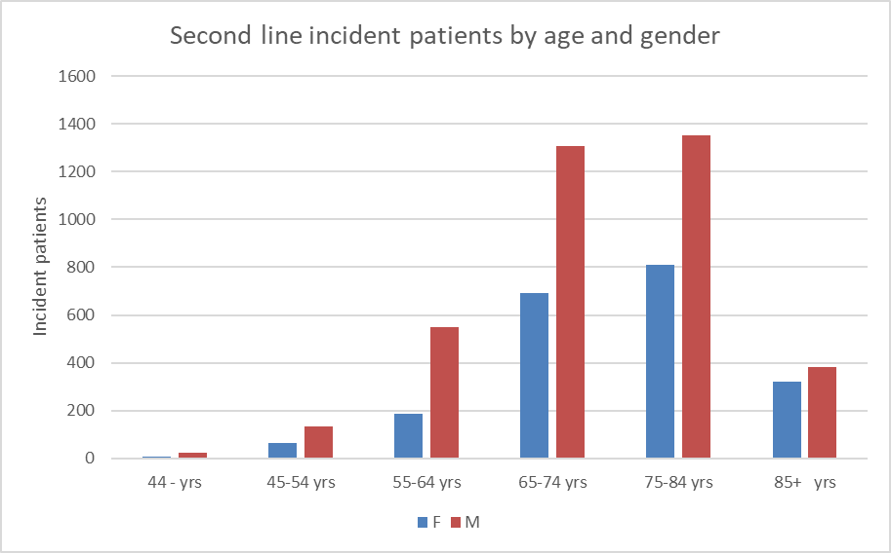
Figure 10: Incident patients supplied second line CLL/SLL drugs by gender and 10-year age group for the period 1 July 2021 to 30 June 2025

Figure 11: Incident patients for CLL/SLL by gender and 10-year age group for 2020
Age and gender structure for first- and second-line therapies match that for the disease, with the ratio of male to female incident patients (approx. 2:1) also matching that of the disease.

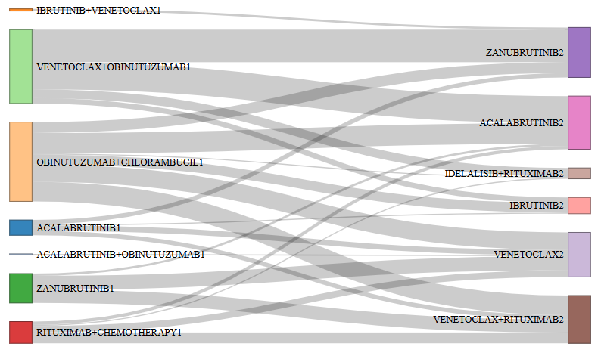
Figure 12: Sankey diagram of patient pathways following initiation on first line to second line therapy for CLL/SLL

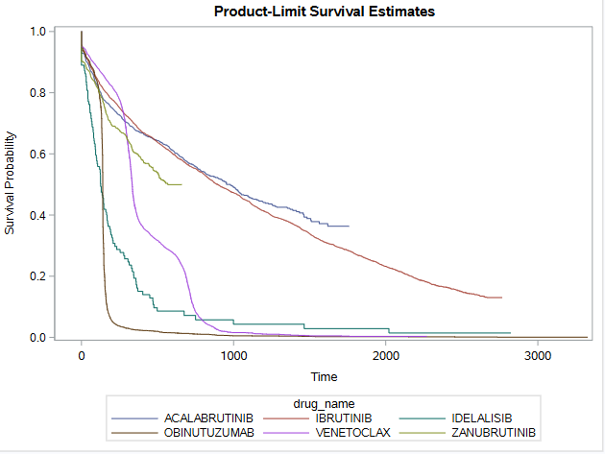
Figure 13: Time on treatment for CLL/SLL drugs in days including breaks in treatment

Figure 13 shows the time on treatment in days for CLL/SLL drugs including treatment breaks. This analysis used prescription data at any line of therapy. The median treatment duration for acalabrutinib was 979 days with 57.3% of patients censored. For ibrutinib the median was 896 days with 24.5% censored. For idelalisib it was 126 days with 7.3% censored and for obinutuzumab it was 140 days with 7.8% censored. For venetoclax it was 333 days with 23.9% censored and for zanubrutinib it was 567 days with 64.4% censored.

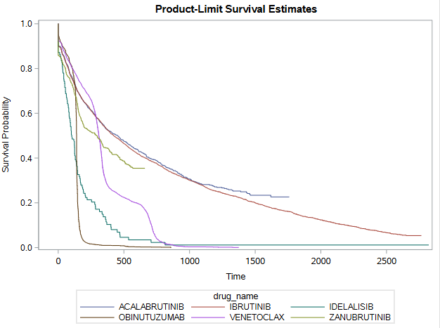

Figure 14: Time on treatment for CLL/SLL drugs in days without treatment breaks

Figure 14 shows the time on treatment in days for CLL/SLL drugs without treatment breaks. This analysis used prescription data at any line of therapy. The median treatment duration for acalabrutinib was 452 days with 43.4% of patients censored. For ibrutinib the median was 423 days with 15.0% censored. For idelalisib it was 103 days with 5.5% censored and for obinutuzumab it was 140 days with 7.5% censored. For venetoclax it was 309 days with 21.2% censored and for zanubrutinib it was 291 days with 52.2% censored.

Additional time sequence analysis based on the line of therapy is provided at Addendum 1.

When analysing the time on treatment data it should be noted that therapy with Bruton's tyrosine kinase inhibitors (acalabrutinib, zanubrutinib, and ibrutinib) and Phosphatidylinositol-3-kinase inhibitor (idelalisib) is continuous until progression or intolerance. While therapy with CD20 (Clusters of Differentiation 20) inhibitors (obinutuzumab, rituximab) or B-cell lymphoma-2 inhibitor (venetoclax) containing regimens are time limited.

Figure 15: Cost to government for first line therapies for CLL/SLL
Note:
Does not include costs for venetoclax dose modification.
The cost to government is based on the published list prices of the medicines. Where Special Pricing Arrangements apply (See Appendix 1) the actual cost to government may be lower than indicated.

Figure 16: Cost to government for second line therapies for CLL/SLL.
Note:
Includes costs for venetoclax dose modification.
The cost to government is based on the published list prices of the medicines. Where Special Pricing Arrangements apply (See Appendix 1) the actual cost to government may be lower than indicated.

Table 11: Cost to Government Dose Modification in First Line Therapy
Financial Year | Cost to Government
2020-21 | $4,680
2021-22 | $27,331
2022-23 | $66,716
2023-24 | $70,843
2024-25 | $47,158
Note:
Treatment is for dose titration purposes were dosing interruption and/or dose reduction for adverse reactions may be required.
The cost to government is based on the published list prices of the medicine. Where Special Pricing Arrangements apply (See Appendix 1) the actual cost to government may be lower than indicated.

Figure 17: Supply settings for first line therapies

Figure 18: Supply settings for second line therapies

Table 12: Percentage of prescriptions supplied by prescriber type
Speciality | First line | Second
Haematology | 61.9% | 59.5%
Pathology | 15.2% | 15.0%
NONVRGP | 14.3% | 9.7%
Internal Medicine | 3.2% | 4.9%
Other | 5.5% | 10.9%
Note:
NONVRGP = Non-vocationally registered GP

Discussion
Over the analysis period there has been an increase in the number of first-line incident and prevalent patients treated since the third quarter (Q3) of 2023 (Figure 4) particularly since the PBS listing of zanubrutinib, acalabrutinib, and venetoclax in combination with ibrutinib with a lessor contribution from acalabrutinib in combination with obinutuzumab (Figure 1). This has to some extent been counterbalanced by a decrease in the use of obinutuzumab in combination with chlorambucil. However, the growth in incident patients since the PBS listing of the above therapies is slowing suggesting that the increase seen since Q3 of 2023 is likely to plateau in the near future. Obinutuzumab in combination with chlorambucil and rituximab in combination with chemotherapy (which does not appear to be currently used in therapy) was replaced with venetoclax in combination with obinutuzumab. The number of incident patients increased with the PBS listings of zanubrutinib, acalabrutinib, venetoclax in combination with ibrutinib, and acalabrutinib in combination with obinutuzumab.
The number of second-line incident and prevalent patients treated has remained constant over the analysis period (Figure 8). This is most likely due to the declining use of ibrutinib and to a smaller extent venetoclax in combination with rituximab being counter balanced by the increasing use of acalabrutinib and zanubrutinib (Figure 5).
When analysing the number of prevalent patients it should be noted that therapy with Bruton's tyrosine kinase inhibitors (acalabrutinib, zanubrutinib, and ibrutinib) and Phosphatidylinositol-3-kinase inhibitor (idelalisib) is continuous until progression or intolerance. While therapy with CD20 (Clusters of Differentiation 20) inhibitors (obinutuzumab, rituximab) or B-cell lymphoma-2 inhibitor (venetoclax) containing regimens are time limited. This affects the number of prevalent patients on these therapies as continuous therapies will have a larger prevalent pool than time limited therapies
Similar median times on treatment with idelalisib were seen in the treatment of refractory follicular B-cell non-Hodgkin's lymphoma, with breaks being 130 days and without breaks 89 days.
The cost to government for first line therapy (Figure 15) has increased largely as a result of the introduction of zanubrutinib, and to a lesser extent acalabrutinib and venetoclax in combination with ibrutinib and acalabrutinib in combination with obinutuzumab. As suggested by the increased number of incident patients, the cost to government of first line therapy is likely to continue to increase at least in the short term.
The cost to government for second line therapy (Figure 16) has generally been stable largely driven by the decreased use of ibrutinib, counterbalanced to some extent with the increased use of zanubrutinib and acalabrutinib. However, with the increased use of first line therapies, the cost of second line therapies is likely to increase in the near term as additional patients transition to second line therapy. It should be noted that the cost to government for 2024-25 may be actually higher than that indicated as data was extracted in early July 2025 so not all claims’ data may have been processed.
DUSC consideration
DUSC noted that there was an increase in first-line incident and prevalent patients, and scripts dispensed in the third quarter of 2023 which coincided with the PBS listing of zanubrutinub on 1 September of 2023, and by the listing of acalabrutinib and acalabrutinib in combination with obinutuzumab on 1 January 2024. DUSC considered that there was a decreasing use of chemoimmunotherapy but noted that fludarabine use is difficult to capture. DUSC considered that this change was due, in part, to the new drugs having an easier route of administration (oral vs IV). DUSC considered that the decrease in the use of rituximab in combination with chemotherapy and obinutuzumab in combination with chlorambucil is likely due to the increase in uptake of venetoclax. DUSC considered that the incident patients in first-line therapy appears to be plateauing with the prevalent pool increasing over time due the Bruton's tyrosine kinase inhibitor (BTKi) therapies being continuous until disease progression. In their Pre-Sub-Committee Response (PSCR) the XXXXXXXXXXXXXXXXX noted that frontline prescribing has shifted rapidly towards novel agents following the PBS listing expansions in 2023–24, with chemoimmunotherapy use now minimal, with treatment choice being guided by TP53 status, comorbidities, and patient preference, with BTKi and venetoclax-based regimens both central to practice. In their PSCR, XXXXXXXXXXXXXXXXXX considered that if the number of first-line incident and prevalent patients has increased and second-line has not increased, then this may mean that the first-line treatment is working giving an extension to the remission period.
DUSC noted that the number of second-line incident and prevalent patients treated, and scripts dispensed has remained constant over the analysis period. DUSC noted that second-line therapy options are to switch between venetoclax based and BTKi based regimes. DUSC considered that there is no clear preferred second-line therapy and that some of the variability was due to patient and physician preferences (such as preference for fixed vs. continuous treatment regimens) and the development of intolerance. DUSC considered that the decrease in ibrutinib was due to the PBS listing and uptake of zanubrutinib, with the fluctuating use of idelalisib in combination with rituximab likely being due to the small numbers of patients being treated with this combination. DUSC considered that the overall prevalence of second-line therapies is stable, however DUSC also considered that given the uptake in first-line therapy and the potential for resistance to appear there will likely be an increase in second-line therapy in the future. In their PSCR, XXXXX noted that second-line prescribing remains stable, reflecting durable responses to novel agents in the first-line setting, but considered that this will likely increase in coming years.
DUSC considered that, overall, the increase in first-line therapies likely reflects new drugs having easier routes of administration and that the change in restrictions to include the International Workshop on CLL (iwCLL) guidelines to guide initiation in September 2023 was unlikely to have led to large increase in incidence. In their PSCR XXXXXXXXXXXX considered that that the removal of the criteria for a patient to be considered inappropriate for fludarabine based chemo-immunotherapy (September 2023) significantly contributed to the increase in first-line incident and prevalent patients, while XXX considered that the increase in the first-line incident and prevalent patients treated since Q3 2023 was partly a result of the availability of new therapies and how they are prescribed.

DUSC Actions

DUSC considered that the utilisation of the reviewed therapies for CLL/SLL was in line with expectations and that no restriction changes were required.

DUSC requested that the report be provided to the PBAC for consideration.
Context for analysis
The DUSC is a Sub Committee of the Pharmaceutical Benefits Advisory Committee (PBAC). The DUSC assesses estimates on projected usage and financial cost of medicines.
The DUSC also analyses data on actual use of medicines, including the utilisation of PBS listed medicines, and provides advice to the PBAC on these matters. This may include outlining how the current utilisation of PBS medicines compares with the use as recommended by the PBAC.
The DUSC operates in accordance with the quality use of medicines objective of the National Medicines Policy and considers that the DUSC utilisation analyses will assist consumers and health professionals to better understand the costs, benefits and risks of medicines.
The utilisation analysis report was provided to the pharmaceutical sponsors of each drug and comments on the report were provided to DUSC prior to its consideration of the analysis.
Sponsors’ comments
Roche Products Pty Ltd: The sponsor has no comment.
BeOne Medicines AUS Pty Ltd: The sponsor has no comment.
Janssen-Cilag Pty Ltd : The sponsor has no comment.
AbbVie Pty Ltd: The sponsor has no comment.
AstraZeneca Pty Ltd: The sponsor has no comment.
Gilead Sciences Pty Limited: The sponsor has no comment.
Sandoz Pty Ltd: The sponsor has no comment.
Celltrion Healthcare Australia Pty Ltd: The sponsor has no comment.
Pfizer Australia Pty Ltd: The sponsor has no comment.
Disclaimer
The information provided in this report does not constitute medical advice and is not intended to take the place of professional medical advice or care. It is not intended to define what constitutes reasonable, appropriate or best care for any individual for any given health issue. The information should not be used as a substitute for the judgement and skill of a medical practitioner.
The Department of Health, Disability and Ageing has made all reasonable efforts to ensure that information provided in this report is accurate. The information provided in this report was up-to-date when it was considered by the Drug Utilisation Sub-committee of the Pharmaceutical Benefits Advisory Committee. The context for that information may have changed since publication.
To the extent provided by law, the Department of Health, Disability and Ageing makes no warranties or representations as to accuracy or completeness of information contained in this report.
To the fullest extent permitted by law, neither the Department of Health, Disability and Ageing nor any Department of Health, Disability and Ageing employee is liable for any liability, loss, claim, damage, expense, injury or personal injury (including death), whether direct or indirect (including consequential loss and loss of profits) and however incurred (including in tort), caused or contributed to by any person’s use or misuse of the information available from this report or contained on any third party website referred to in this report.

Appendix A

PBS listings details (as of 2 July 2025)

Source: the PBS website.

Table A1: PBS listing of Acalabrutinib for CLL/SLL
Item | Name, form & strength, pack size | Max. quant packs. | Rpts | DPMQ | Brand name and manufacturer
13318Y | Acalabrutinib 100 mg tablet, 56 | 1 | 5 | $7414.90 | CALQUENCE, AstraZeneca Pty Ltd
13792X | Acalabrutinib 100 mg tablet, 56 | 1 | 5 | $7414.90 | CALQUENCE, AstraZeneca Pty Ltd
13810W | acalabrutinib 100 mg tablet, 56 | 1 | 6 | $7414.90 | CALQUENCE, AstraZeneca Pty Ltd
Special Pricing Arrangements apply.

Table A2: PBS listing of Ibrutinib for CLL/SLL
Item | Name, form & strength, pack size | Max. quant packs. | Rpts | DPMQ | Brand name and manufacturer
11213E | Ibrutinib 140 mg capsule, 90 | 1 | 5 | $7954.48 | Imbruvica, Janssen-Cilag Pty Ltd
14074R | Ibrutinib 280 mg tablet, 30 | 1 | 5 | $5357.30 | Imbruvica, Janssen-Cilag Pty Ltd
14085H | Ibrutinib 420 mg tablet, 30 | 1 | 5 | $7954.48 | Imbruvica, Janssen-Cilag Pty Ltd
14579H | Ibrutinib 280 mg tablet, 30 | 1 | 5 | $5357.30 | Imbruvica, Janssen-Cilag Pty Ltd
14580J | Ibrutinib 280 mg tablet, 30 | 1 | 2 | $5357.30 | Imbruvica, Janssen-Cilag Pty Ltd
14596F | Ibrutinib 140 mg capsule, 90 | 1 | 4 | $7954.48 | Imbruvica, Janssen-Cilag Pty Ltd
14597G | Ibrutinib 140 mg capsule, 90 | 1 | 2 | $7954.48 | Imbruvica, Janssen-Cilag Pty Ltd
14598H | Ibrutinib 420 mg tablet, 30 | 1 | 2 | $7954.48 | Imbruvica, Janssen-Cilag Pty Ltd
14603N | Ibrutinib 420 mg tablet, 30 | 1 | 5 | $7954.48 | Imbruvica, Janssen-Cilag Pty Ltd
14604P | Ibrutinib 140 mg capsule, 90 | 1 | 5 | $7954.48 | Imbruvica, Janssen-Cilag Pty Ltd
14612C | Ibrutinib 280 mg tablet, 30 | 1 | 4 | $5357.30 | Imbruvica, Janssen-Cilag Pty Ltd
14613D | Ibrutinib 140 mg capsule, 90 | 1 | 5 | $7954.48 | Imbruvica, Janssen-Cilag Pty Ltd
14619K | Ibrutinib 420 mg tablet, 30 | 1 | 5 | $7954.48 | Imbruvica, Janssen-Cilag Pty Ltd
14620L | Ibrutinib 280 mg tablet, 30 | 1 | 5 | $5357.30 | Imbruvica, Janssen-Cilag Pty Ltd
14621M | Ibrutinib 420 mg tablet, 30 | 1 | 4 | $7954.48 | Imbruvica, Janssen-Cilag Pty Ltd
Special Pricing Arrangements apply.

Table A3: PBS listing of Idelalisib for CLL/SLL
Item | Name, form & strength, pack size | Max. quant packs. | Rpts | DPMQ | Brand name and manufacturer
11162L | Idelalisib 150 mg tablet, 60 | 1 | 5 | $5119.79 | Zydelig, Gilead Sciences Pty Limited
11170X | Idelalisib 100 mg tablet, 60 | 1 | 5 | $5119.79 | Zydelig, Gilead Sciences Pty Limited
Special Pricing Arrangements apply.

Table A4: PBS listing of Obinutuzumab for CLL/SLL
Item | Name, form & strength, pack size | Max. quant. | Rpts | DPMQ | Brand name and manufacturer
10407R | Obinutuzumab 1 g/40 mL injection, 40 mL vial | 1000 mg | 7 | $4616.75 | Gazyva, Roche Products Pty Ltd
10418H | Obinutuzumab 1 g/40 mL injection, 40 mL vial | 1000 mg | 7 | $4725.78 | Gazyva, Roche Products Pty Ltd
12193R | Obinutuzumab 1 g/40 mL injection, 40 mL vial | 1000 mg | 8 | $4725.78 | Gazyva, Roche Products Pty Ltd
12204H | Obinutuzumab 1 g/40 mL injection, 40 mL vial | 1000 mg | 8 | $4616.75 | Gazyva, Roche Products Pty Ltd
13787P | Obinutuzumab 1 g/40 mL injection, 40 mL vial | 1000 mg | 7 | $4616.75 | Gazyva, Roche Products Pty Ltd
13793Y | Obinutuzumab 1 g/40 mL injection, 40 mL vial | 1000 mg | 7 | $4725.78 | Gazyva, Roche Products Pty Ltd

Table A5: PBS listing of Venetoclax for CLL/SLL
Item | Name, form & strength, pack size | Max. quant packs. | Rpts | DPMQ | Brand name and manufacturer
11630D | Venetoclax 10 mg tablet [14] (&) Venetoclax 50 mg tablet [7] (&) Venetoclax 100 mg tablet [7] (&) Venetoclax 100 mg tablet [14], 1 pack | 1 | 0 | $1706.83 | Venclexta, AbbVie Pty Ltd
11639N | Venetoclax 100 mg tablet, 120 | 1 | 5 | $7404.80 | Venclexta, AbbVie Pty Ltd
11648C | Venetoclax 50 mg tablet, 7 | 1 | 7 | $244.79 | Venclexta, AbbVie Pty Ltd
12188L | Venetoclax 10 mg tablet [14] (&) Venetoclax 50 mg tablet [7] (&) Venetoclax 100 mg tablet [7] (&) Venetoclax 100 mg tablet [14], 1 pack | 1 | 0 | $1706.83 | Venclexta, AbbVie Pty Ltd
12199C | Venetoclax 100 mg tablet, 120 | 1 | 5 | $7404.80 | Venclexta, AbbVie Pty Ltd
12205J | Venetoclax 100 mg tablet, 120 | 1 | 4 | $7404.80 | Venclexta, AbbVie Pty Ltd
12999E | Venetoclax 10 mg tablet, 2 | 7 | 0 | $104.64 | Venclexta, AbbVie Pty Ltd
14581K | Venetoclax 100 mg tablet, 120 | 1 | 4 | $7404.80 | Venclexta, AbbVie Pty Ltd
14584N | Venetoclax 10 mg tablet [14] (&) Venetoclax 50 mg tablet [7] (&) Venetoclax 100 mg tablet [7] (&) Venetoclax 100 mg tablet [14], 1 pack | 1 | 0 | $1706.83 | Venclexta, AbbVie Pty Ltd
14585P | Venetoclax 100 mg tablet, 120 | 1 | 4 | $7404.80 | Venclexta, AbbVie Pty Ltd
14595E | Venetoclax 100 mg tablet, 120 | 1 | 5 | $7404.80 | Venclexta, AbbVie Pty Ltd
14599J | Venetoclax 10 mg tablet [14] (&) Venetoclax 50 mg tablet [7] (&) Venetoclax 100 mg tablet [7] (&) Venetoclax 100 mg tablet [14], 1 pack | 1 | 0 | $1706.83 | Venclexta, AbbVie Pty Ltd
Special Pricing Arrangements apply.

Table A6: PBS listing of Zanubrutinib for CLL/SLL
Item | Name, form & strength, pack size | Max. quant packs. | Rpts | DPMQ | Brand name and manufacturer
13616P | Zanubrutinib 80 mg capsule, 120 | 1 | 5 | $7932.89 | Brukinsa, BeiGene AUS Pty Ltd
13628G | Zanubrutinib 80 mg capsule, 120 | 1 | 5 | $7932.89 | Brukinsa, BeiGene AUS Pty Ltd
Special Pricing Arrangements apply.

Addendum 1

Addendum to Analysis of the utilisation of treatments for chronic lymphocytic leukaemia or small lymphocytic lymphoma – October 2025

Purpose
As part of the Pre-Subcommittee Response process a sponsor identified that it may be useful to delineate time on treatment for different lines of therapy.

Results
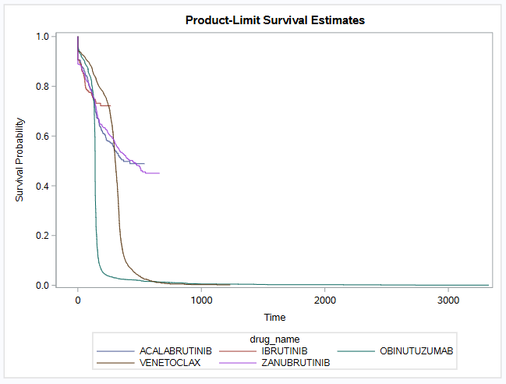

Figure 1A: Time on treatment for first-line CLL/SLL drugs in days including breaks in treatment

Figure 1A shows the time on treatment in days for first-line CLL/SLL drugs including treatment breaks. The median treatment duration for acalabrutinib was 371 days with 64.4% of patients censored. For ibrutinib the median had not been reached, the mean was 146.3 days with 77.8% censored. For obinutuzumab it was 140 days with 7.9% censored. For venetoclax it was 303 days with 23.2% censored and for zanubrutinib it was 444 days with 59.3% censored.

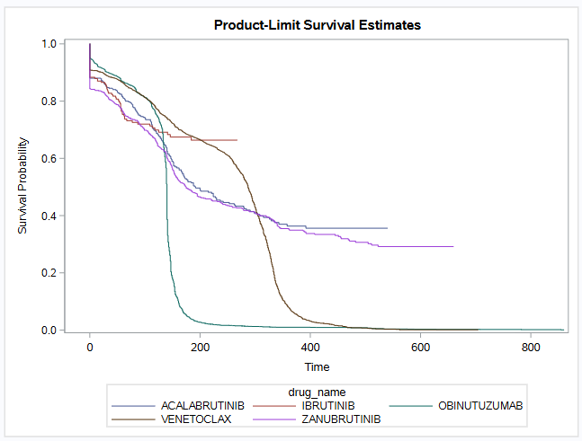
Figure 2A: Time on treatment for first-line CLL/SLL drugs in days without treatment breaks

Figure 2A shows the time on treatment in days for first-line CLL/SLL drugs without treatment breaks. The median treatment duration for acalabrutinib was 191 days with 55.4% of patients censored. For ibrutinib the median had not been reached, the mean was 137.5 days with 73.2% censored. For obinutuzumab it was 140 days with 7.5% censored. For venetoclax it was 287 days with 21.5% censored and for zanubrutinib it was 175 days with 46.2% censored.

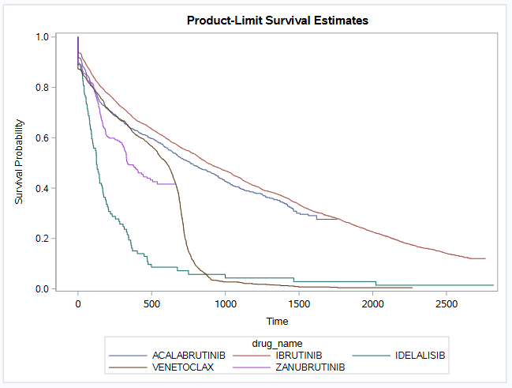
Figure 3A: Time on treatment for second-line CLL/SLL drugs in days including breaks in treatment

Figure 3A shows the time on treatment in days for second-line CLL/SLL drugs including treatment breaks. The median treatment duration for acalabrutinib was 764 days with 46.7% of patients censored. For ibrutinib it was 878 days with 19.7% censored. For idelalisib it was 126 days with 7.3% censored. For venetoclax it was 601 days with 20.2% censored and for zanubrutinib it was 336 days with 58.6% censored.

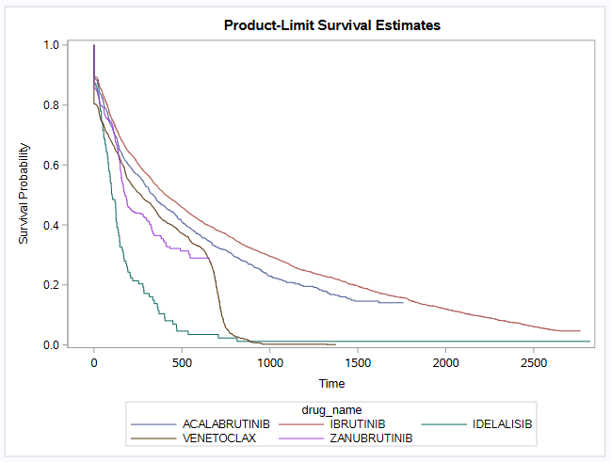
Figure 4A: Time on treatment for second-line CLL/SLL drugs in days without treatment breaks

Figure 4A shows the time on treatment in days for second-line CLL/SLL drugs without treatment breaks. The median treatment duration for acalabrutinib was 337 days with 29.5% of patients censored. For ibrutinib it was 409 days with 10% censored. For idelalisib it was 103 days with 5.5% censored. For venetoclax it was 268 days with 15.6% censored and for zanubrutinib it was 176 days with 48.8% censored.

Definition of CLL OR SLL - NCI Dictionary of Cancer Terms - NCI (accessed 2 July 2025).
Chronic lymphocytic leukaemia (CLL) - Leukaemia Foundation (accessed 2 July 2025).
Chronic lymphocytic leukaemia Australasian consensus practice statement - PubMed (accessed 2 July 2025).
Cancer data in Australia, Blood cancer incidence and survival by histology (experimental data) - Australian Institute of Health and Welfare (accessed 2 July 2025).
Cancer data in Australia, Cancer incidence by age visualisation - Australian Institute of Health and Welfare (accessed 2 July 2025).
Cancer data in Australia, Blood cancer incidence and survival by histology (experimental data) - Australian Institute of Health and Welfare (accessed 2 July 2025).
Pharmaceutical Benefits Scheme (PBS) | Analysis of the utilisation of idelalisib for refractory follicular B-cell non-Hodgkin's lymphoma, October 2024

