Nivolumab for gastro-oesophageal cancers: 24 month predicted versus actual analysis

Drug utilisation sub-committee (DUSC)

June 2025

Abstract

Purpose

Analysis of the predicted versus actual utilisation of nivolumab 24 months following its addition to the Pharmaceutical Benefits Scheme (PBS) for gastro-oesophageal cancers on
1 October 2022.

Data Source / methodology

PBS dispensing data was extracted from the PBS data maintained by the Department of Health and Aged Care, processed by Services Australia.

Key Findings
- The number of prevalent patients has increased steadily from 589 in the first quarter of listing to 1,029 by 2025Q1 while the number of initiating patients has been approximately 280-300 per quarter from the second quarter of listing.
- Both the number of prevalent patients and prescriptions per quarter have appeared to plateau.
- There were 3,301 unique patients by 2025Q1 and the majority were classified as males (2,387) with a median age of 68 years. The remaining 914 patients were classified as female and had a median age of 67 years.
- The median time to resupply for nivolumab was 21 days and the median time on treatment was 168 days.
- Using the Kaplan-Meier analysis and the interquartile range results, the cost per treatment course of nivolumab ranged from $23,647 to $116,148 based on the published prices for the majority of patients.
- Since first listing there have been 3,103 patients who have initiated nivolumab up to 23rd February 2025 and of these, 50.4% may be considered alive according to date of death data up to 23rd February 2025.

Purpose of analysis

Analysis of the predicted versus actual utilisation of nivolumab 24 months following its addition to the Pharmaceutical Benefits Scheme (PBS) for gastro-oesophageal cancers on
1 October 2022.

Background

Clinical situation
Stomach and oesophageal cancers are typically solid tumours formed by an abnormal growth of cells in the stomach or oesophagus. This area of the body is commonly referred to as the upper gastrointestinal tract. Treatment options for gastric-oesophageal cancers depend on location and staging of the disease but may include surgical interventions, radiotherapy and systemic therapies. Systemic therapies can include chemotherapy or immunotherapy with both nivolumab and trastuzumab currently listed for the treatment of gastric-oesophageal cancers.

Pharmacology
Nivolumab is a protein which helps the immune system to attack and destroy cancer cells. It is a human anti PD-1 monoclonal antibody which inhibits the programmed death 1 (PD-1) receptor from binding to its ligands (PD-L1 and PD-L2) on tumour cells, reactivating cytotoxic T lymphocytes and anti-tumour immunity.

Therapeutic Goods Administration (TGA) approved indications
Nivolumab has been approved by the TGA for the following indications:
- Melanoma monotherapy or in combination with ipilimumab
- Non-small cell lung cancer monotherapy or in combination with platinum therapy or ipilimumab
- Malignant pleural mesothelioma in combination with ipilimumab
- Renal cell carcinoma monotherapy or in combination with ipilimumab or cabozantinib
- Classical Hodgkin lymphoma
- Squamous cell carcinoma of the head and neck
- Urothelial carcinoma
- Hepatocellular carcinoma
- Oesophageal squamous cell carcinoma monotherapy or in combination with ipilimumab or platinum therapy
- Adjuvant oesophageal or gastro-oesophageal junction carcinoma
- Gastric cancer, gastro-oesophageal junction carcinoma, or oesophageal adenocarcinoma in combination with platinum therapy.

Dosage and administration
The recommended dose of nivolumab is 360 mg every 3 weeks (30-minute intravenous infusion) with fluoropyrimidine and platinum containing chemotherapy every 3 weeks or 240 mg every 2 weeks (30-minute intravenous infusion) with fluoropyrimidine and platinum containing chemotherapy every 2 weeks.
Treatment should be continued until disease progression, is no longer tolerated or up to 2 years in patients without disease progression.
The current Product Information (PI) and Consumer Medicine Information (CMI) are available from the TGA (Product Information) and the TGA (Consumer Medicines Information).

PBS listing details (as at 31/3/25)

Table 1: PBS listing of nivolumab for advanced or metastatic gastric-oesophageal cancers
Item | Name, form & strength, pack size | Max. quant. | Rpts | DPMQ | Brand name and manufacturer
13117J | Nivolumab, injection  concentrate for  I.V. infusion 100  mg in 10 mL & 40  mg in 4 mL | 480mg | 13 | $9736.96 | Bristol-Myers Squibb Australia Pty Ltd
13121N |  | 480mg | 13 | $9559.69 | Bristol-Myers Squibb Australia Pty Ltd
Source: the PBS website. If a Special Pricing Arrangement is in place this should be noted.

Restriction
Advanced or metastatic gastro-oesophageal cancers

Clinical criteria:
- Patient must have/have had, at the time of initiating treatment with this drug, a WHO performance status no higher than 1,
AND
- Patient must be untreated (up until initiating this drug) with programmed cell death-1/ligand-1 (PD-1/PD-L1) inhibitor therapy for gastro-oesophageal cancer.

Treatment criteria:
- Patient must not be undergoing treatment with this drug as a PBS benefit where the treatment duration extends beyond the following, whichever comes first: (i) disease progression despite treatment with this drug, (ii) 24 months from treatment initiation; annotate any remaining repeat prescriptions with the word 'cancelled' where this occurs.

Population criteria:
- Patient must be in one of the three population subsets described below.

Population 1
Conditions: gastric cancer, gastro-oesophageal junction cancer, oesophageal adenocarcinoma
Concomitant therapies: chemotherapy containing at least a fluoropyrimidine drug plus a platinum drug
Line of treatment: first-line drug treatment
Additional clinical finding: HER2 negative

Population 2
Condition: oesophageal squamous cell carcinoma (can be recurrent)
Concomitant therapies: chemotherapy containing at least a fluoropyrimidine drug plus a platinum drug
Line of treatment: first-line drug treatment
Additional clinical finding: unresectable

Population 3
Condition: oesophageal squamous cell carcinoma (can be recurrent)
Line of treatment: second-line drug treatment after chemotherapy containing at least a fluoropyrimidine drug plus a platinum drug
Additional clinical finding: unresectable

For details of the current PBS listing refer to the PBS website.

Relevant aspects of consideration by the Pharmaceutical Benefits Advisory Committee (PBAC)
The submission was first considered by the PBAC at the November 2021 meeting and was not recommended. The PBAC considered the estimated patient numbers provided with the submission (with the addition of the < 500 patients on compassionate access in the pre-PBAC response) were reasonable but noted there would be an impact on nivolumab utilisation should pembrolizumab be recommended for PBS listing in a similar population. The PBAC also expressed a preference for an aligned restriction across all gastric, gastro-oesophageal junction and oesophageal cancers.
For further details refer to the November 2021 PBAC meeting.
A resubmission was considered by the PBAC out of session at the March 2022 meeting however no substantial changes were made to the financial estimates. The PBAC recommended the submission with an aligned restriction criteria for all ‘gastric-oesophageal cancers’.
For further details refer to the March 2022 PBAC meeting.
The PBAC recommended a submission for nivolumab for second line treatment of oral squamous cell carcinoma in the March 2022 meeting and this was also recommended to be aligned with the overall gastric-oesophageal restriction.
For further details refer to the March 2022 PBAC meeting.

Approach taken to estimate utilisation
The March 2021 submission for nivolumab used an epidemiological approach to estimating use and financial implications. The number of persons diagnosed with GC, GOJC or OC were estimated based on data from the Australian Institute of Health and Welfare (AIHW). The proportion of patients with diagnosed with advanced or metastatic disease and non-HER2 positive was then applied using literature and advisory board recommendations.

Methods
Data from 1 October 2022 to 31 March 2025 were extracted from the PBS data maintained by Department of Health and Aged Care, processed by Services Australia on or before
10 April 2025 for the PBS item codes corresponding to the listings of nivolumab for advanced or metastatic gastric cancers.
PBS prescription data were used to determine the number of prescriptions supplied and the PBS expenditure based on the published list prices. These data were also used to count the number of patients, both incident (new to treatment) and prevalent (number treated in each time period, i.e. year or quarter).
PBS prescription data also contains age and gender information. This information was used to perform a breakdown of prevalent patients by age and gender.
The Kaplan-Meier method was used to determine the length of treatment for patients on nivolumab. A break in treatment was defined as a gap of more than three times the median time between supplies. A patient was deemed to be continuing treatment (classified as censored in the Kaplan-Meier analysis) at the end of the data period (i.e. the end of March 2025) if their last prescription was within three times the median time to resupply of this end date. Otherwise the patient was deemed to have ceased treatment with the treatment coverage end date being the supply date of their last prescription plus a median time to resupply. If a patient’s supply was after a gap of more than three times the median time to resupply, then the patient was deemed to have been re-treated.
The Kaplan-Meier method was repeated for all medicines currently PBS listed for gastric-cancers and the interquartile range, median and mean time on treatments were used to inform an estimate of the cost per treatment course of each medication. This estimate was done using the most commonly dispensed item code and median quantity which was then applied to the currently listed Dispensed Price Maximum Quantity (DPMQ) for that item code available on the PBS website.
Date of death data was provided by Services Australia and current up to 31st August 2024. The number of patients utilising nivolumab for advanced or metastatic cancer were then compared with the date of death data to ascertain the number of patients who had passed away.

Results

Analysis of drug utilisation

Overall utilisation

Figure 1: Utilisation of nivolumab for the treatment of advanced or metastatic gastric-oesophageal cancers
Prescription data between 2022Q4 to 2025Q1 presented as prevalent and initiating patients utilising the PBS item codes related to oesophageal cancers for nivolumab (excluding adjuvant treatments) can be seen in Figure 1. The number of prevalent patients has increased steadily from 589 in the first quarter of listing to 1,029 by 2025Q1 while the number of initiating patients has been approximately 280-300 per quarter from the second quarter of listing. Both the number of prevalent patients and prescriptions per quarter have appeared to plateau.

Utilisation by relevant sub-populations/regions or patient level analysis

Figure 2: Age and gender distribution of patients initiating nivolumab for the treatment of advanced or metastatic gastric-oesophageal cancers
The age and gender distribution for patients initiating on nivolumab can be seen in Figure 3. There were 3,301 unique patients by 2025Q1 and the majority were classified as males (2,387) with a median age of 68 years. The remaining 914 patients were classified as female and had a median age of 67 years.
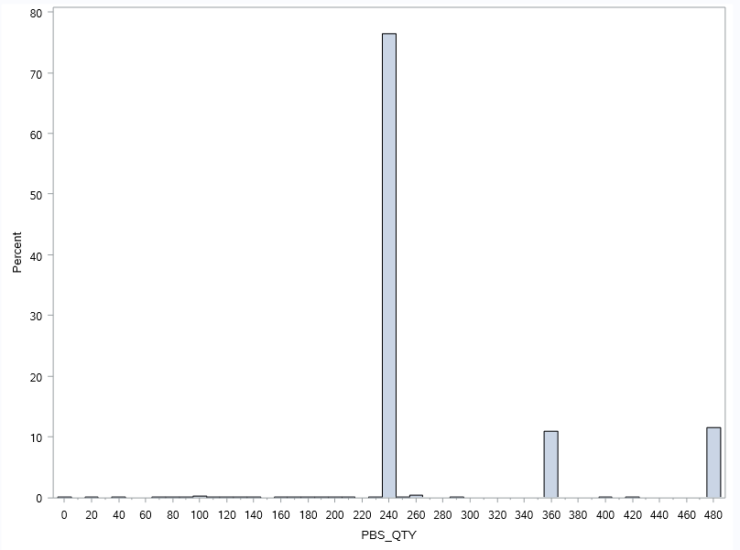

Figure 3: Dose distribution for all nivolumab prescriptions
Approximately 76% of nivolumab prescriptions were dispensed according to the flat-dosing regimen of 240mg and the remaining 24% was split evenly with the 360mg and 480mg flat-dosing regimen (Figure 3).
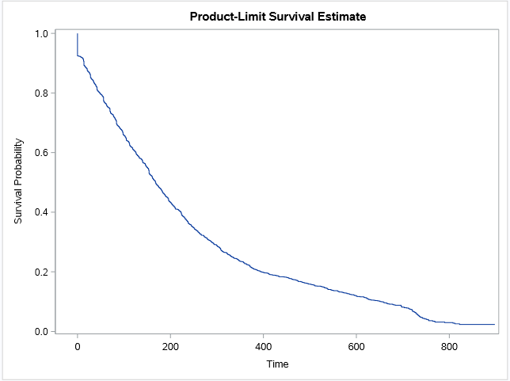
 | Quartile estimates (days) |  |  | Censoring (patients)
 | 25th Percentile | Median | 75th Percentile | Total | Failed | Percent Censored
Nivolumab | 68 | 168 | 334 | 3,241 | 2,387 | 26.35%

Figure 4: Kaplan-Meier analysis of the time on treatment of patients supplied nivolumab for gastric-oesophageal cancers including treatment breaks
The median time to resupply for nivolumab was 21 days. The Kaplan-Meier analysis in Figure 4 includes patients with identified treatment breaks of longer than three times the median time to resupply. Figure 4 shows this analysis where 26.35% of patients were censored and the median time on treatment for the remaining patients was 168 days.

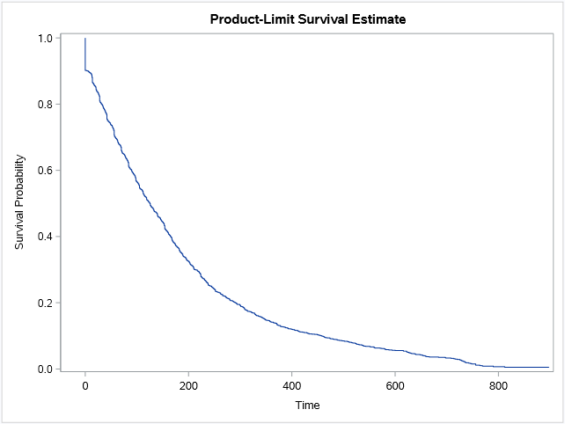
 | Quartile estimates (days) |  |  | Censoring (patients)
 | 25th Percentile | Median | 75th Percentile | Total | Failed | Percent Censored
Nivolumab | 44 | 125 | 244 | 3,241 | 692 | 21.35%

Figure 5: Kaplan-Meier analysis of the time on treatment of patients supplied nivolumab for gastric-oesophageal cancers without treatment breaks
Figure 5 represents a Kaplan-Meier analysis which does not include treatment breaks and therefore is representative of a patient’s first episode of treatment. Approximately 21.35% of patients were censored and the median time on treatment for the remaining patients was 125 days for nivolumab.

Table 2: Basic survival statistics for patients utilising nivolumab for advanced or metastatic gastric-oesophageal cancers
Total initiators (up to 23 February 2025) | Total reported deaths (up to 23 February 2025) | Percent alive
3,103 | 1,536 | 50.4%

Table 2 shows the percentage of patients who began treatment with nivolumab for advanced or metastatic gastric-oesophageal cancers that are still alive according to date of death data up to 23rd February 2025. There have been 3,103 patients who have initiated nivolumab up to 23rd February 2025 and of these 50.4% may be considered alive according to date of death data up to 23rd February 2025.

Changes in the use of other drugs

Figure 6: Number of prevalent patients on all PBS listed medications listed for gastric-oesophageal cancer
The number of prevalent patients per year for all PBS listed medications for gastric-oesophageal cancer can be seen in Figure 6. The number of patients on trifluridine and tipiracil appears to have slightly decreased in the lead up to the listing of nivolumab for gastric-oesophageal cancer in 2022 before rising again in 2024. The listing of nivolumab has had no impact on the utilisation of trastuzumab which is to be expected given the HER2 negative requirement of the nivolumab listing. It is unclear what impact the listing of adjuvant nivolumab has had on the advanced and metastatic listing and further data would be required.

Analysis of expenditure

Figure 7: Cost to the PBS/RPBS for all PBS listed medications listed for gastric-oesophageal cancers

Note: Special pricing arrangements apply for nivolumab and trifluridine+tipiracil and the actual cost to government for these medicines is less than presented.

Figure 7 shows the cost to the government for all PBS listed medications for gastric-oesophageal cancers based on the published prices. Both trastuzumab and trifluridine and tipiracil have cost less than $10 million per year while as of 2024 nivolumab (excl. adjuvant) has cost approximately $90 million.

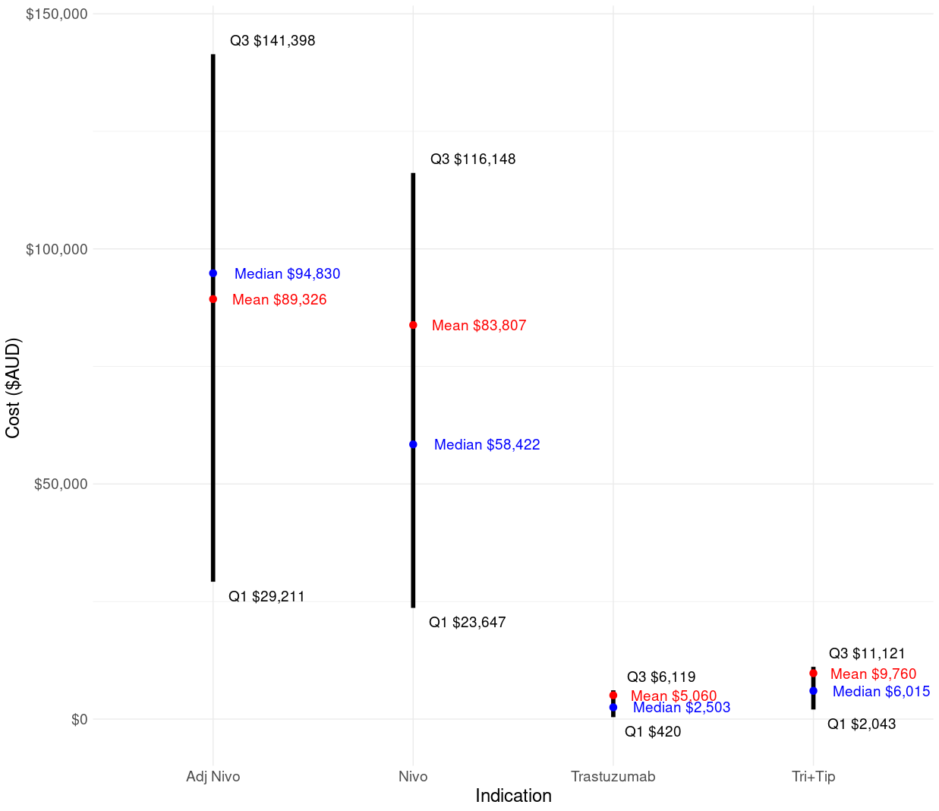
Figure 8: Cost per course of treatment for all PBS listed medications listed for gastric-oesophageal cancers
Note: Treatment durations were based on a Kaplan-Meier analysis where patients were censored if they had a recent prescription within three times the median time to resupply before the end date of the analysis (31/3/2025). Q1 represents the 25th percentile treatment duration and Q3 represents the 75th percentile treatment duration for each indication. Costs were calculated using the latest DPMQs based on the published prices available on the PBS Website for the most common item codes and for the median quantity supplied. Special pricing arrangements apply for nivolumab and trifluridine+tipiracil and the actual cost to government for these medicines is less than presented.
Figure 8 shows the range of cost per treatment based on the interquartile range of treatment durations established through a Kaplan-Meier analysis. The cost per treatment course of nivolumab for advanced or metastatic gastric-oesophageal cancers ranges from $23,647 to $116,148 for the majority of patients. The cost of adjuvant nivolumab is higher than non-adjuvant treatment likely due to the use of higher quantities however it should be noted that adjuvant nivolumab was listed in 2023Q2 and has limited available data.

Analysis of actual versus predicted utilisation

Table 3: Actual versus predicted utilisation and cost to the PBS/RPBS of nivolumab for advanced or metastatic gastric-oesophageal cancers
 |  | Year 1 | Year 2 | Year 3
 |  | 1st October 2022 to 31st September 2023 | 1st October 2023 to 31st September 2024 | 1st October 2024 to 31st September 2025*
Patients | Predicted | XXX | XXX | XXX
 | Actual | 1,472 | 1,851 | 1,399
 | Difference | XXX | XXX | XXX
Prescriptions | Predicted | 22,226 | 20,349 | 20,618
Prescriptions | Actual | 11,981 | 15,286 | 8,404
Prescriptions | Difference | XXX XXX XXX | XXX | XXX
Net Cost PBS/RPBS | Predicted | XXX XXX XXX | XXX XXX XXX | XXX XXX XXX
Net Cost PBS/RPBS | Actual | $66,632,934 | $87,521,145 | $48,754,478
Net Cost PBS/RPBS | Difference | XXX | XXX | XXX
* Year 3 contains data up to March 2025 and is not representative of a full listing year.
Table 3 presents a comparison of the predicted versus actual utilisation and expenditure of nivolumab for gastric-oesophageal cancers since listing in October 2022. In the first year of listing the number of prevalent patients was 1,472 which is XXX to what was predicted. The number of patients in Year 2 was 1,851 which is XXX XXX than what was predicted. The number of prescriptions dispensed in the first year of listing was XXX XXX than what was predicted and the cost to the PBS/RPBS was similarly XXX than predicted. The number of prescriptions in Year 2 was XXX XXX than predicted with a XXX XXX to the cost to PBS/RPBS.

Discussion and DUSC Consideration
DUSC noted the utilisation of nivolumab for advanced or metastatic gastric-oesophageal cancers has been XXX than expected. DUSC noted that the market has become stable and it is unlikely that there will be any substantial growth in the future. However there remains the potential for the market to reduce with the advent of adjuvant nivolumab for stage II or III oesophageal cancer or gastro-oesophageal junction cancer.
DUSC noted actual versus predicted utilisation analysis shows that utilisation in terms of prescription count and costs were XXXXXX XXX than predicted in the initial year of listing despite an accurate accounting of the number of patients. This difference in prescriptions and costs were less apparent in the second year of listing while the number of patients XXX XXX XXX. This suggests that the estimates may have been more accurate if a half cycle correction were applied.

DUSC Actions
DUSC requested that the report be provided to the PBAC for consideration.

Context for analysis
The DUSC is a Sub Committee of the Pharmaceutical Benefits Advisory Committee (PBAC). The DUSC assesses estimates on projected usage and financial cost of medicines.
The DUSC also analyses data on actual use of medicines, including the utilisation of PBS listed medicines, and provides advice to the PBAC on these matters. This may include outlining how the current utilisation of PBS medicines compares with the use as recommended by the PBAC.
The DUSC operates in accordance with the quality use of medicines objective of the National Medicines Policy and considers that the DUSC utilisation analyses will assist consumers and health professionals to better understand the costs, benefits and risks of medicines.
The utilisation analysis report was provided to the pharmaceutical sponsors of each drug and comments on the report were provided to DUSC prior to its consideration of the analysis.

Sponsors’ comments
The sponsor has no comment.

Disclaimer
The information provided in this report does not constitute medical advice and is not intended to take the place of professional medical advice or care. It is not intended to define what constitutes reasonable, appropriate or best care for any individual for any given health issue. The information should not be used as a substitute for the judgement and skill of a medical practitioner.
The Department of Health, Disability and Ageing has made all reasonable efforts to ensure that information provided in this report is accurate. The information provided in this report was up-to-date when it was considered by the Drug Utilisation Sub-committee of the Pharmaceutical Benefits Advisory Committee. The context for that information may have changed since publication.

References
- OPDIVO® (NIVOLUMAB). Consumer Medicine Information. July 2019. Available from https://www.tga.gov.au/consumer-medicines-information-cmi
- Australian Medicines Handbook Online. https://amhonline.amh.net.au/chapters/anticancer-drugs/anticancer-antibodies/nivolumab?menu=hints
- Cancer Australia. (2025, February 1). Stomach cancer statistics. https://www.canceraustralia.gov.au/cancer-types/stomach-cancer/stomach-cancer-statistics

OPDIVO® (NIVOLUMAB). Consumer Medicine Information. July 2019. Available from https://www.tga.gov.au/consumer-medicines-information-cmi
Australian Medicines Handbook Online. https://amhonline.amh.net.au/chapters/anticancer-drugs/anticancer-antibodies/nivolumab?menu=hints
Please note as of June 1st 2025 these criteria have been updated

