Utilisation analysis of cemiplimab for metastatic or locally advanced cutaneous squamous cell carcinoma

Drug utilisation sub-committee (DUSC)

June 2025

Abstract

Purpose
To review the utilisation of cemiplimab Pharmaceutical Benefits Scheme (PBS) listed for metastatic or locally advanced cutaneous squamous cell carcinoma (mCSCC or laCSCC) for patients who are not candidates for curative surgery or curative radiation, as requested by DUSC at its February 2025 meeting.

Date of listing on the Pharmaceutical Benefits Scheme (PBS)
Cemiplimab was first listed on the PBS for mCSCC, laCSCC and non-small cell lung cancer (NSCLC) on 1 November 2022.

Data Source / methodology
Data extracted from the PBS claims database maintained by the Department of Health and Aged Care and processed by Services Australia were used for the analyses. Data were extracted for prescriptions supplied from 1 November 2022 (the PBS listing date for cemiplimab) up to the end of March 2025 for cemiplimab.

Key Findings
- There were 1,535 patients treated with cemiplimab for CSCC in the first year of listing, and 1,930 in the second year. These figures were XXXXXX than predicted at the time of PBS listing.
- The number of cemiplimab prescriptions supplied under the CSCC item code has been steadily increasing since PBS listing. There were 12,819 prescriptions supplied in the first year of listing and 15,633 in the second year.
- The mean ages for patients at initiation were 76 for males and 78 for females, in line with the epidemiology of the condition.
- The median length of treatment for cemiplimab was 8.9 months (38.6 weeks) excluding breaks in supply indicating that the duration of treatment was overestimated at the time of listing.

Purpose of analysis
To review the utilisation of cemiplimab PBS listed for mCSCC or laCSCC for patients who are not candidates for curative surgery or curative radiation, as requested by DUSC at its February 2025 meeting.

Background

Clinical situation
Cutaneous squamous cell carcinoma (CSCC) is the second most common form of skin cancer. Risk factors include exposure to ultraviolet light, immunosuppression, fair skin and advanced age. The majority of CSCC patients can be cured with surgery and/or radiotherapy. However, a small percentage of patients develop locally advanced CSCC (laCSCC) where tumours are large or have penetrated deep into underlying structures and are not amenable to surgery or radiotherapy. Patients may also develop metastatic CSCC (mCSCC) where tumours have spread beyond the original location and this is associated with a poor long-term prognosis.,

Pharmacology
Using synthetic versions of natural immune system chemicals, or by inhibiting proteins that suppress immune functions, immunotherapies boost the immune system’s ability to fight disease. Cemiplimab is the first checkpoint blockade therapy for CSCC. By blocking a protein receptor called PD-1 (programmed death-1), which, under normal circumstances, keeps the immune system in check, cemiplimab releases T cells to target the CSCC.²

Therapeutic Goods Administration (TGA) approved indications
Cemiplimab is approved for the following indications:
- monotherapy for the treatment of adult patients with mCSCC or laCSCC who are not candidates for curative surgery or curative radiation.
- monotherapy for the first-line treatment of adult patients with NSCLC expressing PD-L1 tumour proportion score (TPS) greater than and equal to 50% as determined by a validated test, with no EGFR, ALK or ROS1 aberrations, who have locally advanced NSCLC and who are not candidates for surgical resection or definitive chemoradiation, or metastatic NSCLC.
- in combination with platinum-based chemotherapy is indicated for the first-line treatment of patients with NSCLC whose tumours have no EGFR, ALK or ROS1 aberrations and is locally advanced where patients are not candidates for surgical resection or definitive chemoradiation, or metastatic.
- monotherapy for the treatment of adult patients with locally advanced or metastatic basal cell carcinoma (BCC) previously treated with a hedgehog pathway inhibitor or for whom a hedgehog pathway inhibitor is not appropriate.
Dosage and administration
The recommended dose is 350 mg cemiplimab every 3 weeks administered as an intravenous infusion over 30 minutes. Treatment may be continued until disease progression or unacceptable toxicity. Treatment must be initiated and supervised by physicians experienced in the treatment of cancer.
The current Product Information (PI) and Consumer Medicine Information (CMI) are available from the TGA (Product Information) and the TGA (Consumer Medicines Information).

PBS listing details (as at April 2025)

Table 1: PBS listing of initial treatment phase of cemiplimab for mCSCC or laCSCC
Item | Name, form & strength, pack size | Max. quant. | Rpts | DPMQ | Brand name and manufacturer
13135H | Cemiplimab 350 mg/7 mL injection, 7 mL vial | 350 mg | 2 | $7526.86 | Libtayo, Medison Pharma Australia Pty Ltd
13152F | Cemiplimab 350 mg/7 mL injection, 7 mL vial | 350 mg | 2 | $7380.13 | Libtayo, Medison Pharma Australia Pty Ltd
13153G | Cemiplimab 350 mg/7 mL injection, 7 mL vial | 350 mg | 2 | $7526.86 | Libtayo, Medison Pharma Australia Pty Ltd
13159N | Cemiplimab 350 mg/7 mL injection, 7 mL vial | 350 mg | 2 | $7380.13 | Libtayo, Medison Pharma Australia Pty Ltd
Source: the PBS website.
Caution:
- In the first few months after starting immunotherapy, a transient tumour flare may occur that may be mistaken as disease progression despite an overall positive response to treatment.
Notes:
- No increase in the maximum number of repeats may be authorised.
- Special Pricing Arrangements apply.
- Applications for authorisation under this restriction may be made in real time using the Online PBS Authorities system.

Restriction
Cemiplimab is an Authority Required listing for mCSCC or laCSCC.

Treatment Phase: Initial treatment covering the first 3 treatment cycles
Clinical criteria:
- The condition must be unsuitable for each of (i) curative surgical resection, (ii) curative radiotherapy,
AND
- Patient must have had a WHO performance status of 0 or 1,
AND
- The treatment must be the sole PBS-subsidised therapy for this condition.
Treatment Phase: Continuing treatment
Clinical criteria:
- Patient must have previously received PBS-subsidised therapy with this drug for this condition,
AND
- The treatment must be the sole PBS-subsidised therapy for this condition.
Treatment criteria:
- Patient must not be undergoing treatment with this drug as a PBS benefit where the treatment duration extends beyond the following, whichever comes first:
- disease progression despite treatment with this drug,
- 24 months from treatment initiation; annotate any remaining repeat prescriptions with the word 'cancelled' where this occurs.
For details of the current PBS listing refer to the PBS website.

Relevant aspects of consideration by the Pharmaceutical Benefits Advisory Committee (PBAC)
November 2020
The submission requested a Section 100 listing (Efficient Funding of Chemotherapy)
for cemiplimab for the treatment of patients with mCSCC or laCSCC who are not candidates for curative surgery or curative radiation. The PBAC did not recommend cemiplimab and considered that the data presented were insufficient to adequately determine the magnitude of improvement in effectiveness and safety of cemiplimab compared to best supportive care ± chemotherapy (BSC ± CT) with the comparison of single arm studies highly uncertain. The PBAC considered the incremental cost-effectiveness ratio (ICER) was highly uncertain given the limitations with the clinical data, and substantially underestimated. The PBAC considered the financial impact as estimated in the submission was uncertain and potentially very high.

For further details refer to the Public Summary Document from the November 2020 PBAC meeting.
March 2022
The requested indication in the standard re-entry resubmission was unchanged from the previous submission considered by the PBAC in November 2020. Listing was requested on the basis of a cost-utility analysis versus BSC with or without CT.

The PBAC was satisfied that cemiplimab provides, for some patients, improvement in efficacy over BSC ± CT. The PBAC considered that, while the magnitude of difference in effectiveness of cemiplimab remains uncertain, there is a high unmet clinical need in this population with potential for quality of life (QoL) benefits not encompassed in the available data. The PBAC’s recommendation for listing was based on, among other matters, its assessment that the subsequent uncertainty in the incremental cost-effectiveness ratio (ICER) could be addressed through a lower ICER threshold and resulting price reduction. The PBAC considered the exclusion of patients with an ECOG performance status (PS) of 2 or more appropriate and considered the financial estimates should be amended accordingly. In addition, the PBAC considered a risk sharing arrangement appropriate to manage the risk of use beyond the restriction.

For further details refer to the Public Summary Document from the March 2022 PBAC meeting.

Approach taken to estimate utilisation
The March 2022 resubmission was not considered by DUSC, however the November 2020 submission was. As in the previous submission, the resubmission took an epidemiological approach to estimate the financial impact of the proposed listing of cemiplimab. DUSC considered the estimates presented in the November 2020 submission to be underestimated. The main issues were related to the estimated proportion of laCSCC and mCSCC, not considering patients progressing from earlier stages of disease, using a mixed prevalence and incidence approach rather than a prevalence approach in all six years of estimates, the inclusion of grandfathered patients as an addition to prevalent patients in calculating the number of patients likely to receive cemiplimab in the first year of listing and the underestimated uptake of cemiplimab.

For further details refer to the Public Summary Document from the March 2022 PBAC meeting.

Methods
Data extracted from the PBS claims database maintained by the Department of Health and Aged Care and processed by Services Australia were used for the analyses. Data were extracted for prescriptions supplied from 1 November 2022 (the PBS listing date for cemiplimab) up to the end of March 2025 for cemiplimab.
As this analysis uses date of supply prescription data, there may be small differences compared with publicly available Services Australia Medicare date of processing data. The publicly available Services Australia Medicare data only includes subsidised R/PBS prescriptions with prescriptions under the patient co-payment not included. The Services Australia Medicare data used in this report includes under co-payment prescriptions from 1 April 2012.
Prevalent and initiating patient counts were based on unique patient identifiers in the PBS prescription data. Time of initiation was based on the date of supply of a patient’s first prescription for each indication.
Length of treatment was estimated using Kaplan-Meier survival analysis to account for the varying length of follow up from initiation for each patient and the fact that many patients are still on treatment at the end of the data period.

Results

Analysis of drug utilisation

Overall utilisation
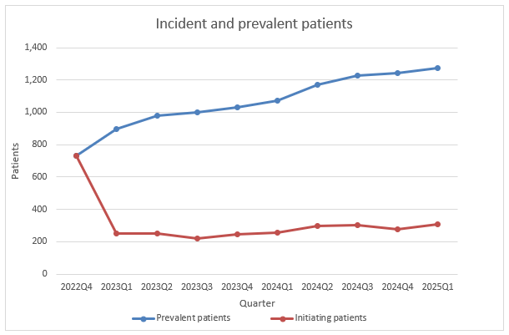
Figure 1: Trend in treated incident and prevalent patients by quarter for cemiplimab for CSCC

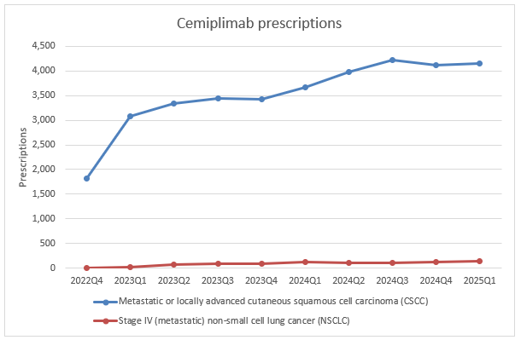
Figure 2: Number of prescriptions by quarter of supply for cemiplimab for CSCC and NSCLC
Figures 1 and 2 show a trend of increasing numbers of prevalent patients and prescriptions since PBS listing. The number of prescriptions for NSCLC were comparatively low and any miscoding for this indication would have minimal impact on the trends in the CSCC indication.

Utilisation by relevant sub-populations and patient level analysis
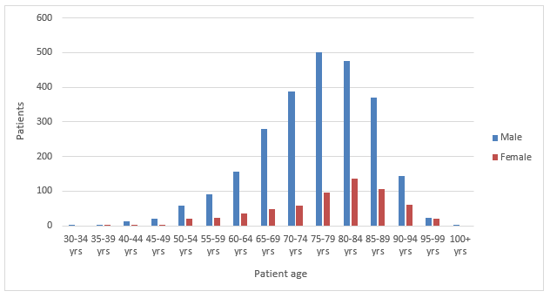
Figure 3: Incident patients of cemiplimab for CSCC by gender and 5-year age group for the period 1/11/2022 (date of listing) to the end of March 2025
Table 2: Mean and median ages at initiation for males and females in Figure 3
 | Male | Female
Mean age (years) | 76 | 78
Median age (years) | 77 | 80

The above Figure 3 and Table 2 illustrate that the most common ages at initiation for the cemiplimab indication are those 75 years and older. This is in line with advanced age being one of the major risk factors for the condition.

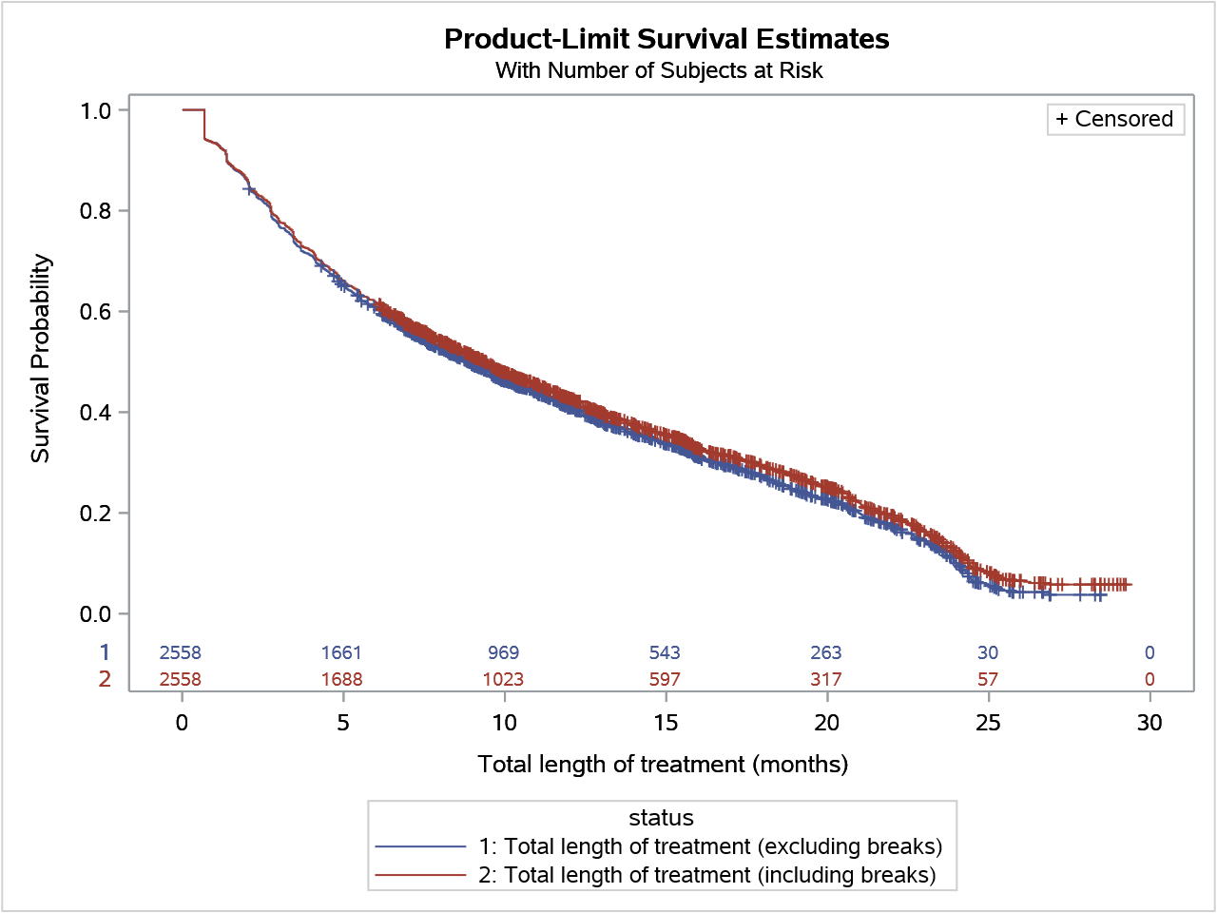
Figure 4: Duration of treatment with cemiplimab for CSCC
The length of treatment with cemiplimab for CSCC was calculated both including and excluding breaks. The median time to re-supply of scripts was 21 days and a break in treatment was deemed to be 3 x the median time to re-supply = 63 days or greater between scripts. The data used to produce Figure 4 show that median length of treatment was 8.9 months excluding breaks and 9.4 months including breaks. If each script is estimated to cover 21 days, 8.9 months excluding breaks equates to 12.6 prescriptions. Figure 4 was produced using Kaplan-Meier survival analysis. A patient was considered to be continuing treatment (i.e. censored) at the end of the analysis period (i.e. 31 March 2025) if they were supplied a prescription within 3 x the median time to re-supply (i.e. 63 days) of the end of the data period. In addition, even though Kaplan-Meier analysis takes into account varying lengths of follow, patients that initiated treatment within 6 months of the end of the data period were deemed that have too short a follow up period and so were excluded from the analysis.

Analysis of expenditure
Cemiplimab has a special pricing arrangement.

Analysis of actual versus predicted utilisation
Table 3: Predicted and actual numbers of patients and prescriptions for the first two years of listing
 |  | Year 1 (Nov 2022 – Oct 2023) | Year 2 (Nov 2023 – Oct 2024)
Patients | Predicted | XXXXX | XXXXX
Patients | Actual | 1,535 (XXXX%) | 1,930 (XXXX%)
Prescriptions | Predicted | XXXXX | XXXXX
Prescriptions | Actual | 12,819 (XXXX%) | 15,633 (XXXX%)
Prescriptions per patient | Predicted | XXXXX | XXXXX
Prescriptions per patient | Actual | 8.35 | 8.1

Table 3 indicates that the actual utilisation has been XXXXX than the predicted patient and prescription numbers at the time of listing. The actual number of prescriptions per patient in each year of listing was XXXXX than predicted.

Discussion and DUSC Consideration
Given the paucity of epidemiology data for mCSCC or laCSCC in the Australian population, the estimates for utilisation of cemiplimab were uncertain at the time of listing. DUSC considered this submission for the November 2020 PBAC meeting and was of an opinion at the time that there was a risk of use outside the proposed restrictions in patients with borderline resectable disease. DUSC also considered that there was a risk of use outside the proposed restrictions as neoadjuvant and adjuvant treatment, i.e. to treat patients so they become candidates for curative surgery or curative radiation, or increase the likelihood of surgery or radiation being curative. Both the actual patient and prescription numbers are XXXXX than estimated and appear to be continuing to grow. DUSC noted that the number of initiating patients each year was increasing therefore it was likely that prevalence had not yet been reached. DUSC discussed that there is likely some use of cemiplimab outside of the restriction by older patients who are poor surgical candidates, and that this was clinically appropriate.
The aetiology for CSCC includes advanced age and skin exposure to ultraviolet light. DUSC noted that the age of patients at initiation for CSCC was generally advanced, in line with the literature.
The mean treatment duration of cemiplimab at the time the medicine was reconsidered by the PBAC was 57.97 weeks based on the data from the pivotal studies. DUSC considered this to likely be overestimated as the PBS population was likely to be older and frailer than the patients in the clinical studies. DUSC noted that the median length of treatment was 8.9 months (38.6 weeks) excluding breaks indicating that the duration of treatment was overestimated at the time of listing. The number of prescriptions per patient was XXXXX. DUSC discussed that the shorter treatment duration in practice could be attributed to a good clinical response to cemiplimab and the cessation of treatment earlier than intended to avoid toxicity in older patients.
DUSC noted that whilst the utilisation had been XXXXX than predicted, the Risk Share Arrangement mitigates the cost to government for cemiplimab. DUSC noted that the utilisation could be reviewed in the future.

DUSC Actions
DUSC requested that the report be provided to the PBAC for consideration.

Context for analysis
The DUSC is a Sub Committee of the Pharmaceutical Benefits Advisory Committee (PBAC). The DUSC assesses estimates on projected usage and financial cost of medicines.
The DUSC also analyses data on actual use of medicines, including the utilisation of PBS listed medicines, and provides advice to the PBAC on these matters. This may include outlining how the current utilisation of PBS medicines compares with the use as recommended by the PBAC.
The DUSC operates in accordance with the quality use of medicines objective of the National Medicines Policy and considers that the DUSC utilisation analyses will assist consumers and health professionals to better understand the costs, benefits and risks of medicines.
The utilisation analysis report was provided to the pharmaceutical sponsor of the drug and comments on the report were provided to DUSC prior to its consideration of the analysis.

Sponsor comments
The sponsor has no comment.

Disclaimer
The information provided in this report does not constitute medical advice and is not intended to take the place of professional medical advice or care. It is not intended to define what constitutes reasonable, appropriate or best care for any individual for any given health issue. The information should not be used as a substitute for the judgement and skill of a medical practitioner.
The Department of Health and Aged Care has made all reasonable efforts to ensure that information provided in this report is accurate. The information provided in this report was up-to-date when it was considered by the Drug Utilisation Sub-committee of the Pharmaceutical Benefits Advisory Committee. The context for that information may have changed since publication.
To the extent provided by law, the Department of Health and Aged Care makes no warranties or representations as to accuracy or completeness of information contained in this report.
To the fullest extent permitted by law, neither the Department of Health and Aged Care nor any Department of Health and Aged Care employee is liable for any liability, loss, claim, damage, expense, injury or personal injury (including death), whether direct or indirect (including consequential loss and loss of profits) and however incurred (including in tort), caused or contributed to by any person’s use or misuse of the information available from this report or contained on any third party website referred to in this report.

Verkerk K, Geurts BS, Zeverijn LJ, van der Noort V, Verheul HM, Haanen JB et al. Cemiplimab in locally advanced or metastatic cutaneous squamous cell carcinoma: prospective real-world data from the DRUG Access Protocol. The Lancet April 2024; volume 39. DOI: 10.1016/j.lanepe.2024.100875
Advanced Squamous Cell Carcinoma Treatment [Internet]. The Skin Cancer Foundation. Available from: https://www.skincancer.org/skin-cancer-information/squamous-cell-carcinoma/advanced-scc/

