Atezolizumab for advanced (unresectable) Barcelona Clinic Liver Cancer Stage B or Stage C hepatocellular carcinoma: predicted versus actual analysis

Drug utilisation sub-committee (DUSC)

June 2025

Abstract

Purpose
At its February 2023 meeting, DUSC considered that a review of atezolizumab for advanced (unresectable) Barcelona Clinic Liver Cancer (BCLC) Stage B or Stage C hepatocellular carcinoma (HCC) should be undertaken in two years.

Date of listing on the Pharmaceutical Benefits Scheme (PBS)
Atezolizumab in combination with bevacizumab, (henceforth atezolizumab) was first listed on the PBS for advanced (unresectable) BCLC Stage B or Stage C HCC on 1 November 2020.

Data Source / methodology
Authorities data and prescriptions data were extracted from the prescription database and
Authorities database maintained by the Department of Health, Disability and Ageing, processed by Services Australia from between 1 November 2020 and 28 February 2025, respectively. Data were extracted based on the date of supply.

Key Findings

The treatment duration has been XXXXXXX than predicted.

There have been XXXXX scripts dispensed then predicted.
- There has been XXXX replacement of lenvatinib or sorafenib for atezolizumab then predicted.
- Therapy with lenvatinib or sorafenib for HCC has been displaced to older, possibly more unwell patients.

Purpose of analysis
At its February 2023 meeting, DUSC considered that a review of atezolizumab for advanced (unresectable) BCLC Stage B or Stage C HCC should be undertaken in two years.

Background

Clinical situation
Liver cancer is the second leading cause of cancer death after lung cancer, has the same mortality rate as stomach cancer and is the seventh most common cancer globally. In most cases, HCC develops in the setting of chronic liver disease, and cirrhosis is present in 85%–90% of affected individuals. Hepatitis C virus and hepatitis B virus are the aetiological factors responsible for 75% of HCC, other risk factors include alcoholic liver disease and fatty liver disease.

Pharmacology
Atezolizumab is an Fc-engineered humanised immunoglobulin G1 monoclonal antibody that directly binds to Programmed death-ligand 1 (PD-L1) and blocks interactions with the PD-1 and B7.1 receptors, releasing PD-L1/PD-1 pathway-mediated inhibition of the immune response, including reactivating the anti-tumour immune response. Atezolizumab leaves the PD-L2/PD-1 interaction intact, allowing PD-L2/PD-1 mediated inhibitory signals to persist. Binding of PD-L1 to the PD-1 and B7.1 receptors found on T cells suppresses cytotoxic T-cell activity through the inhibition of T-cell proliferation and cytokine production. PD-L1 may be expressed on tumour cells and tumour-infiltrating immune cells and can contribute to the inhibition of the anti-tumour immune response in the microenvironment.

Therapeutic Goods Administration (TGA) approved indications²
The various forms of atezolizumab were registered on the Australian Register of Therapeutic Goods (ARTG) on:
1875 mg/15 mL solution for injection vial | 29 February 2024
840 mg/14 mL injection concentrated vial | 31 July 2019
1200 mg/20 mL injection concentrated vial | 27 July 2017

Atezolizumab is currently TGA registered for the following indications:
Early-stage non-small cell lung cancer (NSCLC)
Atezolizumab as monotherapy is indicated as adjuvant treatment following complete resection and no progression after platinum-based adjuvant chemotherapy for adult patients with stage II to IIIA (as per 7th edition of the UICC/AJCC staging system) NSCLC whose tumours have PD-L1 expression on ≥ 50% of tumour cells.
Metastatic non-small cell lung cancer
Atezolizumab in combination with bevacizumab, paclitaxel and carboplatin, is indicated for the first-line treatment of adult patients with metastatic NSCLC. In patients with EGFR mutant or ALK-positive NSCLC, in combination with bevacizumab, paclitaxel and carboplatin, is indicated only after failure of appropriate targeted therapies.
Atezolizumab in combination with nanoparticle albumin-bound paclitaxel (nab-paclitaxel) and carboplatin, is indicated for first-line treatment of patients with metastatic non-squamous NSCLC who do not have tumour EGFR or ALK genomic aberrations.
Atezolizumab as monotherapy is indicated for the treatment of adult patients with locally advanced or metastatic NSCLC after prior chemotherapy. Patients with EGFR mutant or ALK-positive NSCLC should also have received targeted therapies before receiving Atezolizumab.
Small cell lung cancer
Atezolizumab in combination with carboplatin and etoposide, is indicated for the first-line treatment of patients with extensive-stage small cell lung cancer.
Urothelial carcinoma
Atezolizumab is indicated for the treatment of patients with locally advanced or metastatic urothelial carcinoma who are considered cisplatin ineligible and whose tumours express PD-L1 (PD-L1 stained tumour-infiltrating immune cells covering ≥ 5% of the tumour area), as determined by a validated test.
This indication is approved based on overall response rate and duration of response in a single-arm study. Improvements in overall survival, progression-free survival, or health-related quality of life have not been established.
Hepatocellular carcinoma
Atezolizumab in combination with bevacizumab, is indicated for the treatment of patients with unresectable or metastatic hepatocellular carcinoma (HCC) who have not received prior systemic therapy.

Dosage and administration
The recommended dose atezolizumab in HCC for adults is:
Intra-venous (IV) formulation is any one of:
- 840 mg every 2 weeks, or
- 1200 mg every 3 weeks, or
- 1680 mg every 4 weeks.
Sub-cutaneous (SC) formulation:
- 1875 mg every 3 weeks.

Dose modification (delay or discontinuation) is required for adverse reactions related to atezolizumab. Dose reductions are not recommended.
The current Product Information (PI) and Consumer Medicine Information (CMI) (for both the IV and SC formulations) are available from the TGA (Product Information) and the TGA (Consumer Medicines Information).

PBS listing details (as of 1 March 2025)

Table 1: PBS listing of atezolizumab for advanced (unresectable) Barcelona Clinic Liver Cancer Stage B or Stage C hepatocellular carcinoma
Item | Name, form & strength, pack size | Max. quant. | Rpts | DPMQ | Brand name and manufacturer
12167J | Atezolizumab 1.2 g/20 mL injection, 20 mL vial | 1200 mg | 3 | $6976.63 | Tecentriq, Roche Products Pty Ltd
12155R | Atezolizumab 1.2 g/20 mL injection, 20 mL vial | 1200 mg | 8 | $6976.63 | Tecentriq, Roche Products Pty Ltd
12159Y | Atezolizumab 840 mg/14 mL injection, 14 mL vial | 1680 mg | 5 | $9713.34 | Tecentriq, Roche Products Pty Ltd
12171N | Atezolizumab 1.2 g/20 mL injection, 20 mL vial | 1200 mg | 3 | $6837.50 | Tecentriq, Roche Products Pty Ltd
12168K | Atezolizumab 1.2 g/20 mL injection, 20 mL vial | 1200 mg | 8 | $6837.50 | Tecentriq, Roche Products Pty Ltd
12174R | Atezolizumab 840 mg/14 mL injection, 14 mL vial | 1680 mg | 5 | $9536.43 | Tecentriq, Roche Products Pty Ltd
14278L | Atezolizumab 1.875 g/15 mL injection, 15 mL vial | 1 | 3 | $6909.97 | Tecentriq SC, Roche Products Pty Ltd
14277K | Atezolizumab 1.875 g/15 mL injection, 15 mL vial | 1 | 3 | $6747.37 | Tecentriq SC, Roche Products Pty Ltd
14575D | Atezolizumab 1.875 g/15 mL injection, 15 mL vial | 1 | 8 | $6747.37 | Tecentriq SC, Roche Products Pty Ltd
14566P | Atezolizumab 1.875 g/15 mL injection, 15 mL vial | 1 | 8 | $6909.97 | Tecentriq SC, Roche Products Pty Ltd
Source: the PBS website. A Special Pricing Arrangement is in place.

Restriction
Advanced (unresectable) Barcelona Clinic Liver Cancer Stage B or Stage C hepatocellular carcinoma.
Treatment Phase: Initial treatment

Treatment criteria:
- Patient must be undergoing combination treatment with Bevacizumab and Atezolizumab until disease progression, unless not tolerated.
Clinical criteria:
- Patient must have a WHO performance status of 0 or 1,
AND
- Patient must not be suitable for transarterial chemoembolisation,
AND
- Patient must have Child Pugh class A,
AND
- The condition must be untreated with systemic therapy; OR
- Patient must have developed intolerance to a vascular endothelial growth factor (VEGF) tyrosine kinase inhibitor (TKI) of a severity necessitating permanent treatment withdrawal.

Caution
The safety of atezolizumab in combination with bevacizumab has not been established in patients who have incompletely treated varices, variceal bleeding within the previous 6 months or who are at high risk of bleeding. Patients should be assessed for risk of variceal bleeding prior to treatment with this combination.

Note
In the first few months after start of immunotherapy, some patients can have a transient tumour flare with subsequent disease response. When progression is suspected, this should be confirmed through a confirmatory scan, taken at least 4 weeks later.
Note
No increase in the maximum amount or number of units may be authorised.
Note
No increase in the maximum number of repeats may be authorised.
Note
Special Pricing Arrangements apply.

Treatment Phase: Continuing treatment of hepatocellular carcinoma - 3 weekly treatment regimen
Treatment criteria:
- Patient must be undergoing combination treatment with Bevacizumab until disease progression, unless not tolerated.
Clinical criteria:
- Patient must have previously received PBS-subsidised treatment with this drug for this condition,
AND
- Patient must not have developed disease progression while being treated with this drug for this condition.

PBS supply of this drug must be through only one of the two continuing treatment regimens at any given time.

Note
No increase in the maximum amount or number of units may be authorised.
Note
No increase in the maximum number of repeats may be authorised.
Note
Special Pricing Arrangements apply.

Treatment Phase: Continuing treatment where Bevacizumab is discontinued - 4 weekly treatment regimen

Clinical criteria:
- Patient must have previously received PBS-subsidised treatment with this drug for this condition,
AND
- Patient must not have developed disease progression while being treated with this drug for this condition.

PBS supply of this drug must be through only one of the two continuing treatment regimens at any given time.

Note
No increase in the maximum amount or number of units may be authorised.
Note
Increased repeats of up to 11 may be requested for doses of 840 mg administered every 2 weeks
Note
Special Pricing Arrangements apply.

Atezolizumab is also PBS listed for the following conditions:
- Locally advanced or metastatic non-small cell lung cancer (NSCLC).
- Stage IV (metastatic) NSCLC.
- Extensive-stage small cell lung cancer.
- Resected early stage (Stage II to IIIA) NSCLC.

For details of the current PBS listing refer to the PBS website.

Changes to listing
On 31 October 2022 the Grandfather arrangements ceased.
Current PBS listing details are available from the PBS website.

Relevant aspects of consideration by the Pharmaceutical Benefits Advisory Committee (PBAC)
At its July 2020 meeting the PBAC recommended the Section 100 (Efficient Funding of Chemotherapy - Public and Private Hospital) Authority Required (STREAMLINED) listing of atezolizumab IV in combination with bevacizumab for the treatment of patients with advanced unresectable BCLC stage B or stage C HCC who have not received prior systemic treatment.
For further details refer to the Public Summary Document from the July 2020 PBAC meeting.
At its March 2024 meeting the PBAC recommended the dual Section 85 General Schedule and Section 100 (Efficient Funding of Chemotherapy – Related Benefits) Authority Required listings of atezolizumab SC for locally advanced or metastatic NSCLC, stage IV (metastatic) NSCLC, extensive-stage small cell lung cancer (ES-SCLC), advanced (unresectable) Barcelona Clinic Liver Cancer Stage B or Stage C HCC and resected early stage (Stage II to IIIA) NSCLC for which atezolizumab IV is currently listed.
For further details refer to the Public Summary Document from the March 2024 PBAC meeting.

Approach taken to estimate utilisation
The July 2020 submission for the PBS listing of atezolizumab for the treatment of patients with unresectable locally advanced or metastatic BCLC Stage B or Stage C HCC (the submission) used a mixed epidemiological and market model approach to inform the utilisation estimates and financial implications for the listing of atezolizumab in patients with unresectable locally advanced or metastatic BCLC Stage B or C HCC who have not received prior systemic treatment.
An epidemiological approach was utilised to estimate the number of patients eligible for atezolizumab. Given the listings of sorafenib and lenvatinib for advanced BCLC Stage B or Stage C HCC at the time, a combination of PBS item reports and PBS 10% sample market data were used to inform the market environment at the time of the submission and likely replacement with the introduction of atezolizumab.
The submission estimated that XXXXX of patients with HCC have WHO PS 0 or 1. The evaluation considered that this figure likely underestimated eligibility in early-stage diagnosis and overestimated eligibility in later stage diagnosis, which accounts for XXX of patient numbers (Subgroup 4). The PBAC agreed with the Economics Sub-Committee that this figure of XXXXX was a significant overestimate, as patients with BCLC B or C are often frail and do not have WHO PS 0 or 1. Uptake was assumed to be XXX.⁶
The proportion of sorafenib and lenvatinib replaced with atezolizumab after listing was estimated at XXX.6 This was thought to may be an overestimate since it assumes that all patients for whom it is eligible (WHO PS 0-1) will be treated with atezolizumab rather than sorafenib and lenvatinib.5
The submission assumed that there would be XXX Grandfathered patients.⁴ The evaluation of the submission considered this was most likely an overestimate.⁵
The submission did not estimate prevalent patients as it was assumed that in addition to the low survival in advanced HCC, the average duration of treatment being less than one year, and any patients diagnosed in previous years would have already initiated a systemic therapy thus making them ineligible for atezolizumab according to the proposed PBS restriction.
The average treatment duration for atezolizumab was estimated to be XXXXXX days (XXXXX months) and XXXXXX days (XXXXX months).⁶

Previous reviews by the DUSC
For details of the DUSC consideration of atezolizumab for extensive-stage small cell lung cancer refer to the Public Release Document - Atezolizumab for extensive-stage small cell lung cancer: analysis of predicted versus actual utilisation from the September 2022 DUSC meeting.

Methods
Patient level analysis
The number of incident patients, prevalent patients, and scripts dispensed was determined by counting the number of people supplied at least one PBS prescription using person specific numbers (non-identifying) in the data for the specified time periods. Patient initiation was defined as the date of supply of the first PBS or RPBS prescription.
PBS prescription data also contains age and gender information. Patient age was derived as the age at first supply. This information was used to perform a breakdown of incident patients by age and gender.
Treatment sequence
To examine the therapy sequence from a VEGF-TKI to treatment with atezolizumab for HCC, prescription data for sorafenib for advanced Barcelona Clinic Liver Cancer Stage B or Stage C hepatocellular carcinoma and lenvatinib for advanced (unresectable) Barcelona Clinic Liver Cancer Stage B or Stage C hepatocellular carcinoma, were extracted from the start of November 2020 to the end of February 2025. These data were merged with patients who had been supplied atezolizumab for HCC to identify the last medication which was used directly prior to the most recent use of atezolizumab for HCC.

Treatment duration analysis

Time (days) on treatment was obtained for all patients initiating atezolizumab for HCC with follow-up to the end of February 2025 (excluding patients initiating in the last 6 months, i.e. on or after 1 October 2024). Kaplan-Meier analysis was undertaken to analyse the time on treatment. Time on treatment was determined with and without treatment breaks.

Patients were assumed to have had a break in therapy if there was a period of no supply
equivalent to three times the median time between supplies (i.e. 63 days, 3 x 21 days).
Patients who had a supply within 63 days of the analysis end date were assumed to be
continuing on therapy. These patients were censored from the Kaplan-Meier analysis.
Dose modification

Atezolizumab for HCC is taken initially as 1200 mg IV every 3 weeks or 1875 mg every 3 weeks if given SC before moving on to a continuing dose of 1200 mg IV every 3 weeks or 1875 mg every 3 weeks if given SC, if bevacizumab is discontinued treatment is 1680 mg IV every 4 weeks or 840 mg IV every 2 weeks. Dose may be modified due to bevacizumab discontinuation due to unacceptable toxicity. The dose of atezolizumab was determined by calculating the total amount of drug dispensed as the product of the mass per unit of drug supplied by the PBS quantity dispensed.

Predicted versus actual analysis
Predicted versus actual analysis of the number of patients treated, and prescriptions dispensed.
The differences in actual compared to predicted utilisation was determined using the following calculation:
Difference (%) = ((Actual – Predicted)/Predicted) x 100.

Results

Analysis of drug utilisation

Overall utilisation
Table 2: Number of incident (new) prevalent (total treated) patients and scripts by year
Year | Incident patients | Prevalent patients | Scripts
2020¹ | 110 | 112 | 206
2021 | 533 | 657 | 3,727
2022 | 505 | 869 | 5,653
2023 | 522 | 955 | 6,135
2024 | 526 | 1,010 | 7,033
2025² | 94 | 544 | 1,182
Grand Total | 2,290 | 4,147 | 23,936
Note:
¹For the period 1 November 2020 to 31 December 2020
²For the period 1 January 2025 to 28 February 2025.

Figure 1: Number of treated prevalent and incident patients, and scripts by quarter
Note:
Scripts (dotted line) are marked on the secondary axis.
Q42020 and Q12025 have not been included as the data is only derived from partial quarters.

Utilisation by relevant sub-populations/regions or patient level analysis
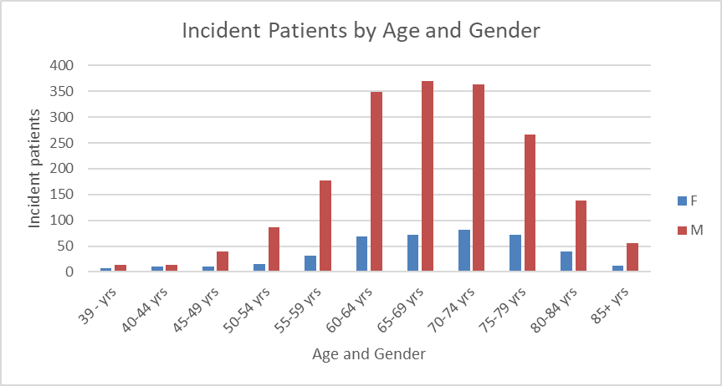
Figure 2: Incident patients by gender and 5-year age group
Males to female ratio of incident patients dispensed atezolizumab for advanced (unresectable) Barcelona Clinic Liver Cancer Stage B or Stage C HCC is approx. 4:1. This is comparable to the rates of HCC (L1.01.01) (crude incident rate for 2020) of 11.2 cases per 100,000 males and females 2.9 case per 100,000 females or approx. 4:1.

Figure 3: Incident cases of HCC
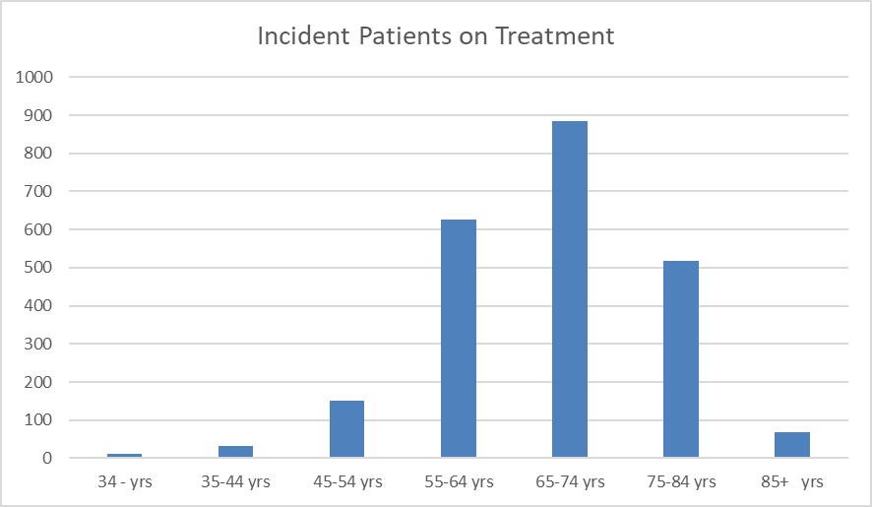
Figure 4: Incident patients on treatment with atezolizumab
25.5% of incident patients on treatment with atezolizumab are 75 years of age or older, while 26.4% of incident cases of HCC are in people 75 years of age or older.

Figure 5: Incident patients and script numbers for initial treatment with atezolizumab
Note:
Scripts (dotted line) are marked on the secondary axis.
Q42020 and Q12025 have not been included as the data is only derived from partial quarters.

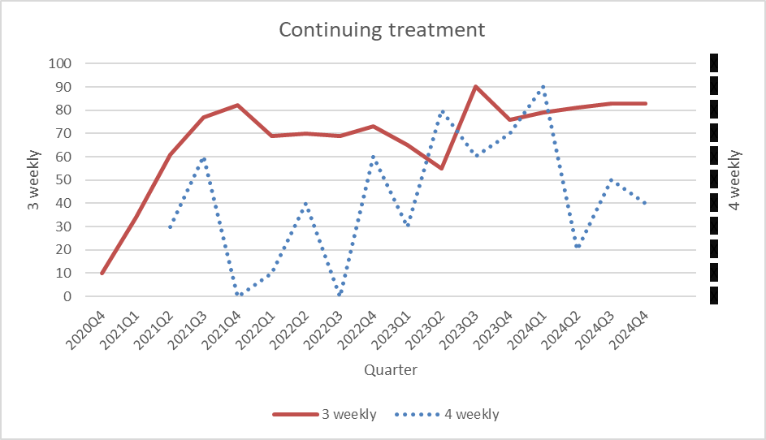
Figure 6: Incident patients for continuing treatment with atezolizumab
Note:
4 (or 2) weekly continuing treatment regime (dotted line) are marked on the secondary axis.
Q42020 and Q12025 have not been included as the data is only derived from partial quarters.
Patient numbers for 4 weekly treatment regime have been redacted as numbers are small.

Table 3: Dose sequence frequency by incident patients
Dose sequence | Proportion of Incident patients
1200 mg | 96.9%
1200 mg ->840 mg | XXXX
1200 mg ->1875 mg | XXXX
840 mg | XXXX
840 mg ->1200 mg | XXXX

Table 4: Dose dispensed
Dose dispensed | Proportion of Scripts
1200mg | 97.7%
1680mg | XXXX
1875mg | XXXX
840mg | XXXX

The proportion of 1200mg scripts which are initial is 42%, while the proportion of those which are continuing is 58%.
Only a small proportion of patients move onto the 4 or 2 weekly regime.
Table 5: Time on treatment (days)
 |  | With breaks | Without breaks
Mean |  | 306.5 | 245.4
Standard error |  | 8.9 | 7.4
Median |  | 167 | 127
95% Confidence  interval | Lower limit | 149 | 120
95% Confidence  interval | Upper limit | 172 | 147

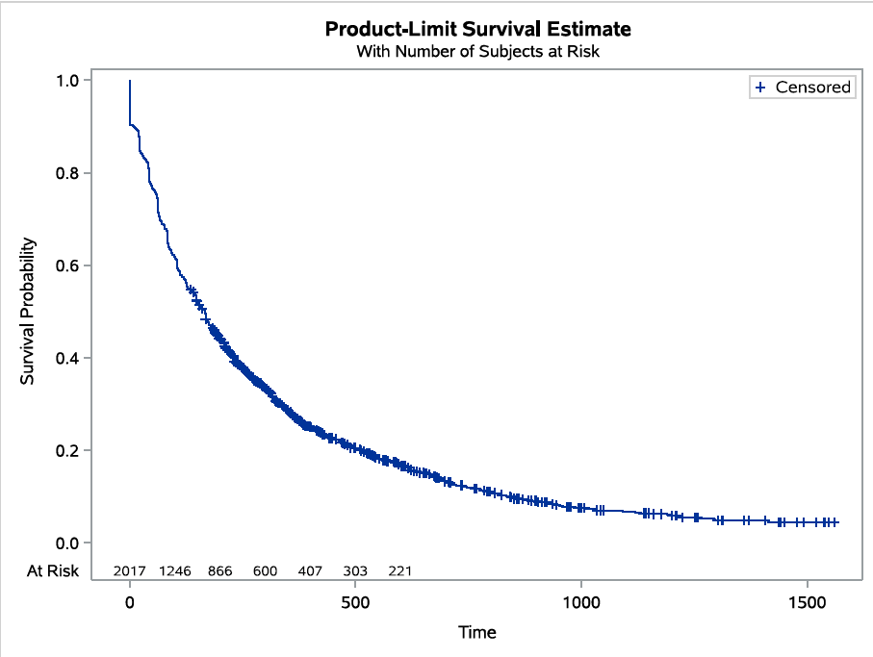
Figure 7: Estimated length of treatment from Kaplan Meier analysis with breaks
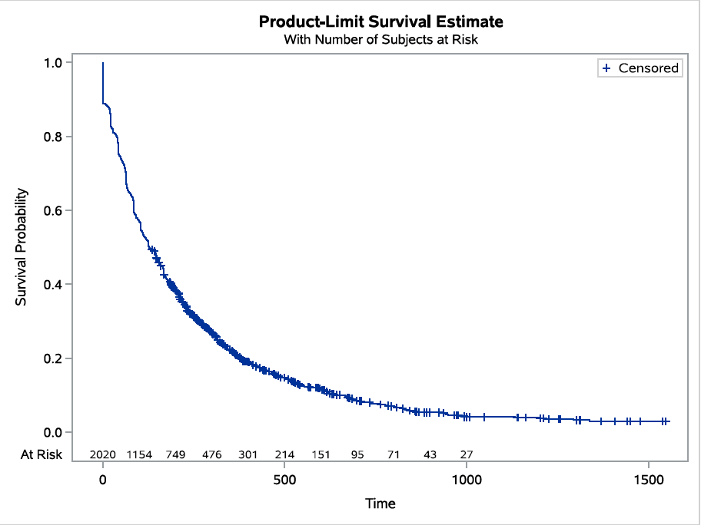
Figure 8: Estimated length of treatment from Kaplan Meier analysis without breaks

Changes in the use of other drugs

Figure 9: Proportion of incident patients by 10-year age group on lenvatinib or sorafenib (1 November 2020 to 28 February 2025)
Table 6: Proportion of lenvatinib and sorafenib being dispensed to the 75 years and older population
Year | 75 + yrs
2019 | 24.1%
2020 | 24.8%
2021 | 25.8%
2022 | 27.9%
2023 | 34.4%
2024 | 24.5%
2025¹ | 31.4%
Note:
¹Based on part year data for the period 1 January 2025 to 28 February 2025.

Figure 10: Change in the proportion of lenvatinib and sorafenib being dispensed by aged group pre to post 1 November 2020
The restriction for lenvatinib and sorafenib requires that patients must have a WHO performance status of 2 or less. For the atezolizumab restriction patients must have a WHO performance status of 0 or 1. Lenvatinib and sorafenib can be used in more unwell, possibly older patients. For incident patients during the period of 1 November 2020 to 28 February 2025) 27.4% of lenvatinib incident patients were 75 years of age or older, while 33.3% of Sorafenib incident patients were 75 years of age or older. Between 1 March 2019 and 1 November 2020 (prior to the listing of atezolizumab) 22.4% Lenvatinib and 26.8% Sorafenib incident patients were 75 years of age or older. This indicates that with the listing of atezolizumab, the treatment of HCC with lenvatinib and sorafenib has shifted to older possibly more unwell patients.

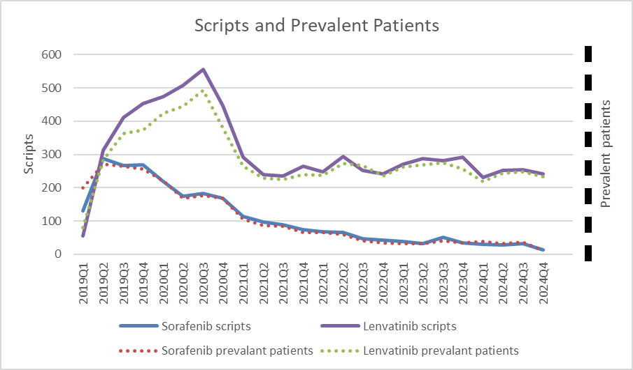
Figure 11: Script numbers and prevalent patients of lenvatinib and sorafenib for the treatment of HCC
Note:
Lenvatinib and Sorafenib prevalent patients (dotted lines) are marked on the secondary axis.
Q12025 have not been included as the data is only up to the end of February 2025.
Prevalent patient numbers have been redacted as numbers are small.

Table 7: Script volumes for lenvatinib and sorafenib year on year
Year | 2020 | 2021 | 2022 | 2023 | 2024
Lenvatinib | 1,985 | 1,031 | 1,034 | 1,131 | 979
Sorafenib | 743 | 372 | 221 | 155 | 103
Total | 2,728 | 1,403 | 1,255 | 1,286 | 1,082
Year on year difference | NA | -1,325 | -148 | +31 | -204
Estimated replaced script volume of sorafenib/lenvatinib for atezolizumab ⁴ | XX | XXXXXX | XXXXXX | XXXXXX | XXXXXX
Note: scripts for the current year were subtracted from scripts from the previous year.

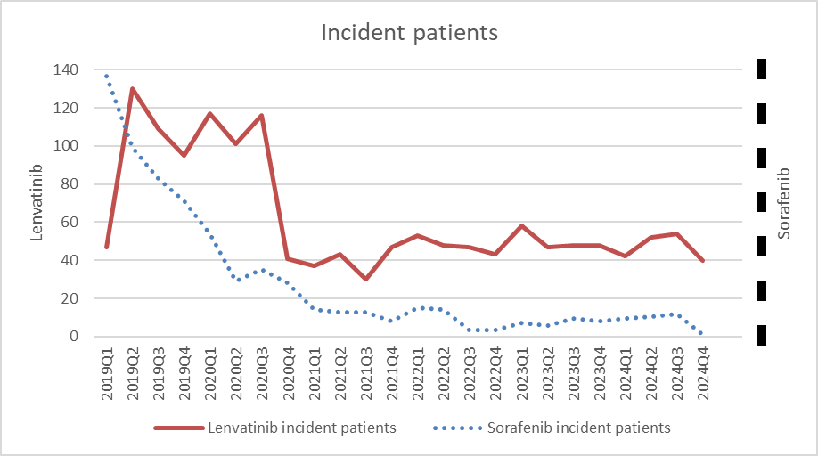
Figure 12: Incident patients for lenvatinib and sorafenib for the treatment of HCC
Note:
Q12025 have not been included as the data is only up to the end of February 2025.
Sorafenib incident patients (dotted lines) are marked on the secondary axis.
Sorafenib incident patient numbers have been redacted as numbers are small.

Table 8: Treatment sequence
Treatment sequence | Proportion of patients
ATEZOLIZUMAB | 61.8%
LENVATINIB | 18.4%
ATEZOLIZUMAB -> LENVATINIB | 10.3%
SORAFENIB | XXXX
LENVATINIB -> ATEZOLIZUMAB | XXXX
ATEZOLIZUMAB -> SORAFENIB | XXXX
ATEZOLIZUMAB -> LENVATINIB -> SORAFENIB | XXXX
SORAFENIB -> ATEZOLIZUMAB | XXXX
Other | XXXX

Analysis of actual versus predicted utilisation
Table 9: Comparison of predicted versus actual utilisation of atezolizumab for each year of listing
Year | Number of patients¹ |  |  | Number of scripts⁵
 | Predicted | Actual | Difference | Predicted | Actual | Difference
2020 | XXX² | 110³ | XXXXXX | XXXXX | 206³ | XXXXXX
2021 | XXX | 533 | XXXXX | XXXXX | 3,727 | XXXXXX
2022 | XXX | 505 | XXXX | XXXXX | 5,653 | XXXXXX
2023 | XXX | 522 | XXXX | XXXXX | 6,135 | XXXXXX
2024 | XXX | 526 | XXXX | XXXXX | 7,033 | XXXXXX
2025 | XXX | 94⁴ | XXXXXX | XXXXX | 1,182⁴ | XXXXXX
Source: The predicted figures were sourced from the final version of the financial estimates model.
Note:
¹Number of initiating or incident patients.
²Includes XXX Grandfathered patients.
³For the period 1 November to 31 December 2020.
⁴For the period 1 January 2025 to 28 February 2025.
⁵As Bevacizumab became an unrestricted listing on 31 May 2021 its script numbers have been removed from the predicted numbers.
⁶Difference is calculated as: ((Actual – Predicted)/Predicted) x 100.

Table 10: Actual prevalent patients for each year of listing
Year | Prevalent patients
2020 | 112
2021 | 657
2022 | 869
2023 | 955
2024 | 1,010
2025 | 544

Table 11: Actual Grandfathered patients for each year of listing
Year | Incident Grandfathered patients
2020 | 35
2021 | 24
2022 | 12
Total | 71
Note:
Item codes: 12163E, 12164F – for Transitioning from non-PBS-subsidised to PBS-subsidised supply - Grandfather treatment commenced on 1 November 2020 and ceased on 31 October 2022.

The submission assumed that there would be XXX Grandfathered patients in year 1.

Table 12: Actual patients being dispensed subcutaneous dosing for each year of listing
Year | Incident patients | Prevalent patients | Scripts
2024 | XXX | XXX | XXX
2024 | XXX | XXX | XXX
2025 | XXX | XXX | XXX
2025 | XXX | XXX | XXX

Discussion
The modelled mean treatment duration for atezolizumab from the IMbrave150 trial was estimated to be XXXXXX XXXX which was XXXXXX than that seen in the actual time of supply with a mean of 306.5 days with breaks and 245.4 days without breaks.
The overall use of lenvatinib or sorafenib for HCC has declined since the introduction of atezolizumab with scripts and incident patients for sorafenib deceasing by 76% and 86% respectively and with scripts and incident patients for lenvatinib decreasing by 35% and 52% respectively. However, the replacement of lenvatinib or sorafenib by atezolizumab for the treatment of HCC was XXXX than predicted.
There has been a shift in the use of lenvatinib and sorafenib to older populations after the listing of atezolizumab on the PBS for HCC. Between 1 March 2019 and 1 November 2020 (prior to the listing of atezolizumab) 26.8% sorafenib and 22.4% lenvatinib incident patients were 75 years of age or older. From 1 November 2020 to 28 February 2025, 27.4% of lenvatinib incident patients were 75 years of age or older, and 33.3% of sorafenib incident patients were 75 years of age or older. This compares with 25.5% of incident patients on treatment with atezolizumab being 75 years of age or older, while 26.4% of incident cases of HCC⁸ are in people 75 years of age or older. If older age is taken as a proxy for disease severity, then atezolizumab was being used in less severe cases as expected.
There were XXXXX scripts being dispensed then predicted, and while the submission assumed that there would be XX prevalent population as, in addition to the low survival in advanced HCC, the average duration of treatment was expected to be XXXX than one year, and any patients diagnosed in previous years would have already initiated a systemic therapy thus making them ineligible for atezolizumab according to the proposed PBS restriction. The XXXXX number of scripts dispensed, and the development of a prevalent population could have been due to patients commencing during the year and surviving into the subsequent year. Additionally, the restriction does allow for atezolizumab treatment of a patient who has developed intolerance to a VEGF-TKI of a severity necessitating permanent treatment withdrawal.
Most patients had continuing treatment with the 3-weekly treatment regime with only a few patients continuing to the 4 (or 2) weekly treatment regime with bevacizumab being discontinued, indicating that treatment is being well tolerated.
There were around 1,800 incident cases of HCC (L1.01.01) in 2020. Assuming the number of incident cases remained relatively constant over the period 2021 to 2024 there would have been approx. 7,200 incident cases over this four-year period. Assuming XXXXX HCC patients had Stage B/C who are ECOG PS 0 or 1, this would indicate that approx. XXXXX patients would be eligible for treatment. With an uptake rate of XXX around XXXXX patients would be treated. From 2021 to 2024 there were 2,086 incident patients on treatment indicating that around XXX of the assumed incident HCC cases were undergoing treatment with atezolizumab through the PBS. This suggest that the assumed percentages of HCC patients having Stage B/C who are ECOG PS 0 or 1 and/or the uptake rate were XXXXXXXXXXXXX.

DUSC consideration
DUSC noted that for most patients atezolizumab in combination with bevacizumab (henceforth atezolizumab) for advanced BCLC Stage B or Stage C HCC was generally well tolerated and most patients remain on treatment.
DUSC noted that the use of the oral therapies lenvatinib or sorafenib for the treatment of HCC had not been replaced by atezolizumab but displaced to older cohorts. DUSC considered that this was more a result of bevacizumab being less well tolerated in older populations then these populations being more unwell in addition to switching from atezolizumab to lenvatinib or sorafenib due to cardio-vascular or immune related risks in older populations and the ease of taking an oral preparation as opposed to an intravenous infusion. In addition, the oral therapies have side effects which may reduce their use in populations which can tolerate atezolizumab.
DUSC noted that the restriction did not reflect real-world use. DUSC noted that the restriction does allow switching, and in effect cycling between atezolizumab and a vascular endothelial growth factor tyrosine kinase inhibitors such as lenvatinib and sorafenib, which, in effect, may have resulted in a very small number of patients using lenvatinib or sorafenib as second line therapy. DUSC noted that while the majority of patients remained on atezolizumab there was some switching and cycling with lenvatinib or sorafenib. DUSC noted that there was some anecdotal evidence which suggested that younger people with HCC due to Hepatitis B or C did not respond as well to treatment with atezolizumab. DUSC considered the proposition that lenvatinib or sorafenib should be available on disease progression (as second-line therapy), rather than only being available due to issues with intolerance or contraindication related to the use of bevacizumab. DUSC considered that there was too little evidence to recommend the use of lenvatinib or sorafenib in persistent disease as second-line therapy.

DUSC noted that the time on treatment was XXXX than that estimated from the clinical trial data contained in the submission. DUSC considered that this variance was most likely due to the real-world population being more unwell than that likely to have been seen in the clinical trial population and that in real world clinical practice a small number of patients cease treatment XXXX after commencing due to their underlying disease being worse than first anticipated. In addition, targeted or local therapies are being used in patients who are not well enough to commence or continue therapy. DUSC considered that the increased use of targeted or local therapies also leads to patients coming off treatment XXXXXXX than those seen in the clinical trial which also XXXXXXX the estimates of time on treatment.
DUSC noted that while the predicted vs actual number of patients was XXXXXXX there was some variance between the predicted versus actual number of scripts with XXXX scripts per year than initially anticipated. DUSC considered that this was due to some patients ceasing treatment XXXXXXX than anticipated.
DUSC noted the very low uptake of the subcutaneous form of atezolizumab. DUSC was informed that this was due to the relative recency of this form being available and relevant protocols were just being developed.

DUSC actions
DUSC requested that the report be provided to the PBAC for consideration.

Context for analysis
The DUSC is a Sub Committee of the Pharmaceutical Benefits Advisory Committee (PBAC). The DUSC assesses estimates on projected usage and financial cost of medicines.
The DUSC also analyses data on actual use of medicines, including the utilisation of PBS listed medicines, and provides advice to the PBAC on these matters. This may include outlining how the current utilisation of PBS medicines compares with the use as recommended by the PBAC.
The DUSC operates in accordance with the quality use of medicines objective of the National Medicines Policy and considers that the DUSC utilisation analyses will assist consumers and health professionals to better understand the costs, benefits and risks of medicines.
The utilisation analysis report was provided to the pharmaceutical sponsors of each drug and comments on the report were provided to DUSC prior to its consideration of the analysis.

Sponsors’ comments
Roche Products Pty Ltd. The sponsor had no comment.

Disclaimer
The information provided in this report does not constitute medical advice and is not intended to take the place of professional medical advice or care. It is not intended to define what constitutes reasonable, appropriate or best care for any individual for any given health issue. The information should not be used as a substitute for the judgement and skill of a medical practitioner.
The Department of Health, Disability and Ageing has made all reasonable efforts to ensure that information provided in this report is accurate. The information provided in this report was up-to-date when it was considered by the Drug Utilisation Sub-committee of the Pharmaceutical Benefits Advisory Committee. The context for that information may have changed since publication.
To the extent provided by law, the Department of Health, Disability and Ageing makes no warranties or representations as to accuracy or completeness of information contained in this report.
To the fullest extent permitted by law, neither the Department of Health, Disability and Ageing nor any Department of Health, Disability and Ageing employee is liable for any liability, loss, claim, damage, expense, injury or personal injury (including death), whether direct or indirect (including consequential loss and loss of profits) and however incurred (including in tort), caused or contributed to by any person’s use or misuse of the information available from this report or contained on any third party website referred to in this report.

Hepatocellular Carcinoma Consensus Statement Working Group. Australian recommendations for the management of hepatocellular carcinoma: a consensus statement. Melbourne: Gastroenterological Society of Australia, 2020. HCC Consensus Statement - Dec 2020.pdf
Tecentriq® (atezolizumab) IV formulation. Australian Approved Product Information. Roche Products Pty Limited. Approved 27 July 2017, updated 25 September 2024. Accessed 3 March 2025. Available from: TGA eBS - Product and Consumer Medicine Information
From final version of financial workbook.
Public Summary Document – July 2020 PBAC Meeting
The submission.
Cancer data in Australia, Cancer incidence and survival by histology (selected cancers) - Australian Institute of Health and Welfare
Cancer data in Australia, Cancer incidence and survival by histology (selected cancers) - Australian Institute of Health and Welfare

