Zanubrutinib for Waldenström macroglobulinaemia: predicted versus actual analysis

Drug utilisation sub-committee (DUSC)

April 2025

Abstract

Purpose
To compare the predicted and actual utilisation of zanubrutinib for the treatment of Waldenström macroglobulinaemia (WM) in treatment-naïve (first line) patients who are unsuitable for chemo-immunotherapy and for relapsed/refractory (second and subsequent lines) patients who have received at least one prior therapy since zanubrutinib’s listing on the Pharmaceutical Benefits Scheme (PBS).

Date of listing on the Pharmaceutical Benefits Scheme (PBS)
Zanubrutinib was first listed on the PBS for WM on 1 July 2022.

Data Source / methodology
Authorities data and prescriptions data were extracted from the prescription database and
Authorities database maintained by the Department of Health, Disability and Ageing, processed by Services Australia from between 1 July 2022 and 30 June 2024, respectively. Data were extracted based on the date of supply.

Key Findings
- Actual patient numbers were XXXX than predicted over the first two years of listing.
- Actual script numbers were XXXX than predicted over the first two years of listing.
- Actual script numbers per patient were XXXX than predicted over the first two years of listing.

Purpose of analysis
To compare the predicted and actual utilisation of zanubrutinib for the treatment of WM in treatment-naïve (first line) patients who are unsuitable for chemo-immunotherapy and for relapsed/refractory (second and subsequent lines) patients who have received at least one prior therapy since zanubrutinib’s listing on the PBS.

Background

Clinical situation
WM is an indolent (slow growing) non-Hodgkin B-cell lymphoid malignancy which is defined by the World Health Organization (WHO) as a disease manifested by a monoclonal IgM paraprotein and infiltration of the bone marrow by lymphoplasmacytic lymphoma cells (clonal small B lymphocytes, plasmacytoid lymphocytes and plasma cells).,

Pharmacology
Zanubrutinib is a small-molecule inhibitor of Bruton’s Tyrosine Kinase (BTK). Zanubrutinib forms a covalent bond with a cysteine residue in the BTK active site, leading to inhibition of BTK activity. BTK is a signalling molecule of the B-cell antigen receptor and cytokine receptor pathways. In B-cells, BTK signalling results in activation of pathways necessary for B-cell proliferation, trafficking, chemotaxis, and adhesion.

Therapeutic Goods Administration (TGA) approved indications
Zanubrutinib was registered on the Australian Register of Therapeutic Goods (ARTG) on 7 October 2021.
Zanubrutinib product information includes a black triangle indicating that it is subject to additional monitoring in Australia. By being included in the Black Triangle scheme, this reminds health professionals and consumers to report suspected adverse events.
Zanubrutinib is currently TGA registered for the following indications:
- For the treatment of adult patients with WM who have received at least one prior therapy, or in first line treatment for patients unsuitable for chemo-immunotherapy.
- For the treatment of adult patients with mantle cell lymphoma (MCL) who have received at least one prior therapy.
- For the treatment of adult patients with marginal zone lymphoma (MZL) who have received at least one-prior anti-CD20-based therapy.
- As monotherapy for the treatment of adult patients with chronic lymphocytic leukaemia (CLL) or small lymphocytic lymphoma (SLL), including patients with deletion 17p and/or TP53 mutation.

Dosage and administration
The recommended total daily oral dose of zanubrutinib is 320 mg. Zanubrutinib may be taken as either 320 mg (four 80 mg capsules) once daily, or as 160 mg (two 80 mg capsules) twice daily. Dose modification is required for severe (Grade 3) or life-threatening (Grade 4) adverse reactions.
The current Product Information (PI) and Consumer Medicine Information (CMI) are available from the TGA (Product Information) and the TGA (Consumer Medicines Information).

PBS listing details (as at 22 October 2024)

Table 1: PBS listing of zanubrutinib
Item | Name, form & strength, pack size | Max. quant. | Rpts | DPMQ | Brand name and manufacturer
13041J | Zanubrutinib 80 mg capsule, 120 | 1 | 5 | $7932.56 | Brukinsa, BeiGene AUS Pty Ltd
Source: the PBS website. A Special Pricing Arrangement is in place.
Note: Item code as per October 2024.

Restriction
Waldenstrom macroglobulinaemia
Treatment Phase: Initial treatment
Clinical criteria:
The condition must have relapsed or be refractory to at least one prior chemo-immunotherapy; OR
Patient must be unsuitable for treatment with chemo-immunotherapy, defined by a Cumulative Illness Rating Scale of 6 or greater, if untreated (i.e. treatment-naive) for this condition,
AND
The treatment must be the sole PBS-subsidised therapy for this condition,
AND
Patient must have a World Health Organisation (WHO) Eastern Cooperative Oncology Group (ECOG) performance status score of 2 or less,
AND
Patient must be untreated with a Bruton's tyrosine kinase inhibitor for this condition; OR
Patient must have developed intolerance to another Bruton's tyrosine kinase inhibitor of a severity necessitating permanent treatment withdrawal, when treated for this condition.

Authority Required
Waldenstrom macroglobulinaemia

Treatment Phase: Continuing treatment
Clinical criteria:
The treatment must be the sole PBS-subsidised therapy for this condition,
AND
The condition must not have progressed while receiving PBS-subsidised treatment with this drug for this condition,
AND
Patient must have previously received PBS-subsidised treatment with this drug for this condition.

Note
No increase in the maximum quantity or number of units may be authorised.
No increase in the maximum number of repeats may be authorised.
Special Pricing Arrangements apply.
Applications for authorisation under this restriction may be made in real time using the Online PBS Authorities system (see www.servicesaustralia.gov.au/HPOS) or by telephone by contacting Services Australia on 1800 888 333.

For details of the current PBS listing refer to the PBS website.

Changes to listing
On 30 June 2023 the Grandfather arrangements ceased.
Current PBS listing details are available from the PBS website.

Relevant aspects of consideration by the Pharmaceutical Benefits Advisory Committee (PBAC)
At its July 2021 meeting the PBAC did not recommend the listing of zanubrutinib for the treatment of WM in two patient subpopulations: (i) treatment-naïve (TN) patients who are ‘unsuitable’ for chemo-immunotherapy and (ii) relapsed/refractory (R/R) patients who have received at least one prior therapy. The PBAC did not have a reliable basis to determine a cost-effective price for zanubrutinib as the economic model did not reflect the expected treatment outcomes of improved quality of life and reduced need for subsequent therapies, including chemotherapy, but instead was based on projected large gains in overall survival, which were not supported by the clinical data and were considered clinically implausible. The PBAC considered the estimated use and financial impact to be underestimated.
For further details refer to the Public Summary Document from the July 2021 PBAC meeting.
At its March 2022 meeting the PBAC recommended the listing of zanubrutinib for the treatment of WM in treatment-naïve (TN) patients who are unsuitable for chemo-immunotherapy and in relapsed/refractory (R/R) patients who have received at least one prior chemo-immunotherapy. The PBAC note that the changes made to the economic model, additional clinical evidence, and revised financial estimates broadly addressed outstanding issues raised by the PBAC.
For further details refer to the Public Summary Document from the March 2022 PBAC meeting.
At its July 2024 meeting the PBAC considered a submission by the sponsor requesting the PBAC to revise the previously estimated utilisation of zanubrutinib for the treatment of WM. The PBAC provided advice regarding the subsidisation caps under the current risk sharing arrangement (RSA) for zanubrutinib for the treatment of WM. The PBAC considered it was reasonable to make amendments to the financial estimates underpinning the RSA to reflect the proposed changes in incidence and prevalence based on new epidemiological data specific to the WM subset in Australia that had not been previously available. The PBAC was satisfied that the submission provided sufficient evidence to support the requested changes to the assumptions in terms of the incidence and prevalence in the March 2022 financial estimates that were the basis for the current RSA.
For further details refer to the Recommendations made by the PBAC – July 2024 from the July 2024 PBAC meeting.

Approach taken to estimate utilisation
The March 2022 resubmission used an epidemiological approach to estimate the financial implications of the listing of zanubrutinib. The resubmission assumed that amongst first-line patients XXX would be treated in year 1 (and year 2) increasing to XXX by years 6 with XXX being unsuitable for chemo-immunotherapy. For second and subsequent lines XXX would be treated in year 1 (and year 2) increasing to XXX by year 6, the proportion of patients progressing to second line is XXX and the proportion surviving two years from diagnosis was XXX, with XXX of relapsed patients being BTK inhibitor naïve. The uptake rate in first and second (and subsequent) line therapy commenced at XXX in year 1 and increasing to XXX by year 6. The sponsor estimated that there would be XXX grandfathered patients initiating in year 1.
The March 2022 resubmission assumed an incidence of XXXXXXXXXXXX (increased to XXXXXXXXXXXX in the Pre-Subcommittee Response), a prevalence of XXXXXXXXXXXX (5-year), and a survival to second and subsequent lines of therapy of XXX. In the July 2024 submission these were updated to an incidence of XXXXXXXXXX, a prevalence of XXXXXXXXXXXX (10-year) and a survival to second and subsequent lines of XXXX.
Both submissions assumed that each patient would have approx. XXXX scripts per year.

Methods
Authorities data and prescriptions data maintained by the Department of Health, Disability and Ageing, processed by Services Australia, was extracted from 1 July 2022 to 30 June 2024. Data was extracted based on the date of supply. Data is presented by financial year 1 July to 30 June.
Patient level analysis
The number of incident patients, prevalent patients, and scripts dispensed was determined by counting the number of people supplied at least one PBS prescription using person specific numbers (non-identifying) in the data for the specified time periods. Patient initiation was defined as the date of supply of the first PBS or RPBS prescription.
PBS prescription data also contains age and gender information. Patient age was derived as the age at first supply. This information was used to perform a breakdown of incident patients by age and gender. Patient age was derived as the age at first supply.
Prescriber analysis
Number and proportion of prescriptions dispensed by prescriber type over time was derived by specialities.
Treatment sequence
To determine the therapy sequence from first-line to second-line treatment with zanubrutinib for WM, prescription data for the first-line medications,, for the treatment of WM listed in Appendix A were extracted from the start of July 2022 to the end of June 2024. These data were merged with patients who had been supplied zanubrutinib to identify the last first-line medication which was used directly prior to the most recent use of zanubrutinib. The data used in this analysis are drawn from the PBS prescription database, it does not include data on non-PBS medications that may have been dispensed in the first-line setting for WM. Medications which are commonly used for the first-line treatment of WM that are either not PBS listed or PBS listed only for other indications are not included in this analysis.

Dose modification

Zanubrutinib for WM is taken either as 160 mg twice a day or 320 mg daily. Dose may be modified due to haematological or non-haematological toxicities, hepatic impairment or concomitant use with CYP3A4 inhibitor. The dose of zanubrutinib was determined by calculating the total amount of drug dispensed as the product of the mass per unit of drug supplied by the PBS quantity dispensed.

Treatment duration analysis

Time (days) on treatment for all patients initiating zanubrutinib for WM with follow-up
to the end of June 2024 (excluding patients initiating in the last 6 months, i.e. on or
after 1 January 2024). Kaplan-Meier analysis was undertaken to analyse the time on
treatment. Time on treatment was determined with and without treatment breaks.
Patients were assumed to have had a break in therapy if there was a period of no supply
equivalent to three times the median time between supplies (i.e. 90 days, 3 x 30 days).
Patients who had a supply within 90 days of the analysis end date were assumed to be
continuing on therapy. These patients were censored from the Kaplan-Meier analysis.
Predicted versus actual analysis
Predicted versus actual analysis of the number of patients treated, and prescriptions dispensed.
The differences in actual compared to predicted utilisation was determined using the following calculation:
Difference (%) = ((Actual – Predicted)/Predicted) x 100.

Results

Analysis of drug utilisation

Overall utilisation
Table 2: Number of incident (new)prevalent (total treated) patients and scripts by listing year
 | Year 1 (2022-23) | Year 2 (2023-24)
Incident patients | 413 | 372
Prevalent patients | 413 | 723
Total scripts supplied | 2,463 | 4,962
Note:
The figures are presented in listing years (July to June).

Figure 1: Number of treated prevalent and incident patients, and scripts by month
Note:
Incident (dotted line) are marked on the secondary axis.

Utilisation by age and gender
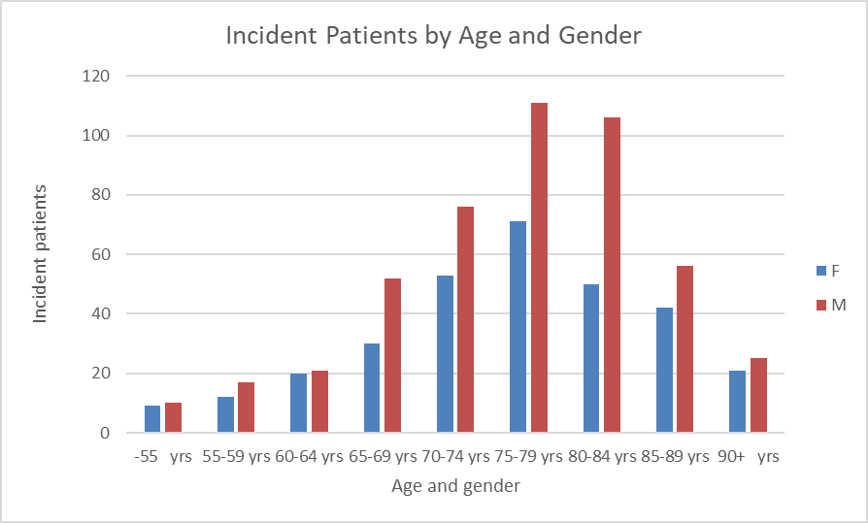
Figure 2: Incident patients by gender and 5-year age group
More males than females were being dispensed zanubrutinib for WM, at a ratio of approx. 5:3 which mirrors the incidence of WM in the Australian population of 0.9 per 100,000 for males and 0.5 per 100,000 for females in 2020 (aged specific incidence all ages standardised to Australian population 2024).

Figure 3: Incident patients on treatment

Figure 4: Incident cases of WM

Prescriber analysis
Table 3: Percentage of prescriptions supplied by prescriber type
Prescriber type | 2022-24
Haematology | 66%
Pathology | 16%
NONVRGP | 11%
Internal Medicine | 3%
VRGP | 3%
Medical Oncology | 2%
Other | 1%
NONVRGP – Non-vocationally registered GP
VRGP - Vocationally registered GP

Treatment sequence
Table 4: Treatment sequence from first-line therapy to zanubrutinib
Treatment sequence¹ | Patients
CYCLOPHOSPHAMIDE -> ZANUBRUTINIB | 29
DEXAMETHASONE -> ZANUBRUTINIB | 16
CHLORAMBUCIL -> ZANUBRUTINIB | <10
Other | <10

Note: ¹Commonly used first-line medications for WM (see Appendix A). Medications which are commonly used for the first-line treatment of WM that are either not PBS listed or PBS listed only for other indications are not included.

Dose modification

Table 5: Dose dispensed
Dose dispensed | Scripts
320 mg | 7,317
160 mg | 82
80 mg | 15

Table 6: Dose modification
Dose modification | Patients
Up titrated¹ | <10
Down titrated² | 13
Note:
¹From lower dose to 320 mg.
²Includes patients returned to original dose.

Treatment duration analysis
Table 7: Time on treatment (days)
 |  | With breaks | Without breaks
Mean |  | 467 | 384
Median |  | - | 531
Standard error |  | 9.3 | 10.0
Number of patients |  | 579 | 579
Censored |  | XXX | XXX
95% Confidence  interval | Lower limit | - | 448
95% Confidence  interval | Upper limit | - | -
Note: The mean survival time and its standard error were underestimated because the largest observation was censored and the estimation was restricted to the largest event time.

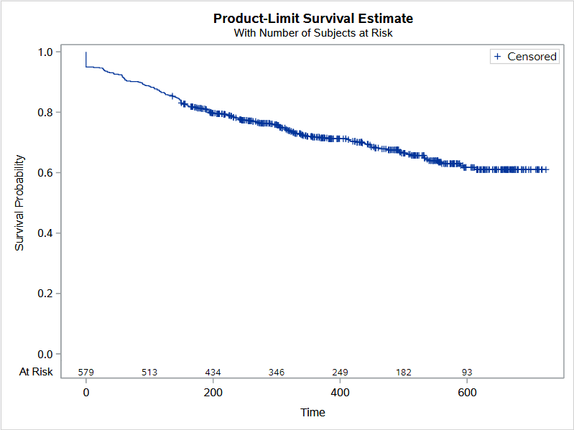
Figure 5: Estimated length of treatment from Kaplan Meier analysis with breaks
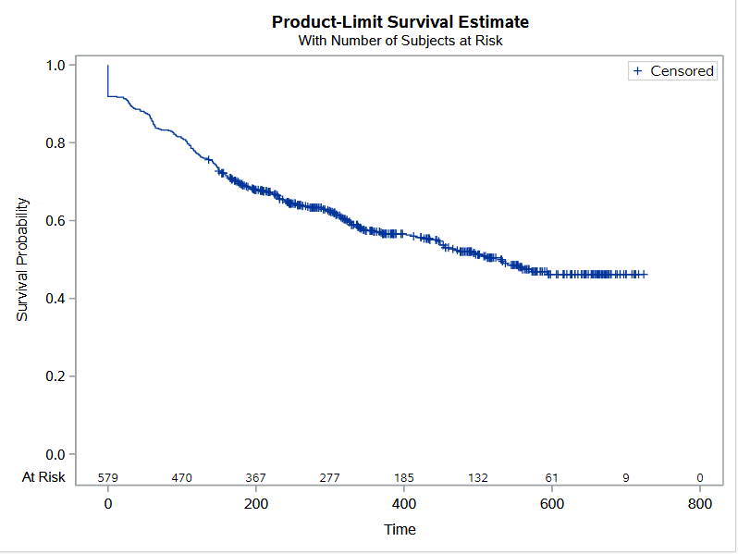
Figure 6: Estimated length of treatment from Kaplan Meier analysis without breaks

Analysis of actual versus predicted utilisation
Table 8: Comparison of predicted versus actual utilisation of zanubrutinib for each year of listing
 | Year 1ª | Year 2ª
Number of patients
Predicted | XXX | XXX
Actual | 413 | 723
Difference ^{b} | XXXX | XXXX
July predicted ^{c} | XXX | XXX
Difference ^{b} | XXX | XXXX
Number of scripts
Predicted | XXXXX | XXXXX
Actual | 2,463 | 4,962
Difference ^{b} | XXX | XXXX
July 2024 predicted ^{c} | XXXXX | XXXXX
Difference ^{b} | XXXX | XXX
Source: The predicted figures were sourced from the final version of the financial estimates model.
Note:
ª The figures are presented in listing years (Jul to Jun).
^{b} Difference is calculated as: ((Actual – Predicted)/Predicted) x 100.
^{c} Predicted values in the July 2024 submission sourced from the final version of the financial estimates model.

Discussion
Actual patient numbers were XXXX than predicted over the first two years of listing. This may have been due to a number of factors. Given the relatively few patients having prior treatment with a PBS listed medication that can be used in the first-line treatment of WM (Table 4), it is possible that XXXX treatment naïve patients are being dispensed zanubrutinib then expected. However, there are limitations which make it difficult to accurately determine if a patient has received another first-line medication of WM prior to zanubrutinib. Patients who were dispensed a non-PBS medication for first-line treatment of WM will not be captured by this analysis. In addition, there are a number of estimates which have various levels of uncertainty associated with them including the proportion of WM patients initiating treatment, duration of treatment, rate of relapse in second- line, survival rate, rate of BTK inhibitor naïve patients, and the uptake rate, and the number of grandfathered patients. The two estimates which may have contributed to the significant difference between the predicted and actual patient population may be that the rate of patients’ ineligible for of chemo-immuno therapy and the prevalent patient pool. Australian Institute of Health and Welfare (AIHW) data on WA indicate a 10 year prevalence rate, all persons, all ages (age-standardised rate – 2024 and crude rate) of 4 per 100,000 as at the end of 2020. It may also be that patients who are fit for chemo-immuno therapy could be accessing zanubrutinib for WM, such as patients who actually have a Cumulative Illness Rating Scale of less than 6. However, as Figures 3 and 4 indicate it is more likely that patients unsuitable (in older age cohorts) for chemo-immunotherapy are receiving zanubrutinib with 62% of incident patients aged 75+ years as compared to 45% of WM incident cases which are aged 75+ years.
While XXXX scripts have been written then predicted there were XXXXX scripts per patient, which is likely due to patients commencing treatment throughout the year which would mean that there would be XXXX than the approx. XXXX scripts per patient per year required. It is unlikely that this is due to other factors such as a lower dose of medication being dispensed or dose modification (Table 5 and Table 6) due to toxicity, hepatic impairment, and/or concomitant use with CYP3A4 inhibitors or given the time on treatment (Table 7) due to patient’s ceasing therapy.
The cap for the deed of agreement for the supply of zanubrutinib for the treatment of WM had been XXXXXXXX for the X XXXXX years of the deed and is likely to XXXXXXXXXXXXX XXXXXX the cap in year 3. At its July 2024 meeting the PBAC was satisfied that the submission provided sufficient evidence to support the requested changes to the assumptions in terms of the incidence and prevalence in the March 2022 financial estimates that were the basis for the current RSA. However, it is likely that the incidence and prevalence have been underestimated and that there may be usage in other patient populations.

DUSC consideration
DUSC noted that the analysis indicated that there are only a few patients moving from first line therapy to second line or relapse/refractory (R/R) zanubrutinib therapy. DUSC noted that the analysis was confounded by the fact that medications commonly used for first line treatment of WM who are suitable for chemo-immunotherapy (CI) were not PBS listed or are PBS listed only for other indications and as such are not included in the analysis. DUSC noted that patients receiving first line treatment from alternate sources were likely to be classified as treatment naïve in the analysis. DUSC considered that the proportion of patients who had received first line therapy with another drug were likely to have been underestimated in the analysis and that a greater proportion were being treated in the second line.
DUSC noted the mean time on treatment of 467 and 384 days with and without breaks respectively and that only a few patients were undergoing dose modification indicating few severe (Grade 3) or life-threatening (Grade 4) adverse reactions. DUSC noted that with only two years of data that the time on treatment data was immature. DUSC considered that once a patient commences zanubrutinib therapy they are likely to remain on therapy as it is well tolerated.
DUSC noted that the expected age and gender distribution of incident treatment did correspond with the age and gender distribution of the WM in the wider population indicating that it is more likely that patients unsuitable (i.e. in older age cohorts) for CI were appropriately receiving zanubrutinib. DUSC noted that in the XXXXXXXXXXXXXXXXX XXXXXXXX XXXXXX XXXXX XXX XXXXXXX did acknowledge that the proportion of treatment naïve patients unsuitable for CI accessing zanubrutinib may be XXXXXX than predicted.
DUSC noted that the actual number of patients being treated was XXXXXXX than the predicted number of patients. DUSC considered that there could be a number of reasons for this including X XXXXXXXXXX XX XXXXXXXX XXXXXXXXX XXXXXXXXXXXX XX XXX XXXXXX XXXX XXXX XX XXXXXXXXX XXXXX XXX XXXXX XXXXXXXXX XX XXXXXXXX XXX XX XXXXXXXXX XXXXX XXXX XXX XXX XXXXXXXXXXXX XX XXXXXXXX XXXXXXXXX XXXXXXXXXXXX XXXXXXXXX XXXX XXXXX XXXXXXX XXX XXXXX XXXXXXXX XXXX XXX XXXXXX XX XX XXXXXXX XXX XX XXXXXXXX XXXXXXXX XXXXX XXXXXXXX XX XXXXXXXXXXXX XX XXX XXXXXXXX XXXXXXXX XXXX, the estimates used of the treatment naïve patients and prevalent patient pool may not have been accurate at the time the sponsor provided their submission with more accurate prevalence data now becoming available. DUSC considered that there were other uncertainties which could have led to the variance in the actual vs. predicted number of patients include the duration of treatment, the rate of relapse in second line, the survival rate, the uptake rate, and the number of grandfathered patients.
DUSC noted that the actual number of scripts was XXXXXXX than the predicted number of scripts, but not as XXXX as the actual vs. predicted number of patients. DUSC considered that this was due to patients commencing therapy throughout the year.
DUSC noted the XXXXXXXXX comments in the XXXX XXXXX to expand the analysis period and include bendamustine plus rituximab (BR) in sequence analysis. DUSC considered that PBS data are not available for these analyses.
DUSC noted the XXXXXXXX comments that there is a preference for zanubrutinib due to less toxicity as compared to other drugs, especially with elderly patients. Further that zanubrutinib has only been available for two years for the treatment of WM and that there could be lower level of knowledge by haematologists. XXXXXXXX comments suggested that the side effects including worsening neuropathy and patient death may contribute to XXXXX number of prescriptions then predicted, and that there is a tendency to prescribe a less effective drug in the first place and then switch to zanubrutinib as soon as possible. DUSC considered that zanubrutinib was well known amongst haematologists, that the side effects seen may be more likely due to the disease or age-related as opposed to the drug, and that it was possible that physicians were trialling less effective first line therapies and then switching to zanubrutinib at the earliest possible opportunity. DUSC considered that this would in effect lead to treatment naïve patients who would otherwise be suitable for CI being treated with zanubrutinib and lead to a XXXXXX number of treated patients than originally expected.
DUSC noted that the XXXXXXX suggested in the XXXX XXXXX that to better track utilisation trends and improve future projections that the PBAC and DUSC consider introducing separate PBS item codes for treatment naïve and R/R patient populations. DUSC considered that under the current restriction it is difficult to differentiate treatment naïve from R/R patients XXX XXXX XX XXXXX XX XXXX XXXXXXXX XXXX XXXXXXXXXX XXX XX XXXXXXXXXXXXX XXX XXXXXXX XXXXXXXXXXX XXX XXXXXXXXX XXXXX XXXXXXXX XX XX XXXXXXXXXX XXX XXXXXXXXXXXXXXXXXXX, consideration could be given to removing the requirement for patients to be R/R to at least one prior chemo-immunotherapy (second line) or that they must be unsuitable for treatment with chemo-immunotherapy (treatment naïve).
DUSC suggested that the treatment criteria for zanubrutinib in the current restrictions for the initial treatment phase could be altered by removing from the clinical criteria ‘The condition must have relapsed or be refractory to at least one prior chemo-immunotherapy; OR Patient must be unsuitable for treatment with chemo-immunotherapy, defined by a Cumulative Illness Rating Scale of 6 or greater, if untreated (i.e. treatment-naive) for this condition’.

DUSC Actions
DUSC considered that the use of all Bruton's tyrosine kinase inhibitors listed on the PBS could be reviewed.
DUSC requested that the report be provided to the PBAC for consideration.

Context for analysis
The DUSC is a Sub Committee of the Pharmaceutical Benefits Advisory Committee (PBAC). The DUSC assesses estimates on projected usage and financial cost of medicines.
The DUSC also analyses data on actual use of medicines, including the utilisation of PBS listed medicines, and provides advice to the PBAC on these matters. This may include outlining how the current utilisation of PBS medicines compares with the use as recommended by the PBAC.
The DUSC operates in accordance with the quality use of medicines objective of the National Medicines Policy and considers that the DUSC utilisation analyses will assist consumers and health professionals to better understand the costs, benefits and risks of medicines.
The utilisation analysis report was provided to the pharmaceutical sponsors of each drug and comments on the report were provided to DUSC prior to its consideration of the analysis.

Sponsors’ comments
BeiGene AUS Pty Ltd:
The Sponsor welcomes DUSC’s recognition that zanubrutinib is being used predominantly in older patients, consistent with its PBS listing for those unsuitable for chemo-immunotherapy. We believe the higher-than-expected use reflects unmet clinical need and evolving prevalence data, and we support refining PBS criteria to ensure appropriate access aligned with clinical best practice.

Disclaimer
The information provided in this report does not constitute medical advice and is not intended to take the place of professional medical advice or care. It is not intended to define what constitutes reasonable, appropriate or best care for any individual for any given health issue. The information should not be used as a substitute for the judgement and skill of a medical practitioner.
The Department of Health, Disability and Ageing has made all reasonable efforts to ensure that information provided in this report is accurate. The information provided in this report was up-to-date when it was considered by the Drug Utilisation Sub-committee of the Pharmaceutical Benefits Advisory Committee. The context for that information may have changed since publication.
To the extent provided by law, the Department of Health, Disability and Ageing makes no warranties or representations as to accuracy or completeness of information contained in this report.
To the fullest extent permitted by law, neither the Department of Health, Disability and Ageing nor any Department of Health, Disability and Ageing employee is liable for any liability, loss, claim, damage, expense, injury or personal injury (including death), whether direct or indirect (including consequential loss and loss of profits) and however incurred (including in tort), caused or contributed to by any person’s use or misuse of the information available from this report or contained on any third party website referred to in this report.

Appendix A

PBS first-line therapies used in sequence analysis: ¹

Rituximab
Dexamethasone
Fludarabine
Cyclophosphamide
Chlorambucil

Note¹: Only PBS listed and restricted to WM or unrestricted were used in the analysis.

The predicted data was taken from the Facilitated Resolution Pathway resubmission to the March 2022 PBAC meeting and not that updated in the Category 3 submission to the July 2024 PBAC meeting as this is outside the analysis period of the initial two year listing of zanubrutinib for the treatment of WM.
Sarosiek S, Treon SP. Bruton tyrosine kinase inhibitors in the management of Waldenström macroglobulinemia. Am J Hematol. 2023;98(2):338‐347. doi:10.1002/ajh.26788
Consensus clinical practice guidelines for the treatment of patients with Waldenström Macroglobulinaemia (June 2022), Myeloma Australia. Accessed 22 October 2024. MSAG-waldenstrom-guidelines-jun22.pdf.
BRUKINSA® (zanubrutinib). Australian Approved Product Information. BeiGene AUS Pty Ltd. Approved 7 October 2021, updated 22 April 2024. Available from https://www.ebs.tga.gov.au/ebs/picmi/picmirepository.nsf/pdf?OpenAgent&id=CP-2021-PI-02239-1&d=20241023172310101
BRUKINSA® (zanubrutinib). Australian Approved Product Information. BeiGene AUS Pty Ltd. Approved 7 October 2021, updated 22 April 2024. Available from https://www.ebs.tga.gov.au/ebs/picmi/picmirepository.nsf/pdf?OpenAgent&id=CP-2021-PI-02239-1&d=20241023172310101
Chan, WL., Chong, V.C.L., Wee, I.J.Y. et al. Efficacy and safety of front-line treatment regimens for Waldenstrom macroglobulinaemia: a systematic review and meta-analysis. Blood Cancer J. 13, 140 (2023). https://doi.org/10.1038/s41408-023-00916-5
Consensus clinical practice guidelines for the treatment of patients with Waldenström Macroglobulinaemia (June 2022), Myeloma Australia. Accessed 22 October 2024. MSAG-waldenstrom-guidelines-jun22.pdf.
Waldenstrom macroglobulinaemia DRC (dexamethasone rituximab CYCLOPHOSPHamide) treatment protocol – eviQ, accessed 29 October 2024, 1654-Waldenstrom macroglobulinaemia DRC (dexamethasone rituximab CYCLOPHOSPHamide) | eviQ
Waldenstrom macroglobulinaemia DRC (dexamethasone rituximab CYCLOPHOSPHamide) treatment protocol – eviQ, accessed 29 October 2024, 1654-Waldenstrom macroglobulinaemia DRC (dexamethasone rituximab CYCLOPHOSPHamide) | eviQ
Source – Australian Institute of Health and Welfare, Cancer data in Australia, Cancer data in Australia, Blood cancer incidence and survival by histology (experimental data) - Australian Institute of Health and Welfare, accessed 6 November 2024.
Source – Australian Institute of Health and Welfare, Cancer data in Australia, Cancer data in Australia, Blood cancer incidence and survival by histology (experimental data) - Australian Institute of Health and Welfare, accessed 6 November 2024.
Source – Australian Institute of Health and Welfare, Cancer data in Australia, Cancer data in Australia, Blood cancer incidence and survival by histology (experimental data) - Australian Institute of Health and Welfare, accessed 6 November 2024.

