Nivolumab and ipilimumab for unresectable malignant mesothelioma: 24 month predicted versus actual analysis

Drug utilisation sub-committee (DUSC)

February 2024

Abstract

Purpose

Analysis of the predicted versus actual utilisation of nivolumab and ipilimumab 24 months following its addition to the Pharmaceutical Benefits Scheme (PBS) for unresectable malignant mesothelioma on 1 July 2021.

Data Source / methodology

PBS dispensing data was extracted from the PBS data maintained by the Department of Health and Aged Care, processed by Services Australia.

Key Findings
- In the first year of listing there was 748 prevalent patients using nivolumab and ipilimumab at a cost to the PBS/RPBS of $58 million. In the second year of listing there were 742 prevalent patients at a cost of $59 million.
- Although there was a lower patient number and lower script count in the second year of listing, the high cost is likely associated with the movement towards three-weekly flat-dosing of nivolumab at 360mg resulting in higher doses being used compared to two-weekly doses at 3mg/kg.
- Approximately 15-20 patients per quarter have no dispensing history of ipilimumab and appear to be undergoing nivolumab monotherapy.
- There were 1,429 unique patients by 2023Q4 and the majority were classified as males (1,122) with a median age of 75 years. The remaining 307 patients were classified as female and had a median age of 71 years.
- The median time to resupply for nivolumab for mesothelioma was 16 days and for ipilimumab it was 42 days. A Kaplan-Meier analysis was undertaken was undertaken to establish time on treatment. Approximately 23-28% of patients were censored and the median time on treatment for the remaining patients was 132 and 120 days for nivolumab and ipilimumab respectively.
- There may be a small number of patients exceeding the 24 month stopping criteria that forms part of the PBS criteria.

Purpose of analysis

Analysis of the predicted versus actual utilisation of nivolumab and ipilimumab 24 months following its addition to the Pharmaceutical Benefits Scheme (PBS) for unresectable malignant mesothelioma on 1 July 2021.

Background

Clinical situation
Mesothelioma is a type of cancer which arises due to the abnormal growth of mesothelial cells. Mesothelial cells are typically found forming a lining which coats the internal organs. The most common form of mesothelioma is malignant pleural mesothelioma where the pleura, which lines lungs and their surrounding cavity, experiences abnormal growth and typically occurs decades after exposure to asbestos. Malignant pleural mesothelioma can be treated by surgery, chemotherapy, immunotherapy, targeted therapies and radiation therapy.

Pharmacology
Nivolumab is a protein which helps the immune system to attack and destroy cancer cells. It is a human anti PD-1 monoclonal antibody which inhibits the programmed death 1 (PD-1) receptor from binding to its ligands (PD-L1 and PD-L2) on tumour cells, reactivating cytotoxic T lymphocytes and anti-tumour immunity.
Ipilimumab is also a protein which helps the immune system to attack and destroy cancer cells. It binds to the cytotoxic T lymphocyte-associated antigen 4 (CTLA‑4) resulting in an enhanced T‑cell mediated immune response which leads to tumour cell death.³

Therapeutic Goods Administration (TGA) approved indications
Nivolumab has been approved by the TGA for the following indications:
- Melanoma monotherapy or in combination with ipilimumab
- Non-small cell lung cancer monotherapy or in combination with platinum therapy or ipilimumab
- Malignant pleural mesothelioma in combination with ipilimumab
- Renal cell carcinoma monotherapy or in combination with ipilimumab or cabozantinib
- Classical Hodgkin lymphoma
- Squamous cell carcinoma of the head and neck
- Urothelial carcinoma
- Hepatocellular carcinoma
- Oesophageal squamous cell carcinoma monotherapy or in combination with ipilimumab or platinum therapy
- Adjuvant oesophageal or gastro-oesophageal junction carcinoma
- Gastric cancer, gastro-oesophageal junction carcinoma, or oesophageal adenocarcinoma in combination with platinum therapy.
Ipilimumab has been approved by the TGA for the following indications:
- Melanoma monotherapy or in combination with nivolumab
- Renal cell carcinoma in combination with nivolumab
- Non-small cell lung cancer in combination with nivolumab
- Malignant pleural mesothelioma in combination with nivolumab
- Oesophageal squamous cell carcinoma in combination with nivolumab.

Dosage and administration
The recommended dose of nivolumab is 3 mg/kg every 2 weeks or 360 mg every 3 weeks in combination with 1 mg/kg of ipilimumab every 6 weeks.
Treatment should be continued until disease progression, unacceptable toxicity, or up to 2 years in patients without disease progression.
The current Product Information (PI) and Consumer Medicine Information (CMI) are available from the TGA (Product Information) and the TGA (Consumer Medicines Information).

PBS listing details (as at 1 December 2023)

Table 1: PBS listing of nivolumab and ipilimumab for unresectable malignant mesothelioma
Item | Name, form & strength, pack size | Max. quant. | Rpts | DPMQ | Brand name and manufacturer
12574T | Nivolumab, injection  concentrate for  I.V. infusion 100  mg in 10 mL & 40  mg in 4 mL | 360mg | 8 | $7333.85 | Bristol-Myers Squibb Australia Pty Ltd
12602G |  | 360mg | 8 | $7191.12 | Bristol-Myers Squibb Australia Pty Ltd
12583G | Ipilimumab, injection  concentrate for  I.V. infusion 50  mg in 10 mL | 120mg | 3 | $16966.38 | Bristol-Myers Squibb Australia Pty Ltd
12601F |  | 120mg | 3 | $17245.95 | Bristol-Myers Squibb Australia Pty Ltd
Source: the PBS website. Note: Special Pricing Arrangements apply.

Restriction
Unresectable malignant mesothelioma
Clinical criteria:
Patient must have a WHO performance status of 0 or 1,
AND
The treatment must be in combination with PBS-subsidised ipilimumab, unless an intolerance to ipilimumab of a severity necessitating permanent treatment withdrawal of ipilimumab,
AND
Patient must not have developed disease progression while being treated with this drug for this condition,
AND
The treatment must not exceed a maximum total of 24 months in a lifetime for this condition.

The patient's body weight must be documented in the patient's medical records at the time treatment is initiated.

For details of the current PBS listing refer to the PBS website.

Date of listing on PBS
Nivolumab and ipilimumab were listed on the PBS for unresectable malignant mesothelioma on 1 July 2021.

Relevant aspects of consideration by the Pharmaceutical Benefits Advisory Committee (PBAC)
Nivolumab and ipilimumab was considered by the PBAC at the March 2021 PBAC meeting where it was recommended based on high clinical need for all mesothelioma patients as it would provide a substantial clinical benefit compared to the current pemetrexed based treatments. At the PBAC meeting it was noted that there was some uncertainty to the inputs provided by the submission.
The submission was considered by DUSC which noted that the second line population may be larger than anticipated and leakage into the adjuvant and potentially neo-adjuvant setting may result in increased financial costs to the PBS. DUSC also noted that considering the late onset nature of mesothelioma, the incidence rate would likely increase over time and that the newer flat-dosing regimens were likely to increase financial costs to the PBS.
For further details refer to the Public Summary Document from the March 2021 PBAC meeting.

Approach taken to estimate utilisation
The submission used an epidemiological model to estimate utilisation. A first line and second line incident population was calculated before applying assumed treatment uptake rates.
The first line incidence rate was estimated based on Australian Institute of Health and Welfare data and applied to projected populations from the Australian Bureau of Statistics.
The second line incident population was established by applying the previous inputs to an earlier population and using the Checkmate 743 trial to estimate diagnosis and disease progression.
Uptake rates were based on suggestions from the sponsor’s advisory board and the number of scripts dispensed was based on the mean number of doses in Checkmate 743 for first line and median number of doses in the INITIATE trial.
For further information about the methods, refer to the Public Summary Document from the March 2021 PBAC meeting.

Methods
Data from 1 July 2021 to 30 November 2023 were extracted from the PBS data maintained by Department of Health and Aged Care, processed by Services Australia on or before 8 December 2023 for the PBS item codes corresponding to the listings of nivolumab and ipilimumab for unresectable malignant mesothelioma.
PBS prescription data were used to determine the number of prescriptions supplied and the PBS expenditure based on the published list prices. These data were also used to count the number of patients, both incident (new to treatment) and prevalent (number treated in each time period, i.e. year or quarter). Utilisation data was looked at collectively for both nivolumab and ipilimumab and prevalent patient counts were established based on the occurrence of unique patient identifiers over a particular period of time. Following this, both medicines were isolated and unique patient counts were done again to establish the number of prevalent patients using either medicine.
PBS prescription data also contains age and gender information. This information was used to perform a breakdown of prevalent patients by age and gender.
The Kaplan-Meier method was used to determine the length of treatment for patients on nivolumab. A break in treatment was defined as a gap of more than three times the median time between supplies. A patient was deemed to be continuing treatment (classified as censored in the Kaplan-Meier analysis) at the end of the data period (i.e. the end of November 2023) if their last prescription was within three times the median time to resupply of this end date. Otherwise the patient was deemed to have ceased treatment with the treatment coverage end date being the supply date of their last prescription plus a median time to resupply. If a patient’s supply was after a gap of more than three times the median time to resupply, then the patient was deemed to have been re-treated.

Results

Analysis of drug utilisation

Overall utilisation

Figure 1: Utilisation of nivolumab and ipilimumab (combined) for the treatment of unresectable malignant mesothelioma.
Prescription data between 2021Q3 to 2023Q3 presented as prevalent and initiating patients utilising the PBS item codes related to unresectable malignant mesothelioma for nivolumab and ipilimumab can be seen in Figure 1. The number of prevalent patients has increased steadily from 344 in the first quarter of listing to 404 by 2023Q3 while the number of initiating patients has ranged from 119-128 per quarter in 2023Q1-Q3.

Figure 2: Prevalent patients for nivolumab and ipilimumab (separated) for the treatment of unresectable malignant mesothelioma.
The prevalent patient numbers for nivolumab and ipilimumab when counted separately indicate that ipilimumab follows the same general trend as nivolumab however appears to be utilised slightly less (Figure 2).
Investigating this discrepancy further results in approximately 15-20 patients per quarter (117 unique patients in total) who have no dispensing history of using ipilimumab and appear to be undergoing nivolumab monotherapy. This practice is not supported by the PBS restriction which requires an ipilimumab trial prior to withdrawal if required.
A brief investigation was done on these 117 patients to look at their prior use of medicines that could be used as prior lines of therapy for mesothelioma. Of these patients 21 had a history of being supplied pemetrexed or bevacizumab.

Utilisation by relevant sub-populations/regions or patient level analysis

Figure 3: Age and gender distribution of patients initiating nivolumab or ipilimumab for unresectable malignant mesothelioma.
The age and gender distribution for patients initiating on either nivolumab or ipilimumab for mesothelioma can be seen in Figure 3. There were 1,429 unique patients by 2023Q4 and the majority were classified as males (1,122) with a median age of 75 years. The remaining 307 patients were classified as female and had a median age of 71 years.

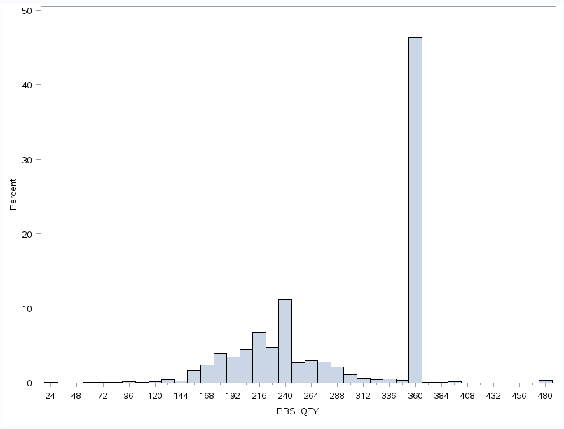
Figure 4: Dose distribution for all nivolumab prescriptions
Approximately 47% of nivolumab prescriptions were dispensed according to the flat-dosing regimen of 360mg and approximately 15% were being dispensed following the 240mg flat-dosing regimen (Figure 4).

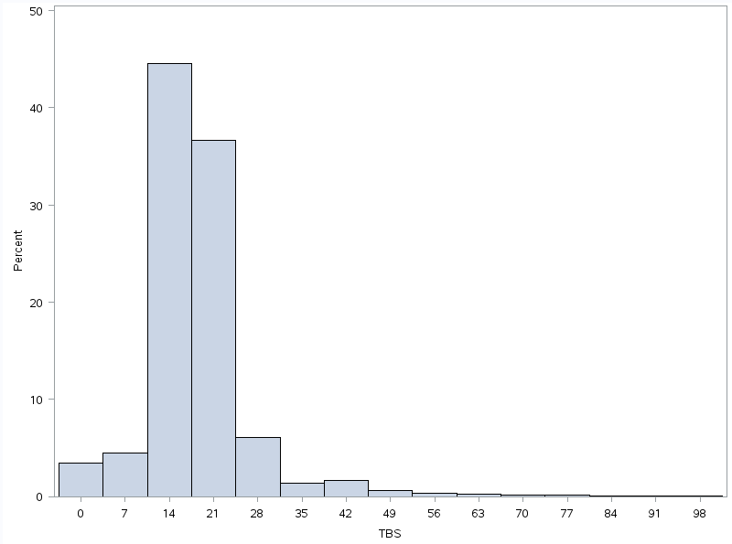
Figure 5: Time Between repeat Scripts (TBS) of nivolumab in days.
Figure 5 shows the time between repeat prescriptions of nivolumab for mesothelioma. The majority of prescriptions were dispensed with either 14 or 21 days between repeats. The 14 day scripts would likely be formed of the sub 360mg doses while the 21 days scripts would likely be those scripts at 360mg.
Further analysis of the TBS of patients using only the 360mg dose indicates that approximately 70% of repeats were processed at 21 day intervals and very few were processed at shorter intervals. This indicates that the 360mg are unlikely to be contributing to the 14 day TBS in Figure 5 and this higher proportion is more likely to be a result of the increased number of two-weekly scripts being processed compared to three-weekly.

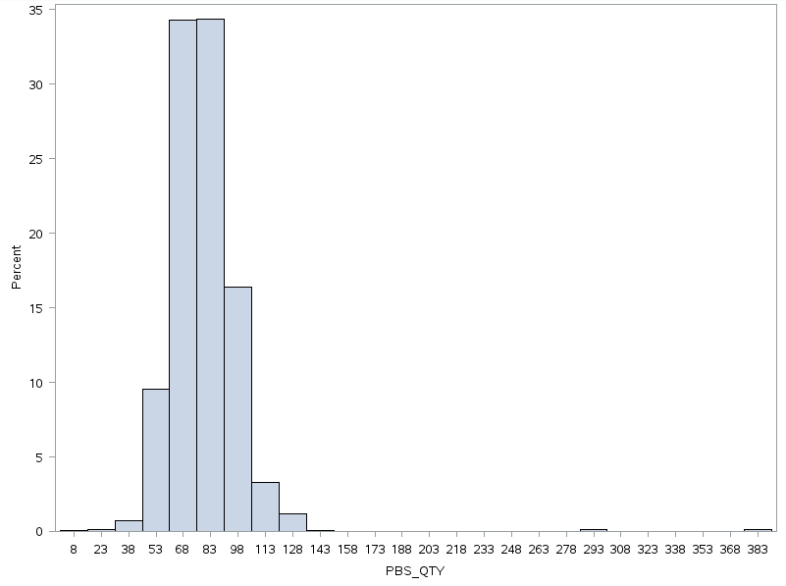
Figure 6: Dose distribution for all ipilimumab prescriptions.
Ipilimumab is dosed at 1mg/kg and Figure 6 shows the variability in dosing seen in practice with the majority of doses sitting between 68-83mg.

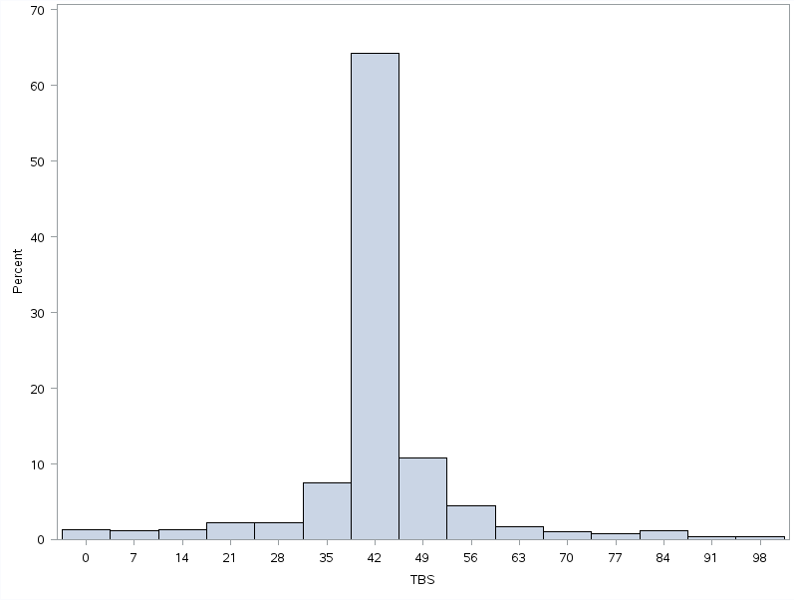Figure 7: Time Between repeat Scripts (TBS) of ipilimumab in days.
The time between repeat prescriptions of ipilimumab was primarily 42 days which corresponds to the recommended dosing regimen for mesothelioma.

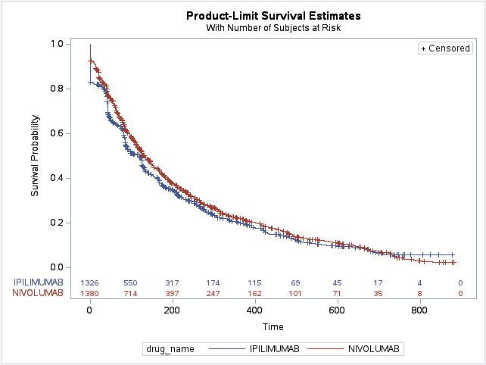
 | Quartile estimates (days) |  |  | Censoring (patients)
 | 25th Percentile | Median | 75th Percentile | Total | Failed | Percent Censored
Nivolumab | 52 | 132 | 314 | 1380 | 1051 | 23.8%
Ipilimumab | 41 | 120 | 281 | 1326 | 952 | 28.2%

Figure 8: Kaplan-Meier analysis of the time on treatment of patients supplied nivolumab and ipilimumab for unresectable malignant mesothelioma including treatment breaks.
The median time to resupply for nivolumab for mesothelioma was 16 days and for ipilimumab it was 42 days. The Kaplan-Meier analysis in Figure 8 includes patients with identified treatment breaks of longer than three times this median time to resupply. Figure 8 shows this analysis where 23-28% of patients were censored and the median time on treatment for the remaining patients was 132 and 120 days for nivolumab and ipilimumab respectively.
It should be noted that Figure 8 also indicates that there may be a small number of patients exceeding the 24 month stopping criteria that forms part of the PBS criteria.
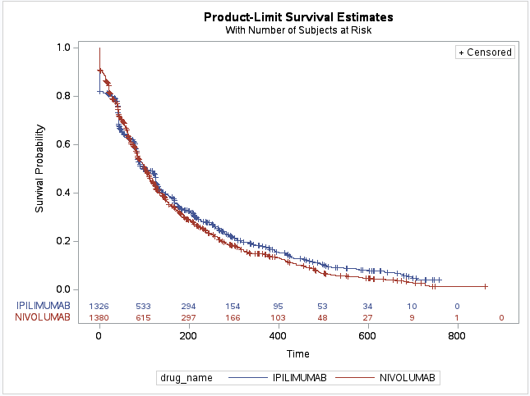
 | Quartile estimates (days) |  |  | Censoring (patients)
 | 25th Percentile | Median | 75th Percentile | Total | Failed | Percent Censored
Nivolumab | 41 | 103 | 233 | 1380 | 1109 | 19.6%
Ipilimumab | 41 | 98 | 266 | 1326 | 964 | 27.3%

Figure 9: Kaplan-Meier analysis of the time on treatment of patients supplied nivolumab and ipilimumab for unresectable malignant mesothelioma excluding treatment breaks.
Figure 9 represents a Kaplan-Meier analysis which does not include treatment breaks and therefore is representative of a patient’s first episode of treatment. Approximately 19-27% of patients were censored and the median time on treatment for the remaining patients was 103 and 98 days for nivolumab and ipilimumab respectively.

Analysis of actual versus predicted utilisation

Table 2: Actual versus predicted utilisation and cost to the PBS/RPBS of nivolumab and ipilimumab for unresectable malignant mesothelioma
 |  | Year 1 | Year 2 | Year 3
 |  | 1st July 2021 to 30th June 2022 | 1st July 2022 to 30th June 2023 | 1st July 2023 to 30th June 2024*
Patients | Predicted | XXXXXXXXXXXX | XXXXXXXXXXXX | XXXXXXXXXXXX
Patients | Actual | 748 | 742 | 502
Patients | Difference | XXXXXXXXXXXX | XXXXXXXXXXXX | NA
Prescriptions | Predicted | XXXXXXXXXXXX | XXXXXXXXXXXX | XXXXXXXXXXXX
Prescriptions | Actual | 7997 | 7724 | 3387
Prescriptions | Difference | XXXXXXXXXXXX | XXXXXXXXXXXX | NA
Net Cost PBS/RPBS | Predicted | XXXXXXXXXXXX | XXXXXXXXXXXX | XXXXXXXXXXXX
Net Cost PBS/RPBS | Actual | $58,009,360 | $59,793,100 | $27,911,298
Net Cost PBS/RPBS | Difference | XXXXXXXXXXXX | XXXXXXXXXXXX | XXXXXXXXXXXX
* Year 3 contains data up to November 2023 and is not representative of a full listing year.
Table 2 presents a comparison of the predicted versus actual utilisation and expenditure of nivolumab and ipilimumab for unresectable malignant mesothelioma since listing in July 2021. In the first year of listing the number of prevalent patients was 748 which is XXXXX than what was predicted. The number of patients in Year 2 was 742 which is XXXXX than what was predicted. The number of prescriptions dispensed in the first year of listing was XXXXX than what was predicted however the cost to the PBS/RPBS was only XXXXXthan predicted. The number of prescriptions in Year 2 was XXXXX than predicted however the cost to PBS/RPBS was XXXXX than predicted.

Discussion
The overall utilisation with regards to patient count and prescription count of nivolumab and ipilimumab for unresectable malignant mesothelioma is XXXXXto what was predicted in the submission. As noted by the PBAC and DUSC in March 2021, there is an increasing incidence of mesothelioma. This is likely contributing to the slight increase in initiating patients per quarter and resulting in the higher than expected number of prevalent patients and contributing to the increased costs.
The dosing of nivolumab was primarily three-weekly flat-dosing with approximately 47% of prescriptions dispensed as 360mg. The submission based the cost per infusion on the Checkmate 743 protocol of 3mg/kg and an average patient weight of 72.75kg. The PBAC and DUSC considered that this would underestimate utilisation as patients in the trial would likely be fitter than the general Australian population which would also have a higher proportion of males. The increased actual cost to the PBS/RPBS seen in Year 2 of XXXXX illustrative of these higher doses being used.
The Kaplan-Meier analysis of time on treatment indicated that there was a proportion of patients that appeared to be longer term users of nivolumab and ipilimumab and these patients combined with those who were censored in the analysis and continuing treatment are likely also contributing to the increased costs.

DUSC consideration
The overall utilisation with regards to patient count and prescription count of nivolumab and ipilimumab for unresectable malignant mesothelioma is XXXXXto what was predicted in the submission. As noted by the PBAC and DUSC in March 2021, there is an increasing incidence of mesothelioma. This is likely contributing to the slight increase in initiating patients per quarter and resulting in the higher than expected number of prevalent patients and contributing to the increased costs.
The dosing of nivolumab was primarily three-weekly flat-dosing with approximately 47% of prescriptions dispensed as 360mg. The submission based the cost per infusion on the Checkmate 743 protocol of 3mg/kg and an average patient weight of 72.75kg. The PBAC and DUSC considered that this would underestimate utilisation as patients in the trial would likely be fitter than the general Australian population which would also have a higher proportion of males. The increased actual cost to the PBS/RPBS seen in Year 2 of XXXXX illustrative of these higher doses being used.
The Kaplan-Meier analysis of time on treatment indicated that there was a proportion of patients that appeared to be longer term users of nivolumab and ipilimumab and these patients combined with those who were censored in the analysis and continuing treatment are likely also contributing to the increased costs.

DUSC actions
DUSC requested that the report be provided to the PBAC for consideration.

Context for analysis
The DUSC is a Sub Committee of the Pharmaceutical Benefits Advisory Committee (PBAC). The DUSC assesses estimates on projected usage and financial cost of medicines.
The DUSC also analyses data on actual use of medicines, including the utilisation of PBS listed medicines, and provides advice to the PBAC on these matters. This may include outlining how the current utilisation of PBS medicines compares with the use as recommended by the PBAC.
The DUSC operates in accordance with the quality use of medicines objective of the National Medicines Policy and considers that the DUSC utilisation analyses will assist consumers and health professionals to better understand the costs, benefits and risks of medicines.
The utilisation analysis report was provided to the pharmaceutical sponsors of each drug and comments on the report were provided to DUSC prior to its consideration of the analysis.

Sponsors’ comments
The sponsor has no comment.

References
- OPDIVO® (NIVOLUMAB). Consumer Medicine Information. July 2019. Available from https://www.tga.gov.au/consumer-medicines-information-cmi
- Australian Medicines Handbook Online.

Disclaimer
The information provided in this report does not constitute medical advice and is not intended to take the place of professional medical advice or care. It is not intended to define what constitutes reasonable, appropriate or best care for any individual for any given health issue. The information should not be used as a substitute for the judgement and skill of a medical practitioner.
The Department of Health and Aged Care has made all reasonable efforts to ensure that information provided in this report is accurate. The information provided in this report was up-to-date when it was considered by the Drug Utilisation Sub-committee of the Pharmaceutical Benefits Advisory Committee. The context for that information may have changed since publication.
To the extent provided by law, the Department of Health and Aged Care makes no warranties or representations as to accuracy or completeness of information contained in this report.
To the fullest extent permitted by law, neither the Department of Health and Aged Care nor any Department of Health and Aged Care employee is liable for any liability, loss, claim, damage, expense, injury or personal injury (including death), whether direct or indirect (including consequential loss and loss of profits) and however incurred (including in tort), caused or contributed to by any person’s use or misuse of the information available from this report or contained on any third party website referred to in this report.

OPDIVO® (NIVOLUMAB). Consumer Medicine Information. July 2019. Available from https://www.tga.gov.au/consumer-medicines-information-cmi
Australian Medicines Handbook Online. https://amhonline.amh.net.au/chapters/immunomodulators-antineoplastics/non-cytotoxic-antineoplastics/antineoplastic-antibodies

